IEEE P802.11
Wireless LANs
Clause 6 – Investigation
Date: 2022-02
Author(s):
Name | Affiliation | Address | Phone | email
Graham SMITH | SR Technology | Sunrise, FL, USA. | 916 799 9563 | gsmith@srtrl.com
Abstract
Look in depth at Clause 6
Rev 1 START AT PAGE 9

Background:
Contribution 21/1822 noticed that Clause 6 consumes 434 pages MORE THAN Clause 11 (398 pages) and questioned if it was really worth it.
Contribution 21/1822 also looked at refeerrences in text to Clause 6 and proposed an approach along the lines of

ACTION.request primitives are detailed in this clause when they do not directly correspond to frame described in “Clause 9” or Clause 11 (note some might be elsewhere), or where the primitive parameters significantly differ.

Hence, first short list might be:
6.3.2 MLME-POWERMGT
6.3.3 MLME SCAN
6.3.4 MLME JOIN (synchronization)
6.3.5 MLME AUTHENTICATE
6.3.6 MLME DEAUTHENICATE
6.3.7 MLME ASSOCIATE
6.3.8 MLME REASSOCIATE
6.3.9 MLME DISASSOCIATE
6.3.10 MLME RESET
6.3.11 MLME START
6.3.12 MLME STOP

6.3.19 MLME-SETKEYS

At Feb 24 telecon meeting:
Consensus on worthwhile work.
Noted diagrams in 6.3.13 and TDLS and Timing. As these are “abstract” not sure these figures are needed here. Should fit the standard model.

Possible Way ahead is to expand the Introduction to 6.3. Add diagrams showing the two different models, internal command, and request/response.
Possibly a list of all “standard” promitives meeting one or other model. Maybe with reference to Clause 9 or 11 where the respective packet is defined.

First some acronyms:
SME – Station management entity
MLME – MAC sublayer management entity
PLME – PHY layer management entity
SAP – Service Access Point

6.3 MLME SAP interface

The services provided by the MLME to the SME are specified in this subclause. These services are
described in an abstract way (following the model described in ITU-T Recommendation X.210 [B55]) and
do not imply any particular implementation or exposed interface. MLME SAP primitives are of the general
form ACTION.request primitive followed by ACTION.confirm primitive (for an exchange initiated by the
SAP client) and ACTION.indication primitive followed by ACTION.response primitive (for an exchange
initiated by the MLME). The SME uses the services provided by the MLME through the MLME SAP

NOTE: “These services are described in an abstract way…and do not imply any particular implementation…”
Let’s list this out clearer:
MLME SAP primitives are of the general form
For an exchange initiated by the SAP client
- ACTION.request primitive,
- ACTION.confirm primitive
For an exchange initiated by the MLME
- ACTION.indication primitive
- ACTION.response primitive

Now most exchanges are of the form “Request / Response”
BTW I coud not find any similar drawing or indeed anything useful in the ITU document.
Based on this “General Form” I interpret this as following diagram:

FIGURE 1 – General form of MLME SAP Primitives for Request/Response

FIGURE 2 – General form of MLME SAP Primitives for SME requests MLME to something that does not initiate a packet to a peer STA, e.g. START

AND there is a third
FIGURE 3 – General form of MLME SAP Primitives for request to perform a requested Action and report on it.

Soo…let’s look at an example that we should all understand. ASSOCIATE.

MLME-ASSOCIATE.request
This primitive requests association with a specified peer MAC entity that is within an AP.

When generated:
This primitive is generated by the SME when a STA wishes to establish association with an AP or PCP.

Effect of receipt
This primitive initiates an association procedure. In the case that a response is received from the responder STA, the MLME subsequently issues an MLME-ASSOCIATE.confirm primitive that reflects the results.

MLME-ASSOCIATE.confirm
This primitive reports the results of an association attempt with a specified peer MAC entity that is in an AP or PCP.

When generated:
This primitive is generated by the MLME as a result of an MLME-ASSOCIATE.request primitive or receipt of an Association Response frame from the peer MAC entity to associate with a specified peer MAC entity that is in an AP or PCP.
NOTE: This seems to indicate that the MLME sends a ‘confirmation’ of receipt back to the SME, and then later on, the confirmation that the Association Response frame has been received. Maybe this should have been “on” receipt.
NOTE 2 (3/7/meeting) Could be that a .confirm is sent if error in the .request or time out or ??? Might need look at the error codes and then sort out. But in any case, would need a lot more description – if it was worth it!

Effect of receipt
The SME is notified of the results of the association procedure.
NOTE: This does not align if really is “or”

MLME-ASSOCIATE.indication
This primitive indicates that a specific peer MAC entity is requesting association with the local MAC entity, which is in an AP or PCP

When generated:
This primitive is generated by the MLME as a result of the receipt of an association request from a specific peer MAC entity

Effect of receipt
The SME is notified of the receipt of the association request

MLME-ASSOCIATE.response
This primitive is used to send a response to a specific peer MAC entity that requested an association with the
STA that issued this primitive, which is in an AP or PCP.

When generated:
This primitive is generated by the SME of a STA that is in an AP or PCP as a response to an MLMEASSOCIATE.indication primitive

Effect of receipt
This primitive initiates transmission of an AssociationResponse to the specific peer MAC entity that requested association.

Is this right? It fits exactly with the description. Does SME need a confirm?

Note
MLME-REASSOCIATE.confirm
This primitive is generated by the MLME as a result of an MLME-REASSOCIATE.request primitive to reassociate with a specified peer MAC entity that is in an AP or PCP.

NOTE: REASSOCIATE not include the “immediate” confirm. Neither does the DISASSOCIATE.

FIRST PROPOSED CHANGE
I suggest the “or” should be changed to “on”.

Then ASSOCIATE meets the general form FIG. 1.

Let’s look at another diagram that was inserted. TDLS direct link establishment. How many problems here?

This is scary. I suspect it has never been looked at since it was written.
Do we need a primitive if no response happens?
Discussion (3/7/22) This is a 3 exchange scheme hence, 3 type 4 exchanges, single

Also look at Figure 6.8.
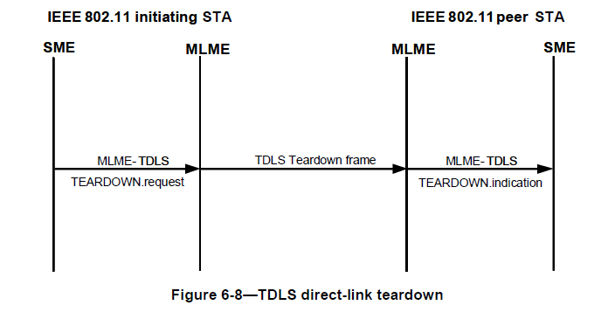

With no response at all, should this even be here? Note should be Type 4 case.

Let’s discuss.

There are 24 Figures in Clause 6.3. How many are really needed? If they meet one of the “General Cases” they need not be there?

Let’s now look at FIG. 6.3

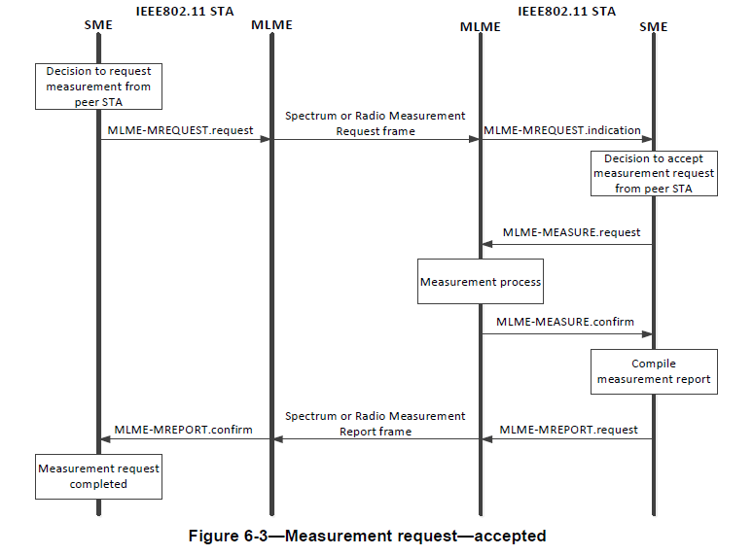
This is classic case of General Form #3. The action is pretty clear from the text, i.e. get a request, do it, then send the response.

NEXT STEPS
Go through all figures in 6.3. Look at text to see if they meet one of the “General Forms” and how they are actually referred to.

Are they needed? Is description in Clause 9 or 11 sufficiently clear. What about the boxes?

We could in text refer to which “Form” of MLME SAP primitive is used.

Make decision if any do not fit the four “General Forms”. Is there another?

OBJECTIVE
Write Introduction with descriptions of the 4 General Forms and see if these adequately cover all the 125 cases minus the 12 listed earlier.

In Clause 12.2.10. P3097.10, we have
The SME of the non-AP STA may change the MAC address by generating an MLMEUPDATEMACADDRESS. request primitive containing the new MAC address. On receipt of an MLME-UPDATEMACADDRESS.request primitive, the MLME shall attempt to update the MAC address that is to be used by the MAC entity and shall generate an MLME-UPDATEMACADDRESS.confirm primitive to notify the SME whether the MAC address has been changed to the new value.

Note that it appears at 6.3.117 P815. In this case it is clear that we do not need 6.3.117.

__________________________________________________________________

Proposed new 6.3 Introduction

6.3 MLME SAP interface

6.3.1 Introduction
The services provided by the MLME to the SME are specified in this subclause. These services are described in an abstract way (following the model described in ITU-T Recommendation X.210 [B55]) and do not imply any particular implementation or exposed interface. MLME SAP primitives are of the general form ACTION.request primitive followed by ACTION.confirm primitive (for an exchange initiated by the SAP client) and ACTION.indication primitive followed by ACTION.response primitive (for an exchange initiated by the MLME). The SME uses the services provided by the MLME through the MLME SAP.

6.3.1.1 Types of MLME-SAP interface primitive forms

There are six general forms of MLME-SAP interface primitives.

Figure 6.x depicts Type 1. The Type 1 general form is used for the exchange of request/response frames between an initiating STA and a peer STA.

FIGURE 6.x – Type 1 form of MLME SAP primitives for request/response process

The .request primitive is generated by the SME of the initiating STA to request that a Request frame is sent to a peer STA.
The .indication primitive is generated by the MLME of the peer STA when the Request frame is received.
The .response primitive is generated by the SME of the peer to request that a Response frame be sent to the initiating STA.
The .confirm primitive includes a Result Code reporting success or failure of the request, and is generated by the MLME of the initiating STA when the either Response frame from the peer STA is acknowledged, or the (re)transmission of the request frame fails.

Figure 6.xx depicts Type 2. The Type 2 general form is used for the SME requesting a process to be initiated by the MLME.

FIGURE 6.xx – Type 2 form of MLME SAP primitives for SME requesting MLME to perform a process
The .request primitive is generated by the SME to request that a process is initiated by the MLME.
The .confirm primitive generally includes a Result Code reporting success or failure of the request, and is generated by the MLME when the requested action of process is completed, or fails.
??? We also have several .request only, i.e., no .confirm. Do we need a separate figure/type for this, or just cover it in the text as follows.
If the SME does not require a confirmation then the .confirm primitive may be omitted.

Figure 6.xxx depicts Type 3. The Type 3 general form is used for the exchange of request/response frames between an initiating STA and a peer STA where the peer STA is requested to perform an action before responding.

FIGURE 6.xxx – Type 3 form of MLME SAP primitives for request to peer STA to perform an action before responding.
The .request primitive is generated by the SME of the initiating STA to request that a Request frame is sent to a peer STA.
The .indication primitive is generated by the MLME of the peer STA when the Request frame is received.
The .request primitive is generated by the SME of the peer STA to request that a process is initiated by the MLME of the peer STA.
The .confirm primitive from the MLME of the peer STA generally includes a Result Code reporting success or failure of the request, and is generated by the MLME when the requested action of process is completed, or fails.
The .response primitive is generated by the SME of the peer STA to request that a Response frame be sent to the initiating STA.
The .confirm primitive includes a Result Code reporting success or failure of the request, and is generated by the MLME of the initiating STA when the either Response frame from the peer STA is acknowledged, or the (re)transmission of the request frame fails.

Figure 6.xxxx depicts Type 4. The Type 4 general form is used for the transmission of a frame from one STA to a peer STA that does not require a response from the peer STA.

FIGURE 6.xxxx – Type 4 form of MLME SAP primitives for frame transmission not requiring a response

The .request primitive is generated by the SME of the initiating STA to request that a Request frame is sent to a peer STA.
The .indication primitive is generated by the MLME of the peer STA when the Request frame is received.

Figure 6.xxxxx depicts Type 5. The Type 5 general form is used for the transmission of a frame that does not require a response, but does require a confirmation that it was sent.

FIGURE 6.xxxxx – Type 5 form of MLME SAP primitives for a frame transmission from a STA, but does require a confirmation that it was sent

The .request primitive is generated by the SME to request that the MLME transmits a frame.
The .confirm primitive generally includes a Result Code reporting success or failure of the request, and is generated by the MLME when the requested frame transmission is completed, or fails.

Figure 6.xxxxxx depicts Type 6. The Type 6 general form when the MAC informs the SME of an event.

FIGURE 6.xxxxxx – Type 6 form of MLME SAP primitives for MAC informing SME of an event

The .indication primitive is generated by the MLME to inform the SME of an event.

6.3.1.2 MLME-SAP Primitives

MLME-SAP primitives are detailed in this clause when they do not directly correspond to frame exchanges described in Clause 9 or Clause 11, where the primitive parameters differ significantly from the fields in the respective Action frames, or when the primitives may not be clear from the descriptions in Clauses 9 or 11.

Include the following, renumbering where necessary:
6.3.2 MLME-POWERMGT Type 2
6.3.3 MLME SCAN Type 2 plus STOP request (with no confirm)
6.3.4 MLME JOIN (synchronization) Type 2
6.3.5 MLME AUTHENTICATE Type 1
6.3.6 MLME DEAUTHENICATE request.confirm,indication
6.3.7 MLME ASSOCIATE Type 1
6.3.8 MLME REASSOCIATE Type 1
6.3.9 MLME DISASSOCIATE request.confirm,indication
6.3.10 MLME RESET request (Type 2 no confim)
6.3.11 MLME START Type 2
6.3.12 MLME STOP request (Type 2 no confirm)
6.3.13 Protocol layer model for spectrum management and radio measurement
6.3.19 MLME-SETKEYS (renumber to 6.3.14)

Look through the rest, one by one to see if a case for keeping them or if adequately described in the relate text.

Look at recommendations in 21/1822 for text changes related to 6.3 references in text.

6.3.14 Measurement Request
MREQUEST. Request and indication.
Type 4

6.3.15 Channel measurement
MEASURE. Request and confirm.
Type 2

6.3.16 Measurement report
MREPORT.request and indication
Type 4,

COMMENT: These measurement primitives seem that they should be better served by type 1. Discuss.

6.3.17 Channel switch
Type 1

6.3.18 TPC request
Type 2
11.7.7

6.3.20 Delete keys
Request only. Type 2 without the confirm. Is that right?

6.3.21 MIC failure
Indication only.
Type 6.

6.3.22 EAPOL
Type 2

6.3.23 Set Protection
Request only. Type 2 without the confirm

6.3.24 Protected frame dropped - (Note different heading!!)
Indication only.
Type 6

6.3.25 TS management
LOOK AT THIS ONE. Think all Type 1

6.3.26 Higher layer synchronization support
Type 4

6.3.27 Block Ack
ADDBA Type 1.
DELBA Type 4.

6.3.28 Schedule element management
Type 4

6.3.29 Vendor Specific action
Type 4

6.3.30 Neighbor report
Type 4

6.3.31 Neighbor report response
Type 4
COMMENT – Why two Type 4’s, surely should be Type 1 or 3

6.3.32 Link Measure request
Type 2

6.3.33 Resource request (again different heading style)
Type 1
Resource Request - Local
Type 2. (MIGHT NEED LOOKING AT) Why not separate?

6.3.34 Remote requests (Different heading format)
Type 4

6.3.35 Extbded channel switch announcement
Type 1

6.3.36 DSE power constraint announcement
Type 1

6.3.37 Enablement
Type 1

6.3.38 Deenablement
Type 4

6.3.39 SA Query support
Type 1

6.3.40 Get TSF timer
Type 2

6.3.41 Timing Advertisement
Type 4

6.3.42 TDLS Discovery
Type 1

6.3.43 TDLS direct link establishement
See discussion

6.3.44 TDLS direct link teardown
Type 4

6.3.45 TDLS peer U-APSD
Type 1

6.3.46 TDLS channel switching
Type 1

6.3.47 TDLS peer PSM
Type 1

6.3.48 Event request
Type 4

6.3.49 Event report
Type 4 Why two Type 4’s, surely should be Type 1 or 3

6.3.50 Event
Type 2

6.3.51 Diagnostic request
Type 4

6.3.52 Diagnostic reporo
Type 4 Why two Type 4’s, surely should be Type 1 or 3

6.3.53 Location configuration request
Type 1

6.3.54 Location track notification
Type 4

6.3.55 Timing measurement
Need to study this.
Type 4, followed by type 4 with an added .confirm. Begs the question why not a confirm on the first one. I.e. is an ACK always followed by a confirm? Seems superfluous. The more I look at these the worse it gets.

6.3.56 Fine timing measurement
Same as Timing.

6.3.57 BSS transition management procedure
Type 4 , then Type 1

Diagram appears useful, does it appear in similar form in text? No but primitives are described in text. (see 11.21.7.4) So decision is whether it is clear without the diagram in 6.3.57?

6.3.58 FMS setup
Type 1

6.3.59 Collocated interference request
Type 4

6.3.60 Collocated interference response
Type 4
AGAIN why two type 4’s. Should be Type 1 or 3

6.3.61 TFS setup
Type 1

6.3.62 WNM sleep mode request
Type 1

6.3.63 TIM broadcast setup
Type 1

6.3.64 QoS traffic capability update
Type 4

6.3.65 Channel Usage request
Type 1 (but really is a Type 3)

6.3.66 DMS or GCR request and response procedure (Again not standard heading)
GATS is type 1 or 3
GATS TERM is type 4

6.3.67 WNM notification request
Type 4

6.3.68 WNM notification response
Type 4 AGAIN why two type 4’s. Should be Type 1 or 3

6.3.69 Network discovery and selection support
Type 1

6.3.70 QoS Map element management
Type 4 (Note: Lots of normative text in the General. Is this the right place for this? Hopefully it is in the main text)

6.3.71 Mesh peering management
Type 1

6.3.72 Mesh power management
Type 2

6.3.73 Mesh neighbor offset synchronization
Three Type 2 START, CALCULATE, STOP

6.3.74 Mesh TBTT adjustment
Type 1

6.3.75 MCCA management interface
A single .request MAC to “activate MCCA” Type 2A
Then a Type 1

6.3.76 MBSS congestion control
Type 4

6.3.77 MBSS proxy update
Type 1

6.3.78 MBSS mesh gate announcement
Type 4

6.3.79 Mesh link metric
Type 1

6.3.80 HWMP mesh path selection
Type 4

6.3.81 QMF policy
POLICY Type 2
POLICYCHANGE Type 4
POLICYSET single .request why no .confirm? Type 2A

6.3.82 SCS request and response procedure
Type 1
Then Type 4

6.3.83 QLoad report management
Type 1

6.3.84 HCCA TXOP advertisement management
Type 1

6.3.85 GCR group membership management
Type 1

6.3.86 AP PeerKey management
Type 4

6.3.87 On-channel Tunneling operation
Type 6

6.3.88 Multi band operation
Type 1 SETUP
Type 1 ACK
Type 4 TEARDOWN, but think it should be Type 2?

INCOMING Single .request (no-confirm) Type 2A

6.3.89 DMG relay operation
SEARCH Type 1
RLS Type 1
TEARDOWN Type 4

6.3.90 Quieting adjacent BSS operation
Type 1

6.3.91 DMG beamforming
SISO Type 6
SISO MIMO Type 6
MIMO Beamforming Type 6
MIMO hybrid Type 6
MIMO hybrid beamforming Type 6

6.3.92 PN event report
Two .indications Type 6.

6.3.93 Channel availability query
Type 1

6.3.94 Channel schedule management
Type 1

6.3.95 Contact verification signal
Type 4

6.3.96 GDD Enablement
Type 1

6.3.97 Network channel control management
Type 1

6.3.98 White space map
Type 4

6.3.99 Estimated Throughput
Type 2

6.3.100 Get authentication and association state
Type 2

6.3.101 FILS Container
Type 1

6.3.102 Dynamic AID assignemtn operation
Type 1

6.3.103 Sync control
Type 4

6.3 104 STA Information Announcement
Type 4

6.3.105 EDCA Parameter Set update
Type 4

6.3.106 EL operation
Type 4

6.3.107 TWT setup
Type 1

6.3.108 TWT teardown
Type 4

6.3.109 Sectorized Group ID List management
Type 4

6.3.110 Header Compression procedure
Type 1

6.3.111 Reachhable Address update
Type 4

6.3.112 Control response MCS negotiation operation
Type 1

6.3.113 S1G relay
Type 1

6.3.114 DCS procedure
MEASUREMENT Type 1
DCS Type 1

6.3.115 Update
Type 2

6.3.116 MSCSrequest and response procedure
Type 1
MSCS TERM Type 4

6.3.117 MAC Address update
Type 2

6.3.118 Quiet time period
Type 1

6.3.119 TDD beamforming
Type 1 without the response. Is this another type?

6.3.120 TDD sector switch
Type 1 without the response. Is this another type?

6.3.121 TDD beam measurement
Type 1 without the response. Is this another type?

6.3.122 TDD structure and schedule
STRUCTURE Type 2
SCHEDULE Type 2
ANNOUNCE Type 1 without the response. Is this another type?
BANDWIDTH Type 1 without the response. Is this another type?

6.3.123 WUR mode set up
Type 1

6.3.124 WUR mode teardown
Type 4

6.3.125 WUR Discosvery
Type 2.

