IEEE P802.11
Wireless LANs
Proposed Resolution for CID 1090
Date: 2022-03-15
Author:
Name | Affiliation | Address | Phone | Email
Emily Qi | Intel Corporation |  |  | Emily.h.qi@intel.com
Mark Hamilton | Ruckus/CommScope |  |  | mark.hamilton2152@gmail.com
Jerome Henry | Cisco System |  |  | Jerome Henry (jerhenry) <jerhenry@cisco.com>
Jouni Malinen | Qualcomm |  |  | jouni@qca.qualcomm.com

Abstract

This submission presents proposed resolutions for CID 1090

The proposed changes are based on REVme D1.0.

Revision history:

R0 – Initial version
R1 – Incorporated the suggestion from Jouni.

CID | Commenter | Clause Number(C) | Page(C) | Line(C) | Assignee | Comment | Proposed Change
1090 | Emily Qi | 9.4.5.31 | 1830 | 10 | Emily Qi | The Info ID field and Length field are included in Figure 9-1057 as part of Venue SLA Policy Tuple subfield. Why? | Remove "Info ID" field and "Length" fields in Figure 9-1057.

Discussion:
Cited text:

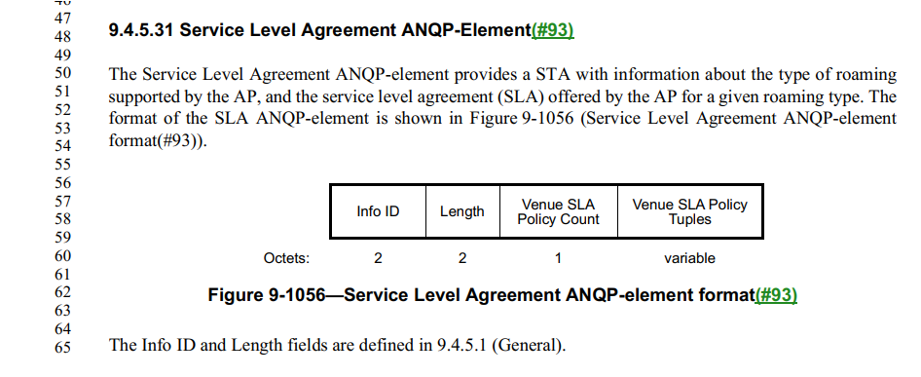
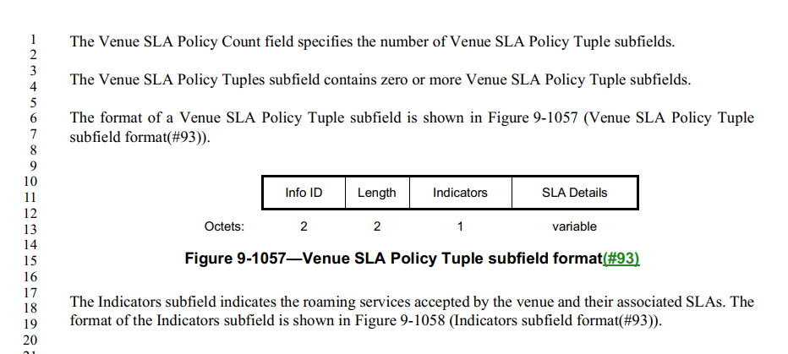

Summary of changes:
- Removed the Info ID field. The Length field is still needed.
- Added the definition for the Length field.

Proposed resolution: Revised.
TGm editor: Changes 9.4.5.31 as follows:
- Service Level Agreement ANQP-Eelement
The Service Level Agreement ANQP-element provides a STA with information about the type of roaming supported by the AP, and the service level agreement (SLA) offered by the AP for a given roaming type. The format of the SLA ANQP-element is shown in Figure 9-1056 (Service Level Agreement ANQP-element format(#93)).
 | Info ID | Length | Venue SLA Policy Count | Venue SLA Policy  Tuples
Octets: | 2 | 2 | 1 | variable
- Service Level Agreement ANQP-element format

The Info ID and Length fields are defined in 9.4.5.1 (General).
The Venue SLA Policy Count field specifies the number of Venue SLA Policy Tuple subfields.
The Venue SLA Policy Tuples subfield contains zero or more Venue SLA Policy Tuple subfields.
The format of a Venue SLA Policy Tuple subfield is shown in Figure 9-1057 (Venue SLA Policy Tuple subfield ANQP-element format(#93)).
 | Info ID | Length | Indicators | SLA Details
Octets: | 2 | 2 | 1 | variable
- Venue SLA Policy Tuple subfield format(#93)
The Length field contains the length of the remaining fields in octets.
The Indicators subfield indicates the roaming services accepted by the venue and their associated SLAs. The format of the Indicators subfield is shown in Figure 9-1058 (Indicators subfield format(#93)).
 | B0 B1 | B2 B3 | B4 B5 | B6 B7
 | First Settlement Indicator | First SLA Indicator | Second Settlement Indicator | Second SLA Indicator
Bits: | 2 | 2 | 2 | 2
- Indicators subfield format(#93)

The First Settlement Indicator and Second Settlement Indicator subfields each indicate a type of roaming service accepted by the venue. The values of the First Settlement Indicator and Second Settlement Indicator subfields are specified in Table 9-421 (Settlement indicator values(#93)).
- Settlement indicator values(#93)
Value | Settlement Type
0 | All
1 | Free services
2 | Paid services
3 | Reserved

The First SLA Indicator and Second SLA Indicator subfields each indicate the SLA that the AP offers for the respective settlement type. The values of the First SLA Indicator and Second SLA Indicator subfields are specified in Table 9-422 (SLA indicator values(#93)) and follow the Olympic model defined in IETF RFC 2597([B30]).
- SLA indicator values(#93)
Value | SLA
0 | No Olympic SLA
1 | Bronze
2 | Silver
3 | Gold

If the First SLA Indicator subfield is set to 0, the Second Settlement Indicator and Second SLA Indicator subfields are reserved. Otherwise, the First SLA Indicator and Second SLA Indicator subfields differ, and a nonzero value in the First SLA Indicator subfield takes precedence over a value of 0 in the Second SLA Indicator subfield, for the settlement type indicated by the First SLA Indicator subfield.
The SLA Details subfield is an optional vendor specific UTF-8 string that can be used to indicate the details of the SLA (e.g., minimum bandwidth, max jitter or delay, etc.). The content of this subfield is beyond the scope of this standard(#1560).

