IEEE P802.11
Wireless LANs
Proposed Resolution for CID 1090
Date: 2022-03-01
Author:
Name | Affiliation | Address | Phone | Email
Emily Qi | Intel Corporation |  |  | Emily.h.qi@intel.com
Mark Hamilton | Ruckus/CommScope |  |  | mark.hamilton2152@gmail.com
Jerome Henry | Cisco System |  |  | Jerome Henry (jerhenry) <jerhenry@cisco.com>

Abstract

This submission presents proposed resolutions for CID 1090

The proposed changes are based on REVme D1.0.

Revision history:

R0 – initial version
R1

CID | Commenter | Clause Number(C) | Page(C) | Line(C) | Assignee | Comment | Proposed Change
1090 | Emily Qi | 9.4.5.31 | 1830 | 10 | Emily Qi | The Info ID field and Length field are included in Figure 9-1057 as part of Venue SLA Policy Tuple subfield. Why? | Remove "Info ID" field and "Length" fields in Figure 9-1057.

Discussion:
Cited text:

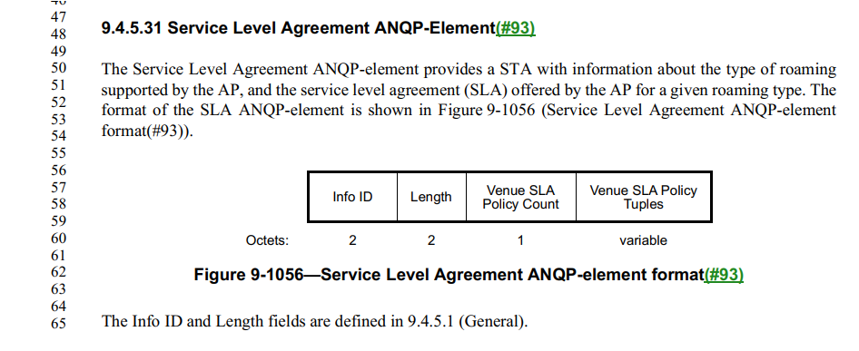
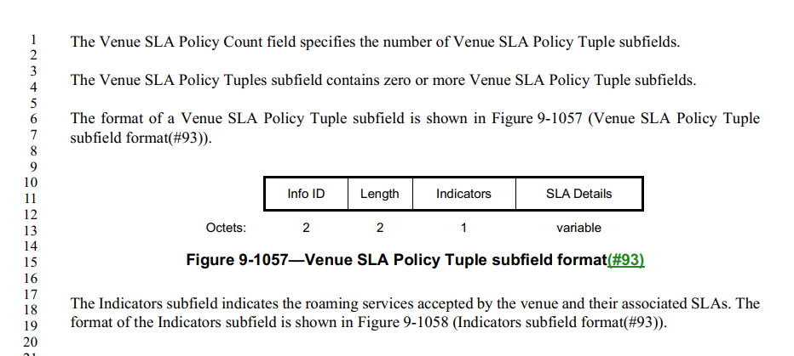

Offline discussion from Mark H :
- Info ID is included so that this ANQP-element is extensible to add other types of Tuples/information in the future, and be able to tell what type of “sub-element” each one is. However, I note that I don’t see that the “Info ID” for the Venue SLA Policy Tuple is defined. That seems like an oversight.
- Length is there because the SLA Details subfield is just a variable length string, and there can be multiple Venue SLA Policy Tuples in the SLA ANQP-element, so we need a length to determine the length of the string to parse the subfields.

Okay, Agreed.
Summary of Changes:
- Define a value of “Info ID” for the Venue SLA Policy Tuple.
- Change the definition of the Venue SLA Policy Tuple to the Venue SLA Policy ANQP-element.
- Given that the Service Level Agreement ANQP-Element may include multiple ANQP elements, (for now, only one type of ANQP-elements is included), restructure 9.4.5.31 Service Level Agreement ANQP-Element to be extensible.

Proposed resolution: Revised.
TGm editor: Insert a new line to Table 9-410 ANQP-element definitions as follows and changed the Reserved row correspondingly:

- ANQP-element definitions
ANQP-element name | InfoID | ANQP-element (subclause)
Venue SLA Policy | <ANA> | 9.4.5.33 (Venue SLA Policy ANQP-element)

TGm editor: Changes 9.4.5.31 as follows:
- Service Level Agreement ANQP-Eelement
The Service Level Agreement ANQP-element provides a STA with information about the type of roaming supported by the AP, and the service level agreement (SLA) offered by the AP for a given roaming type. The format of the SLA ANQP-element is shown in Figure 9-1056 (Service Level Agreement ANQP-element format(#93)).
 | Info ID | Length | Venue SLA Policy Count | Optional ANQP-elements
Octets: | 2 | 2 | 1 | variable
- Service Level Agreement ANQP-element format

The Info ID and Length fields are defined in 9.4.5.1 (General).
The Venue SLA Policy Count field specifies the number of Venue SLA Policy Tuple subfields.
The Optional ANQP-elements field contains one or more ANQP-elements as shown in Table 9-X0.
Table 9-X0 ANQP-elements included in the Optional ANQP-elements field
ANQP-element name | InfoID | Notes
Venue SLA Policy | <ANA> | One or more Venue SLA Policy ANQP-elements are included.

The Venue SLA Policy Tuples subfield contains zero or more Venue SLA Policy Tuple subfields.
Note to TGm editor: the following text will be moved the end of subclause 9.4.5 as a new clause 9.4.5.33.

9.4.5.33 Venue SLA Policy ANQP-element

The format of a Venue SLA Policy Tuple subfield ANQP-element is shown in Figure 9-1057 (Venue SLA Policy Tuple subfield ANQP-element format(#93)).
 | Info ID | Length | Indicators | SLA Details
Octets: | 2 | 2 | 1 | variable
- Venue SLA Policy Tuple subfield ANQP-element format(#93)
The Info ID and Length fields are defined in 9.4.5.1 (General).
The Indicators subfield indicates the roaming services accepted by the venue and their associated SLAs. The format of the Indicators subfield is shown in Figure 9-1058 (Indicators subfield format(#93)).
 | B0 B1 | B2 B3 | B4 B5 | B6 B7
 | First Settlement Indicator | First SLA Indicator | Second Settlement Indicator | Second SLA Indicator
Bits: | 2 | 2 | 2 | 2
- Indicators subfield format(#93)

The First Settlement Indicator and Second Settlement Indicator subfields each indicate a type of roaming service accepted by the venue. The values of the First Settlement Indicator and Second Settlement Indicator subfields are specified in Table 9-421 (Settlement indicator values(#93)).
- Settlement indicator values(#93)
Value | Settlement Type
0 | All
1 | Free services
2 | Paid services
3 | Reserved

The First SLA Indicator and Second SLA Indicator subfields each indicate the SLA that the AP offers for the respective settlement type. The values of the First SLA Indicator and Second SLA Indicator subfields are specified in Table 9-422 (SLA indicator values(#93)) and follow the Olympic model defined in IETF RFC 2597([B30]).
- SLA indicator values(#93)
Value | SLA
0 | No Olympic SLA
1 | Bronze
2 | Silver
3 | Gold

If the First SLA Indicator subfield is set to 0, the Second Settlement Indicator and Second SLA Indicator subfields are reserved. Otherwise, the First SLA Indicator and Second SLA Indicator subfields differ, and a nonzero value in the First SLA Indicator subfield takes precedence over a value of 0 in the Second SLA Indicator subfield, for the settlement type indicated by the First SLA Indicator subfield.
The SLA Details subfield is an optional vendor specific UTF-8 string that can be used to indicate the details of the SLA (e.g., minimum bandwidth, max jitter or delay, etc.). The content of this subfield is beyond the scope of this standard(#1560).

