IEEE P802.11
Wireless LANs
802.11bc ANA Discussion
Date: February 18, 2022
Author(s):
Name | Affiliation | Address | Phone | email
Carol Ansley | Cox |  |  | carol@ansley.com

Abstract
This submission discusses feedback from the ANA coordinator. He has recommended changes to the definition of several fields/frames.

Revisions:
- Rev 0: Initial version of the document.

I received the following feedback from Robert Stacey on the ANA requests in the table below:

- Based on your draft, I think you are looking for a Data frame subtype allocation and not a Frame Type allocation. However, there are no Data frame subtypes available – all have been allocated. You might want to look into using the Extension frame type.
- Element ID allocations require a WG motion to approve. There are very few left and they are reserved for special needs, for example, 11ad used one because the beacon size was critical (Element IDs are one byte shorter than Element ID Extensions). So, unless you really really need one byte less I would just go for an Element ID Extension.

Type of Request | Resource Name | Item Name | Item Description | Requested Value (if any) (marked with *)
Allocate | FrameTypes |  | EBCS Data (Table 9-1)
Allocate | ElementIDs |  | EBCS Parameters element (Table 9-32)
Allocate | ElementIDs |  | EBCS TIM (Table 9-32)
Allocate | ElementIDs |  | EBCS Parameters element (Table 9-41) | 112*
Allocate | Element ID Extension 1 |  | EBCS Parameters (Table 9-92)
Allocate | Element ID Extension 1 |  | EBCS TIM (Table 9-92)
Allocate | Info IDs | Enhanced Broadcast Services | (table 9-331)
Allocate | Info IDs | Enhanced Broadcast Services Request | (table 9-331)
Allocate | Info IDs | Enhanced Broadcast Service Response | (table 9-331)
Allocate | dot11StationConfigEntry | dot11EBCSSupportActivated | (C.3 MIB)
Allocate | dot11StationConfigEntry | dot11EBCSContentList | (C.3 MIB)
Allocate | dot11StationConfigEntry | dot11EBCSInfoInterval | (C.3 MIB)
Allocate | dot11StationConfigEntry | dot11EBCSHCFAKeyChangeInterval | (C.3 MIB)
Allocate | dot11StationConfigEntry | dot11EBCSHCFAHashDistance | (C.3 MIB)
Allocate | dot11StationConfigEntry | dot11EBCSInfoTxRate | (C.3 MIB)
Allocate | dot11StationConfigEntry | dot11EBCSDTIMPeriod | (C.3 MIB)
Allocate | dot11StationConfigEntry | dot11EBCSTerminationNoticeTime | (C.3 MIB)
Allocate | dot11StationConfigEntry | dot11EBCSTermination NoticeMinimumInterval | (C.3 MIB)
Allocate | dot11StationConfigEntry | dot11EBCSTermination NoticeMaximumInterval | (C.3 MIB)
Allocate | dot11StationConfigEntry | dot11EBCSRelayingServiceSupported | (C.3 MIB)
Allocate | dot11Groups | dot11EBCSComplianceGroup | (C.3 MIB)
Allocate | dot11Compliances | dot11EBCSCompliance | (C.3 MIB)
Allocate | ExtendedCapabilities | EBCS Support | (Table 9-153) | 90*
Allocate | ExtendedCapabilities | EBCS Relaying Supported | (Table 9-153) | 91*

Text from 802.11-2020:
9.3.4 Extension frames
9.3.4.1 Format of Extension frames
The format of Extension frames is defined in Figure 9-75. The MAC header of an Extension frame starts
with the Frame Control field followed by the Duration field. The MAC header of different Extension frames
can have different number and types of fields following the Duration field.
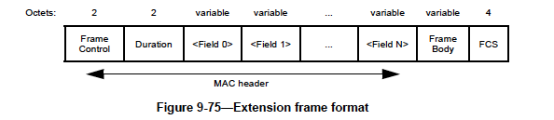
There are currently 2 Extension frames defined: 9.3.4.2 DMG Beacon, 9.3.4.3 S1G Beacon.
Volunteer(s) to look into this?
Text from 802.11-2020:
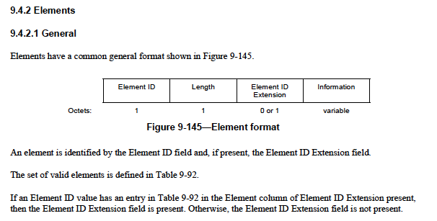
TGbc requested 2 Element IDs: 9.4.2.296 EBCS Parameters Element and 9.4.2.297 EBCS TIM Element.
Volunteer(s) to restructure these elements to be use the element extension type.

