IEEE P802.11
Wireless LANs
Resolution to CIDs 1195 -1198
Date: 2022-02-22
Author(s):
Name | Affiliation | Address | Phone | email
Jarkko Kneckt,  Yong Liu,  Qi Wang,  Tianyu Wu, Jinjing Jiang | Apple Inc | Cupertino, CA |  | jkneckt@apple.com
Abstract
This submission presents comment resolutios for 3 CIDs 1195, 1197 and 1198.

R1: updates after presenting the submission on 3/10 PM1 in 802.11me.
R2: CID 1196 is removed from the submission. Off-line modifications provided by Mark Rison are implemented to the submission.

CID | Page | Clause | Comment | Proposed Change
1198 | 1077.30 | 9.4.1.7 | One mechanism to limit the size of the transmitted PPDUs is to configure the Block Ack Window size. Some times the transmitted PPDU size may need to be adjusted while the STA is associated. Currently, DELBA frame can tear down the block ack in both UL and DL directions. The transmitter of the DELBA frame can setup a new block ack with adjusted window size, but currently, the receiver of the DELBA frame is not setting up the BA after the termination. The DELBA should have a new reason code that requests the peer device also to setup the BA again, so that data transmissions can continue to enjoy efficient delivery. | Please add a new Reason Code to Table 9-77 and assign available value for the code:"PEER_ASKING_FOR_NEW_BA_PARAMETERS". Please add the following sentence to the clause 10.25.4, p.2264, at the end of the line 16:" If a STA receives DELBA frame with Reason Code PEER_ASKING_FOR_NEW_BA_PARAMETERS, then the STA should setup Block ack again with the peer."

Discussion

The 802.11 specification allows devices to setup Block Ack (BA) and delete the BA. The BA termination has not been often deployed and maybe the main reason for little use is that peer STA does not typically setup BA after the BA termination, i.e., the opposite direction transmissions do not have BA after the BA termination. The lack of BA to the opposite direcetion traffic causes very poor transmission efficiency.

The new proposed Reason Code seems simple solution for this problem. The Reason Code allows the peer device to know why the BA is deleted and it communicates that peer STA is expected to setup again the BA. Without the new proposed reason code, the BA termination feature is not practical.

Proposed Resolution

Revised.
Agree in principle with the comment. Please make the changes in this document for the CID 1198 as described below.

Proposed specification text

9.4.1.7 Reason Code field
TGme Editor: Please append the Table9–77 as shown below.

Table 9-77—Reason codes
Reason Code | Name | Meaning
<ANA> | PEER_ASKING_FOR_NEW_BA | The block ack agreement is deleted. The peer STA requests a new block ack agreement setup for the same TID.

11.5.3.3 Procedure at the recipient of the DELBA frame
TGme Editor: Please change the clause as shown below.
A STA shall issue an MLME-DELBA.indication primitive with the parameter ReasonCode having a value of REQUESTED when a DELBA frame is received. The ReasonCode parameter is set to PEER_ASKING_FOR_NEW_BA if this reason code is present in the DELBA frame, otherwise the ReasonCode parameter is set to REQUESTED.
If the MLME-DELBA.indication primitive has the ReasonCode parameter equal to PEER_ASKING_FOR_NEW_BA, then the MLME shall issue a new MLME-ADDBA.request primitive for the same TID.

CID | Page | Clause | Comment | Proposed Change
1197 | 1568.14 | 9.4.2.170.1 | A non-AP STA may have multiple radios, for instance data radio and low power receive radio. These radios may be used for instance in EMLSR channel access.  The low power receive radio may have limited capability to receive frames and no transmission capability. For instance, the low power receive radio may be capable to receive only non-HT PPDUs that are transmitted less than 24 Mbit/s rate.  AP should provide out-of-band signaling to the STAs whether the STAs may receive AP's Beacon frame with low power receive radio. This allows STA to optimize the scaning radio selection and ensure that STA is capable to receive the transmitted beacon. | Please add a new Beacon Type subfield as the bit 7 of the BSS Parameters subfield of the Reduced Neighbor Report. This subfield is set to 1, if the reported AP transmits Beacons as non-HT PPDU and with less than 24 Mbit/s rate.

Discussion
Non-AP STAs can save power by using low power receive radio to passively scan available APs. The reliability of the AP discovery can be improved by providing information how APs send their Beacon frames.

Proposed Resolution
Revised. Agree in principle with the comment. Please implement the changes shown in this document for the CID 1197.

Proposed specification text:

9.4.2.170.2 Neighbor AP Information field
TGme Editor: Please update the Figure 9-709a as shown below and add the new paragraph as the second last paragraph of the clause.

 | OCT Recommended | Same SSID | Multple BSSID | Transmitted BSSID | Member Of ESS With 2.4/5 GHz Co-located AP | Unsolicited Probe Response Active | Co-Located AP | Beacon Type Reserved
Bits: | 1 | 1 | 1 | 1 | 1 | 1 | 1 | 1

Figure 9-709a—BSS Parameters subfield format

The Beacon Type subfield is set to 1 if the reported AP is transmitting all Beacon frames in a non-HT PPDU or a non-HT Duplicate PPDU and the transmission rate of the PPDU containing the Beacon frame is less or equal to 24 Mb/s and is set to 0 otherwise.

11.49 Reduced neighbor report
TGme Editor: Please add the following text as the new sixth paragraph

The Beacon Type field of the TBTT Information field of the Reduced Neighbor Report element helps a passive scanning STA to estimate whether it can receive Beacon frames from the reported AP.

CID | Page | Clause | Comment | Proposed Change
1195 | 2141.31 | 10.6.5.3 | Clause 26.17.2.2 defines Beacon frame transmission rules at 6 GHz band. One of the allowed PPDU format for the Beacons in the 6 GHz band is a non-HT Duplicate PPDU format.  Clause 10.6.5.3 defines the group frames transmission rates, but for some reason 802.11ax did not add rate selection rules for non-HT Duplicate PPDU transmissions in the 6 GHz band.  Clause 10.6.5.3 defines transmission rate selection only for non-HT PPDUs. 802.11me should add the rate selection rules to transmit Beacons and group frames as non-HT Duplicate PPDUs, because the rate selection rules are missing and the PPDU type may be used to transmit these frames. The transmission rules should be similar for non-HT Duplicate and Non-HT PPDUs. | Please add rate selection rules for group addressed data and Beacon frames when these frames are transmitted in non-HT duplicate PPDU format.  Please change the second paragraph the following sentences:" If the BSSBasicRateSet parameter is not empty, a Data or Management frame (excluding the frames listed above) with a group address in the Address 1 field shall be transmitted in a non-HT PPDU, or in the 6 GHz band in a non-HT Duplicate PPDU, using one of the rates included in the BSSBasicRateSet parameter or the rate chosen by the AP, described in 11.21.8 (FMS multicast rate processing), if the Data frames are part of an FMS stream."

Discussion
The associated STAs may receive non-HT duplicate frames similarly as the non-HT frames.

The 802.11 allows Beacon frames transmission in the 6 GHz band in non-HT duplicate format. These Beacon frames in the 6 GHz band may have longer coverage than group addressed data frames. To enable the associated STAs in such BSS to receive group addressed frames and Beacons, the AP should transmit the group frames as non-HT duplicate frames and 802.11 should clearly define the rules for the group frames transmission.

The FCC 6 GHz regulation allows Low-power-indoor (LPI) APs and STAs that can have constant power spectral density. The LPI devices can have longer range for non-HT duplicate frames than for Non-HT frames.

Proposed Resolution:
Revised, agree in principle. Agree in principle with the comment. Please implement the changes shown in this document for the CID 1195.

TGme Editor: Please make the changes as shown below

10.6.5.3 Rate selection for other group addressed Data and Management frames
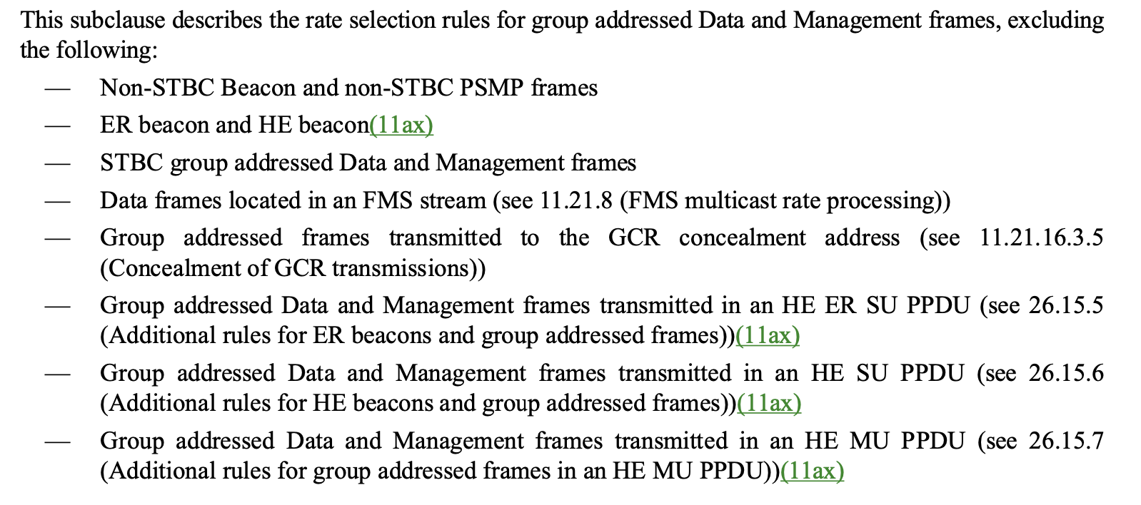
If the BSSBasicRateSet parameter is not empty, a Data or Management frame (excluding the frames listed above) with a group address in the Address 1 field shall be transmitted in a non-HT PPDU, or in the 6 GHz band in a non-HT duplicate PPDU, using one of the rates included in the BSSBasicRateSet parameter or the rate chosen by the AP, described in 11.21.8 (FMS multicast rate processing), if the Data frames are part of an FMS stream.

