IEEE P802.11
Wireless LANs
D1.0 CRs on 36.2.6.1
Date: 2022-02-06
Author(s):
Name | Affiliation | Address | Phone | email
Bo Gong | Huawei |  |  | gongbo8@huawei.com
Osama |  |  |  | Osama.AboulMagd@huawei.com
Jian Yu |  |  |  | ross.yujian@huawei.com
Bo Sun | ZTE |  |  | sun.bo1@ZTE.COM.CN

This submission shows
- Resolution for 6 comments received from TGbe comment collection (based on TGbe Draft D1.0)
- The proposed changes are based on 11be D1.4.

The submission provides the resolution to CIDs 7992, 4536, 4644, 4899, 4900, 4901.

Revision Notes

R0 | Initial revision

CID 7992
Page. Line | Clause Number | Comment | Proposed Change | Resolution
333.26 | 36.2.6.1 | Figure 36-2 and 36-3 are impossible to read, and thus cannot be reviewed | Re-draw the figures and/or re-write contents so that it is readable. | Revised  Agreed in principle. Reflect the detailed explanation.  Instructions to the editor  Please make the changes as shown in 11/22-0322r1

Discussion:

- Figure 36-2 describes the receive procedure of the EHT PHY, which includes three steps as follows.

- Format detection : The EHT PHY identifies the format of the received PPDU according to the PHY preamble.
- Once a PPDU is received and detected as a non-HT/HT/VHT/HE PPDU, the RXVECTOR parameters obtained from the received PPDU are mapped to the EHT PHY RXVECTOR parameters in Table 36-1 as the way described in 36.2.6.2 Support for non-HT format /36.2.6.3 Support for HT format /36.2.6.4 Support for VHT format /36.2.6.5 Support for HE format. Then, the EHT PHY issues a PHY-RXSTART.indication (RXVECTOR) primitive to report the REVECTOR parameters to the MAC layer.
- The EHT PHY presents PSDU to the MAC by a series of PHY-DATA.indication (DATA) primitive and issues the primitive PHY-RXEND.indication to indicate that the PPDU being received is complete. There exist no difference between the primitives PHY-DATA.indication/ PHY-RXEND.indication described in Clause 36 and Clause 15/16/17/18/19/21.
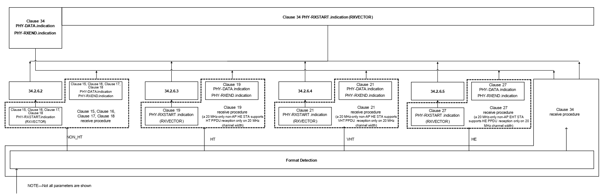
Figure 36-2—PHY interaction on receive for various PPDU formats

- Figure 36-3 describes the procedure of configuring all PHYs including non-HT/HT/VHT/HE/EHT PHY and the procedure of CCA for EHT PHY. Figure 36-3 can be divided into 3 parts.

- The EHT PHY configures all PHYs once receving PHY-CONFIG.request (PHYCONFIG_VECTOR) primitive. For non-HT/HT/VHT/HE PHYs, the PHYCONFIG_VECTOR described in Clause 36 are first mapped to the PHYCONFIG_VECTOR described in Clause 15/16/17/18/19/21/27 as the way described in 36.2.6.2 Support for non-HT format/36.2.6.3 Support for HT format/36.2.6.4 Support for VHT format/36.2.6.5 Support for HE format. Then the MIB values corresponding to non-HT/HT/VHT/HE/EHT PHY are set according to their own PHYCONFIG_VECTOR as the way described in Clause 15/16/17/18/19/21/27/36.
- The EHT PHY confirms the configuration of all PHYs through the primitive PHY-CONFIG.confirm.
- For CCA procedure of EHT PHY, the requirements are defined in Clause 36.
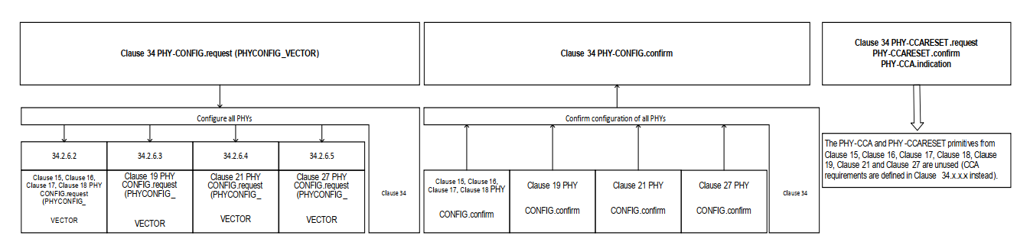
Figure 36-3—PHY-CONFIG and CCA interaction with various PPDU formats

- A 20 MHz-only non-AP EHT STA shall support some RU/MRUs in the primary 20 MHz channel within 40 MHz, 80 MHz, and 160 MHz PPDU widths. For HE PHY supports OFDMA, it is inaccurate to illustrate that a 20 MHz-only non-AP EHT STA supports HE transmission/reception only on 20 MHz channel width.

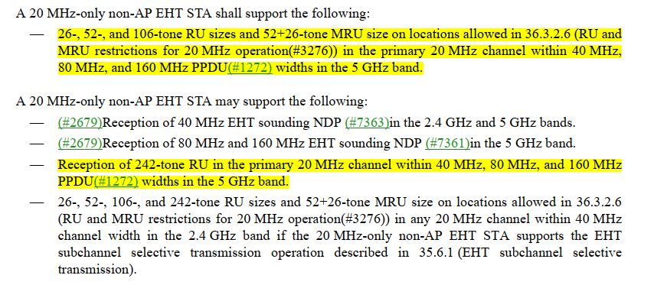

Instructions to the editor:

- Please make the following changes in Figure 36-1 (Line 22, Page 480) in TGbe Draft D1.4:

In the following Figure 36-1,

- Change ‘Clause 34’ in red box to ‘Clause 36’ and change ‘34.2.6.5/34.2.6.4/34.2.6.3/34.2.6.2/Clause 34.3.13’ in red box to ‘36.2.6.5/36.2.6.4/36.2.6.3/36.2.6.2/Clause 36.3.13’.
- Change ‘Clause 34’ in blue box to ‘Clause 27’
- Change ‘HE STA’ in the two green boxes to ‘EHT STA’
- Change ‘Clause 27 transmit procedure (a 20 MHz-only non-AP EHT STA supports HE transmission only on 20 MHz channel width )’ to ‘Clause 27 transmit procedure’

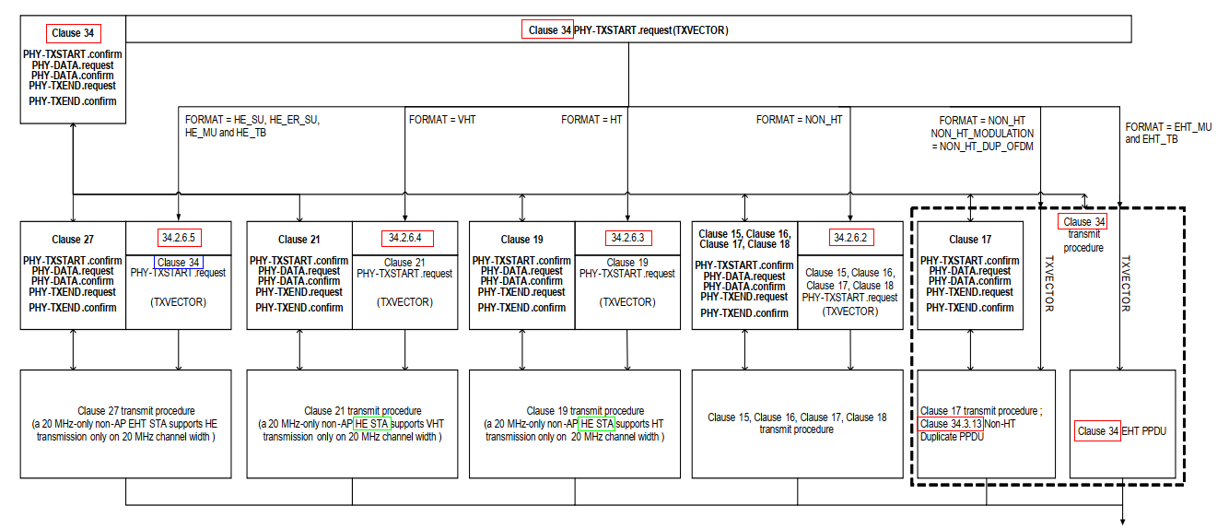
Figure 36-1 PHY interaction on transmit for various PPDU formats

- Please make the following changes in Figure 36-2 (Line 41, Page 480) in TGbe Draft D1.4:

In the following Figure 36-2,

- Change ‘Clause 34’ in red boxes to ‘Clause 36’ and change ‘34.2.6.5/34.2.6.4/34.2.6.3/34.2.6.2’ in red boxes to ‘36.2.6.5/36.2.6.4/36.2.6.3/36.2.6.2’.
- Change the frame with red circle for format detection and receive procedure in Clause 36 with dash line.
- Label the last arrow with blue circle with ‘EHT’.
- Change ‘HE STA’ in the two green boxes to ‘EHT STA’.
- Change ‘Clause 27 receive procedure (a 20 MHz-only non-AP EHT STA supports HE PPDU reception only on 20 MHz channel width)’ to ‘Clause 27 receive procedure’.

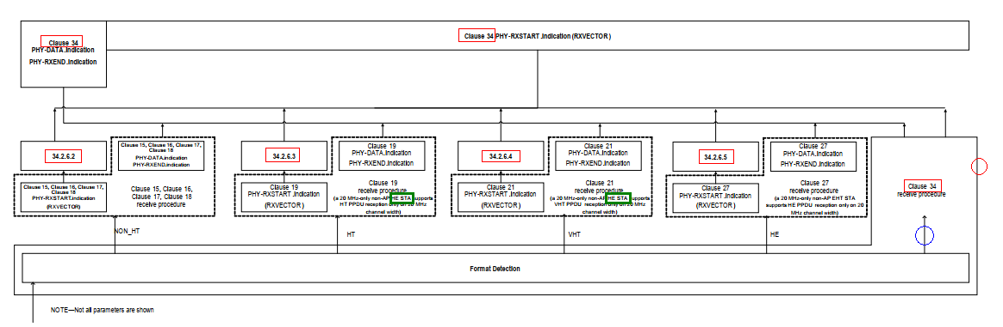
Figure 36-2—PHY interaction on receive for various PPDU formats

- Please make the following changes in Figure 36-3 (Line 56, Page 480) in TGbe Draft D1.4:

In the following Figure 36-3,

- Change ‘Clause 34’ in red boxes to ‘Clause 36’ and change ‘34.2.6.5/34.2.6.4/34.2.6.3/34.2.6.2’ in red boxes to ‘36.2.6.5/36.2.6.4/36.2.6.3/36.2.6.2’.
- Change ‘34.xxx’ to ‘36’.

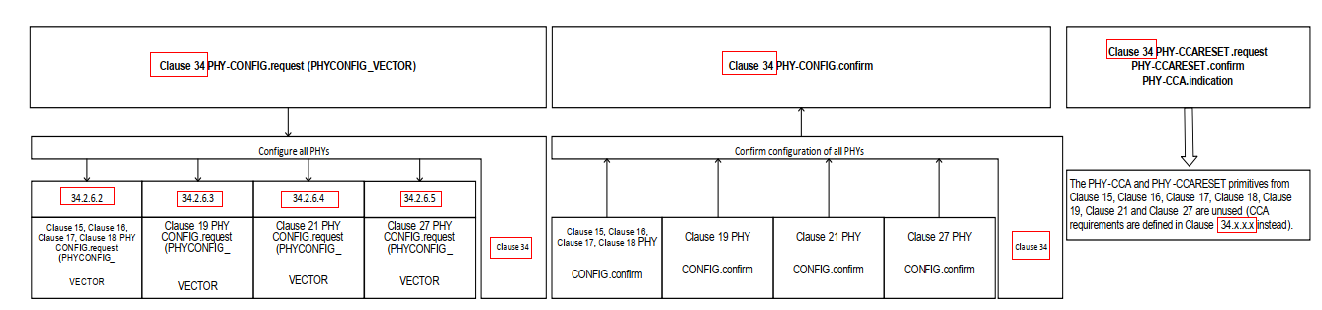

Figure 36-3—PHY-CONFIG and CCA interaction with various PPDU formats

- Please make the following changes in Line 5, Page 484 in TGbe Draft D1.4:

36.2.6.5 Support for HE format
The behavior of an EHT PHY on receipt of a PHY-TXSTART.request (TXVECTOR) primitive with the TXVECTOR parameter FORMAT equal to HE_SU, HE_ER_SU, HE_MU, or HE_TB is defined in Clause 27 (High Efficiency (HE) PHY specification) except that the requirements in 36.3.19.3 (Transmit center frequency and symbol clock frequency tolerance) apply instead of the requirements in 27.3.19.3 (Transmit center frequency and symbol clock frequency tolerance).

The TXVECTOR parameters in Table 36-1 (TXVECTOR and RXVECTOR parameters) are mapped directly to the Clause 27 (High Efficiency (HE) PHY specification) TXVECTOR parameters in Table 27-1 (TXVECTOR and RXVECTOR parameters). The TXVECTOR parameters not listed in Table 27-1 (TXVECTOR and RXVECTOR parameters) are not present.

On receipt of a PHY-CONFIG.request(PHYCONFIG_VECTOR) primitive, the EHT PHY behaves, for the purposes of HE PPDU transmission and reception, as if it were a Clause 27 (High Efficiency (HE) PHY specification) PHY that received the PHY-CONFIG.request(PHYCONFIG_VECTOR) primitive (#4624)except that:
— the CHANNEL_WIDTH parameter, if it is equal to 320 MHz, is replaced by 160 MHz
— the CENTER_FREQUENCY_SEGMENT_0 parameter, if the CHANNEL_WIDTH parameter is equal
to 320 MHz, is replaced by the center of the primary 160 MHz channel.

As defined in 36.3.22 (EHT receive procedure), once a PPDU is received and detected as an HE PPDU, the behavior of the EHT PHY is defined in Clause 27 (High Efficiency (HE) PHY specification). The RXVECTOR parameters in Table 27-1 (TXVECTOR and RXVECTOR parameters) are mapped directly to the RXVECTOR parameters in Table 36-1 (TXVECTOR and RXVECTOR parameters). The RXVECTOR parameters not listed in Table 27-1 (TXVECTOR and RXVECTOR parameters) are not present.

CID 4536

Page. Line | Clause Number | Comment | Proposed Change | Resolution
333.26 | 36.2.6 | Figure 36-1, 36-2 and 36-3: need to update all the clause 34 to clause 36 | as in the comment. | Accepted  Note to the Editor:  The resolution for CIDs 4536, 4644, 4899, 4900 and 4901 are the same, which has been included in the resolution for CID 7992. No futher changes are needed.

CID 4644
Page. Line | Clause Number | Comment | Proposed Change | Resolution
333.26 | 36.2.6.1 | The figures on this page contain "clause 34" when "clause 36" is meant | Change 34's to 36's (about x3x9 times). Double check sub-section numbers. | Accepted  Note to the Editor:  The resolution for CIDs 4536, 4644, 4899, 4900 and 4901 are the same, which has been included in the resolution for CID 7992. No futher changes are needed.

CID 4899
Page. Line | Clause Number | Comment | Proposed Change | Resolution
333.26 | 36.2.6.1 | In figure 36-1, change clause 34 with 'Clause 36" | As in comment | Accepted  Note to the Editor:  The resolution for CIDs 4536, 4644, 4899, 4900 and 4901 are the same, which has been included in the resolution for CID 7992. No futher changes are needed.

CID 4900
Page. Line | Clause Number | Comment | Proposed Change | Resolution
333.47 | 36.2.6.1 | In figure 36-2, change clause 34 with 'Clause 36" | As in comment | Accepted  Note to the Editor:  The resolution for CIDs 4536, 4644, 4899, 4900 and 4901 are the same, which has been included in the resolution for CID 7992. No futher changes are needed.

CID 4901
Page. Line | Clause Number | Comment | Proposed Change | Resolution
334.03 | 36.2.6.1 | In figure 36-3, change clause 34 with 'Clause 36" | As in comment | Accepted  Note to the Editor:  The resolution for CIDs 4536, 4644, 4899, 4900 and 4901 are the same, which has been included in the resolution for CID 7992. No futher changes are needed.

