IEEE P802.11
Wireless LANs
Proposed Resolution for REVme LB258 Editor1 ad-hoc Comments
Date: 2022-05-05
Author:
Name | Affiliation | Address | Phone | Email
Emily Qi | Intel Corporation | 2111 NE 25th Ave.  Hillsboro OR 97124 |  | Emily.h.qi@intel.com

This submission present proposed resolutions for comments in the Editor1 ad-hoc group.

The proposed changes are based on REVme/D1.0.

Revision history:

R0 – initial version
R1 – Incorporated feedback from April Adhoc meeting.
R2 – Added more comments and proposed resolutions, starting with CID 2308.

CID | Page | Clause | Comment | Proposed Change
1091 | 1067.55 | 9.3.4.3 | "Optionally, element(s) that are not listed in thistable, but are allowed in Beacon frames (seeTable 9-60 (Beacon frame body)), in the orderthey appear in Table 9-60 (Beacon framebody)". Too many references. The sentence can be simplified. | Change the cited sentence to "Optionally, element(s) that are not listed in thistable, but are allowed in the Beacon frame, in the order they appear in the Beacon frame (seeTable 9-60 (Beacon frame body))"

Discussion:
The same reference showed twice in a one sentence. It is not necesory.
Cited text and proposed changes:
Optionally, element(s) that are not listed in this table, but are allowed in Beacon frames (see Table 9-60 (Beacon frame body)), in the order they appear in Table 9-60 (Beacon frame body).
Or:
Optionally, element(s) that are not listed in this table, but are allowed in Beacon frames (see 9.3.3.2 (Beacon frame format Table 9-60 (Beacon frame body)), in the order they appear in Table 9-60 (Beacon frame body).
Proposed resolution:
Accepted.

CID | Page | Clause | Comment | Proposed Change
1093 | 982.48 | 9.3.1.19 | In Figure 9-80, "STA Info 1" "..." " STA Info n" fields are repeat fields, which should be avoided. Please see Editorial Style Guide doc11-09-1034. Also, no need to have the arrow "MAC header". | Replace the repeating fields with the "STA Info List" field and add definition for the "STA Info List" field, or use the same format as defined in Figure 9-76.

Discussion:
Cited text:
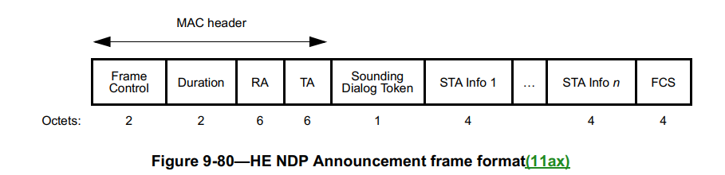

The comment pointed out two issues:
- Repeating fields should be avoided in the frame/element/field format figure. If a field needs to be repeated, create a container field with “List” in the name, e.g., Name List field.
- Arrow should not be used in the frame format figures, except where labelling parts of the structure or the MAC Header in the top-level frame format.

Proposed resolution:
Revised.
Replace Figure 9-80 with the following figure:
 | Frame Control | Duration | RA | TA | Sounding Dialog Token | STA Info List | FCS
Octets: | 2 | 2 | 6 | 6 | 1 | n × 4 | 4

At 985.10, add the following paragraph:
“The STA Info List field contains one or more (n) STA Info fields.”

<Proposed resolution: Revised; Incorporate the changes indicated by CID 1093 in doc 11-22/0319r0 < https://mentor.ieee.org/802.11/dcn/22/11-22-0319-01-000m-revme-wg-lb258-editor1-ad-hoc-comments.docx>

CID | Page | Clause | Resn Status | Comment | Proposed Change
1094 | 981.12 | 9.3.1.19 |  | The paragraph at 981.12 to 981.18 seems misplaced. It should be moved to 981.46. | Move the paragraph at 981.12 to 981.46.
1095 | 982.56 | 9.3.1.19 |  | There are several duplications in 9.3.1.19. For example, 1. Figure 9-76 and Figure 9-80 are similar and can be combined. 2. the definitions for Sounding Dialog Token field and Sounding Dialog Token Number field have been repeated multiple times. | 1. Combine Figure 9-76 and Figure 9-80 2. Combine the paragraph from 982.56 to 982.64 with the paragraph from 981.10 to 981.45. Or reorganize 9.3.1.19.

Discussion:
After reviewing contents in 9.3.1.19, I think I am okay with the existing text. Therefore, I would like to withdraw these two comments.
Proposed resolution:
Rejected.
Reject Reason: Commenter withdrew the comments.

CID | Page | Clause | Resn Status | Comment | Proposed Change | Resolution
1416 |  |  | V | "in which case," comma spurious except when followed by subordinate subclause | I can provide locations | REVISED (ED1: 2022-04-27 21:05:28Z) - at 269.50. At 2421.41 and 2432.52 delete "then"

Discussion:
at 269.50:
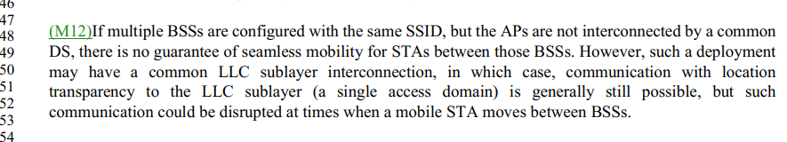

At 2421.41,
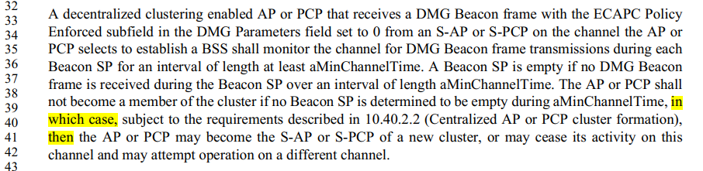

At 2432.52.
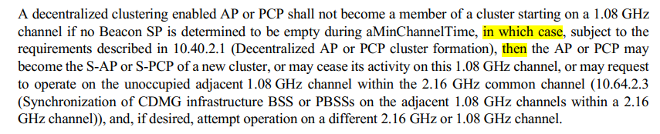
Proposed resolution:
Revise, at 269.50, delete “,” in “in which case,”. At 2421.41 and 2432.53 delete "then"

CID | Page | Clause | Resn Status | Comment | Proposed Change | Resolution
1660 |  |  |  | Follow-up to CID 326: "EDCA parameter values" should be "EDCA parameters" | I can provide locations for the changes

Discussion:
Mark provided locations: 1312.17/22, 1313.1, 1314.1, 2079.28, 4133.52/53, 4134.37/39, 5570.50, 5592.13
For example, 1312.17/22:
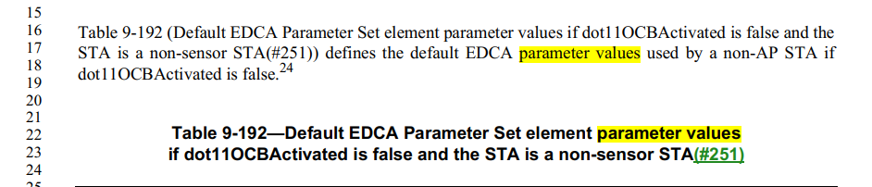
Proposed resolution:
Revised. At the following locations: 1312.17/22, 1313.1, 1314.1, 2079.28, 4133.52/53, 4134.37/39, 5570.50, 5592.13, change "EDCA parameter values" to "EDCA parameters"

CID | Page | Clause | Resn Status | Comment | Proposed Change | Resolution
1662 |  |  | A | "actively transmit" -- you can't passively transmit, so the adverb is spurious | Delete "actively " (4x -- I can provide locations) | ACCEPTED (ED1: 2022-04-27 21:24:50Z). Note to editor, Locations are 2666.1, 2837.20, 3320.34, 5587.35.
Discussion:
Mark provided locations: 2666.1, 2837.20, 3320.34, 5587.35.
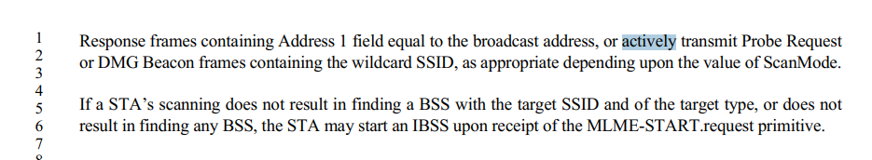
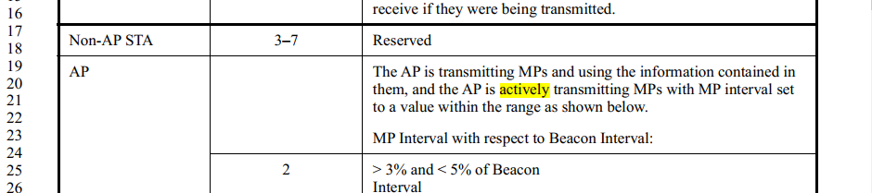
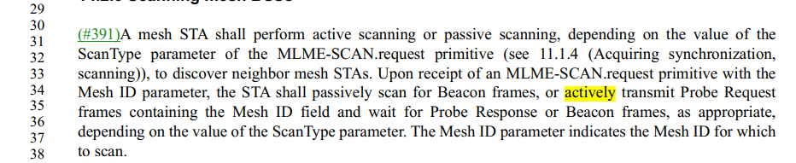
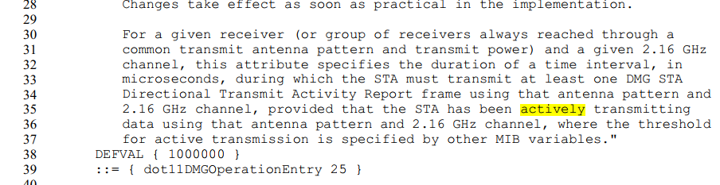
Proposed resolution:
ACCEPTED. Note to editor, Locations are 2666.1, 2837.20, 3320.34, 5587.35.
CID | Page | Clause | Resn Status | Comment | Proposed Change | Resolution
1685 |  |  |  | "beacon report" should be "Beacon report" | I can provide locations for the changes (~10x)

Discussion:
Mark provided locations: 1206.38/39, 1207.24, 2817.31/32, 2819.16/20 (2x), 2975.53/54
1206.38/39:
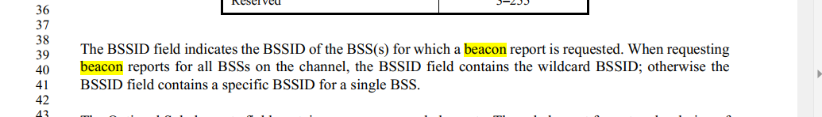
2975.53/54
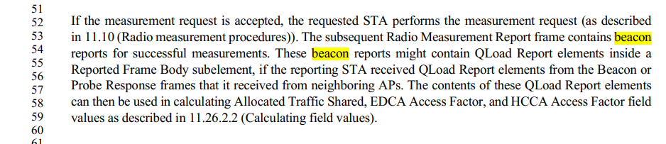
Proposed resolution:
Revised. Change “beacon report” to “Beacon report” at the following locations: 1206.38/39, 1207.24, 2817.31/32, 2819.16/20 (2x), 2975.53/54.

CID | Page | Clause | Resn Status | Comment | Proposed Change | Resolution
1755 |  |  |  | "Mesh ID" should be "mesh ID" except when referring to the element etc. | Change "Mesh ID" to "mesh ID" at 375.29 (2x), 469.34 rightmost, 1460.34, 2672.13 (2x), 3318.52 (2x), 3318.53, 3319.9, 14.2.6 (I can provide locations), 14.13.3.2, 5467.20

Discussion:
Mark provided: Locations in 14.2.6 are 3320.36 (rightmost), 3320.40/41/45/46/47 (leftmost)/48 (2x).
At 375.29,
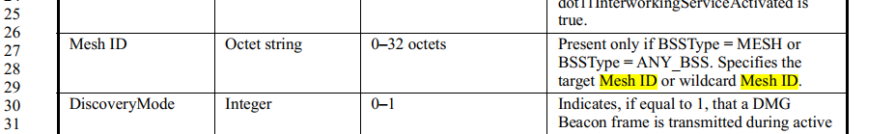

At 468.35,
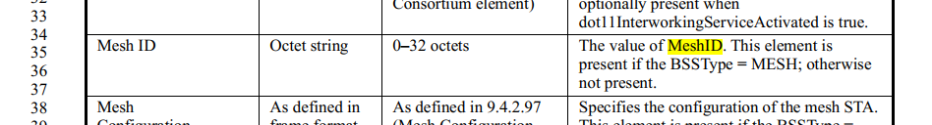
In 14.2.6,
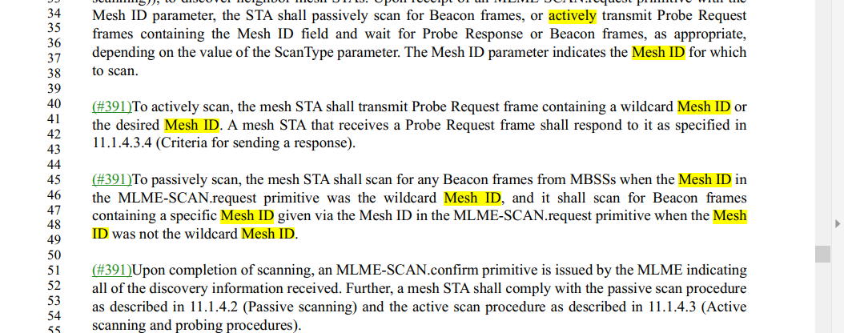
In 14.13.3.2
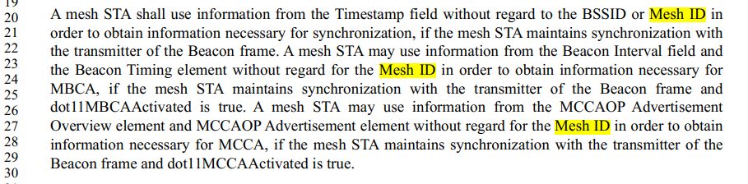
Proposed resolution:
Revised.
Change "Mesh ID" to "mesh ID" at 375.29 (2x), 469.34 rightmost, 1460.34, 2672.13 (2x), 3318.52 (2x), 3318.53, 3319.9, 5467.20, 14.2.6, and 14.13.3.2,
In 14.2.6, locations are: 3320.36 (rightmost), 3320.40/41/45/46/47 (leftmost)/48 (2x).
In 14.13.3.2, locations are: 3399.20/23/27

CID | Page | Clause | Resn Status | Comment | Proposed Change | Resolution
1849 |  | 9.4.2.24.1 |  | "expressed as hexidecimal value" -- people who can cope with the 802.11 spec don't need to be told the decimal equivalent of hexadecimal | Delete the 10x ", expressed as hexadecimal value"s (I can provide locations)
Discussion:
Mark provided: Locations as 1289.20/21/31/32/42/43/52/53, 1290.4/5
Page 1289,
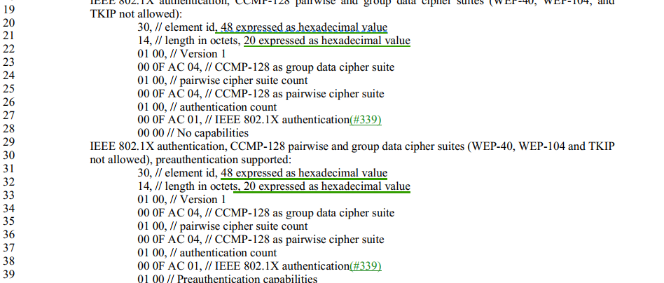
“expressed as hexidecimal value" is helpful.
Proposed resolution:
Revise.
Change “<x> expressed as hexidecimal value” to “i.e., <x> in decimal” at the following locations: 1289.20/21/31/32/42/43/52/53, 1290.4/5

CID | Page | Clause | Resn Status | Comment | Proposed Change | Resolution
1850 |  | 9.4.2.24.1 |  | The case after the //s is haphazard | Make it lowercase in all instances
Discussion:
Mark provided: Locations are 1289.22/28/33/39/44/47/54/60, 1290.6
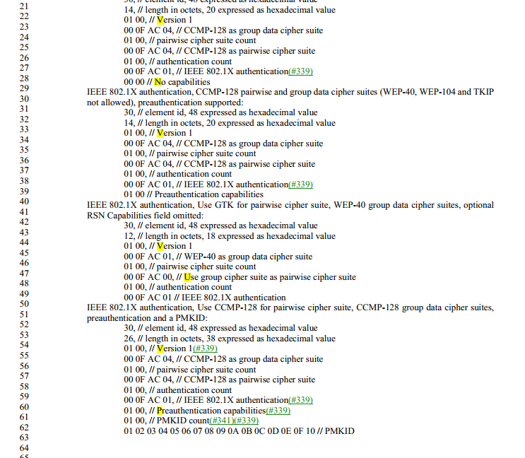

Proposed resolution:
Revised.
Change the first lowercase letter after "//" to uppercase in the following locations: D1.0P1289 lines 20, 21, 24, 26, 31, 32, 35, 37, 42, 43, 46, 48, 52, 53, 56, and 58, and D1.0P1290 lines 4, 5, 8, 11, and 14.

CID | Page | Clause | Resn Status | Comment | Proposed Change | Resolution
1875 |  |  |  | "field of the TXVECTOR" should be "parameter of the TXVECTOR" (11x) | I can provide locations

Discussion:
Mark provided: Locations are 3476.44/55/60, 3483.31/43, 3549.60, 3551.3, 3563.18/19, 3616.27, 4476.33
Page 3476, as an example,
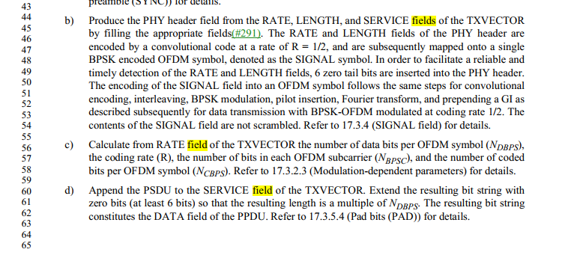
Proposed resolution:
Revised
At the following locations 3476.44/55/60, 3483.31/43, 3549.60, 3551.3, 3563.18/19, 3616.27, 4476.33, change "field of the TXVECTOR" or "fields of the TXVECTOR" to "parameter of the TXVECTOR" or "parameters of the TXVECTOR", respectively.

CID | Page | Clause | Resn Status | Comment | Proposed Change
2308 | 208.02 | 3.2 |  | There are two occurances of the word "operating" in the same sentence and some of the sentence can be shortened. | Change the sentence as follows: "A non-AP HE STA, in the frequency band in which it operates, that indicates in the Supported Channel Width Set subfield in the HE PHY Capabilities Information field in the HE Capabilities element that it does not support a channel width greater than 20 MHz"

Discussion:

Cited text at 208.2:
20 MHz-only non-access-point (non-AP) high-efficiency station (HE STA): A non-AP HE STA that, for
the frequency band in which it is operating, indicates in the Supported Channel Width Set subfield in the HE PHY Capabilities Information field in the HE Capabilities element that it does not support operating with a channel width greater than 20 MHz.(11ax)

Proposed changes:
20 MHz-only non-access-point (non-AP) high-efficiency station (HE STA): A non-AP HE STA, in the frequency band in which it operates, that indicates in the Supported Channel Width Set subfield in the HE PHY Capabilities Information field in the HE Capabilities element that it does not support a channel width greater than 20 MHz

Proposed resolution:
Accepted.

CID | Page | Clause | Resn Status | Comment | Proposed Change
2309 | 208.07 | 3.2 |  | There are missing articles in the sentence and some of the sentence can be shortened. | Change the sentence as follows: "A non-AP HE STA operating in a 20 MHz channel width mode, such as a 20 MHz-only non-AP HE STA or an HE STA,that has reduced its operating channel width to 20 MHz using an operating mode indication (OMI)."

Discussion:

Cited text and proposed changes:
20 MHz operating non-access-point (non-AP) high-efficiency station (HE STA): A non-AP HE STA
that is operating in 20 MHz channel width mode, such as a 20 MHz-only non-AP HE STA or an HE STA that has reduced its operating channel width to 20 MHz using operating mode indication (OMI).

Proposed resolutions:
Accepted.

CID | Page | Clause | Resn Status | Comment | Proposed Change
1259 | 2483.38 | 10.42.6.4.1 |  | The requirement that "The responding STA shall reply to the transmit beam refinement training with a BRP frame containing a DMG Beam Refinement element with the TX-TRN-OK field and TX-train-response field both set to 1 and the BS-FBCK field set to indicate the TRN-T subfield on which the responding STA received the best signal (the determination of best signal is implementation dependent)." is confusing and uses "which" strangely. | Replace "The responding STA" with "A STA", replace "the" with "a", insert "request" following the word "training", replace "on which" with "that".

Discussion:

Cited text and proposed changes:

A STA requests transmit beam refinement training by sending a BRP frame as follows. In the BRP Request field, the TX-TRN-REQ field is set to 1, and the FBCK-REQ field indicates the feedback type. The Sector ID Order Requested subfield in the FBCK-REQ field shall be set to 0. In the TXVECTOR, the PPDU_TYPE parameter is set to TRN-T-PACKET, and the TRN_LEN parameter indicates the number of AGC and TRN-T subfields appended to the PPDU.

The responding A STA shall reply to the a transmit beam refinement training request with a BRP frame containing a DMG Beam Refinement element with the TX-TRN-OK field and TX-train-response field both set to 1 and the BS-FBCK field set to indicate the TRN-T subfield that on which the responding STA received the best signal (the determination of best signal is implementation dependent).

Proposed Resolutions:
??
CID | Page | Clause | Resn Status | Comment | Proposed Change
1260 | 2485.37 | 10.42.6.4.2 |  | The use of "in which" is not a clear way specify that a subfield is 0, nor is it a clear way to specify the content of the reply. | Replace "in which the EDMG-SHORT-BRP" with "with a", replace "was" with "equal to", replace "in which the Comeback" with "with the Comeback"

Discussion:

Cited text and proposed changes:

An EDMG STA responding to a TXSS sector list feedback request with a subfield equal to 0 may respond within MBFIS with a BRP frame with the Comeback Delay field in the EDMG BRP Request element is set to a nonzero value.

Proposed Resolutions:

CID | Page | Clause | Resn Status | Comment | Proposed Change
1358 | 899.08 | 9.2.3 |  | Something odd happened to the structure of this text (why the parenthetical in the middle of this sentence? | Investigate what this was supposed to say, and fix it.

Discussion:

Cited text in D 1.0
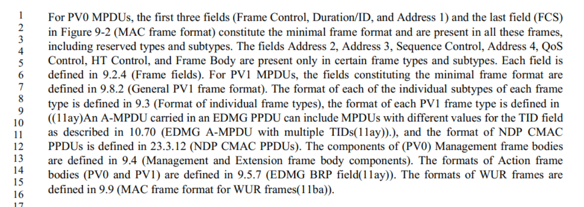

Cited text in D0.0 and D1.2:
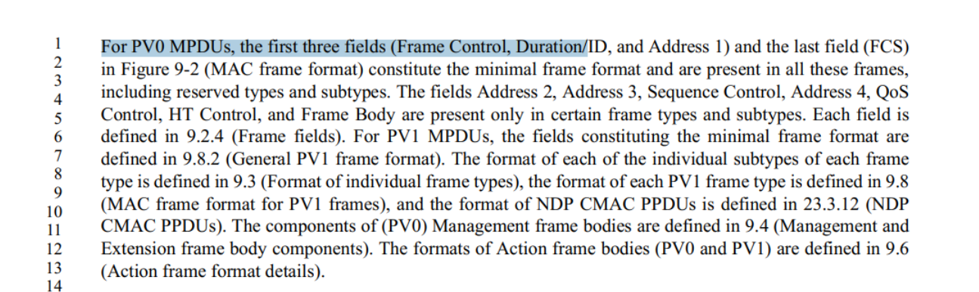

This is an editorial error. The issue is fixed in D1.2.
But I found similar issudes in D1.2, 4 instances.

Proposed Resolution

Revised.

At the following locations in D1.2: 900.37, 2180.16, 2621.61, 2628.31,

Change “((11ay)An A-MPDU carried in an EDMG PPDU can include MPDUs with different values for the TID field as described in 10.70 (EDMG A-MPDU with multiple TIDs(11ay)).)”
To: “9.8 (MAC frame format for PV1 frames)”.

CID | Page | Clause | Resn Status | Comment | Proposed Change
1180 | 1149.46 | 9.4.1.65 |  | The text here is talking about Nr and Nc so I think Equation(9-3) (in P1118) rather than Equation(9-1) (in P919) should be referred. | Replace (9-1) with (9-3) at P1149L46.

Discussion:

Cited text at 1149.46 in D1.0:

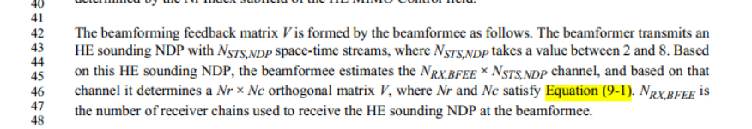

At 1118.64 in D1.0:
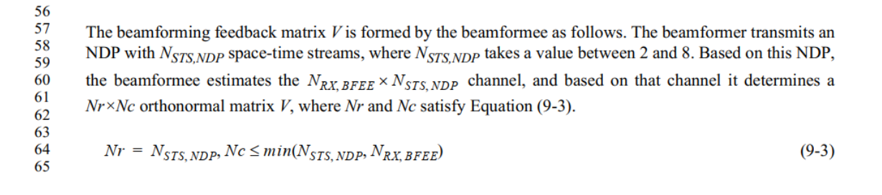
At 919.58 in D1.0,
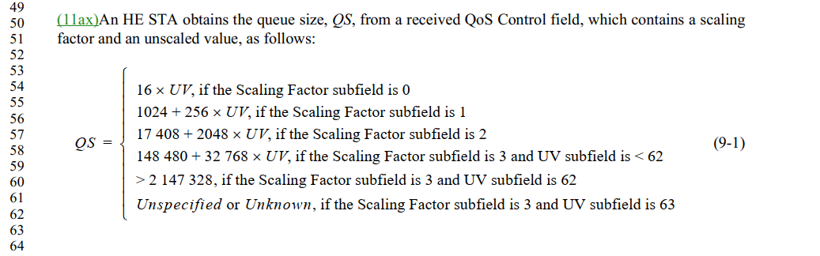

In D0.0, at 983.54, the same text and equation is Equation (9-1), see:
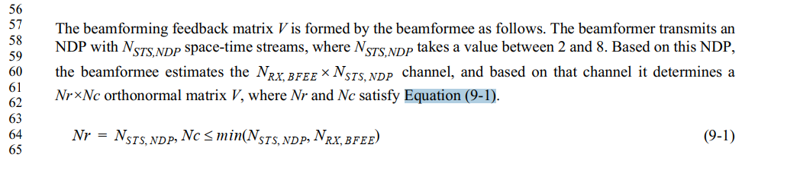

11ax added two new equations before the original equation 9-1. Therefore, Equation 9-1 in D0.0 becomes 9-3.

Proposed Resolution:
Accepted.

CID |  | Page | Clause | Resn Status | Comment | Proposed Change
1181 |  | 1157.49 | 9.4.1.66 |  | The referred Equation was (9-2) in 11ax but now it is (9-4) in REVme. The references should be updated. | Replace (9-2) with (9-4) at P1157L49 and L53.

Discussion:
Agreed. 11ax added two new equations.

Cited text:
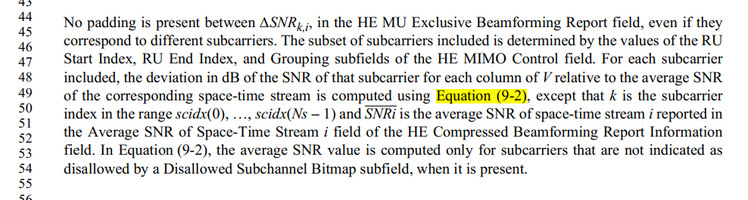
Equation 9-2 is:
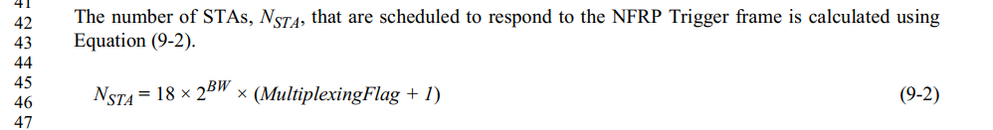

Equation 9-4 is:

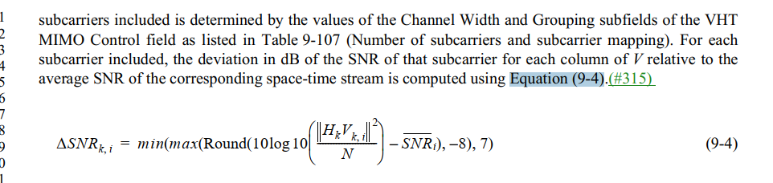

Proposed Resolution:
Accepted.

CID | Page | Clause | Resn Status | Comment | Proposed Change
1340 | 1013.13 | 9.3.2.2.2 |  | Why is the mesh A-MSDU subframe structure burried in the Basic A-MSDU subframe subclause? | Start a new subclause at P1013.13, titled "Mesh A-MSDU subframe structure"

Discussion:
Cited text:
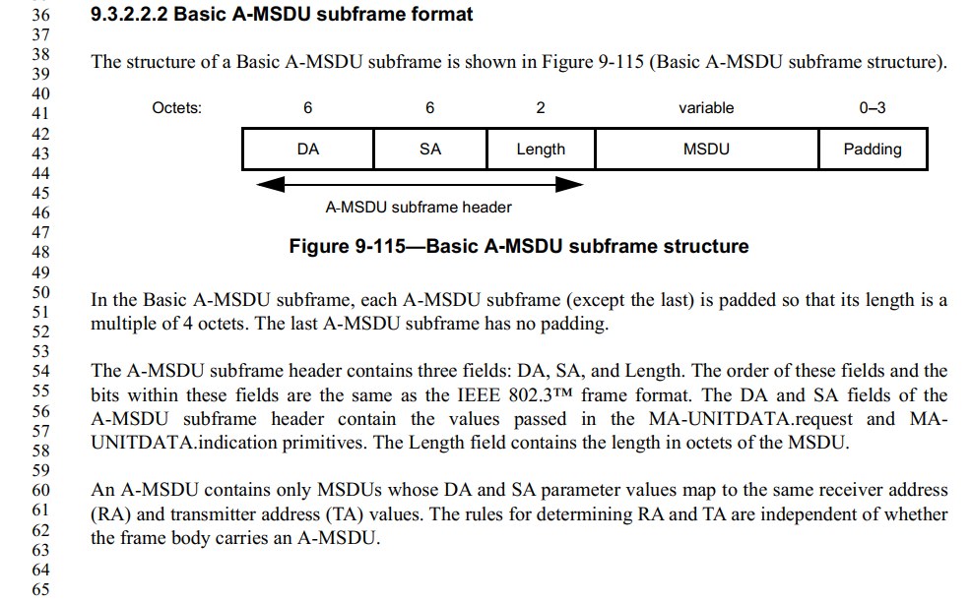
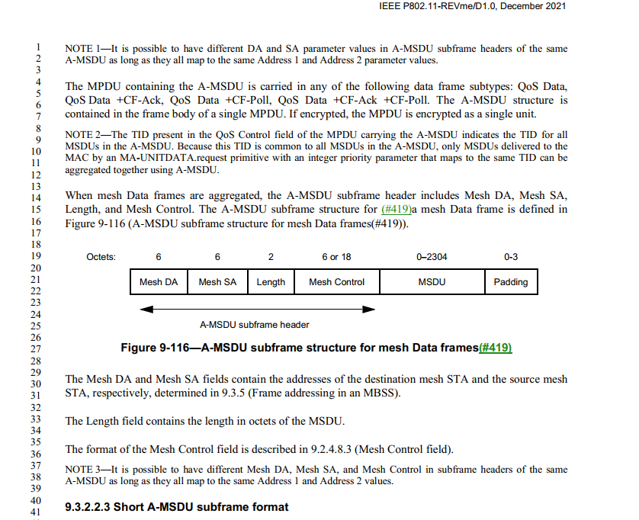

Proposed Resolution:
Accepted.
CID | Page | Clause | Resn Status | Comment | Proposed Change
1348 | 974.21 | 9.3.1.8.9 | A | Figure 9-64's title should include "BA" to align with the other figures in earlier subclauses, and not be confusing with the general Information field. And, the title should also include that this is the EDMG Multi-TID BlockAck variant. | Add "BA" and "(EDMG Multi-TID BlockAck)", so the title is "BA Information field format (EDMG Multi-TID BlockAck)"

Discussion:

Cited text:

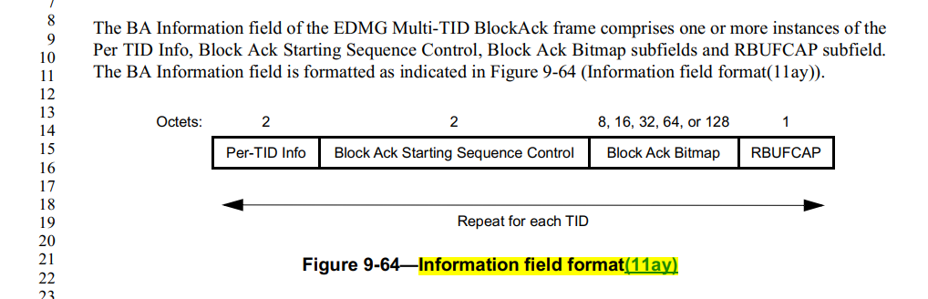

As example, Figure 9-63 shows:
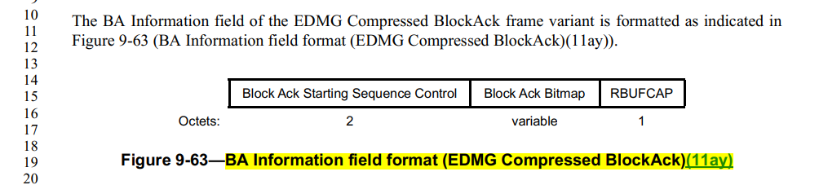

Agreed with commenter.

Proposed Resolution:
Accepted.
CID | Page | Clause | Resn Status | Comment | Proposed Change
1356 | 213.24 | 3.2 |  | "direct-link" should not have a hyphen. | Remove the hyphen from "direct-link" occurrences throughout the Standard (I found 91 of them - about 1/4 of the occurrences of "direct link").

Discussion:

Cited text:

I found:
91 instances of "direct-link".
258 instances of "direct link"

Proposed Resolutions:
Accepted.
Note to Editor: Delete the hyphen from "direct-link" occurrences throughout the Standard.

CID | Page | Clause | Resn Status | Comment | Proposed Change
1357 | 1935.09 | 9.6.12.4 |  | While it is clear from context that this "direct link" is a TDLS direct link, it is confusing/inconsistent that P1934.61 (for example) says "TDLS" but this one does not. | Insert "TDLS" to be consistent.

Discusison:

Cited sentence:
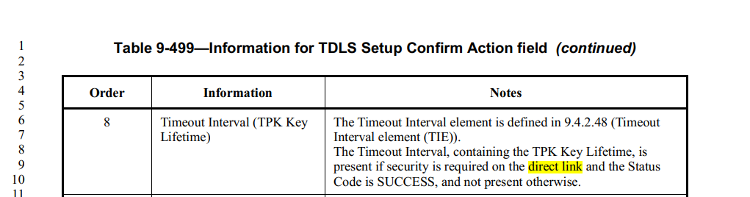

TPK stands for "TDLS PeerKey".

Agree to add "TDLS" before "direct link".

Note that I found 110 instances of "TDLS direct link".

Proposed Resolution:
Accpeted.
CID | Page | Clause | Resn Status | Comment | Proposed Change
1361 | 2208.37 | 10.23.2.4 |  | In 10.23.2.4, there is a reference saying internal collisions are handled in 10.23.2.4. This self-referential xref is not useful. | Change the xref to point to 10.23.2.2 (and bullet (d) if that can be done), as the better reference for where this condition is handled.

Discussion:

Cited text:
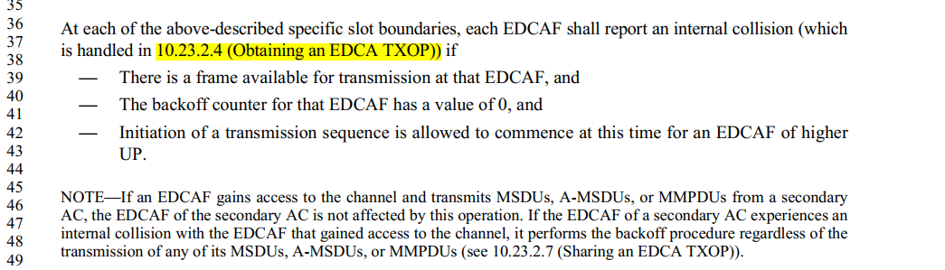

Proposed new Xref is in 10.23.2.2,
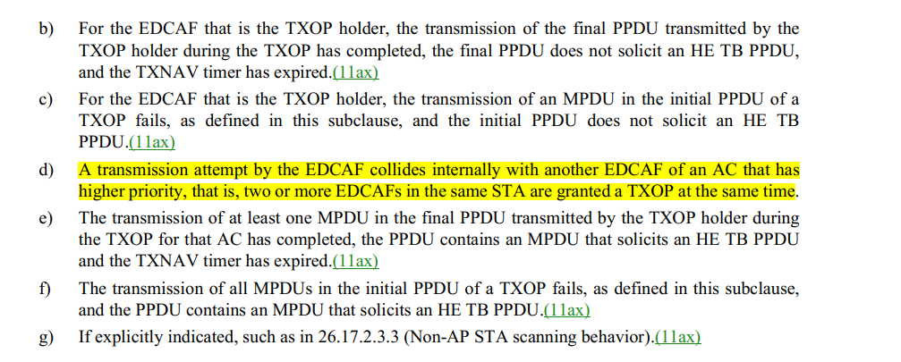

Proposed Resolution:
Revised.

Change “10.23.2.4” to “10.23.2.2”.

Note to editor: if xref to (d) can be added, also add “(see bullet (d))” after “10.23.2.2”.
CID | Page | Clause | Resn Status | Comment | Proposed Change
1192 | 276.23 | 4.3.11.1 |  | "Wireless LAN (WLAN) radio measurements enable STAs to understand the radio environment in whichthey exist." is an overstaement and implies a STA is capable of 'understanding'. | Delete it.

Discussion:

Cited text:
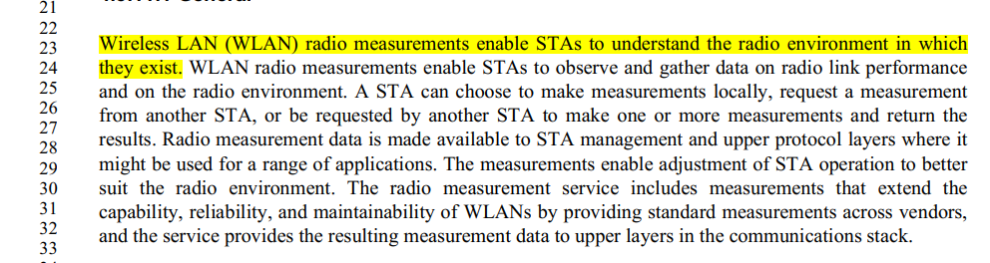

Proposed Resolution:
Accepted.

CID | Page | Clause | Resn Status | Comment | Proposed Change
1295 |  | 3.2 |  | It is a comment resulting from a recent discussion on a specific CID in TGbe. No hyphen is needed for "access point". | Delete hyphen in all appearances of "access-point: in subclause 3.2.

Discussion:

I found 23 instances in 3.2. They are in the context of “non-access-point (non-AP)”.

Example of cited texts:

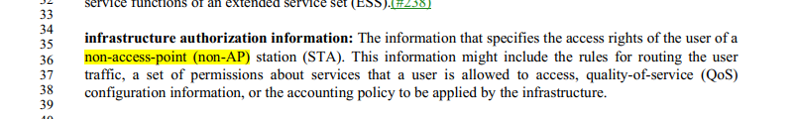

According to the styple guide, section 2.11 of 09/1034r20 ( https://mentor.ieee.org/802.11/dcn/09/11-09-1034-20-0000-802-11-editorial-style-guide.docx),
“non-access-point (non-AP)” should be changed to “non–access point (non-AP)”, note that “–” is an en-dash, not regular dash.

See Section 2.11 in 09/1034r20:

Follow the Chicago Manual of Style for use of the hyphen with a prefix; a hyphen should be used with a prefix in the following cases:

- Before a capitalized word, abbreviation or a numeral, such a non-AP, pre-1950;
- Before a compound term, such as non-self-sustaining, non–access point (see below for en-dash vs dash);
- To separate two i’s, two a’s, and other combinations of letters or syllables that might cause misreading, such as anti-intellectual, extra-alkaline, pro-life;
- To separate the repeated terms in a double prefix, such as sub-subentry;
- When a prefix or combining form stands alone, such as over- and underused, macro- and microeconomics.

Note that when the hyphen is used before an open compound term, the hyphen is an en-dash (e.g., non–access point). This provides a visual clue that the prefix applies to the whole compound and not just the first word. When the hyphen is before a hyphenated compound, then a regular dash is used (e.g., non-self-sustaining).

Proposed Resolutions:

Change “non-access-point (non-AP)” to ““non–access point (non-AP)” through the draft, 23 instances in 3.2 in D1.0.
Note that “–” is an en-dash, not regular dash (“-”).

CID | Page | Clause | Resn Status | Comment | Proposed Change | Resolution
1630 |  | 3.2 |  | "protected dual of public action frame:" has the wrong capitalisation | Change to "Protected Dual of Public Action frame:" | REJECTED (ED1: 2022-01-13 01:40:22Z)- The location for the cited term is 235.25. The cited term is in the definition. It shall be lower cases.

Discussion:

Cited text:
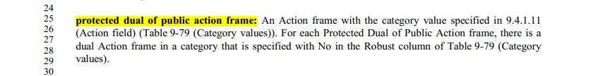

A general convention is that words that are being defined are in all lower case (except the acronyms, which are also spelled out and their constituent words are in lower case).

Proposed Resolution:

Rejected.

The location for the cited term is 235.25. The cited term is in the definition in 3.2. A general convention is that words that are being defined are in all lower case (except the acronyms, which are also spelled out and their constituent words are in lower case).
CID | Page | Clause | Resn Status | Comment | Proposed Change | Resolution
2318 | 1184.38 | 9.4.2.5.1 |  | Typo "an UL". This acronym is typically pronounced "Yew Ell", so does not require "an" as an article. Additionally see P289L42 "a URL" that shows a similar example. | Change to "a UL". Also see P1184L58, P2114L60, P2593L6, P4175L46, P4243L46, P4243L49 and P4415L21. | REVISED (ED1: 2022-03-11 19:46:58Z)

Discussion:

When an indefinite article is needed immediately before an abbreviation, the pronunciation of the abbreviation determines whether ‘a’ or ‘an’ should be used. ‘A’ is the correct choice before abbreviations beginning with a consonant sound, including a vowel pronounced as a ‘w’ or ‘y’ sound.

"UL" is the abbreviation of "uplink".

Do we pronounce "UL" in "UL MU" (uplink multi-user) as "Yew Ell" or "uplink"?

Have discussed this item with WG editor, Robert’s feeback is:

The correct article for UL is “a” since it is pronounced yow-el. If you pronounce it “uplink” then you are not really saying what is written. I guess you can say it that way, but you aren’t pronouncing UL, you are pronouncing uplink.

Proposed Resolution: Accepted.

CID | Page | Clause | Resn Status | Comment | Proposed Change
1319 | 396.23 | 6.3.3.3.2 |  | It looks like we got rid of most occurrences of "colocated" (with one 'L') except in MIB attribute names. However, 2 hyphenated occurrences got left, and 2 occurrences in MIB description text got left. | Change colocated (hyphenated or not) to "collocated" at the cited location, and P1816.13, P5286.14, and P5286.28.

Discussion:

In 802.11-2020, we have changed most occurrences of colocated and co-located to “collocated” except MIB variables, field names, and subelement names.

At 1816.13:

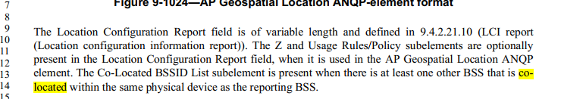

Page 5286,
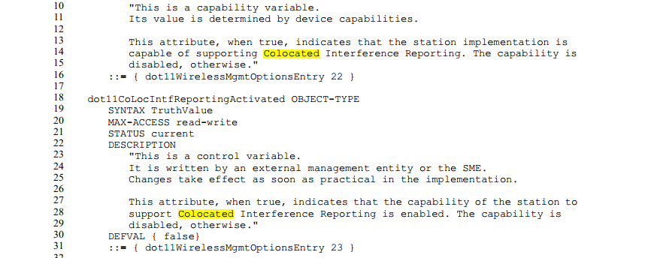

Proposed resolutions:

Accepted.

CID | Page | Clause | Resn Status | Comment | Proposed Change
1320 | 216.34 | 3.2 |  | We still have a mixed bag of "co-located" and "collocated" in the Standard. Pick one. | I would suggest changing "collocated" to "co-located", as my research indicates that "collocated" is an old word with a slightly different meaning. But, either way, make them all the same spelling, picking one or the other.

Discussion:

Assinged this comment to the commenter, Mark Hilmiton

We have cleaned up those inconsistences and decided to use “collocated” in 802.11-2020.
Cited text was introduced in 11ax.

Cited text:
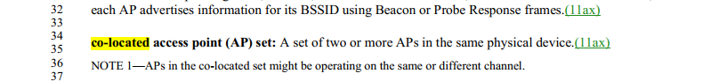

Proposed Resoultion:
Revised.
Change “co-located” to “collocated” at 216.35, 216.36, 38, .......

