IEEE P802.11
Wireless LANs
Proposed Resolution for REVme LB258 Editor1 ad-hoc Comments
Date: 2022-04-28
Author:
Name | Affiliation | Address | Phone | Email
Emily Qi | Intel Corporation | 2111 NE 25th Ave.  Hillsboro OR 97124 |  | Emily.h.qi@intel.com

This submission present proposed resolutions for comments in the Editor1 ad-hoc group.

The proposed changes are based on REVme/D1.0.

Revision history:

R0 – initial version

CID | Page | Clause | Comment | Proposed Change
1091 | 1067.55 | 9.3.4.3 | "Optionally, element(s) that are not listed in thistable, but are allowed in Beacon frames (seeTable 9-60 (Beacon frame body)), in the orderthey appear in Table 9-60 (Beacon framebody)". Too many references. The sentence can be simplified. | Change the cited sentence to "Optionally, element(s) that are not listed in thistable, but are allowed in the Beacon frame, in the order they appear in the Beacon frame (seeTable 9-60 (Beacon frame body))"

Discussion:
The same reference showed twice in a one sentence. It is not necesory.
Cited text and proposed changes:
Optionally, element(s) that are not listed in this table, but are allowed in Beacon frames (see Table 9-60 (Beacon frame body)), in the order they appear in Table 9-60 (Beacon frame body).
Or:
Optionally, element(s) that are not listed in this table, but are allowed in Beacon frames (see 9.3.3.2 (Beacon frame format Table 9-60 (Beacon frame body)), in the order they appear in Table 9-60 (Beacon frame body).
Proposed resolution:
Accepted.

CID | Page | Clause | Comment | Proposed Change
1093 | 982.48 | 9.3.1.19 | In Figure 9-80, "STA Info 1" "..." " STA Info n" fields are repeat fields, which should be avoided. Please see Editorial Style Guide doc11-09-1034. Also, no need to have the arrow "MAC header". | Replace the repeating fields with the "STA Info List" field and add definition for the "STA Info List" field, or use the same format as defined in Figure 9-76.

Discussion:
Cited text:
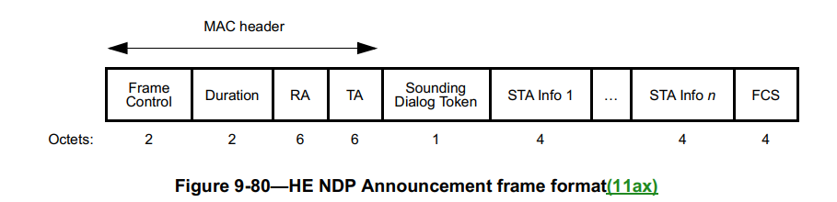

The comment pointed out two issues:
- Repeating fields should be avoided in the frame/element/field format figure. If a field needs to be repeated, create a container field with “List” in the name, e.g., Name List field.
- Arrow should not be used in the frame format figures, except where labelling parts of the structure or the MAC Header in the top-level frame format.

Proposed resolution:
Revised.
Replace Figure 9-80 with the following figure:
 | Frame Control | Duration | RA | TA | Sounding Dialog Token | STA Info List | FCS
Octets: | 2 | 2 | 6 | 6 | 1 | n × 4 | 4

At 985.10, add the following paragraph:
“The STA Info List field contains one or more (n) STA Info fields.”

<Proposed resolution: Revised; Incorporate the changes indicated by CID 1093 in doc 11-22/0319r0 < https://mentor.ieee.org/802.11/dcn/22/11-22-0319-01-000m-revme-wg-lb258-editor1-ad-hoc-comments.docx>

CID | Page | Clause | Resn Status | Comment | Proposed Change
1094 | 981.12 | 9.3.1.19 |  | The paragraph at 981.12 to 981.18 seems misplaced. It should be moved to 981.46. | Move the paragraph at 981.12 to 981.46.
1095 | 982.56 | 9.3.1.19 |  | There are several duplications in 9.3.1.19. For example, 1. Figure 9-76 and Figure 9-80 are similar and can be combined. 2. the definitions for Sounding Dialog Token field and Sounding Dialog Token Number field have been repeated multiple times. | 1. Combine Figure 9-76 and Figure 9-80 2. Combine the paragraph from 982.56 to 982.64 with the paragraph from 981.10 to 981.45. Or reorganize 9.3.1.19.

Discussion:
After reviewing contents in 9.3.1.19, I think I am okay with the existing text. Therefore, I would like to withdraw these two comments.
Proposed resolution:
Rejected.
Reject Reason: Commenter withdrew the comments.

CID | Page | Clause | Resn Status | Comment | Proposed Change | Resolution
1416 |  |  | V | "in which case," comma spurious except when followed by subordinate subclause | I can provide locations | REVISED (ED1: 2022-04-27 21:05:28Z) - at 269.50. At 2421.41 and 2432.52 delete "then"

Discussion:
at 269.50:
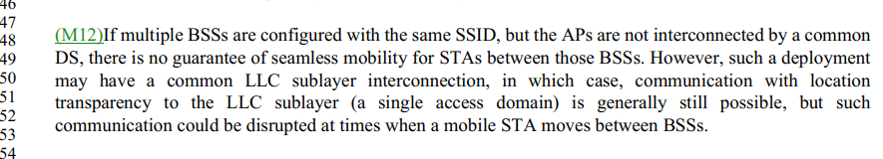

At 2421.41,
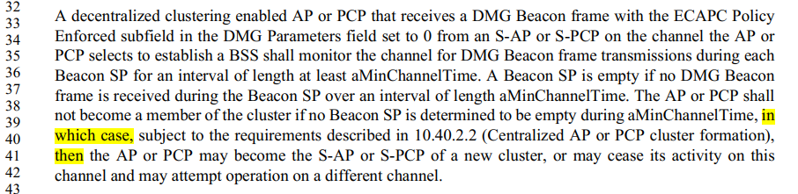

At 2432.52.
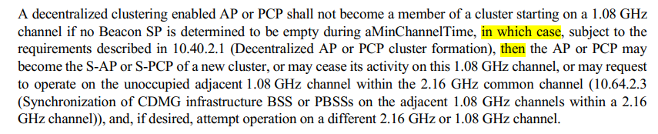
Proposed resolution:
Revise, at 269.50, delete “,” in “in which case,”. At 2421.41 and 2432.53 delete "then"

CID | Page | Clause | Resn Status | Comment | Proposed Change | Resolution
1660 |  |  |  | Follow-up to CID 326: "EDCA parameter values" should be "EDCA parameters" | I can provide locations for the changes

Discussion:
Mark provided locations: 1312.17/22, 1313.1, 1314.1, 2079.28, 4133.52/53, 4134.37/39, 5570.50, 5592.13
For example, 1312.17/22:
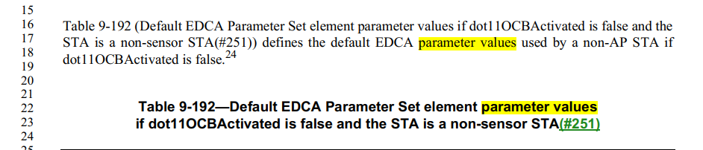
Proposed resolution:
Revised. At the following locations: 1312.17/22, 1313.1, 1314.1, 2079.28, 4133.52/53, 4134.37/39, 5570.50, 5592.13, change "EDCA parameter values" to "EDCA parameters"

CID | Page | Clause | Resn Status | Comment | Proposed Change | Resolution
1662 |  |  | A | "actively transmit" -- you can't passively transmit, so the adverb is spurious | Delete "actively " (4x -- I can provide locations) | ACCEPTED (ED1: 2022-04-27 21:24:50Z). Note to editor, Locations are 2666.1, 2837.20, 3320.34, 5587.35.
Discussion:
Mark provided locations: 2666.1, 2837.20, 3320.34, 5587.35.
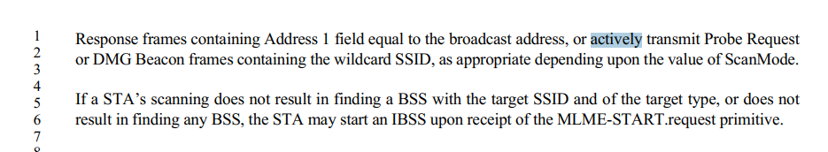
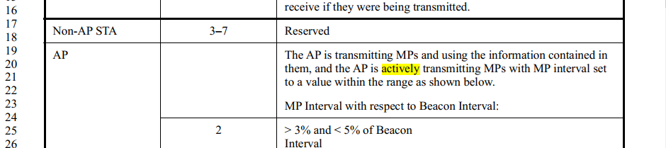
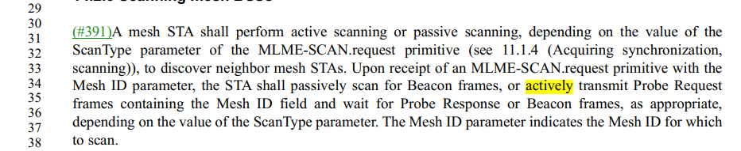
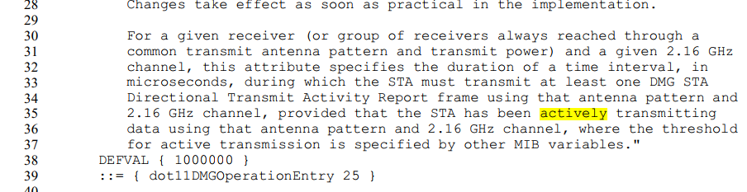
Proposed resolution:
ACCEPTED. Note to editor, Locations are 2666.1, 2837.20, 3320.34, 5587.35.
CID | Page | Clause | Resn Status | Comment | Proposed Change | Resolution
1685 |  |  |  | "beacon report" should be "Beacon report" | I can provide locations for the changes (~10x)

Discussion:
Mark provided locations: 1206.38/39, 1207.24, 2817.31/32, 2819.16/20 (2x), 2975.53/54
1206.38/39:
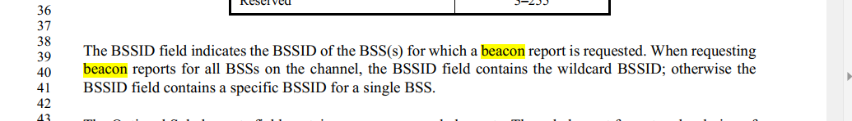
2975.53/54
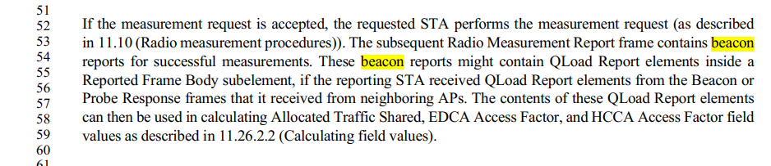
Proposed resolution:
Revised. Change “beacon report” to “Beacon report” at the following locations: 1206.38/39, 1207.24, 2817.31/32, 2819.16/20 (2x), 2975.53/54.

CID | Page | Clause | Resn Status | Comment | Proposed Change | Resolution
1755 |  |  |  | "Mesh ID" should be "mesh ID" except when referring to the element etc. | Change "Mesh ID" to "mesh ID" at 375.29 (2x), 469.34 rightmost, 1460.34, 2672.13 (2x), 3318.52 (2x), 3318.53, 3319.9, 14.2.6 (I can provide locations), 14.13.3.2, 5467.20

Discussion:
Mark provided: Locations in 14.2.6 are 3320.36 (rightmost), 3320.40/41/45/46/47 (leftmost)/48 (2x).
At 375.29,
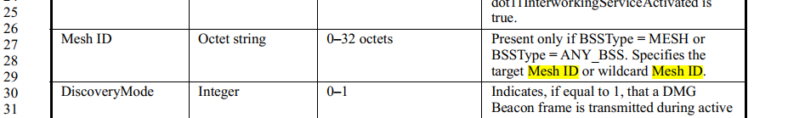

At 468.35,
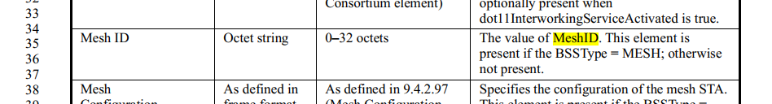
In 14.2.6,
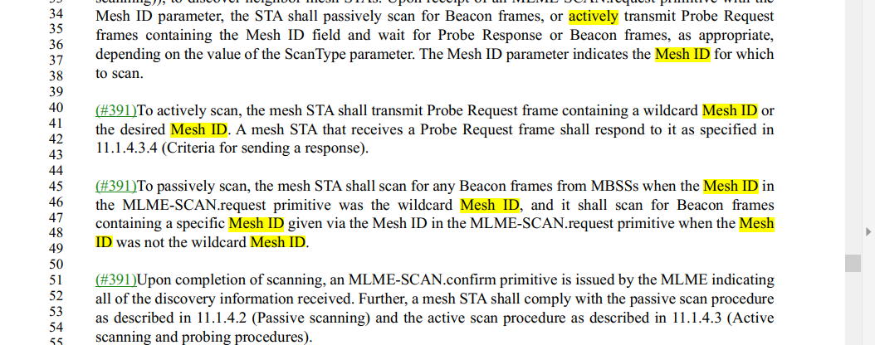
In 14.13.3.2
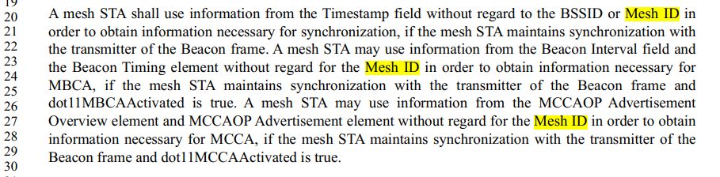
Proposed resolution:
Revised.
Change "Mesh ID" to "mesh ID" at 375.29 (2x), 469.34 rightmost, 1460.34, 2672.13 (2x), 3318.52 (2x), 3318.53, 3319.9, 5467.20, 14.2.6, and 14.13.3.2,
In 14.2.6, locations are: 3320.36 (rightmost), 3320.40/41/45/46/47 (leftmost)/48 (2x).
In 14.13.3.2, locations are: 3399.20/23/27

CID | Page | Clause | Resn Status | Comment | Proposed Change | Resolution
1849 |  | 9.4.2.24.1 |  | "expressed as hexidecimal value" -- people who can cope with the 802.11 spec don't need to be told the decimal equivalent of hexadecimal | Delete the 10x ", expressed as hexadecimal value"s (I can provide locations)
Discussion:
Mark provided: Locations as 1289.20/21/31/32/42/43/52/53, 1290.4/5
Page 1289,
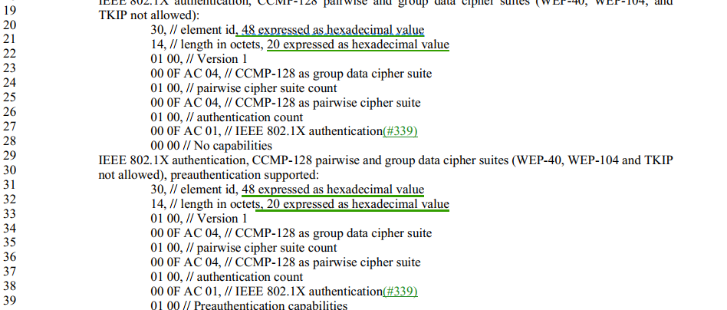
“expressed as hexidecimal value" is helpful.
Proposed resolution:
Revise.
Change “<x> expressed as hexidecimal value” to “i.e., <x> in decimal” at the following locations: 1289.20/21/31/32/42/43/52/53, 1290.4/5

CID | Page | Clause | Resn Status | Comment | Proposed Change | Resolution
1850 |  | 9.4.2.24.1 |  | The case after the //s is haphazard | Make it lowercase in all instances
Discussion:
Mark provided: Locations are 1289.22/28/33/39/44/47/54/60, 1290.6
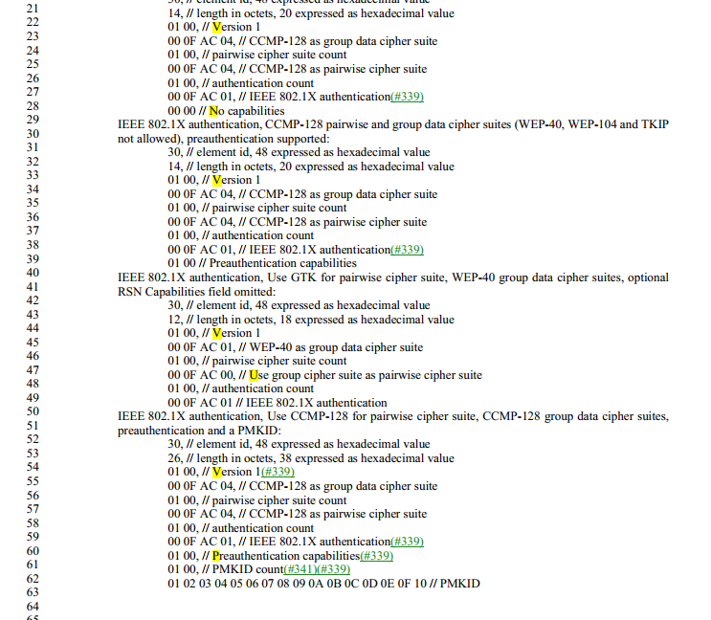

Proposed resolution:
Revised.
Change the first lowercase letter after "//" to uppercase in the following locations: D1.0P1289 lines 20, 21, 24, 26, 31, 32, 35, 37, 42, 43, 46, 48, 52, 53, 56, and 58, and D1.0P1290 lines 4, 5, 8, 11, and 14.

CID | Page | Clause | Resn Status | Comment | Proposed Change | Resolution
1875 |  |  |  | "field of the TXVECTOR" should be "parameter of the TXVECTOR" (11x) | I can provide locations

Discussion:
Mark provided: Locations are 3476.44/55/60, 3483.31/43, 3549.60, 3551.3, 3563.18/19, 3616.27, 4476.33
Page 3476, as an example,
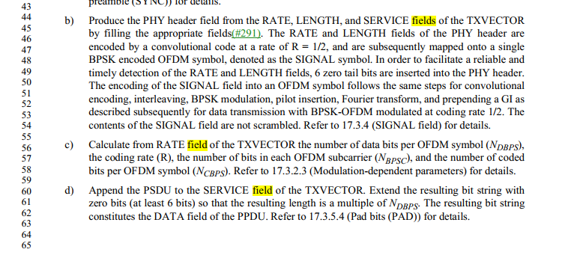
Proposed resolution:
Revised
At the following locations 3476.44/55/60, 3483.31/43, 3549.60, 3551.3, 3563.18/19, 3616.27, 4476.33, change "field of the TXVECTOR" or "fields of the TXVECTOR" to "parameter of the TXVECTOR" or "parameters of the TXVECTOR", respectively.

