IEEE P802.11
Wireless LANs
SA1 Comment Resolution for CID 7036
Date: 2022-2-9
Author(s):
Name | Affiliation | Address | Phone | Email
Ali Raissinia | Qualcomm Inc. |  |  | alirezar@qti.qualcomm.com
Jonathan Segev | Intel |  |  | jonathan.segev@intel.com
Assaf Kasher | Qualcomm Inc. |  |  | akasher@qti.qualcomm.com

Abstract

This document proposes resolution for CID 7036

CID | Clause Number(C) | Page(C) | Line(C) | Comment | Proposed Change | Resolution
7036 | 9.4.2.167 | 67 | 1 | Table 9-280 "Format and Bandwidth" - Previously the entries in the table implied a sort of backward compatibility, as in a larger value signalled support of all smaller values, how is that now handled? | Double check text in "11.21.6.4.2 EDCA based ranging measurement exchange" to see if new table entries need additional language | Revised  TGaz editor make the changes identified below in 11-22-0297-00-00az Comment resolution for CID7036  https://mentor.ieee.org/802.11/dcn/21/11-22-0297-00-00az-comment-resolutions-for-cid7036.docx

Discussion for CID 7036.

The table below shows the added EDCA based HE to the Format And Bandwidth table in the baseline standard. The commenter suggess for clarification of the field selection when device selects now the addition of EDCA based HE Format And Bandwidth.

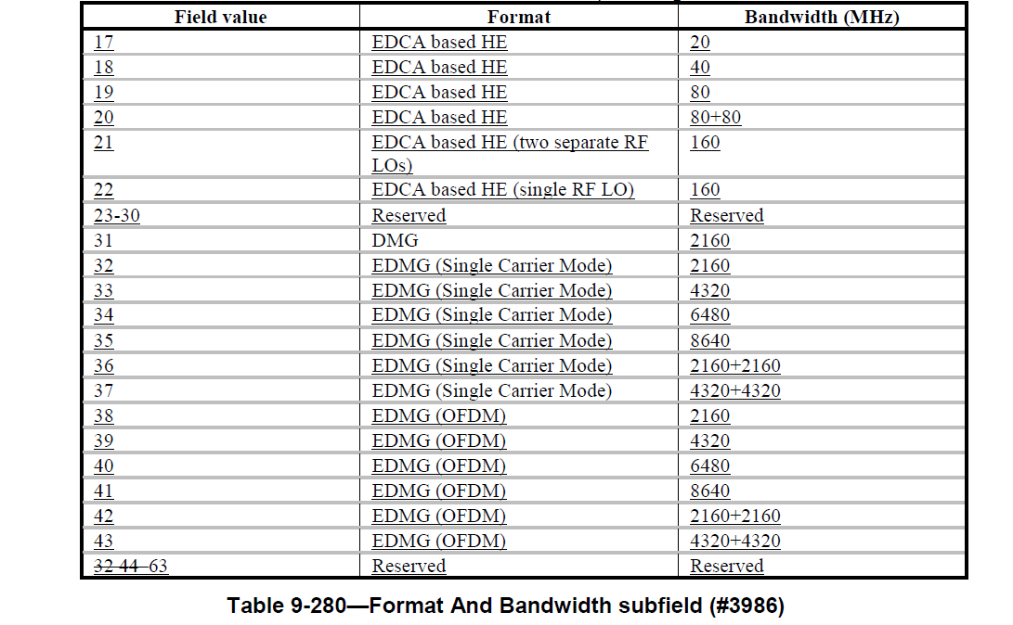

The format and bandwidth field for all values indicates two parameters: 1. The widest supported bandwidth for FTM and the format, however for the 80+80, 160 single LO and 160 two separate LOs it also indicates the number of LOs. Support for 80MHz suggests also support for lower bandwidths of the same format, however support for single LO does not infer support for two LOs or vice versa.

As mentioned above, the format and bandwidth field value also provides information of the supported formats:
- support for format VHT infer support for HT,
- support for HE infer support for VHT.
However:
- support for EDMG and DMG formats of all kinds does not infer support of HE, VHT or HT mixed.
- support for HT does not infer support for non HT

This is detailed out in the paragraph in P.129 L.2:
“The responding STA shall not indicate a VHT format if DMG, HT-mixed or non-HT format was requested. The responding STA shall not indicate an HT format if DMG or non-HT format was requested. The responding STAshall not indicate a DMG format if VHT, HT-mixed or non-HT format was requested.”

The limitations on assignment should be expanded to the 11az HE format for EDCA based operation. The limitation on assignment should also be expanded to EDMG format selection when DMG is requested by initating STA. Also support for EDMG single carrir does not mean that support EDMG OFDMA.

Resolution for CID 7036: TGaz editor change 802.11az D4.0 P.128 L.8-11 as follows:

In the case when ISTA requests for Format equal to VHT and/or EDCA based HE and bandwidth equal to160 MHz (80+80, 160 single RF LO, or 160 two separate RF LOs), the RSTA shall assign the same Format and Bandwidth as requested by ISTA for 160 MHz bandwidth, otherwise it shall assign Format and Bandwidth less than or equal to 80MHz.

Resolution for CID 7036: TGaz editor change 802.11az D4.0 P.128 L.40 to P.129L-11 as follows:

When the request was successful
— The RSTA shall indicate, in the Format And Bandwidth field, a format and bandwidth that it supports. The RSTA should indicate the same format and bandwidth in the Format And Bandwidth field as that requested by the ISTA, if the RSTA supports this. The RSTA shall not assign a value that indicates

- a bandwidth wider than requested
- an EDCA based HE format if VHT, DMG, HT mixed or non-HT format was requested
- a VHTformat if DMG, HT-mixed or non-HT format was requested
- an HT format if DMG or non-HT format was requested
- a DMG format if EDCA based HE, VHT, HT-mixed or non-HT format was requested (#2466, #2465)
- an EDCA based HE format only if EDCA based HE was requested, see 26.17.2 (HE BSS operation in the 6GHz band), and the STA is operating in the 6 GHz band; otherwise the STA shall not indicate EDCA based HE format
- a VHT (160 with two separate RF LOs) or a VHT (80+80) if a VHT (160 with single RF LO) was requested
- a VHT (160 with single LO) or a VHT (80+80) if a VHT (160 with two separate RF LOs) was requested
- a VHT (160 with single LO) or a VHT (160 with two separate RF LOs) if a VHT (80+80) was requested
- an EDCA based HE (160 with two separate RF LOs) or an EDCA based HE 80+80 if an EDCA based HE (160 with single RF LO) was requested
- an EDCA based HE (160 with single LO) or an EDCA based HE (80+80) if an EDCA based HE (160 with two separate RF LOs) was requested
- an EDCA based HE (160 with single LO) or an EDCA based HE (160 with two separate RF LOs) if an EDCA based HE (80+80) was requested
- an EDMG format if a DMG format was requested
- an EDMG OFDM format if an EDMG SC format was requested

References:
[1] Draft P802.11az_D4.0
[2] IEEE Std 802.11-2020

