IEEE P802.11
Wireless LANs
CC36 Resolution for CIDs related to MLO Power-save – Part 2
Date: February 8, 2022
Author(s):
Name | Affiliation | Address | Phone | email
Abhishek Patil | Qualcomm Inc |  |  | appatil@qti.qualcomm.com
Gaurang Naik
George Cherian
Alfred Asterjadhi
Duncan Ho
Yanjun Sun
Abdel Karim

Abstract
This submission proposes resolutions for following 9 CIDs received for TGbe CC36: 5261 5353 6303 8036 6159 7501 8297 7876 8362

Revisions:
- Rev 0: Initial version of the document.
- Rev 1: Added CIDs 7876 and 8362

Interpretation of a Motion to Adopt

A motion to approve this submission means that the editing instructions and any changed or added material are actioned in the TGbe Draft. This introduction is not part of the adopted material.

Editing instructions formatted like this are intended to be copied into the TGbe Draft (i.e., they are instructions to the 802.11 editor on how to merge the text with the baseline documents).

TGbe Editor: Editing instructions preceded by “TGbe Editor” are instructions to the TGbe editor to modify existing material in the TGbe draft. As a result of adopting the changes, the TGbe editor will execute the instructions rather than copy them to the TGbe Draft.

CID | Commenter | Clause | Pg/Ln | Comment | Proposed Change | Resolution
5261 | Insun Jang | 35.3.10.2 | 266.29 | Need to change "a non-AP MLD" to "a STA affilaited with a non-AP MLD" to be consistent with "the other STA(s)" although it is on a single link | As in the comment | Revised  The reference to non-AP MLD is correct in the text cited by the comment. For example, the non-AP MLD needs to keep track of critical updates to a particular link or monitor traffic indication and track time (TSF) for each link. In order to provide further clarification, the text is updated to state that the non-AP MLD monitors Beacon frames on each link via its affiliated STA. The NOTE on critical updates is moved under the first paragraph in this subclause since the second paragraph is focused on traffic indication.  TGbe editor, please make changes as shown in 11-22-0292r1 tagged 5261
5353 | Jarkko Kneckt | 35.3.10.2 | 266.28 | The sentence is very hard to understand:"This is in addition to mechanisms such as individual TWT agreement." | Please clarify or delete the sentence. Individual TWT is optional mechanism for non-AP STA and it is not clear why its maintenance is considered here. | Revised  The cited sentence is updated to clarify that each STA of a non-AP MLD can employ different mechanisms for performing additional power-save on their respective link.  TGbe editor, please make changes as shown in 11-22-0292r1 tagged 5353
6303 | Ming Gan | 35.3.10.2 | 266.28 | Not sure why "Not every non-STA affiliated with the non-AP MLD is required to receive Beacon frame" is removed, please add it back as in D0.3 | as in the comment | Rejected  The cited sentence was deleted since the first sentence of this subclause says the same – i.e., a non-AP MLD can monitor Beacon frames (via its affiliated STA) on one or more links.
8036 | Yuchen Guo | 35.3.10.2 | 266.35 | What does "shall be consistent" mean? Does it mean the TIM on all links shall be the same? What if one STA is in PS mode, the other STA in the same MLD is in acive mode? | Please clarify | Revised  The sentence was updated to clarify what is meant by ‘consistent’ – i.e., the bit position in the PVB of TIM element for a particular non-AP MLD is the same in all the Beacon frames transmitted by the APs affiliated with the AP MLD with which the non-AP MLD has performed multi-link setup.  TGbe editor, please make changes as shown in 11-22-0292r1 tagged 8036
4068 | Abhishek Patil | 35.3.10.4 | 267.10 | The AID space 1 to 2^n - 1 is reserved for nontransmitted multiple BSSIDs in a multiple BSSID set. Therefore, the AP MLD must not assign AID value that falls in this space for any link | Add a sentence as follows: "The AID value assigned to a non-AP MLD shall be greater than or equal to 2^N where N is the maximum of MaxBSSID Indicator (n) for each link where the corresponding AP belongs to a multiple BSSID set." | Revised  Agree with the comment. The paragraph related to AID assignment is modified to accommodate the changes suggested by the comment.  TGbe editor, please make changes as shown in 11-22-0292r1 tagged 4068
6159 | Michael Montemurro | 4.3.19.2 | 45.30 | If you define the BSS MAX Idle period feature to work for MLO there is no association between affiliated STAs. | Change "When association is not for a multi-link setup, BSS max idle period management enables an AP to indicate a time period during which the AP does not disassociate a STA due to nonreceipt of frames from the STA (also see 4.3.19.23a (MLD max idle period management) for the case when the association is for a multi-link setup)(#2561). This supports improved STA power saving and AP resource management." to "BSS max idle period management enables an AP to indicate a time period during which the AP does not disassociate a STA due to nonreceipt of frames from the STA. For MLO, MLD MAX Idle period is described in 4.3.19.23a (MLD max idle period management) for the case when multi-link setup establishes a connection between two MLDs." | Rejected  The text in the cited sentence was updated as a resolution to CID 8222. The resolution to CID 8222 differentiates between a legacy association and an MLO association. Therefore, no further changes are needed.
7501 | Tomoko Adachi | 4.3.19.23a | 45.58 | Why does MLD max idle period management need to be described in different subclause other than 4.3.19.2? The description is repeated except that the AP becomes AP MLD and STA becomes non-AP MLD. Change 4.3.19.2 subclause title to also cover the MLD max idle period and combine the description therein. It may be enough to say that, for MLD association, MLD max idle period management service is used instead of the BSS max idle period management service and applied among all setup links. | As in comment. | Rejected  There is very little duplication of text between the two subclauses and the actions are applicable to different subjects. In 4.3.21.2, the subjects are AP and non-AP STA while that in 4.3.21.24 it is the respective MLDs. In addition, with MLO, we have the concept of ‘setup links’ and the frame exchange needs to occur on one of the setup link for the AP MLD to not disassociate a non-AP MLD for exceeding the specified Max idle period.
8297 | Zhiqiang Han | 9.6.13.20 | 158.13 | The link doesn't belong to any STA. the STA can transmits frames on the link. In the draft, there are many places to express the meaning of Link ID. It's better to keep the definition same. | as in comment. | Rejected  The comment fails to identify an issue at the cited location. The usage of Link ID field is consistent across the spec text.
7876 | Yongho Kim | 3.2 | 41.35 | Duplicated sentence. Delete from "An extended power save mode...." in L40. | As in the comment | Accepted
8362 | Zhiqiang Han | C.3 | 591.11 | Add dot11MldMaxIdlePeriod | as in comment. | Revised  There is only one instance of this in the spec which is not necessary. During ML (re)setup, the BSS Max Idle Period element carries in the (Re)Association Response frame provides the MLD Max Idle Period value and the same MIB variable dot11BssMaxIdlePeriod would govern the presence of this element. TGbe doesn’t need to define a separate MIB variable.  TGbe editor, please delete “or dot11MldMaxIdlePeriod is nonzero” from the TGbe draft (reference in D1.4 P277L1)

TGbe editor: The baseline for this document is 11be D1.4

      - Basic BSS operation
TGbe editor: Please update the contents of this subclause as shown below:
A non-AP MLD shall be able to perform basic operations (such as receiving a traffic indication, time synchronization, receiving BSS parameter updates) by monitoring Beacon frames[5261] via one or more of its affiliated STAs on their respective enabled links. [5353]This is accomplished in addition to other power-save mechanisms (such as individual TWT agreement or APSD), if setup, between the STA affiliated with the non-AP MLD and the corresponding AP affiliated with the AP MLD with which the non-AP MLD has performed association. With these mechanisms, a non-AP MLD can receive basic information about the AP MLD and all the APs affiliated with the AP MLD on a single link while the other STA(s) affiliated with the non-AP MLD are in doze state.
[5261]NOTE—Each AP affiliated with an MLD provides a critical updates indication when there is an update to the BSS parameters for another AP affiliated with the AP MLD (see 35.3.10 (BSS parameter critical update procedure)).
[4068]An AP MLD shall assign a single AID to a non-AP MLD during multi-link setup. The AID value that an AP MLD assigns to a non-AP MLD shall be greater than or equal to 2^{N} where N is the maximum of MaxBSSID Indicator value (see 9.4.2.45 (Multiple BSSID element) for each link where the corresponding AP belongs to a multiple BSSID set. [8036]The traffic indication for a non-AP MLD shall be consistent (i.e., the bit in the partial virtual bitmap, of the TIM element, that matches to the AID of the non-AP MLD is set to the same value) across the Beacon frames transmitted by APs affiliated with an AP MLD, that are operating on the links that are part of the multi-link setup (see 35.3.12.4 (Traffic indication)).
[5261]

Discussion: No CID. Bug in figure 35-10 (pointed out by Morteza (Meta))
Per baseline spec, a STA remains in its current power management mode until it informs the AP of a power management mode change via a frame exchange that includes an acknowledgment from the AP (see 11.2.3.1 & 11.2.3.2). Figure 35-10 is missing a ACK frame after the frame indicating PM=1 is sent on Link 1.

35.3.12.1 General
TGbe editor: Please update Figure 35-10 as shown below:

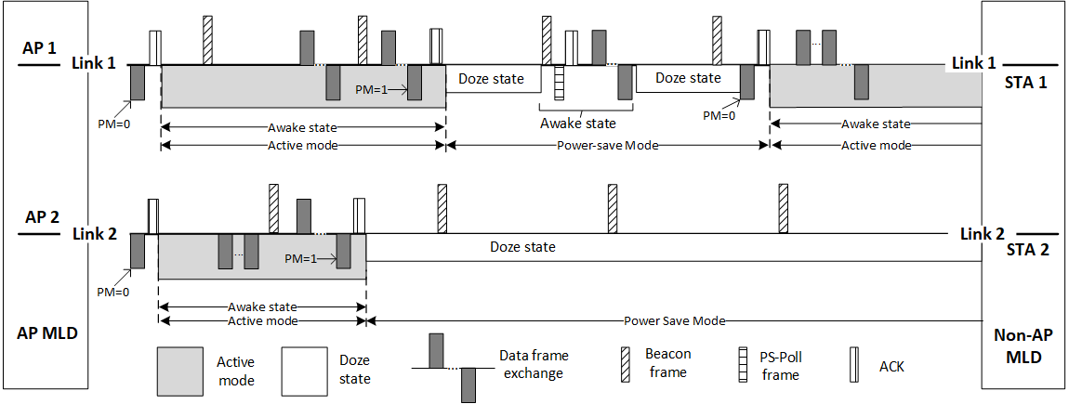
Figure 35-10—Each STA affiliated with a non-AP MLD maintains its own power state

