IEEE P802.11  
Wireless LANs

|  |  |  |  |  |
| --- | --- | --- | --- | --- |
| LB258: Resolution for CID 2350 | | | | |
| Date: 2022-02-04 | | | | |
| Author: | | | | |
| Name | Affiliation | Address | Phone | Email |
| Yan Xin | Huawei Technologies | 303 Terry Fox Drive, Suite 400, Ottawa, Ontario K2K 3J1 |  | yan.xin@huawei.com |
|  |  |  |  |  |
|  |  |  |  |  |
|  |  |  |  |  |
|  |  |  |  |  |

This submission includes the resolution for CID 2350 for P802.11-REVme D1.0. The baseline document is P802.11-REVme D1.0.

##### Revision history:

##### R0 – initial version

**CID: 2350**

|  |  |  |  |  |  |  |
| --- | --- | --- | --- | --- | --- | --- |
| CID | Clause | Page | Line | Comment | Proposed Change | Proposed resolution |
| 2350 | 28.3.2.2 | 4564 | 26 | "As shown in Figure 28-4--EDMG PPDU format, EDMG-Header-A is defined as one of Pre-EDMG modulated fields. However, in Figure 28-5--EDMG A-PPDU format, EDMG-Header-A is included in EDMG modulated fields starting from the 2nd PPDU in A-PPDU transmission. As described in P4564L59-62, ""For 4.32 GHz, 6.48 GHz and 8.64 GHz EDMG PPDU transmissions, the pre-EDMG modulated fields shall  be transmitted using the non-EDMG duplicate format"". It is not clear how to transmit EDMG-Header-A located in the 2nd PPDU or later in an A-PPDU transmission." | Modify Figure 28-5 and clarify transmission of EDMG-Header-A located in the 2nd PPDU or later in an A-PPDU transmission. | REVISED  TGm editor: Please revise the text in subclauses 28.5.3.3.2 and 28.6.3.2.2 in 802.11REVme D1.0  as suggested in 11-22/0282r0. |

***Discussion:***

EDMG A-PPDU includes an EDMG SC mode A-PPDU or an EDMG OFDM mode A-PPDU. In **Figure 28-5** (**EDMG A-PPDU format**), EDMG Header-A is defined as one of Pre-EDMG modulated fields in the first EDMG PPDU and as one of EDMG modulated fields in each subsequent EDMG PPDUs starting from the second EDMG PPDU.

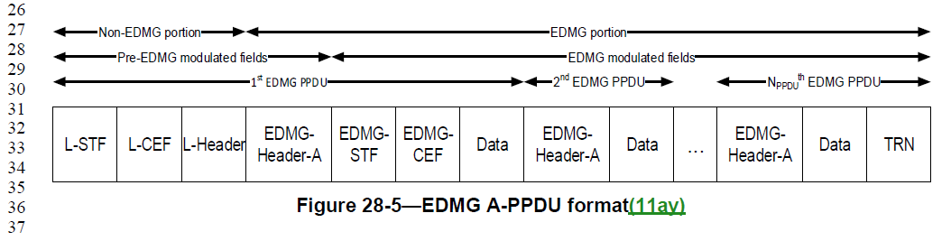

For the EDMG SC mode (**28.5 EDMG and non-EDMG SC mode**), Subclause **28.5.3.3.1 Pre-EDMG modulated fields of PPDU transmission** defines how to generate EDMG-Header-A in the pre-EDMG modulated fields in a PPDU transmission. However, the definition on how to generate EDMG-Header-A located in EDMG modulated fields in an A-PPDU transmission is missing in **28.5.3.3.2 EDMG modulated fields of SU PPDU transmission**. The text in Subclauses **28.5.3.3.1 Pre-EDMG modulated fields of PPDU transmission** and **28.5.3.3.2 EDMG modulated fields of SU PPDU transmission**) is shown as below. Similarly, for the EDMG OFDM mode, the definition on how to generate EDMG-Header-A located in EDMG modulated fields in an A-PPDU transmission is also missing in **28.6.3.2.2 EDMG modulated fields of SU PPDU transmission** for the EDMG OFDM mode (**28.6 EDMG OFDM mode**).

This contribution proposes the revised text for subcluases **28.5.3.3.2 EDMG modulated fields of SU PPDU transmission** (in **28.5 EDMG and non-EDMG SC mode**) and **28.6.3.2.2 EDMG modulated fields of SU PPDU transmission** (in **28.6 EDMG OFDM mode**).

**28.5 EDMG and non-EDMG SC mode**



TGm Editor: please revise the text as following.

**28.5 EDMG and non-EDMG SC mode**

**28.5.3.3.2 EDMG modulated fields of SU PPDU transmission**

Figure 28-15 (Transmitter block diagram for the EDMG modulated fields of an SU PPDU transmission(11ay)) shows the transmitter blocks used to generate the EDMG modulated fields of an SU

PPDU. The EDMG-STF and EDMG-CEF fields are generated using the Preamble builder block. The TRN

field is generated using TRN builder block. The EDMG-Header-A field in the PPDU starting from the second PPDU in the EDMG A-PPDU and Data field of the PPDU are generated using the scrambler, LDPC encoder, constellation mapper, interleaver, and GI insertion blocks. If STBC encoder is applied, then $N_{SS}$ spatial streams are mapped to ${2×N}_{SS}$ space-time streams as defined in 28.5.9.5.4 (Space-time block coding (STBC)). The $N_{STS}$ space-time streams are further mapped to $N_{TX}$ transmit chains, where $N_{STS}≤N_{TX}$.

**28.6 EDMG OFDM mode**

**28.6.3.2.2 EDMG modulated fields of SU PPDU transmission**

Figure 28-33 (Transmitter block diagram for the EDMG modulated fields of an SU PPDU transmission(11ay)) shows the transmitter blocks used to generate the EDMG modulated fields of an SU

PPDU. The EDMG-STF and EDMG-CEF fields are generated using the preamble builder, IDFT, and GI

insertion blocks. The TRN field is generated using the TRN builder, IDFT, and GI insertion blocks. The

EDMG-Header-A field in the PPDU starting from the second PPDU in the EDMG A-PPDU and Data field of the PPDU are generated using the scrambler, the LDPC encoder, the constellation mapper, the interleaver, IDFT, and GI insertion blocks. If the STBC encoder is applied, then $N_{SS}$ spatial streams are mapped to ${2×N}_{SS}$ space-time streams as defined in 28.6.9.3.10 (Space-time block coding). The $N_{STS}$ space-time streams are further mapped to $N_{TX}$ transmit chains, where $N_{STS}≤N_{TX}$.