IEEE P802.11
Wireless LANs
Resolution for CID 1018
Date: May 19, 2022
Author(s):
Name | Affiliation | Address | Phone | email
Abhishek Patil | Qualcomm Inc |  |  | appatil@qti.qualcomm.com
Gaurang Naik
Jouni Malinen

Abstract
This submission proposes resolutions for CID 1018 received in LB258 (REVme D1.0).

Revisions:
- Rev 0: Initial version of the document.

Interpretation of a Motion to Adopt

A motion to approve this submission means that the editing instructions and any changed or added material are actioned in the TGm Draft. This introduction is not part of the adopted material.

CID | Commenter | Clause | Page | Line | Comment | Proposed Change | Resolution
1018 | Abhishek Patil | 10.28.11 | 2305 | 21 | The procedure described in 10.28.11 and 10.28.12 doesn't work when a fragmentable element is carried as a subelement within a (legacy) element (such as Multiple BSSID element carried a Beacon frame) that is not fragmentable. The (de)fragmentation procedure described in clause 10.28 needs to be updated to account for such case. The simplest approach is to adjust the length requirement for fragmentation from 255 octets to that matching the remaining length of the subelement. | The commenter will provide a contribution to address this issue. | Revised  Agree with the comment. The standard needs to provide a mechanism for handling element fragmentation for the case where the element is carried as a sub-element within an element that is not fragmentable.  The proposed resolution adds two subclauses after 10.28.12 to cover the fragmentation and defragmentation under this scenario. An example of element fragmentation for a nontransmitted BSSID is provided.  Relevant parts of the spec are updated to refer to the newly added subclauses.  TGm editor please implement changes as shown in this document.

TGm editor: The baseline for this section is REVme D1.2.

TGm editor: Please add the following new subclauses after clause 10.28.12 as shown below
10.28.12a Element fragmentation within a subelement of a non-fragmentable element
If a non-fragmentable element (i.e., has a No in the Fragmentable column listed in Table 9-128 (Element IDs)) includes a fragmentable element, as a subelement, then the maximum octets of the fragmentable element that can be carried within the subelement are limited by the remaining length in the subelement. In such a case, if the remaining length of the subelement is less than the length of the Information field of the fragmentable element, then the element is fragmented by following procedures described in 10.28.11 (Element fragmentation) where the length considerations are based on the pending octets in the subelement(s) that carries it. In addition, the non-fragmentable element is followed by at least one element having the same value in the Element ID field and Element ID Extension field (if applicable) as the non-fragmentable element (e.g., see Figure 11-5 (Example of nontransmitted BSSID profile fragmented across multiple Multiple BSSID elements)). Each subsequent non-fragmentable element includes, as a first subelement, the same subelement (that carried the fragmented element) and carries a Fragment element (see 9.4.2.188 (Fragment element)) containing the remaining of the contents of the fragmented element. The maximum length of the Fragment element is based on the pending octets in the subelement. The fragmentable element may be fragmented across subelements carried across multiple elements. An example of a fragmentable element carried in a Nontransmitted BSSID Profile subelement of a Multiple BSSID element is shown in Figure 10-46a (Example of a fragmentable element in a nontransmitted BSSID profile carried across Multiple BSSID elements).
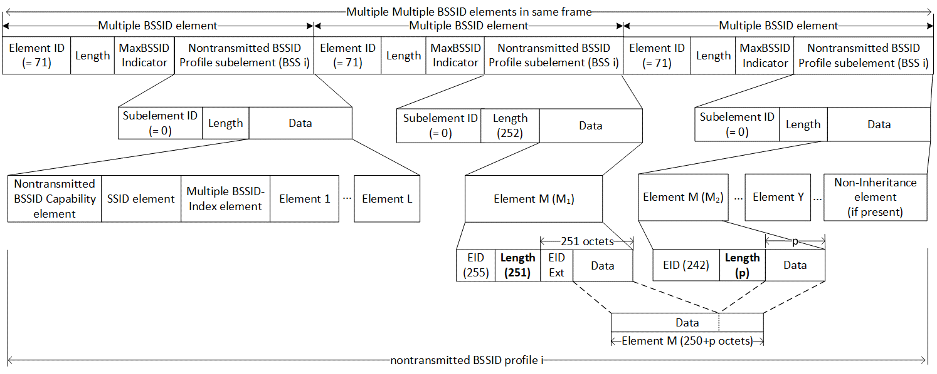
Figure 10-46a Example of a fragmentable element in a nontransmitted BSSID profile carried across Multiple BSSID elements
10.28.12b Element defragmentation within a subelement of a non-fragmentable element
When an element that is fragmentable is carried as a subelement within an element that is not fragmentable, the procedure for defragmentation shall be the same as that described in 10.28.12 (Element defragmentation) with the additional consideration that the fragments of the element are carried across subelements contained in multiple nonfragmentable elements.

- Element fragmentation
TGm editor: please update the first paragraph in this subclause as shown below:
The general format of elements limits the size of the information to 255 octets in an element without Element ID Extension field (Figure 10-47 (Example of the element fragmentation without Element ID Extension)) or 254 octets in an element with Element ID Extension field (Figure 10-48 (Example of the element fragmentation with Element ID Extension)). A STA may transmit information that is too large to fit in a single element by fragmenting the element into a series of elements consisting of the element that the information does not fit, immediately followed by one or more Fragment elements as illustrated in Figure 10-47 (Example of the element fragmentation without Element ID Extension). Information that fits in a single element shall not be fragmented. The rules related to element fragmentation for the case where a fragmentable element is carried as a subelement within an element that is not fragmentable are described in 10.28.12a. All the information for a fragmented element shall be in the same MMPDU.

- Element defragmentation
TGm editor: please update the following paragraph in this subclause as shown below:
Elements that have had their information fragmented shall be followed by one or more Fragment elements. To reconstruct the original information, the portion of information from the leading element shall be concatenated, in order, with the portions of information from the series of Fragment elements that follow it. The rules related to element defragmentation for the case where a fragmentable element is carried as a subelement within an element that is not fragmentable are described in 10.28.12b. The defragmentation procedure shall complete when any element other than a Fragment element is encountered, or the end of the MMPDU is reached.

- Nontransmitted BSSID profile
TGm editor: please update the following paragraph in this subclause as shown below:
If there is a need to fragment a nontransmitted BSSID profile across more than one Multiple BSSID element in a frame, an AP shall not fragment an element in the profile across multiple Multiple BSSID elements, and it shall place the next element in that profile as the first element in the first Nontransmitted BSSID Profile subelement of the immediately following Multiple BSSID element. An AP shall not fragment a nontransmitted BSSID profile across two frames. If a frame carries multiple Multiple BSSID elements, the MaxBSSID Indicator field in all the Multiple BSSID elements shall carry the same value. In addition, an AP corresponding to the transmitted BSSID shall follow the procedures described in 10.28.12a if a nontransmitted BSSID profile carries a fragmentable element whose Information field cannot fit the remaining length of the subelement.
TGm editor: please add the following paragraph in this subclause after the one above as shown below:
A non-AP STA shall determine that a nontransmitted BSSID profile is fragmented if the next element in the frame is a Multiple BSSID element in which, the first Nontransmitted BSSID Profile subelement does not contain the Nontransmitted BSSID Capability element as the first element. In addition, the non-AP STA shall follow the procedures described in 10.28.12b if the first element in the first Nontransmitted BSSID Profile subelement of the subsequent Multiple BSSID element is a Fragment element.
TGm editor: please replace “Element L+1” with “Element M” in Figure 11-5 this subclause

