IEEE P802.11
Wireless LANs
Proposed Draft Text for DMG sensing procedure
Date: 2022-01-24
Author(s):
Name | Affiliation | Address | Phone | email
Solomon Trainin | Qualcomm |  |  | strainin@qti.qualcomm.com
Abstract

This document includes proposed draft text for the “DMG sensing (SENS) procedure” sub-clause as defined in TGbf’s SFD. The DMG sensing procedure is defined in the SFD by 7.3 DMG sensing (SENS) procedure.

TGbf Editor: Insert the following text after 11.21.17

11.21.18.x DMG sensing (SENS) procedure

11.21.18.x.1 Overview (Motion 55, 21/2015r4)
DMG sensing types include monostatic, bistatic, multistatic, monostatic sensing with coordination, bistatic sensing with coordination, and passive sensing
In monostatic sensing the sensing transmitter and the sensing receiver are the same STA.
In bistatic sensing, the sensing transmitter and the sensing receiver are two distinct STAs.
In multi-static sensing, the sensing transmitters and the sensing receivers are at least three distinct STAs, for example, one transmitter STA and multiple receiver STAs or one receiver STA and multiple transmitter STAs.
In passive sensing, the STA receives PPDUs transmitted by one or more STAs that are not necessarily intended for DMG sensing (such as DMG Beacon frames).
Monostatic sensing with coordination is an extension of monostatic to coordinate monostatic devices. Bistatic sensing with coordination is an extension of bistatic type to coordinate multiple sensing responders by one sensing initiator.

In the monostatic sensing with coordination sensing type, the transmissions of one or more devices that perform monostatic sensing are coordinated by a PCP/AP (Motion 40, 21/1914r0).

The DMG sensing procedure defines all DMG sensing types.

The behavior of each type of DMG sensing type is defined separately (Motion 56, 22/0031r0).

A DMG sensing procedure is a subset of the WLAN sensing procedure. Unless otherwise noted, the rules for WLAN SENS apply to DMG SENS.

DMG sensing procedure defines the behavior of a single sensing initiator with one or more sensing responders (Motion 56, 22/0031r0).

A DMG sensing procedure is composed of one or more of the following: DMG sensing session setup (11.21.18.x.2), DMG measurement setup (11.21.18.x.3), DMG sensing burst (11.21.18.x.4), DMG sensing instance (11.21.18.x.5), DMG measurement setup termination (TBD), and DMG sensing session termination (TBD).

A DMG sensing procedure may be comprised of multiple DMG sensing bursts. A DMG sensing burst may be comprised of multiple DMG sensing instances.

NOTE – Measurements over a certain time period are needed to compute the Doppler frequency shift. The occupancy time per link access cannot exceed the TXOP limit. If a longer measurement time is needed, then the approach of the DMG sensing burst allows scheduling of the multiple link accesses to collect measurements for the Doppler frequency shift computation.

One sensing responder may participate in multiple DMG sensing bursts and DMG sensing instances associated with different DMG measurement setups.

A sensing initiator may maintain multiple sensing responders in multiple DMG sensing bursts and DMG sensing instances associated with different DMG measurement setups.

A sensing initiator may instruct the sensing responder in the sensing receiver role or in the sensing receiver and sensing transmitter role to report at the DMG sensing instance, and/or it may instruct the sensing responder to accumulate the results and report once per DMG sensing burst.

Examples of DMG sensing procedures are shown in the following figures: Figure 11-x1 – Figure 11-x7. Figure 11-x1 illustrates the case when an PCP/AP performs DMG sensing with one non-AP STAs, which is referred to as STA with MAC addresses A.
The example starts with a sensing session setup procedure performed between the AP and STA A that establishes a sensing session identified by the AID of STA A (AID 1). A measurement setup procedure is then performed, which defines a set of operational attributes labelled with a DMG Measurement Setup ID equal to 1. The agreed operational attributes include the intra-burst and the inter-burst interval. The time between consecutive instances in the DMG sensing burst is the intra-burst interval, and the time between the consecutive burst is the inter-burst interval. The concept of DMG Measurement Setup ID is defined in 11.21.18.x.3.
After the measurement setup, DMG sensing instances are performed based on the defined operational attribute set (DMG Measurement Setup ID equal to 1). Each sensing instance is labeled with a DMG sensing instance Nmb (see 11.21.18.x.5), DMG Sensing burst ID (11.21.18.x.4), and DMG Measurement Setup ID.
The DMG sensing instances are grouped in the DMG sensing bursts, identified by the DMG Sensing burst ID. The figure presents two DMG sensing bursts, with DMG sensing bursts ID=1 and DMG sensing bursts =2. The DMG Sensing instances Nmb uniquely identifies the DMG sensing instances per the DMG sensing burst ID. There are 3 DMG sensing instances in each burst, numbered DMG sensing instances Nmb=1, DMG sensing instances Nmb=2, and DMG sensing instances Nmb=3, respectively.

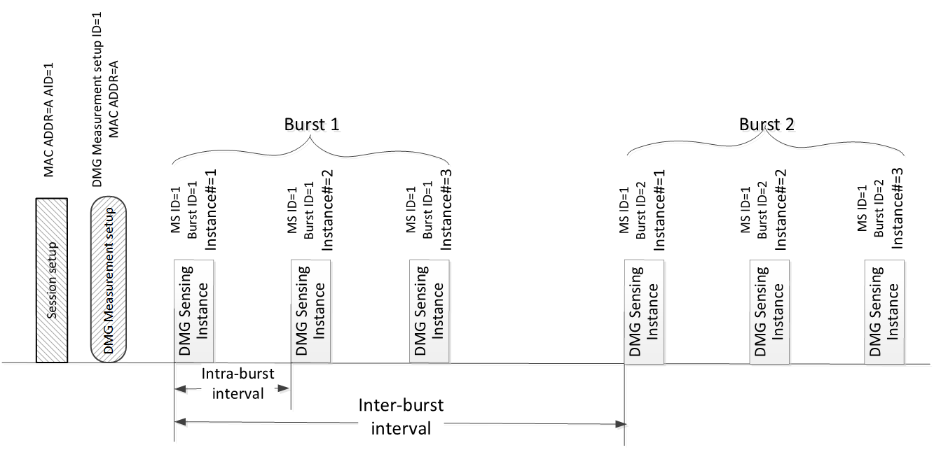
Figure 11-x1: DMG sensing procedure with one sensing responder.

Figure 11-x2 illustrates one DMG sensing burst of the DMG sensing type - monostatic. The DMG sensing procedure is initiated by the PCP/AP that is not capable of DMG sensing. The PC/AP establishes the sensing session with one responder STA A and negotiates the operational attributes with it.
The operational attributes of the measurement belong to the DMG measurement setup ID=1 and include the intra-burst interval. The burst contains three DMG sensing instances identified by the DMG sensing instance Nmb=1, 2, and 3, respectively. The instances in the burst are separated by the intra-burst interval. Each DMG sensing instance contains sounding and reporting phases separated by the SIFS interval.

The example starts in the DMG sensing instance Nmb=1. In the sounding phase, the STA A transmits the PPDU and receives the reflected signal. In the example, the STA A is not ready to report the results of the immediately preceding sensing phase. So, it indicates the result as invalid in the reporting frame. In the DMG sensing instance Nmb=2 the STA A performs the sounding in the sounding phase. At the reporting phase, the STA A is ready with the results of the sounding performed at the previous DMG sensing instance Nmb=1. It delivers the report indicated as belonging to the DMG sensing instance Nmb=1. In the DMG sensing instance Nmb=3, the STA A performs the sounding and delivers the report of the DMG sensing instance Nmb=2 sounding to the PCP/AP.

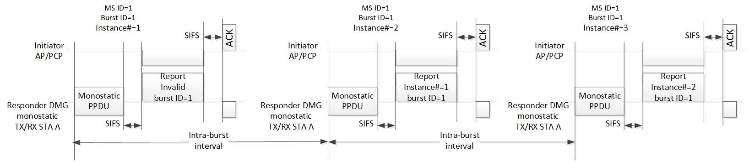
Figure 11-x2: DMG sensing instances of one DMG sensing burst with PCP/AP as sensing initiator and a single monostatic sensing device as sensing responder. Per DMG sensing instance delayed reporting.

Figure 11-x3 illustrates per burst aggregated reporting. The aggregated reporting contains the results of all DMG sensing instances belonging to one DMG sensing burst. The DMG sensing type is monostatic. The DMG sensing procedure is initiated by the PCP/AP that is not capable of DMG sensing. The PC/AP establishes the sensing session with one responder STA A and negotiates the operational attributes with it.
The operational attributes of the measurement belong to the DMG measurement setup ID=1 and include the intra-burst and inter-burst intervals. Each DMG sensing burst contains three DMG sensing instances identified by the DMG sensing instance Nmb=1, 2, and 3, respectively. The instances in the burst are separated by the intra-burst interval.
Each DMG sensing instance contains a sounding phase. The first DMG sensing instance in each DMG sensing burst contains sounding and reporting phases separated by the SIFS interval.

The example starts in the DMG sensing instance Nmb=1 contained in the DMG sensing burst ID=1. In the sounding phase, the responding STA transmits the PPDU and receives the reflected signal. In the example, the responding STA is not ready to report the aggregated results of the immediately preceding DMG sensing burst. So, it indicates the aggregated result as invalid in the reporting frame. In the DMG sensing instance Nmb=2, 3, the responding STA performs the sensing mesurement in the sounding phase. At the reporting phase of the DMG sensing instance Nmb=1 in the DMG sensing burst ID=2, the STA is ready with the aggregated results of the sounding performed in the instances during the previous DMG sensing burst ID=1. It delivers the aggregated report is indicated as belonging to the DMG sensing burst ID=1.

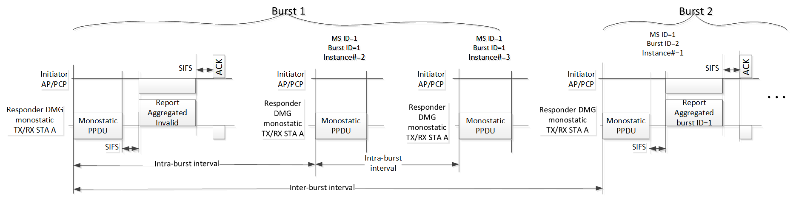
Figure 11-x3: DMG sensing instances with PCP/AP as sensing initiator and single monostatic sensing device as sensing responder. Per DMG sensing burst delayed delivery of the aggregated report.

Figure 11-x4 illustrates one DMG sensing burst of the DMG sensing type - bistatic. The DMG sensing procedure is initiated by the PCP/AP. The PC/AP establishes the sensing session with one responder STA and negotiates the operational attributes with it.
The operational attributes of the measurement belong to the DMG measurement setup ID=1 and include the intra-burst interval. The PCP/AP is in the role of transmitter and the responder STA is the receiver. The burst contains three DMG sensing instances identified by the DMG sensing instance Nmb=1, 2, and 3, respectively. The instances in the burst are separated by the intra-burst interval. Each DMG sensing instance contains sounding and reporting phases separated by the BRPIFS interval.

The example starts in the DMG sensing instance Nmb=1. In the sounding phase, the PCP/AP transmits the BRP frame, and the responder STA receives the frame. The responder STA performs the sensing measurements on the TRN fields. In the example, the responder STA is not ready to report the results of the immediately preceding sensing phase. So, it indicates the result as invalid in the reporting frame. In the DMG sensing instance Nmb=2 the responding STA performs the sensing measurement in the sounding phase. At the reporting phase, the responding STA is ready with the results of the sounding performed at the previous DMG sensing instance Nmb=1. It delivers the report indicated as belonging to the DMG sensing instance Nmb=1 in the BRP frame. In the DMG sensing instance Nmb=3, the responding STA performs the sounding and delivers the report of the DMG sensing instance Nmb=2 sounding to the PCP/AP.

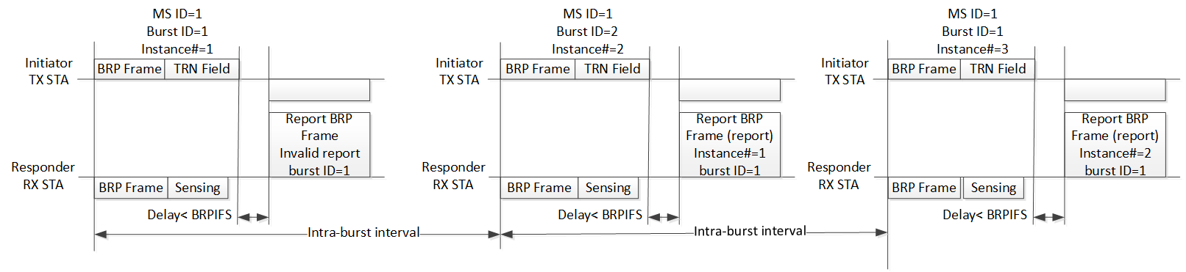
Figure 11-x4: DMG sensing instances of one DMG sensing burst of bistatic DMG sensing with the sensing initiator in the sensing transmitter role. Per DMG sensing instance delayed delivery of the report. NOTE: The BRP frame is an Action No Ack frame.

Figure 11-x5 illustrates the case when an AP performs DMG sensing procedre with three non-AP STAs, which are referred to as STAs with MAC addresses A, B, and C, respectively. The example starts with a DMG sensing session setup procedure performed between the AP and STAs A, B, and C that establishes a sensing session identified by the AID 1, AID 2, and AID 3, respectively.

A DMG measurement setup procedure is then performed, which defines a set of operational attributes. Two sets are established. The AP establishes with the STA A and the STA B the set labeled with a DMG Measurement Setup ID equal to 1, and it establishes with the STA A and the STA C another set labeled with a DMG Measurement Setup ID equal to 2. The operational attributes identified with the same DMG Measurement Setup ID may be different among the involved STAs, besides the intra-burst and inter-burst intervals. The intervals for both STAs are equal as per the equal Measurement Setup ID.

After the measurement setup, DMG sensing instances are performed based on the defined operational attribute sets (DMG Measurement Setup ID =1 and DMG Measurement Setup ID =2).
The initiator performs each DMG sensing measurement instance with the STA A and STA B under the DMG Measurement Setup ID =1 and with the STA A, and STA C under the DMG Measurement Setup ID =2
Each DMG sesning instance is labeled with a DMG sensing instance Nmb, DMG Sensing burst ID, and DMG Measurement Setup ID.
The DMG sensing instances are grouped in the DMG sensing bursts. Each DMG sensing burst is identified by the DMG sensing burst ID. It is unique per the DMG Measurement Setup ID. The figure presents two bursts (DMG sensing burst ID=1, and DMG sensing burst ID=2) of the DMG Measurement Setup ID=1, and two bursts (DMG sensing burst ID=1, and DMG sensing burst ID=2) of the DMG Measurement Setup ID=1.
Two DMG sensing bursts belonging to the DMG Measurement Setup ID =1 are performed with the intra-burst interval=T1 and the inter-burst interval=T2. Another two DMG sensing bursts belonging to the DMG Measurement Setup ID =2 are performed with different burst parameters: intra-burst interval=T3 and the inter-burst interval=T4.
The DMG sensing instances Nmb uniquely identifies the DMG sensing instance per the DMG sensing burst ID. There are 3 DMG Measurement Instances in each burst, numbered DMG Measurement Instances Nmb=1, DMG Measurement Instances Nmb=2, and DMG Measurement Instances Nmb=3, respectively.

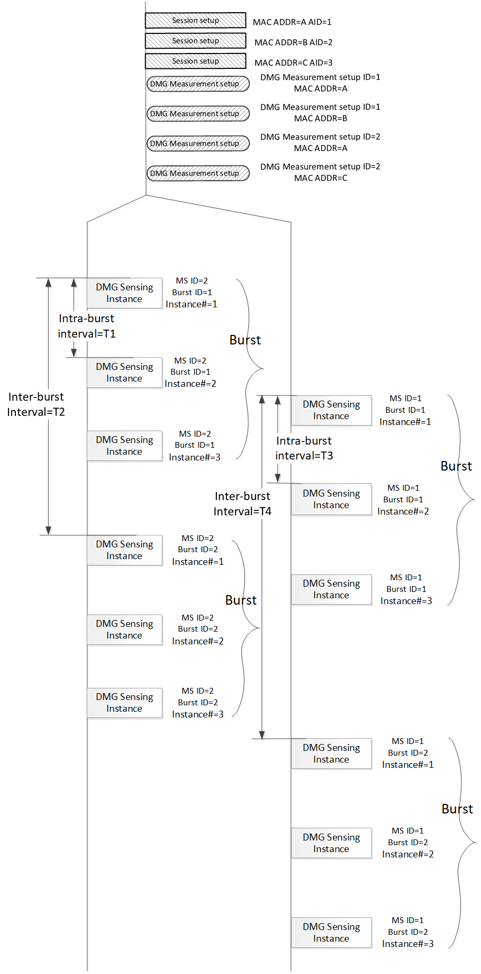
Figure 11-x5: DMG sensing procedure with three sensing responders.

Figure 11-x6 illustrates one DMG sensing instance presented in Figure 11-x5, which is identified by the DMG measurement ID=1, DMG sensing burst ID=1, and DMG sensing instance Nmb=1. The example is about the coordinated monostatic sensing type with the not-sensing capable Initiator and two Responders STA A and STA B.
The example starts with the initiation phase. The handshake between the initiator and the responder provides the responders with the order of the sounding and reporting. It also indicates to the initiator the readiness of the responders to participate in the sounding and reporting phases. The sounding phase of both monostatic devices in the instance may happen in parallel. In this example, the sounding phase is followed by the reporting phase of the same responder and the sounding phases of the two responders are sequential. In its sounding phase, the responder STA (A and B) transmits the PPDU and receives the reflected signal. In the immediately following reporting phase it reports with the results that are labeled with the DMG measurement setup ID=1, DMG sensing burst ID=1 and the DMG sensing instance Nmb=1 to the Initiator. The illustration in Figure 11-x6 applies to any instance depicted in Figure 11-x5 by replacing the DMG measurement setup ID, DMG sensing burst ID, and DMG sensing instance Nmb as per values indicated in the DMG sensing instances in Figure 11-x5.

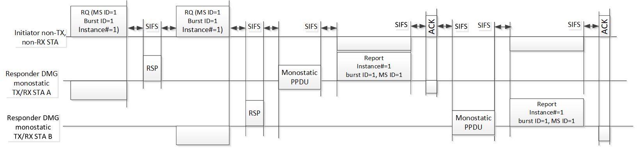
Figure 11-x6: DMG sensing instance of the coordinated monostatic type with PCP/AP as sensing initiator and two monostatic sensing devices as sensing responders.

Figure 11-x7 illustrates one DMG sensing instance presented in Figure 11-x5, which is identified by the DMG measurement ID=1, DMG sensing burst ID=1, and DMG sensing instance Nmb=1. The example is about the multistatic sensing type with the Initiator in the transmitter role and two Responders STA A and STA B in the receiver role.
The example starts with the initiation phase. The handshake between the initiator and the responders activates the responders to be ready to participate in the sounding and report in the order in the reporting phase. It also indicates to the initiator the readiness of the responders to participate in the sounding and reporting phases. In the sounding phase, the Initiator transmits the PPDU for synchronization and DMG sensing purposes. The Responder STA A uses the preamble, and the STA B uses the Sync field to synchronize with the transmitter clock. The Initiator in the transmitter role transmits the TRN fields and the responder STA A and STA B in the receiver role measures the reflected signals.
In the reporting phase, the responder STA A and STA B reports in the predefined order to the Initiator. The reports are labeled with the DMG measurement setup ID=1, DMG sensing burst ID=1, and the DMG sensing instance Nmb=1. The illustration in Figure 11-x7 applies to any instance depicted in Figure 11-x5 by replacing the DMG measurement setup ID, DMG sensing burst ID, and DMG sensing instance Nmb as per values indicated in the DMG sensing instances in Figure 11-x5.

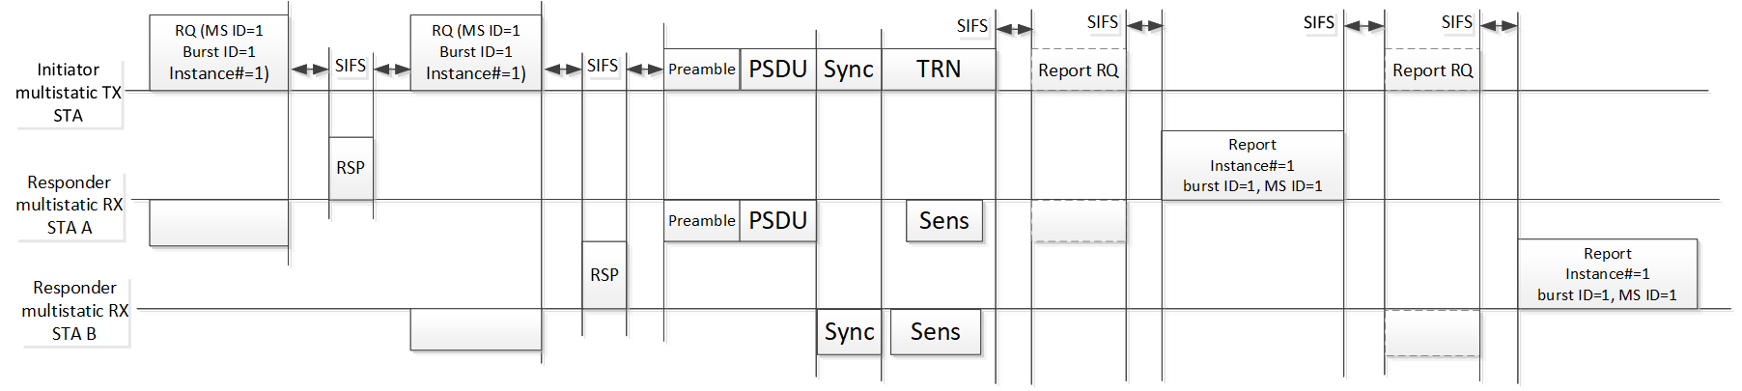
Figure 11-x7: DMG sensing instances of multistatic sensing. The PCP/AP is the sensing initiator in the role of sensing transmitter and two sensing responders are in the role of sensing receivers.

11.21.18.x.2 DMG sensing session setup (Motion 56, 22/0031r0)
In a DMG sensing session setup of a DMG sensing procedure, the sensing initiator and the sensing responder exchange DMG sensing capabilities. The capabilitiesinclude the types of DMG sensing and the roles the STA may assume for each of the supported DMG sensing types. The DMG Sensing Short Capabilities element (9.4.2.x1) [2], and the DMG Sensing Capabilities element (9.4.2.x) [1] contain the sensing capabilities of the DMG STA.
The sensing capable (TBD MIB) PCP/AP STA shall convey the DMG Sensing Short Capabilities element in the DMG beacon and Announce frames. The PCP/AP shall set the Sensing Supported subfield of the Short Sensing Capabilities field to 1 to indicate it supports any type of sensing.

The sensing capable (TBD MIB) DMG STA shall include the DMG Sensing Capabilities element (9.4.2.x) in the probe frames and the association frames.

The PCP/AP STA may set up the DMG measurement with the non-PCP/AP STA capable of one of the DMG sensing types.

The PCP/AP STA shall not initiate the DMG measurement setup with the non-PCP/AP STA if the STA is not capable of at least one of the DMG sensing types.

To coordinate more than one sensing responder, the sensing initiator of DMG sensing shall be a PCP/AP STA.

The sensing initiator may be capable of the roles of sensing transmitter, sensing receiver, both sensing transmitter and sensing receiver, or none of them.

A sensing responder may be capable of one or more of the following roles: Sensing receiver, sensing transmitter, and both sensing transmitter and sensing receiver.

A sensing initiator of the DMG sensing types monostatic and coordinated monostatic shall be capable of the roles of both sensing transmitter and sensing receiver, or neither of them.

A sensing responder of the DMG sensing types monostatic and coordinated monostatic shall be capable of the roles of both sensing transmitter and sensing receiver.

A sensing initiator of the DMG sensing types bistatic and coordinated bistatic shall be capable of the sensing transmitter and/or the sensing receiver role.

A sensing responder of the DMG sensing types bistatic and coordinated bistatic shall be capable of the sensing transmitter and/or the sensing receiver role.

The sensing initiator of the DMG sensing type multistatic shall be capable of the sensing transmitter and/or the sensing receiver role.

The sensing responder of the DMG sensing type multistatic shall be capable of the sensing transmitter and/or the sensing receiver role.

11.21.18.x.3 DMG measurement setup (Motion 56, 22/0031r0)

11.21.18.x.3.1 General
DMG measurement setup may require an accomplishment of beamforming training between the sensing initiator and the sensing responder(s) in advance. (10.42, 11.36)

An optional negotiation process in the DMG measurement setup is defined that allows for a sensing initiator and a sensing responder to exchange and agree on operational attributes associated with DMG sensing bursts and DMG sensing instances. The operational attributes may include intra-burst and inter-burst schedule, number of instances per burst, sensing initiator’s and sensing responder’s roles, DMG sensing type, DMG measurement report types, and other parameters. The set of the operational attributes agreed between the sensing initiator and the sensing responder is labelled with the DMG Measurement setup ID.
The Measurement setup request and response frames are defined in (TBD). The information is conveyed in IE (TBD).
The negotiation rules are presented below (TBD)

More than one type of DMG sensing measurement result may be defined. The type of measurement result reported in a DMG sensing procedure shall be decided by its sensing initiator per sensing responder capabilities per DMG sensing types. The types of the measurement results are defined in 9.4.2.A DMG Sensing Report element [3], 9.4.2.268 (EDMG Channel Measurement Feedback element), and 9.4.2.136 (Channel Measurement Feedback element)

The sensing initiator requests DMG measurement setup separately with each sensing responder. The set of the operational attributes and parameters established upon the negotiation is identified by the DMG Measurement Setup ID. The same DMG Measurement Setup ID may be asserted to the agreement with different sensing responders if the sensing initiator schedules to address the sensing responders in the same DMG measurement instance.

During a DMG measurement setup, the role(s) of the sensing initiator and sensing responder shall be determined as defined per DMG sensing types.

The sensing initiator and the sensing responder may proceed with the DMG positioning during a DMG measurement setup. They may exchange DMG positioning results such as ranging, AOA, and AOD. They may also exchange LCI and civic location.

11.21.18.x.3.2 Setup for monostatic and coordinated monostatic DMG sensing type
The sensing initiator of a coordinated monostatic DMG sensing measurement may be a STA not capable of monostatic DMG sensing.

11.21.18.x.3.3 Setup for bistatic and coordinated bistatic DMG sensing type
The sensing initiator of a bistatic DMG sensing measurement shall be capable of bistatic DMG sensing.

In DMG measurement instances of a DMG sensing procedure of sensing type bistatic, the sensing initiator shall interact with one sensing responder, and no more.

In DMG measurement instances belonging to the same DMG Measurement Setup ID, the sensing responder shall be in the sensing receiver role if the sensing initiator is in the sensing transmitter role, and vice versa.

11.21.18.x.3.4 Setup for multistatic measurement DMG sensing type
The sensing initiator of a multistatic DMG sensing measurement shall be capable of multistatic DMG sensing.

In DMG measurement instances of a DMG sensing procedure of sensing type multistatic, the sensing initiator may interact with one or more sensing responders.

In DMG measurement instances belonging to the same DMG Measurement Setup ID, all sensing responder(s) shall be in the sensing receiver role if the sensing initiator is in the sensing transmitter role. In DMG measurement instances belonging to the same DMG Measurement Setup ID, all sensing responder(s) shall be in the sensing transmitter role if the sensing initiator is in the sensing receiver role.

11.21.18.x.4 DMG sensing burst (Motion 56, 22/0031r0)
A DMG burst may be defined to include more than one sensing measurement instance. Each instance is limited by the TXOP limit.

The DMG sensing burst lasts from the beginning of the first DMG sensing instance until the end of the last DMG sensing instance belonging to the DMG sensing burst.
Two parameters, the intra-burst interval, and inter-burst interval characterize the DMG sensing burst.
The intra-burst interval defines the time between the beginning of two consecutive instances belonging to the same burst.
The inter-burst interval defines the time between the beginning of two consecutive bursts.

A DMG burst is identified with the DMG Burst ID.

The DMG burst parameters defined at the measurement setup shall be identified by the DMG Measurement Setup ID.

A specific DMG burst may belong to not more than one DMG Measurement Setup ID.

All DMG sensing instances in the DMG burst shall belong to the same DMG Measurement Setup ID.

The sensing responder may aggregate the reports and report once per DMG burst if aggregated reporting is set in the DMG measurement setup.

11.21.18.x.5 DMG sensing instance (Motion 56, 22/0031r0)

11.21.18.x.5.1 General
A DMG sensing instance is limited to one TXOP.

A DMG sensing instance belongs to one DMG Measurement Setup ID.

A DMG sensing instance includes the following phases: initiation phase, sounding phase, and reporting phase. The sounding phase is mandatory, and the initiation and reporting phases are optional.
DMG measurement instances of the DMG sensing types monostatic and the bistatic may not contain the initiation phase.

DMG measurement instances of the DNG sensing types coordinated monostatic, coordinated bistatic, and multistatic shall contain the initiation phase.

The reporting phase is mandatory if the sensing responder is in the sensing receiver role and in the sensing transmitter and sensing receiver role.

A DMG sensing instance is identified with the DMG sensing instance number. The DMG sensing instance number shall be sequential in increasing order.

The DMG sensing instance number shall be unique in range (e.g. 0-31, the number is TBD).

The DMG sensing instance may belong to the DMG burst. The DMG sensing instance number shall be unique per the DMG Burst ID.

11.21.18.x.5.2 Coordinated monostatic instance

11.21.18.x.5.2.1 Initiation
In a coordinated monostatic instance of one or more sensing responders the following rules shall apply:
- The number of sensing responders in each instance of the same DMG Measurement Setup ID may be different
- The sensing initiator shall send a Coordinated Monostatic Instance Request frame (TBD) to each sensing responder it requests to participate in the instance
- The sensing responder shall not respond with the Coordinated Monostatic Instance Response frame to the sensing initiator later than SIFS time after the request
- The sensing responder that responded to the sensing initiator shall proceed with monostatic sensing
- The order of sounding is indicated in the Coordinated Monostatic Instance Request frame
- The format of the Coordinated Monostatic Instance Request frame and the Coordinated Monostatic Instance Response frame is TBD

11.21.18.x.5.2.2 Sounding
The RA shall be set equal to the TA in the PSDU contained in the monostatic PPDU (name of this PPDU is TBD).

11.21.18.x.5.2.3 Reporting
- If the responses are configured to happen during the DMG measurement instance, each sensing responder shall respond in no longer than SIFS time after the monostatic PPDU, and
- If the polled responses are configured, each sensing responder shall respond in no longer than SIFS time after the polling by the sensing initiator.

11.21.18.x.5.3 Bistatic and coordinated bistatic instance

11.21.18.x.5.3.1 Initiation
In the coordinated bistatic instance of one or more sensing responders the following rules shall apply:
- Number of the sensing responders in each instance of the same DMG Measurement Setup ID may be different
- The sensing initiator shall send the Bistatic Instance Request frame (TBD) to each sensing responder it invites to participate in the sensing instance
- The sensing responder shall not respond with the Bistatic Instance Response frame to the sensing initiator later than in SIFS time
- The sensing responder that responded to the sensing initiator shall remain active to receive the BRP PPDU
- The order of sounding is indicated in the Bistatic Instance Request Frame
- The format of the Bistatic Instance Request frame and of the Bistatic Instance Response frame is TBD

11.21.18.x.5.3.2 Sounding
(Motion 45, 21/1865r1) EDMG transmitter initiator bistatic sensing is based on a BRP Request frame in a BRP-RX/TX, BRP-TX, BRP-RX PPDU (as defined in Clause 28 of 802.11) and a BRP Response frame. Feedback for DMG sensing measurement is carried in the BRP Response frame:
- Feedback may be delayed
- Feedback may be aggregated (single feedback for some measurements, to facilitate Doppler measurement)

(Motion 46, 21/1865r1) EDMG/DMG sensing receiver initiator bistatic sensing is based on a BRP Request frame that includes a request for the sensing responder to transmit a BRP-RX/TX, BRP-TX, BRP-RX PPDU (as defined in Clause 28 of 802.11).

11.21.18.x.5.3.3 Reporting
In a measurement instance, the responses of the sensing responder in the DMG sensing receiver role to the sensing initiator in the sensing transmitter role may contain no more than one measurement report

11.21.18.x.5.4 Mulstistatic instance

11.21.18.x.5.4.1 Initiation
In a multistatic instance of one or more sensing responders the following rules shall apply:
- Number of sensing responders in each instance of the same DMG Measurement Setup ID may be different
- The sensing initiator shall send the Multistatic Instance Request frame (TBD) to each sensing responder it invites to participate in the sensing instance
- The sensing responder shall not respond with the Multistatic Instance Response frame to the sensing initiator later than in SIFS time
- The sensing responder that responded to the sensing initiator shall remain active to receive the Multistatic PPDU (name of this PPDU is TBD)
- The format of the Multistatic Instance Request frame and the Multistatic Instance Response frame is TBD

11.21.18.x.5.4.2 Sounding
(Motion 58, 21/2023r0) A multi-static EDMG sensing measurement instance has the following parts:
- An Instance Request frame (frame type TBD) sent to each STA sequentially, and each STA responds to it.
- A multi-static EDMG sensing PPDU. The format of the EDMG sensing PPDU is TBD.
- A feedback part in which the sensing initiator polls each sensing responder for a report, and the sensing responders respond with a report.

11.21.18.x.5.4.3 Reporting
If the responses are configured to happen during the DMG measurement instance, each sensing responder shall respond in no longer than SIFS time after polling by the sensing initiator.

11.21.18.x.6 Passive DMG sensing (Motion 56, 22/0002r0) [2]

Passive DMG Sensing enables a sensing capable STA to use beacon transmission by enabling a STA to acquire information about the transmit settings of the transmitted DMG Beacon frames and the AP location.
A PCP/AP advertises the capability to perform passive sensing in the DMG Sensing Short Capabilities element. The PCP/AP shall set the Passive Sensing Support subfield to 1 if it supports DMG passive sensing. The PCP/AP shall set the Accurate Timing of Beacons to 1 if the SBIFS between beacon transmission in the BTI is exactly 1760TC±TC2 where TC is defined in Table 20-4 (Timing related parameters). The PCP/AP shall set the Location Available subfield to 1 if it can provide an LCI field in a DMG Passive Sensing Beacon Info element.
A STA requests information about the transmit settings of the DMG Beacon frame from a PCP/AP by sending an Information Request frame with the Element Id of the DMG Passive Sensing Beacon Info element in the Request element field. The PCP/AP responds with an Information Report frame that includes a DMG Passive Sensing Beacon Info element and one or more DMG Beacon Sector Descriptors elements as defined in 11.28.1.

11.21.18.x.7 DMG sensing by proxy (DMG SBP) procedure (Motion 56, 22/0031r0)
DMG sensing by proxy (DMG SBP) is the DMG variant of the SBP procedure. The DMG SBP allows a non-AP and AP STA that is not the sensing initiator to request the sensing initiator to perform the measurement and report the results. The sensing initiator shall provide the DMG SBP service.

References:

- 11-22-0240-00-00bf-DMG-Sensing-Capabilites
- 11-22-0241-02-00bf-pdt-dmg-passive-sensing
- 11-22-0251-00-00bf-PDT-DMG-Sensing-Report-IE

