IEEE P802.11
Wireless LANs
Proposed Draft Text for MLME
Date: 2022-02-07
Author(s):
Name | Affiliation | Address | Phone | email
Claudio da Silva | Meta Platforms, Inc |  |  | claudiodasilva@fb.com
Solomon Trainin | Qualcomm
Edward Au | Huawei
Abstract
This document includes proposed draft text that covers the broad MLME topic as defined in TGbf’s SFD by the following:

“The 11bf amendment shall define a new subclause under 6.3 (MLME SAP interface) that specifies request, confirm, indication, and response primitives for WLAN sensing.”

Baseline documents: Rev. me (D1.0) and 11be (D1.4)

Discussion
TGbf’s SFD defines that for TB sensing measurements:

- “The sensing measurement setup procedure consists of:
- The transmission of a sensing measurement setup request frame by the sensing initiator to a sensing responder with which it intends to perform a sensing measurement setup, followed by the transmission of an Ack frame by the intended sensing responder; and
- The transmission of a sensing measurement setup response frame by the intended sensing responder to the sensing initiator which transmitted the sensing measurement setup request frame to accept or reject the sensing measurement setup, followed by the transmission of an Ack frame by the sensing initiator.” (Motion 41, 21/1735r3; Motion 51, 21/1828r4)

- “A TB sensing measurement instance includes a polling phase, an NDPA sounding phase, and a TF sounding phase. The order of the NDPA sounding phase and of the TF sounding phase is TBD.” (Motion 25c, 21/0990r2)

- “In the polling phase, an AP sends a Trigger frame to check the availability of STAs. If a STA is available, it responds with a CTS-to-self.” (Motion 25c, 21/0990r2)

- “Examples of possible TB sensing measurement instances are shown in Figure 3. In this figure,
- How to define the sounding order, as in example 3 or as in example 4, is TBD.
- The reporting phase in example 5 may be separated from the sounding phases (TBD).
- The polling in the reporting phase in example 5 could be addressed to sensing responders other than those involved in the sounding (TBD).” (Motion 29, 21/1543r1)

Figure 3: TB sensing measurement instance (examples). (Motion 29, 21/1543r1)

- “The NDPA sounding phase consists of
- The transmission of a Sensing NDP Announcement (NDPA) frame by an AP; and
- The transmission of an NDP by an AP SIFS after the transmission of the Sensing NDPA frame.” (Motion 25c, 21/0990r2; Motion 26c, 21/1015r2)

- “Transmission of the Sensing Measurement Report frame is initiated by an MLME primitive.” (Motion 21, 21/0908r2)

- “The TF sounding phase consists of
- The transmission of a Trigger frame by an AP to solicit NDP transmission(s) from STA(s); and
- The transmission of an NDP by STA(s) SIFS after receiving the Trigger frame.” (Motion 25c, 21/0990r2; Motion 27, 21/1015r2)

With all of this in mind, we propose the text below to be added into sub-clause 6.3. The diagram in the next page depicts Examples 1 and 2 of Figure 3 in the SFD (above).
Contribution

Insert the following new subclause at the end of 6.3:

6.3.127 WLAN sensing
6.3.127.1 General
The following set of MLME primitives supports the WLAN sensing procedure described in (Clause 11).

Figure 6-28a depicts a TB sensing measurement procedure that consists of either NDPA sounding or TF sounding (see Clause 11). The figure is an example of the basic procedure and is not meant to be exhaustive of all possible uses of the protocol.

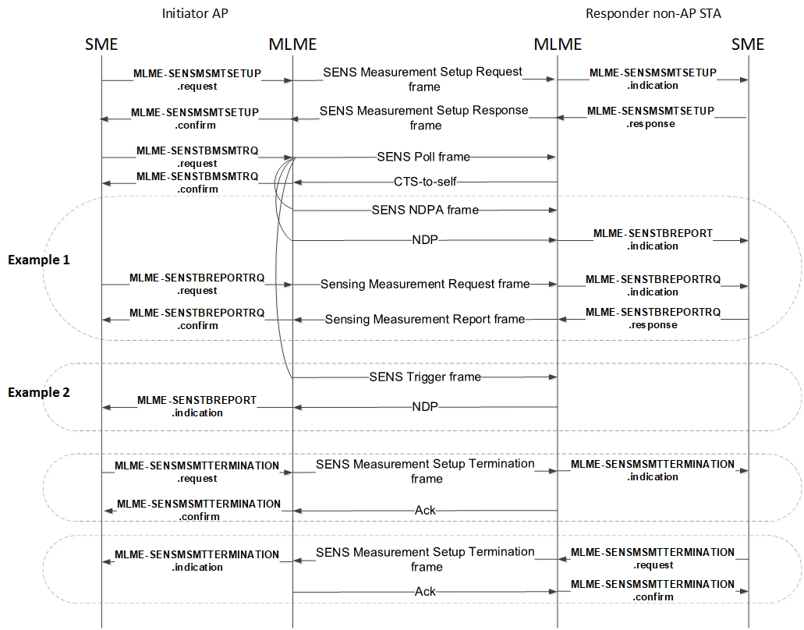
Figure 6-28a: WLAN sensing procedure, TB measurement instance.

Discussion: Primitives below are for sensing measurement setup

6.3.127.2 MLME-SENSMSMTSETUP.request
6.3.127.2.1 Function
This primitive requests the transmission of a Sensing Measurement Setup Request frame to a peer STA.

6.3.127.2.2 Semantics of the service primitive
The primitive parameters are as follows:
MLME-SENSMSMTSETUP.request ( TBD )

6.3.127.2.3 When generated
This primitive is generated by the SME to request that a Sensing Measurement Setup Request frame be sent to a peer STA to setup sensing measurement instance(s).

6.3.127.2.4 Effect of receipt
On receipt of this primitive, the MLME constructs a Sensing Measurement Setup Request frame and causes it to be transmitted to the peer MAC address.

6.3.127.3 MLME-SENSMSMTSETUP.indication
6.3.127.3.1 Function
This primitive indicates that a Sensing Measurement Setup Request frame has been received requesting the setup of sensing measurement instance(s).

6.3.127.3.2 Semantics of the service primitive
The primitive parameters are as follows:
MLME-SENSMSMTSETUP.indication ( TBD )

6.3.127.3.3 When generated
This primitive is generated by the MLME when a Sensing Measurement Setup Request frame is received.

6.3.127.3.4 Effect of receipt
On receipt of this primitive, the SME should operate according to the procedure in (Clause 11) and either accept or reject the sensing measurement setup request.

6.3.127.4 MLME-SENSMSMTSETUP.response
6.3.127.4.1 Function
This primitive is generated in response to a MLME-SENSMSMTSETUP.indication and requests the transmission of a Sensing Measurement Setup Response frame.

6.3.127.4.2 Semantics of the service primitive
The primitive parameters are as follows:
MLME-SENSMSMTSETUP.response ( TBD )

6.3.127.4.3 When generated
This primitive is generated by the SME to request that a Sensing Measurement Setup Response frame be sent to a peer STA to either accept or reject a sensing measurement setup request.

6.3.127.4.4 Effect of receipt
On receipt of this primitive, the MLME constructs a Sensing Measurement Setup Response frame
and causes it to be transmitted to the peer MAC address.

6.3.127.5 MLME-SENSMSMTSETUP.confirm
6.3.127.5.1 Function
This primitive reports the results of a request to setup sensing measurement instance(s).

6.3.127.5.2 Semantics of the service primitive
The primitive parameters are as follows:
MLME-SENSMSMTSETUP.confirm ( TBD )

6.3.127.5.3 When generated
This primitive is generated by the MLME when the STA receives a Sensing Measurement Setup Response frame.

6.3.127.5.4 Effect of receipt
On receipt of this primitive, the SME should operate according to the procedure in (Clause 11).

Discussion: Primitives below are for sensing measurement setup termination

6.3.127.6 MLME-SENSMSMTTERMINATION.request
6.3.127.6.1 Function
This primitive requests the transmission of a Sensing Measurement Setup Termination frame to a peer STA.

6.3.127.6.2 Semantics of the service primitive
The primitive parameters are as follows:
MLME-SENSMSMTTERMINATION.request ( TBD )

6.3.127.6.3 When generated
This primitive is generated by the SME to request that a Sensing Measurement Setup Termination frame be sent to a peer STA to terminate a sensing measurement setup.

6.3.127.6.4 Effect of receipt
On receipt of this primitive, the MLME constructs a Sensing Measurement Setup Termination frame and causes it to be transmitted to the peer MAC address.

6.3.127.7 MLME-SENSMSMTTERMINATION.indication
6.3.127.7.1 Function
This primitive indicates that a Sensing Measurement Setup Termination frame has been received requesting the termination of a sensing measurement setup, and the corresponding Ack frame has been transmitted.

6.3.127.7.2 Semantics of the service primitive
The primitive parameters are as follows:
MLME-SENSMSMTTERMINATION.indication ( TBD )

6.3.127.7.3 When generated
This primitive is generated by the MLME when a Sensing Measurement Setup Termination frame is received.

6.3.127.7.4 Effect of receipt
On receipt of this primitive, the SME should operate according to the procedure in (Clause 11).

6.3.127.8 MLME-SENSMSMTTERMINATION.confirm
6.3.127.8.1 Function
This primitive confirms that a Sensing Measurement Setup Termination frame has been received by the peer STA to which it was sent.

6.3.127.8.2 Semantics of the service primitive
The primitive parameters are as follows:
MLME-SENSMSMTTERMINATION.confirm ( TBD )

6.3.127.8.3 When generated
This primitive is generated by the MLME when an Ack frame corresponding to the Sensing Measurement Setup Termination frame is received from the peer STA.

6.3.127.8.4 Effect of receipt
On receipt of this primitive, the SME uses the information contained within the notification.

Discussion: Primitives below are for sensing TB sensing measurement instance request

6.3.127.9 MLME-SENSTBMSMTRQ.request
6.3.127.9.1 Function
This primitive is used by the SME of an AP STA to request a TB sensing measurement instance to be performed with one or more non-AP STAs as defined in (Clause 11).

6.3.127.9.2 Semantics of the service primitive
The primitive parameters are as follows:
MLME-SENSTBMSMTRQ.request ( TBD )

6.3.127.9.3 When generated
This primitive is generated by the SME of an AP STA to request a TB sensing measurement instance to be performed with one or more non-AP STAs.

6.3.127.9.4 Effect of receipt
On receipt of this primitive, the MLME constructs a Sensing Poll frame and causes it to be transmitted to the identified non-AP STA(s). As defined in (Clause 11), an NDPA sounding phase and/or a TF sounding phase are then performed with the non-AP STA(s) that respond to the Sensing Poll frame with a CTS-to-self frame.

6.3.127.10 MLME-SENSTBMSMTRQ.confirm
6.3.127.10.1 Function
This primitive confirms that a TB sensing measurement instance has been initiated.

6.3.127.10.2 Semantics of the service primitive
The primitive parameters are as follows:
MLME-SENSTBMSMTRQ.confirm ( TBD )

6.3.127.10.3 When generated
This primitive is generated by the MLME when a CTS-to-Self frame corresponding to a Sensing Poll frame is received from one or more non-AP STAs.

6.3.127.10.4 Effect of receipt
On receipt of this primitive, the SME uses the information contained within the notification.

Discussion: Primitives below are for sensing TB measurement/report

6.3.127.11 MLME-SENSTBREPORT.indication
6.3.127.11.1 Function
This primitive indicates that a WLAN Sensing measurement has been obtained.

6.3.127.11.2 Semantics of the service primitive
The primitive parameters are as follows:
MLME-SENSTBREPORT.indication ( TBD )

6.3.127.11.3 When generated
This primitive is generated by the MLME when a WLAN Sensing measurement is obtained.

6.3.127.11.4 Effect of receipt
On receipt of this primitive, the SME should operate according to the procedure in (Clause 11).

Discussion: Primitives below are for sensing measurement request/report

6.3.127.12 MLME-SENSTBREPORTRQ.request
6.3.127.12.1 Function
This primitive requests the transmission of a Sensing Measurement Request frame to a peer STA.

6.3.127.12.2 Semantics of the service primitive
The primitive parameters are as follows:
MLME-SENSTBREPORTRQ.request ( TBD )

6.3.127.12.3 When generated
This primitive is generated by the SME to request that a Sensing Measurement Request frame be sent to a peer STA to obtain a sensing measurement report.

6.3.127.12.4 Effect of receipt
On receipt of this primitive, the MLME constructs a Sensing Measurement Request frame and causes it to be transmitted.

6.3.127.13 MLME-SENSTBREPORTRQ.indication
6.3.127.13.1 Function
This primitive indicates that a Sensing Measurement Request frame has been received requesting a sensing measurement report.

6.3.127.13.2 Semantics of the service primitive
The primitive parameters are as follows:
MLME-SENSTBREPORTRQ.indication ( TBD )

6.3.127.13.3 When generated
This primitive is generated by the MLME when a Sensing Measurement Request frame is received.

6.3.127.13.4 Effect of receipt
On receipt of this primitive, the SME should operate according to the procedure in (Clause 11).

6.3.127.14 MLME-SENSTBREPORTRQ.response
6.3.127.14.1 Function
This primitive is generated in response to a MLME-SENSTBREPORTRQ.indication and requests the transmission of a Sensing Measurement Response frame.

6.3.127.14.2 Semantics of the service primitive
The primitive parameters are as follows:
MLME-SENSTBREPORTRQ.response ( TBD )

6.3.127.14.3 When generated
This primitive is generated by the SME to request that a Sensing Measurement Response frame be sent to a peer STA with a sensing measurement report.

6.3.127.14.4 Effect of receipt
On receipt of this primitive, the MLME constructs a Sensing Measurement Response frame and causes it to be transmitted.

6.3.127.15 MLME-SENSTBREPORTRQ.confirm
6.3.127.15.1 Function
This primitive reports the results of a request for a sensing measurement report.

6.3.127.15.2 Semantics of the service primitive
The primitive parameters are as follows:
MLME-SENSTBREPORTRQ.confirm ( TBD )

6.3.127.15.3 When generated
This primitive is generated by the MLME when the STA receives a Sensing Measurement Response frame.

6.3.127.15.4 Effect of receipt
On receipt of this primitive, the SME uses the information contained within the notification.

