IEEE P802.11
Wireless LANs
Proposed Draft Text for MLME
Date: 2022-01-28
Author(s):
Name | Affiliation | Address | Phone | email
Claudio da Silva | Meta Platforms, Inc |  |  | claudiodasilva@fb.com
Abstract
This document includes proposed draft text, which is being discussed by the TTT, that covers the broad MLME topic as defined in TGbf’s SFD.
Discussion
TGbf’s SFD defines that for TB sensing measurements:

- The sensing measurement setup procedure consists of:
- The transmission of a sensing measurement setup request frame by the sensing initiator to a sensing responder with which it intends to perform a sensing measurement setup, followed by the transmission of an Ack frame by the intended sensing responder; and
- The transmission of a sensing measurement setup response frame by the intended sensing responder to the sensing initiator which transmitted the sensing measurement setup request frame to accept or reject the sensing measurement setup, followed by the transmission of an Ack frame by the sensing initiator.

- A TB sensing measurement instance includes a polling phase, an NDPA sounding phase, and a TF sounding phase. The order of the NDPA sounding phase and of the TF sounding phase is TBD.

- In the polling phase, an AP sends a Trigger frame to check the availability of STAs. If a STA is available, it responds with a CTS-to-self.

- Examples of possible TB sensing measurement instances are shown in Figure 3. In this figure,
- How to define the sounding order, as in example 3 or as in example 4, is TBD.
- The reporting phase in example 5 may be separated from the sounding phases (TBD).
- The polling in the reporting phase in example 5 could be addressed to sensing responders other than those involved in the sounding (TBD).

- The NDPA sounding phase consists of
- The transmission of a Sensing NDP Announcement (NDPA) frame by an AP; and
- The transmission of an NDP by an AP SIFS after the transmission of the Sensing NDPA frame.

- Transmission of the Sensing Measurement Report frame is initiated by an MLME primitive.

- The TF sounding phase consists of
- The transmission of a Trigger frame by an AP to solicit NDP transmission(s) from STA(s); and
- The transmission of an NDP by STA(s) SIFS after receiving the Trigger frame.

With all of this in mind, we propose the text below to be added into sub-clause 6.3. The diagram in the next page depitcts Examples 1 and 2 of Figure 3 in the SFD (above).
Contribution

Editor - Add the following to TGbf’s D0.1:

6.3.118 WLAN sensing
6.3.118.1 General
The following MLME primitives support the signaling of the WLAN sensing procedure described in 11.X. Figure 6-1 depicts a TB sensing measurement procedure that consists of NDPA sounding (Example 1) or TF sounding (Example 2). The figure is an example of only the basic procedure and is not meant to be exhaustive of all possible uses of the protocol.

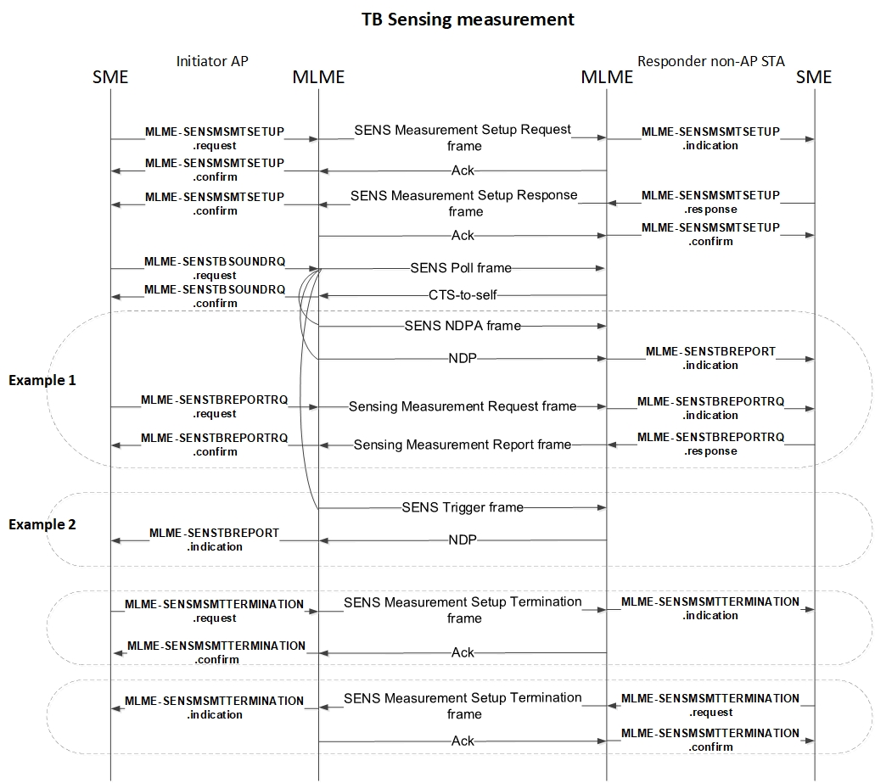
Figure 6-1: WLAN sensing procedure, TB measurement instance.

6.3.118.2 MLME-SENSMSMTSETUP (request, indication, response, confirm)

6.3.118.3 MLME-SENSTBSOUNDRQ (request, indication, confirm)

6.3.118.4 MLME-SENSTBREPORTRQ (request, indication, response, confirm)

6.3.118.5 MLME-SENSTBREPORT (indication)

6.3.118.6 MLME-SENSMSMTTERMINATION (request, indication, confirm)

6.3.119 Sensing by proxy
6.3.119.1 General
The following MLME primitives support the sensing by proxy procedure described in 11.X and depicted in Figure 6-2. The figure is an example of only the basic procedure and is not meant to be exhaustive of all possible uses of the protocol.

Figure 6-2: Sensing by proxy.

6.3.119.2 MLME-SENSSBPMSMTRQ (request, indication, response, confirm)

6.3.119.3 MLME-SENSSBPREPORT (request, indication)

6.3.119.4 MLME-SENSSBPTERMINATION (request, indication, confirm)

