IEEE P802.11
Wireless LANs
CC36 CR for UL power headroom
Date: 2022.01.27
Author(s):
Name | Company | Address | Phone | email
Mengshi Hu | Huawei Technologies | F3-6-A118, Huawei Base, Bantian, Longgang, Shenzhen, Guangdong, China, 518129 |  | humengshi@huawei.com
Ross Yu | Huawei Technologies
Ming Gan | Huawei Technologies

Revision Notes
Abstract
This submission contains proposed comment resolutions for the following 1 comment on P802.11be D1.0:

CID: 5570 (This is a defered CID in 11-21-1170-02-00be-cc36-cr-for-transmit-requirements-for-ppdus-sent-in-response-to-a-triggering-frame)

R0 | Initial revision

CID 5570
Page.  Line | Clause Number | Comment | Proposed Change | Resolution
509.19 | 36.3.16.2 | There's no the subfield in EHT TB PPDU nor the description in 35.4.2.3 about UL power headroom. Clarify or delete it. | As in comment | REVISED.  The rules related to UPH is defined in 26.5.2.4. In 35.4.2.3 of 802.11be D1.3, the text shows that the same rules in 26.5.2.4 also apply to EHT TB PPDUs. Thus the reference can be updated accordingly.  Instructions to the editor:  Please make the changes as shown under CID 5570 in 11-22/0231r0.

A STA includes its UL power headroom in the EHT TB PPDU following the rules defined in 26.5.2.4 (A-MPDU contents in an HE TB PPDU), where the rules related to HE TB PPDUs also apply to EHT TB PPDUs. See 35.4.2.3 (Non-AP STA behaviour for UL MU operation) for details.

Discussion:
The commenter talks about the following sentence:
Compared with D1.0 (the following first figure), 11be D1.3 (the following second figure) adds the following sentence colored with green, which indicates the support of UPH in EHT (26.5.2.4).
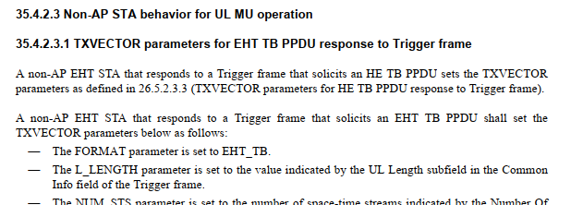
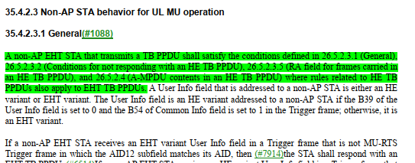

Thus, it becomes reasonable that we use the reference 35.4.2.3 now, but should notice that the rules are actually defined in 26.5.2.4.
(We can find that the UPH related information is shown in subclause 26.5.2.4, and this is indicated in 35.4.2.3.1 Genaral)
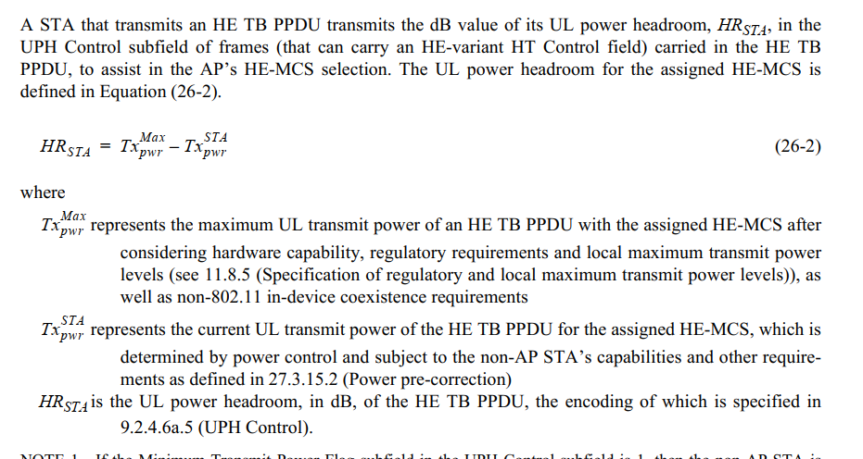
Discussion ends.

