IEEE P802.11
Wireless LANs
PhyTxRxVector CID 4643
Date: 2022-02-24
Author(s):
Name | Affiliation | Address | Phone | email
Brian Hart | Cisco Systems |  |  | brianh@cisco.com

Abstract
This submission proposes resolutions for the following comments from comment collection on P802.11be D1.0:

4643

The baseline used in this document is D1.3.

NOTE – Set the Track Changes Viewing Option in the MS Word to “All Markup” to clearly see the proposed text edits.

Revision History:

R0: Initial version.
R1: Addressed L_DATARATE and L_LENGTH
R2: Updated explanation; moved xref into a distinct row in table, added L_DATARATE to the table.

4643 | 36.2.2 | 329.24 | Since the standard is 4000+ pages long, a lot of items can only be practically found by text searching. However, text searching for the source of a TXVECTOR parameter used in clause 36 will fail because of this opaque "See also" language. | Enumerate all the parameters needed from Table 27-1 in this clause (agreed that the description can be delegated to clause 27). | Revised.  After further discussion with the commenter, something somewhat more aligned with 11meD1.0 is chosen, with changes defined in 22/0195<motionedRevision>.

Discussion

The commenter asks for all TX/RXVECTOR parameters. However, an analysis shows there are about 5-10 “leaf” parameters per PHY clause (i.e., parameters not used in dependent amendments), there are many antecendent clauses (15, 16, 17, 18, 19, 21, 27), and many of the parameters are of minimal interest to EHT (e.g., signal quality of a DSSS waveform, SQ) so including lists of these leaf parameters does indeed seem like the wrong direction, contrary to the comment.

Closely related, 11me took a streamlined approach to the TX/RXVECTOR in previous amendments, where these parameters are listed by cross reference to each of the antecedent PHY clauses. However, in 11me, the list occurs outside the actual TX/RXVECTOR table, but we shall see below that there is an even superior approach.

The following issues with the current text were identified, and some revisions are proposed below:
- The MAC needs a single TXVECTOR/RXVECTOR that enables the MAC to transmit/receive a PPDU in EHT format or any antecedent PHY format. It would be most elegant if this were a single table, and indeed historically the TX/RXVECTOR table was not intended to be limited to the clause’s own PHY format only, and we still this in important aspects, such as:
  - The table title is not limited to EHT PPDUs
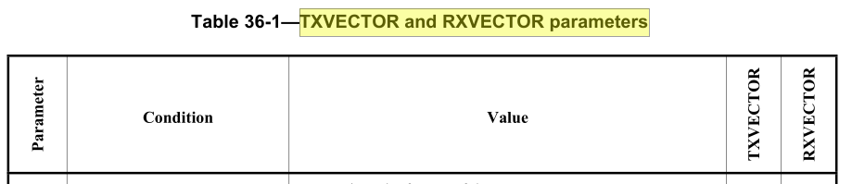
  - The table contents cannot be limited to EHT PPDUs, since the FORMAT parameter is needed to identify if an antecendent PHY clause needs to be invoked:
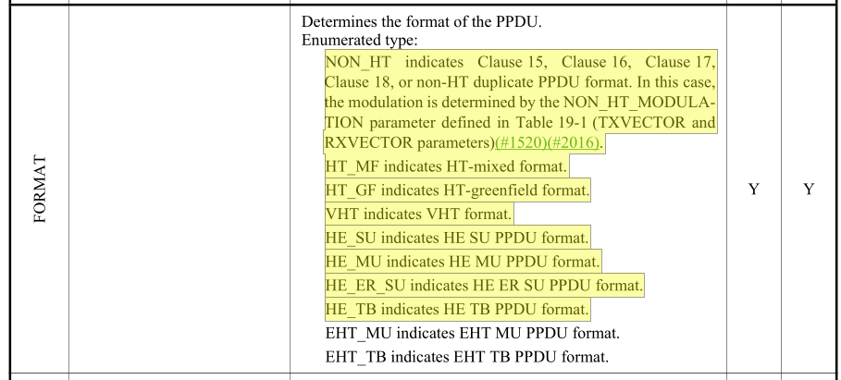
  - Many existing entries do still apply to multiple antecedent clauses
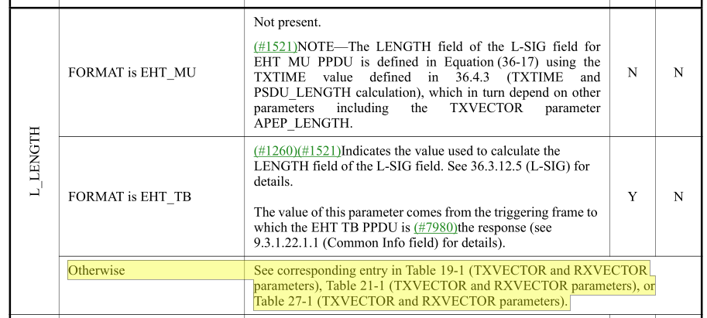

  - Thus it seems like the most natural and valuable TX/RXVECTOR table includes all the TX/RXVECTOR parameters used by the MAC, either explicitly (since they pertain to the EHT PHY clause) or by cross-reference(s) (for parameters only relevant to earlier PHYs).
- Should the cross reference(s) be to HE only (since HE is also aware of VHT/ HT / 11a/b/g?) or all antecedent PHYs?
  - BTW, the existing text contains a cross-reference to HE only, in each of two places:
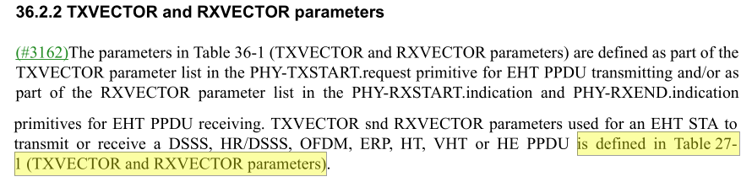
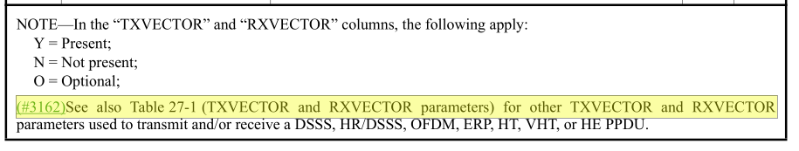
  - However, Figure 36-1 shows that the EHT PHY directly “calls” the relevant antecedent PHY (e.g. EHT HT), and doesn’t call it recursively (e.g. EHT HE VHT HT).
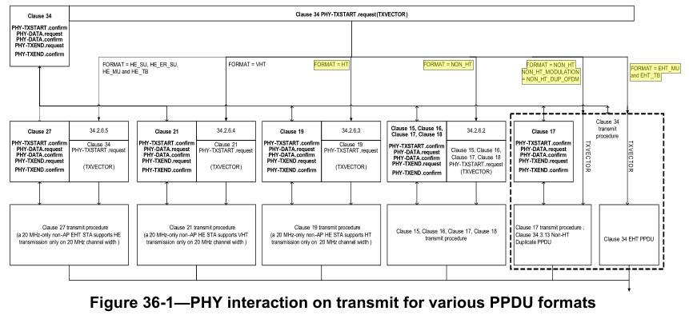
  - Then, for consistency, cross-references for all antecedent PHYs makes more sense (and also is more aligned with 11me)
- Can we use the cross references as is?
  - Actually they are not quite sufficient since, uniquely, L_LENGTH and L_DATARATE are remapped (renamed) within clause 36 to LENGTH and DATARATE respectively, for clause 15-18 PHYs
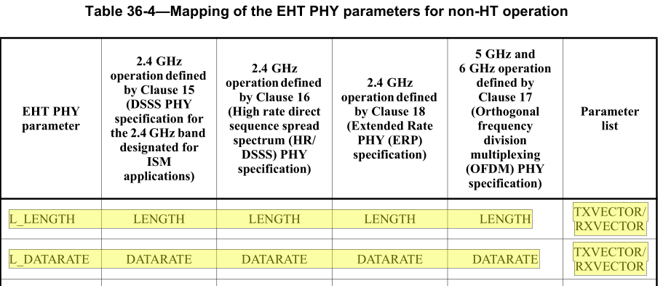
  - Thus the cross references to the earlier TX/RXVECTOR tables should account for this special case.
  - And, if we include cross-references for all antecedent PHYs, L_DATARATE can be defined in clause 36 without regard to clause 27 (and so we can remove some red text).

In summary:
- Define cross references to each antecedent PHY clause in the body of the table, so the body of the table holds (explicitly or by cross-ref) the complete list of parameters available to the MAC
- Remove the prior preamble, which is now superseded by the cross references in the body of the table
- Remove the (duplicative!) cross-references in the foot of the table, which is also now superseded by the cross references in the body of the table
- For the cross references in the body of the table, selectively excise LENGTH and DATARATE since the MAC presents L_LENGTH and L_DATARATE, and it is the PHY that remaps these internally for claises 15-18
- Add L_DATARATE explicitly to the TX/RXVECTOR to connect the dots on this remapping function.

TGbe editor: change (following Word track changes):

36.2.2 TXVECTOR and RXVECTOR parameters
(#3162)(#4643)The parameters in Table 36-1 (TXVECTOR and RXVECTOR parameters) are defined as part of the TXVECTOR parameter list in the PHY-TXSTART.request primitive for PPDU transmitting and/or as part of the RXVECTOR parameter list in the PHY-RXSTART.indication and PHY-RXEND.indication primitives for PPDU receiving.

Table 36-1—TXVECTOR and RXVECTOR parameters
TGbe editor, insert the following row immediately after the L_LENGTH row
L_DATARATE | FORMAT is NON_HT | See corresponding entry in Table 19-1 (TXVECTOR and RXVECTOR parameters) | Y | Y
 | Otherwise | Data rate signaled in LSIG field:  6 | Y | N
…
(#3162)(#4643)Further TXVECTOR and RXVECTOR parameters for transmitting or receiving a DSSS, HR/DSSS, OFDM,
ERP, HT, VHT or HE PPDU, as determined by the FORMAT and NON_HT_MODULATION parameters, are defined in:
— DSSS PPDU: Table 15-1 (TXVECTOR parameters) and Table 15-2 (RXVECTOR parameters), excepting the LENGTH and DATARATE parameters
— HR/DSSS PPDU: Table 16-5 (Parameter vectors), excepting the LENGTH and DATARATE parameters
— OFDM PPDU: Table 17-1 (TXVECTOR parameters) and Table 17-2 (RXVECTOR parameters), excepting the LENGTH and DATARATE parameters
— ERP PPDU: Table 18-1 (TXVECTOR parameters) and Table 18-3 (RXVECTOR parameters), excepting the LENGTH and DATARATE parameters
— HT PPDU: Table 19-1 (TXVECTOR and RXVECTOR parameters)
— VHT PPDU: Table 21-1 (TXVECTOR and RXVECTOR parameters)
—HE PPDU: Table 27-1 (TXVECTOR and RXVECTOR parameters)
NOTE—In the “TXVECTOR” and “RXVECTOR” columns, the following apply:
Y = Present;
N = Not present;
O = Optional;

