IEEE P802.11
Wireless LANs
PhyTxRxVector CID 4643
Date: 2022-01-25
Author(s):
Name | Affiliation | Address | Phone | email
Brian Hart | Cisco Systems |  |  | brianh@cisco.com

Abstract
This submission proposes resolutions for the following comments from comment collection on P802.11be D1.0:

4643

The baseline used in this document is D1.3.

NOTE – Set the Track Changes Viewing Option in the MS Word to “All Markup” to clearly see the proposed text edits.

Revision History:

R0: Initial version.
R1: Addressed L_DATARATE and L_LENGTH

4643 | 36.2.2 | 329.24 | Since the standard is 4000+ pages long, a lot of items can only be practically found by text searching. However, text searching for the source of a TXVECTOR parameter used in clause 36 will fail because of this opaque "See also" language. | Enumerate all the parameters needed from Table 27-1 in this clause (agreed that the description can be delegated to clause 27). | Revised.  After further discussion with the commenter, something more aligned with 11meD1.0 is chosen, with changes defined in 22/0195<motionedRevision>.

Discussion

11me took a streamlined approach to the TX/RXVECTOR in previous amendments, where these parameters are listed by cross reference to previous PHY clauses above the table.

In 11me, the list occurs outside the actual table. Here we note that the MAC needs a single TXVECTOR/RXVECTOR that enables the MAC to transmit/receive a PPDU with EHT or any antecedent PHY format. Furthermore, historically the TX/RXVECTOR table was not intended to be limited to the clause’s own PHYs only, and we still this in important aspects, such as:
- the title “TXVECTOR and RXVECTOR parameters” not “TXVECTOR and RXVECTOR parameters for EHT PPDUs”, and
- the contents such as “FORMAT … NON_HT” or “RCPI … See corresponding entry in Table 19-1 (TXVECTOR and RXVECTOR parameters), Table 21-1 (TXVECTOR and RXVECTOR parameters), or Table 27-1 (TXVECTOR and RXVECTOR parameters).” (i.e., it references all associated PHYs, not just an exemplar)
Thus the change text now lists the existence of other TX/RXVECTOR parameters within the table, via cross-reference. Related text before the table is omitted to reduce duplication (and for another reason as described below).

Closely related, Figure 36-1 shows that the EHT PHY directly “calls” the relevant antecedent PHY (e.g. EHT HT), and doesn’t call it recursively (e.g. EHT HE VHT HT), so the 11me style of providing cross-references for all antecedent PHYs, not just the most recent, is most consistent. This is a second reason to omit the related text before the table, sine that only refers back to clause 27.

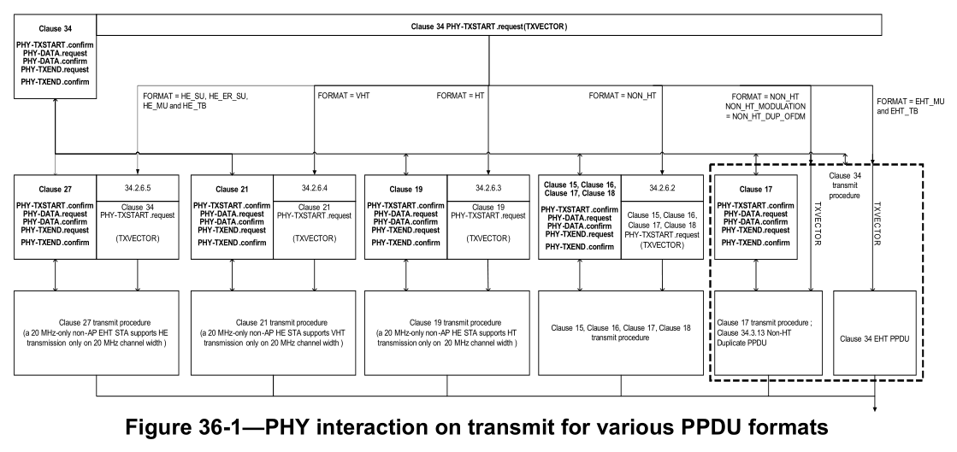
Uniquely, L_LENGTH and L_DATARATE are remapped (renamed) within clause 36 to LENGTH and DATARATE respectively, for clause 15-18 PHYs (see below), so the cross references to the earlier TX/RXVECTOR tables should account for this special case.
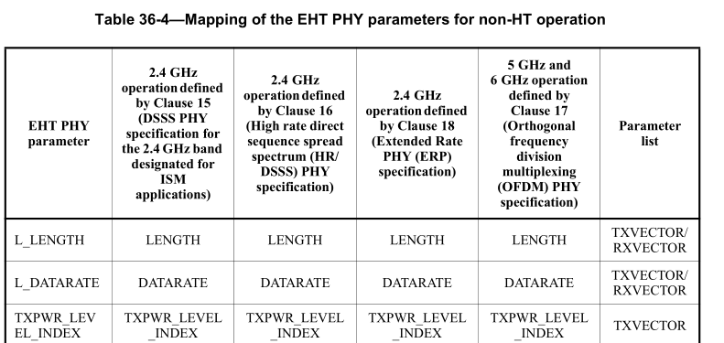

Finally, with this approach, L_DATARATE can be defined in clause 36 without regard to clause 27.

TGbe editor: change (following Word track changes):

36.2.2 TXVECTOR and RXVECTOR parameters
(#3162)(#4643)The parameters in Table 36-1 (TXVECTOR and RXVECTOR parameters) are defined as part of the TXVECTOR parameter list in the PHY-TXSTART.request primitive for PPDU transmitting and/or as part of the RXVECTOR parameter list in the PHY-RXSTART.indication and PHY-RXEND.indication primitives for PPDU receiving.

Table 36-1—TXVECTOR and RXVECTOR parameters
TGbe editor, insert the following row immediately after the L_LENGTH row
L_DATARATE | FORMAT is NON_HT | See corresponding entry in Table 19-1 (TXVECTOR and RXVECTOR parameters) | Y | Y
 | Otherwise | Data rate signaled in LSIG field:  6 | Y | N
…
NOTE—In the “TXVECTOR” and “RXVECTOR” columns, the following apply:
Y = Present;
N = Not present;
O = Optional;
(#3162)(#4643)Further TXVECTOR and RXVECTOR parameters for transmitting or receiving a DSSS, HR/DSSS, OFDM,
ERP, HT, VHT or HE PPDU, as determined by the FORMAT and NON_HT_MODULATION parameters, are defined in:
— DSSS PPDU: Table 15-1 (TXVECTOR parameters) and Table 15-2 (RXVECTOR parameters), excepting the LENGTH and DATARATE parameters
— HR/DSSS PPDU: Table 16-5 (Parameter vectors), excepting the LENGTH and DATARATE parameters
— OFDM PPDU: Table 17-1 (TXVECTOR parameters) and Table 17-2 (RXVECTOR parameters), excepting the LENGTH and DATARATE parameters
— ERP PPDU: Table 18-1 (TXVECTOR parameters) and Table 18-3 (RXVECTOR parameters), excepting the LENGTH and DATARATE parameters
— HT PPDU: Table 19-1 (TXVECTOR and RXVECTOR parameters)
— VHT PPDU: Table 21-1 (TXVECTOR and RXVECTOR parameters)
— HE PPDU: Table 27-1 (TXVECTOR and RXVECTOR parameters)

