IEEE P802.11
Wireless LANs
IEEE 802.11bf - January 2022 Interim Meeting Minutes
Date: 2021-11-15
Author(s):
Name | Affiliation | Address | Phone | email
Leif Wilhelmsson | Ericsson AB | Mobilvägen 1, 22632 Lund, Sweden | +46-706-216956 | leif.r.wilhelmsson@ericsson.com
Abstract
Rev 0: This document contains the meeting minutes of IEEE 802.11bf teleconferences held during the IEEE 802.11 Interim meeting in January 2022.
Rev 1: Typo corrected.

Tuesday, January 18, 2022, 9:00-11:00 am (ET)

Meeting Agenda:
The meeting agenda is shown below, and published in the agenda document: https://mentor.ieee.org/802.11/dcn/21/11-21-1981-01-00bf-tgbf-meeting-agenda-2022-01-interim.pptx

- Call the meeting to order
- Patent policy and logistics
- Approve TGbf meeting minutes
- TGbf Timeline
- Call for contribution
- Teleconference Times
- Presentation of submissions
- Any other business?
- Recess

- The chair, Tony Xiao Han, calls the meeting to order at 9:00am (about 120 persons are on the call after 10 minutes of the meeting).

- The chair goes through “Meeting Protocol, Attendance, Voting &Documentation Status” (slide 4), “Registration for the January 802 electronic Interim session” (slide 5), “Participants have a duty to inform the IEEE” (slide 7), and “Ways to inform IEEE” (slide 8).

The chair makes a Call for Potentially Essential Patents. No potentially essential patents reported, and no questions asked.

The chair goes through “Other Guideline for IEEE WG meetings” (slide 9), “Patent related information” (slide 10), “ IEEE SA Copyright Policy” (slides 11 and 12), “Participant behavior in IEEE-SA activities is guided by the IEEE Codes of Ethics & Conduct” (slide 13), “Participants in the IEEE-SA “individual process” shall act independently of others, including employers”(slide 14), and “IEEE-SA standards activities shall allow the fair & equitable consideration of all viewpoints” (slide 15), and “Required notices” (slide 16).

The chair goes through the agenda (slide 17) and asks if there are any questions or comments on the agenda. No response from the group.

The chair asks if there is any objection to approve the agenda by unanimous consent. No objection from the group so the agenda is approved.

- Motion: Approve TGbf meeting minutes:

Move to approve TGbf minutes of meetings and teleconferences from November 2021 meeting to today:
  - November Plenary: https://mentor.ieee.org/802.11/dcn/21/11-21-1889-01-00bf-ieee-802-11bf-november-2021-plenary-meeting-minutes.docx
  - Teleconferences November - January: https://mentor.ieee.org/802.11/dcn/21/11-21-1948-13-00bf-ieee-802-11bf-teleconference-minutes-november-2021-january-2022.docx

Move: Leif Wilhelmsson
Second: Sang Kim

Result: Motion passed by unanimous consent.

- The Chair presents the TGbf Timeline (slide 19 and slide 20).
The Timeline has been slightly updated (LB4.0 has been added). In addition, a detailed (tentative) Timeline for D0.1 has been added. The timeline for D0.1 is presented in detail by Claudio.

Q: Can also non-voting members make comments?
A: Yes.

Q: Is the deadline on the 21 of January for uploading or for having confirmed the contents with the TTT members.
A: For uploading. The intention is to make sure work has started. Of course, the more contents the better, but it is up to the POC.

After some discussion in the group, the deadline is moved from 21st to 28th of January.

- The Chair presents slide 21, Call for contributions. Unchanged.
- The Chair presents the teleconference times, (slide 22).
- Presentation of submissions:

11-22/0036r3, “WLAN Sensing Functionality Indicator”, Rui Du (Huawei):

Q: How is the PHY behavior changed when it receives the indication? Basically, do we need it?
A: I believe the processing is different and therefore we believe it is needed.

Straw Poll 1: Do you support to add the following to 11bf SFD:

- Sensing functionality shall be explicitly indicated in L-Header/DMG Header.

Result: Y/N/A: 30/8/48

Straw Poll 2: Do you support to add the following to 11bf SFD:

- Use the reserved bits in Scrambler Initialization field in L-Header/DMG Header in control mode to indicate the sensing functionality (as shown in slide 8).

Result: Y/N/A: 20/18/44

Straw Poll 3:

- Which option in L-Header/DMG Header (as shown in slide 8) in SC/OFDM mode do you support for the sensing functionality indication?

Result: Option 1 (B47)/Option 2 (reserved bits in Last RSSI field)/Neither/Abstain: 8/7/18/50

11-22/0002r0, “DMG Passive Sensing”, Assaf Kasher (Qualcomm): Motivation slide 3

Q: The application of this is for non-AP STAs?
A: Yes.

Q: Is this for associated or non-associated STAs?
A: It is easier if the STA is associated, but I don’t think it rules out STAs that are not associated.
Based on a question from the group the SP is updated so that the word “may” is added. Sensing information may include:

Straw Poll: Do you agree to add to the SFD:

- DMG passive sensing is enabled by
  - capability bit in the beacon
  - Sensing information request and response that will provide information about the beacon
  - Sensing information may include:
    - azimuth and elevation for each sector id (of beacons)
    - location information of the PCP/AP

Result: Y/N/A: 34/6/46

11-21/2023r0, “DMG Multi-Static Procedure Instance”, Assaf Kasher (Qualcomm):

Straw Poll: Do you agree to add to the SFD the following text:

- A multi-static EDMG sensing measurement instance has the following parts:
  - An instance request frame (frame type TBD) sent to each STA sequentially, and each STA responds to it.
  - A multi-static EDMG sensing PPDU. The format of the EDMG sensing PPDU is undefined.
  - A feedback part in which the initiator polls each responding STA for a report and the responders respond with a report.

Result: Y/N/A: 27/5/39

11-22/0040r1, “DMG use of multiple Golay sequences”, Assaf Kasher (Qualcomm):

Run out of time.

- The Chair asks if there is any other business. No response from the group.

- The meeting is recessed without objection at 10.55 am (ET).

Wednesday, January 19, 2022, 9:00-11:00 am (ET)

Meeting Agenda:
The meeting agenda is shown below, and published in the agenda document: https://mentor.ieee.org/802.11/dcn/21/11-21-1981-02-00bf-tgbf-meeting-agenda-2022-01-interim.pptx

- Call the meeting to order
- Patent policy and logistics
- TGbf Timeline
- Call for contribution
- Teleconference Times
- Presentation of submissions
- Any other business?
- Recess

- The chair, Tony Xiao Han, calls the meeting to order at 9:00am (about 60 persons are on the call after 10 minutes of the meeting).

- The chair goes through “Meeting Protocol, Attendance, Voting &Documentation Status” (slide 4), “Registration for the January 802 electronic Interim session” (slide 5), “Participants have a duty to inform the IEEE” (slide 7), and “Ways to inform IEEE” (slide 8).

The chair makes a Call for Potentially Essential Patents. No potentially essential patents reported, and no questions asked.

The chair goes through “Other Guideline for IEEE WG meetings” (slide 9), “Patent related information” (slide 10), “ IEEE SA Copyright Policy” (slides 11 and 12), “Participant behavior in IEEE-SA activities is guided by the IEEE Codes of Ethics & Conduct” (slide 13), “Participants in the IEEE-SA “individual process” shall act independently of others, including employers”(slide 14), and “IEEE-SA standards activities shall allow the fair & equitable consideration of all viewpoints” (slide 15), and “Required notices” (slide 16).

The chair goes through the agenda (slide 19) and asks if there are any questions or comments on the agenda. Chaoming requests his presentation to be deferred to the next session.

The chair asks if there is any objection to approve the agenda by unanimous consent. No objection from the group so the agenda is approved.

- The Chair presents the TGbf Timeline (slide 20 and slide 21).
The Timeline has been slightly updated (LB4.0 has been added). In addition, a detailed (tentative) Timeline for D0.1 has been added. The timeline for D0.1 is presented in detail by Claudio.

Q: Can also non-voting members make comments?
A: Yes.

Q: Is the deadline on the 21 of January for uploading or for having confirmed the contents with the TTT members.
A: For uploading. The intention is to make sure work has started. Of course, the more contents the better, but it is up to the POC.

After some discussion in the group, the deadline is moved from 21st to 28th of January.

- The Chair presents slide 22, Call for contributions. Unchanged.
- The Chair presents the teleconference times, (slide 23).
- Presentation of submissions:

11-22/0040r1, “DMG use of multiple Golay sequences”, Assaf Kasher (Qualcomm):
This is a continuation of what was presented in the previous session.

Straw Poll: Do you agree to add to the SFD:

- “DMG bi-static and multi-static sensing may optionally use groups of the 8 (128×N_{CB}) Golay sequences in bi-static and multi-static sensing.
  - the sequences are the Golay sequences defined in EDMG (Ga and Gb in Table 28-75 in P802.11-2020)
  - The order of the sequences in the group is TBD”

The Straw Poll is deferred.

11-21/1865r1, “DMG Multi-Static PPDU structure”, Assaf Kasher (Qualcomm):

Straw Poll 1: Do you agree to add to the SFD the following text:

- A multi-static EDMG sensing measurement instance has the following parts:
  - A measurement setup/trigger frame sent to each STA, each STA responds with an ACK.
  - A multi-static EDMG sensing PPDU
  - A feedback part in which the initiator polls each responding STA for feedback.

Result: Y/N/A: 10/5/20

Straw Pol1 2 is deferred.

11-21/0031r0, “DMG sensing procedure part two”, Solomon Trainin (Qualcomm):
Overview

Q: It seems to me the response time is very stringent which have some implementation impact.
A: There is a mechanism allowing for reporting at a later time, since there is an ID which indicates when the measurement was done.

Straw Poll: Do you agree to append the text to the SFD?

The text of the referred documents is not part of the submitted text.

Result: Y/N/A: 12/7/16

11-22/0038r1, “WLAN Sensing Use Cases”, Oscar Au (Origin Wireless):

Run out of time. Will allocate some time in the next session.

- The Chair asks if there is any other business. No response from the group.

- The meeting is recessed without objection at 11.00 am (ET).

Friday, January 21, 2022, 9:00-11:00 am (ET)

Meeting Agenda:
The meeting agenda is shown below, and published in the agenda document: https://mentor.ieee.org/802.11/dcn/21/11-21-1981-03-00bf-tgbf-meeting-agenda-2022-01-interim.pptx

- Call the meeting to order
- Patent policy and logistics
- TGbf Timeline
- Call for contribution
- Teleconference Times
- Motion (51-59)
- Presentation of submissions
- Any other business?
- Recess

- The chair, Tony Xiao Han, calls the meeting to order at 9:00am (about 110 persons are on the call after 10 minutes of the meeting).

- The chair goes through “Meeting Protocol, Attendance, Voting &Documentation Status” (slide 4), “Registration for the January 802 electronic Interim session” (slide 5), “Participants have a duty to inform the IEEE” (slide 7), and “Ways to inform IEEE” (slide 8).

The chair makes a Call for Potentially Essential Patents. No potentially essential patents reported, and no questions asked.

The chair goes through “Other Guideline for IEEE WG meetings” (slide 9), “Patent related information” (slide 10), “ IEEE SA Copyright Policy” (slides 11 and 12), “Participant behavior in IEEE-SA activities is guided by the IEEE Codes of Ethics & Conduct” (slide 13), “Participants in the IEEE-SA “individual process” shall act independently of others, including employers”(slide 14), and “IEEE-SA standards activities shall allow the fair & equitable consideration of all viewpoints” (slide 15), and “Required notices” (slide 16).

The chair goes through the agenda (slide 20) and asks if there are any questions or comments on the agenda. Pei asks that his presentation is deferred.

The chair asks if there is any objection to approve the agenda by unanimous consent. No objection from the group so the agenda is approved.

- The Chair presents the TGbf Timeline (slide 21 and slide 22).
- The Chair presents slide 23, Call for contributions. Unchanged.
- The Chair presents the teleconference times, (slide 24).
- Presentation of submissions:

11-22/0038r2, “WLAN Sensing Use Cases”, Oscar Au (Origin Wireless):
This presentation was finalized in the last session, but there was no time for Q&A. The contribution has been updated to revision 2, in which the SPs have been slightly updated.

Q: Basically, it seems you want use cases where the report is not sent back?
A: Yes.

Q: I believe Case 4 is already supported.

Based on feedback from the group SP1 is updated as follows:
Straw Poll 1:

Do you agree that for the case when the sensing initiator is the sensing transmitter, the reporting phase is optional?

Result: Y/N/A: 43/2/21

- Motions

Motion 51: Move to add the following to the TGbf SFD:

- The sensing measurement setup procedure consists of
- the transmission of a sensing measurement setup request frame by the sensing initiator followed by the transmission of an Ack frame by the intended sensing responder; and
- the transmission of a sensing measurement setup response frame by the intended sensing responder followed by the transmission of an Ack frame by the sensing initiator.

Move: Chaoming Luo
Second: Pei Zhou
Result: Motion passed by unanimous consent.

Note：
- * Amended result accounts for removal of X votes of non-voting members.
- Related document 21/ 1828r4
- SP Result: 20Y/ 1N/ 15A

Motion 52: Move to add the following to the TGbf SFD:

- In a sensing measurement setup procedure, if the sensing responder intends to reject the assigned operational parameters included in the sensing measurement setup request frame, it may provide its preferred operational parameters in the sensing measurement setup response frame.
- For the accept case, whether the responder may provide its preferred operational parameters or not is TBD.

Move: Chaoming Luo
Second: Insun Jang
Preliminary Result: Y/N/A: 34/2/19 (There is a request for a recorded vote)
Result*:
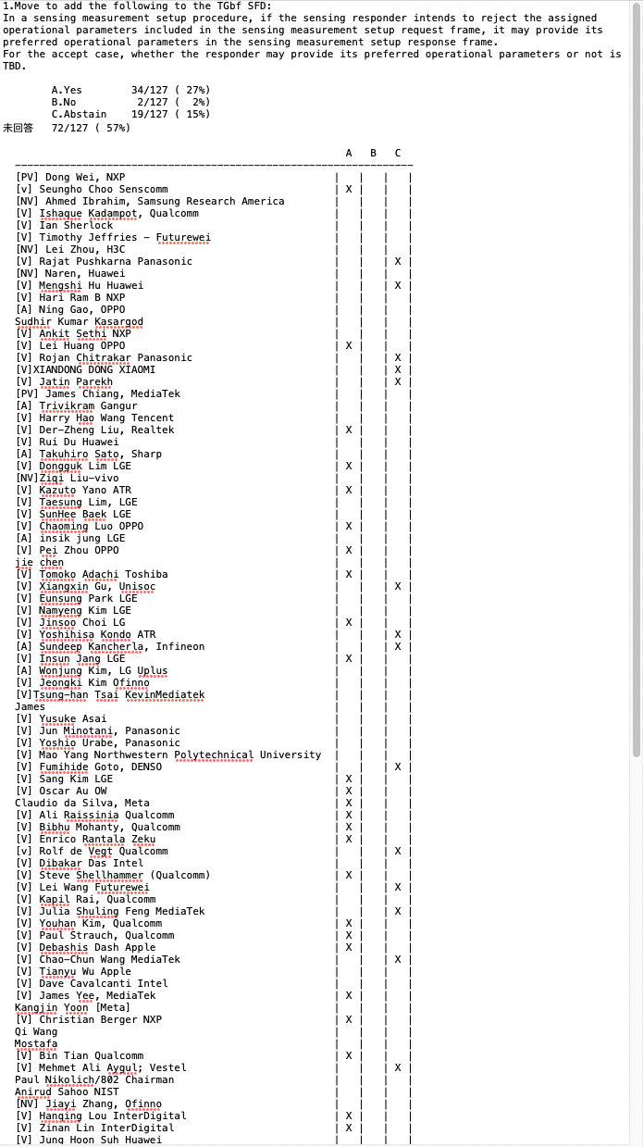
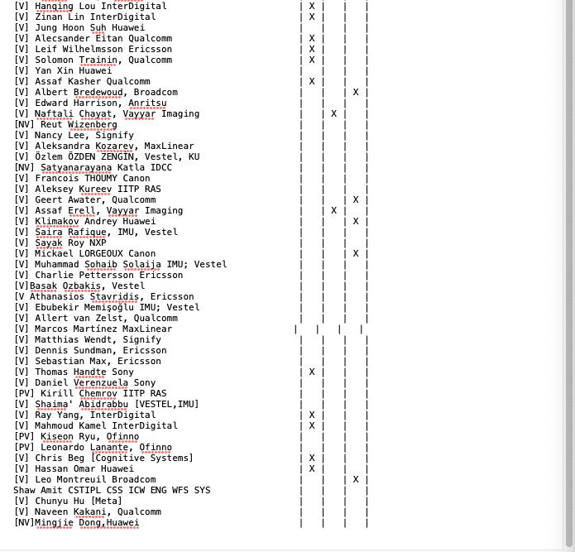

Note：
- * Amended result accounts for removal of X votes of non-voting members.
- Related document 21/ 1828r4
- SP Result: 14Y/ 6N/ 14A

Motion 53: Move to add the following to the TGbf SFD:

- 11bf shall define both public and protected action frames, which include sensing measurement setup request/response, sensing measurement report, sensing measurement setup termination, and SBP request/response frames.
- Note: Other public and protected action frames for sensing are TBD.

Motion Deferred

Motion 54: Move to add the following to the TGbf SFD:

- Measurement Setup ID is set by Sensing Initiator, the tuple <Sensing Initiator’s MAC address, Measurement Setup ID> is used to identify a specific Measurement Setup.
- How the SBP Requesting STA identifies the sensing measurement setup ID is TBD.

Move: Pei Zhou
Second: Chaoming Luo
Preliminary Result: Y/N/A: 28/3/26
Result*:

Note：
- * Amended result accounts for removal of X votes of non-voting members.
- Related document 21/ 1941r1
- SP Result: 20Y/ 4N/ 16A

Motion 55:

- Move to append the text on page 2 and the figures of the 11-21-2015-04-00bf-DMG-Sensing-procedure to the SFD

Move: Solomon Trainin
Second: Alecsander Eitan
Result: Motion passed by unanimous consent.

Note：
- * Amended result accounts for removal of X votes of non-voting members.
- Related document 21/ 2015r3
- SP Result: 18Y/ 4N/ 18A

Motion 56:

- Move to append the text of the “11-22-0031-00-00bf-DMG Sensing procedure part two” to the SFD
- The text does not include the references

Move: Solomon Trainin
Second: Assaf Kasher
Result: Motion passed by unanimous consent.

Note：
- * Amended result accounts for removal of X votes of non-voting members.
- Related document 22/ 0031r0
- SP Result: Y/ N/ A

Motion 57: Move to add the following to the TGbf SFD:

- DMG passive sensing is enabled by
• A capability bit in the beacon
• Sensing information request and response that will provide information about the beacon
• Sensing information may include:
a. azimuth and elevation for each sector id (of beacons)
b. location information of the PCP/AP

Move: Assaf Kasher
Second: Solomon Trainin
Result: Motion passed by unanimous consent.

Note：
- * Amended result accounts for removal of X votes of non-voting members.
- Related document 22/ XXXX r0
- SP Result: Y/ N/ A

Motion 58: Move to add the following to the TGbf SFD:

- A multi-static EDMG sensing measurement instance has the following parts:
• An instance request frame (frame type TBD) sent to each STA sequentially, and each STA responds to it.
• A multi-static EDMG sensing PPDU. The format of the EDMG sensing PPDU is undefined.
• A feedback part in which the initiator polls each responding STA for a report and the responders respond with a report.

Move: Assaf Kasher
Second: Solomon Trainin
Result: Motion passed by unanimous consent.

Note：
- * Amended result accounts for removal of X votes of non-voting members.
- Related document 22/ XXXX r0
- SP Result: Y/ N/ A

Motion 59: Move to add the following to the TGbf SFD:

A multi-static EDMG sensing PPDU is an EDMG BRP-RX, BRP-TX, BRP-RX/TX PPDU with an addition of sync fields between the data and the TRN field

Move: Assaf Kasher
Second: Alecsander Eitan
Result: Motion passed by unanimous consent.

Note：
- * Amended result accounts for removal of X votes of non-voting members.
- Related document 22/ XXXX r0
- SP Result: Y/ N/ A

- The Chair asks if there is any other business. No response from the group.

- The meeting is recessed without objection at 10. 57am (ET).
Monday, January 24, 2022, 9:00-11:00 am (ET)

Meeting Agenda:
The meeting agenda is shown below, and published in the agenda document: https://mentor.ieee.org/802.11/dcn/21/11-21-1981-04-00bf-tgbf-meeting-agenda-2022-01-interim.pptx

- Call the meeting to order
- Patent policy and logistics
- TGbf Timeline
- Call for contribution
- Teleconference Times
- Motion (60-XX)
- Presentation of submissions
- Any other business
- Adjourn

- The chair, Tony Xiao Han, calls the meeting to order at 9:00am (about 60 persons are on the call after 10 minutes of the meeting).

- The chair goes through “Meeting Protocol, Attendance, Voting &Documentation Status” (slide 4), “Registration for the January 802 electronic Interim session” (slide 5), “Participants have a duty to inform the IEEE” (slide 7), and “Ways to inform IEEE” (slide 8).

The chair makes a Call for Potentially Essential Patents. No potentially essential patents reported, and no questions asked.

The chair goes through “Other Guideline for IEEE WG meetings” (slide 9), “Patent related information” (slide 10), “ IEEE SA Copyright Policy” (slides 11 and 12), “Participant behavior in IEEE-SA activities is guided by the IEEE Codes of Ethics & Conduct” (slide 13), “Participants in the IEEE-SA “individual process” shall act independently of others, including employers”(slide 14), and “IEEE-SA standards activities shall allow the fair & equitable consideration of all viewpoints” (slide 15), and “Required notices” (slide 16).

The chair goes through the agenda (slide 21) and asks if there are any questions or comments on the agenda. Pei asks that his presentation is deferred.

The chair asks if there is any objection to approve the agenda by unanimous consent. No objection from the group so the agenda is approved.

- The Chair presents the TGbf Timeline (slide 22 and slide 23).
- The Chair presents slide 24, Call for contributions.
- The Chair presents the teleconference times, (slide 25).
- Presentation of submissions:

11-21/1934r3, “Discussion on Session Setup”, Chaoming Luo (OPPO):
The contribution is concerned with the details of the setup procedure and frame formats.

All Straw Polls are deferred after some discussion in the group.

- Motion:

Motion 60: Move to add the following to the TGbf SFD:
  - For the case when the sensing initiator is the sensing transmitter, the reporting of sensing measurement results to the sensing initiator is optional.

Move: Oscar Au
Second: Claudio Da Silva
Result: Motion passed by unanimous consent.

Note：
- * Amended result accounts for removal of X votes of non-voting members.
- Related document 22/ 0038 r2
- SP Result: 43Y/ 2N/ 21A

Presentations:

11-21/r1910r2, “Measurement Instance Sharing”, Oscar Au (Origin Wireless):
The contribution is concerned with means to reduce the total amount of measurement instances.

The Straw Polls are deferred.

11-22/r0099r0, “WLAN Sensing Privacy Use Cases”, Oscar Au (Origin Wireless):
The contribution is concerned with privacy protection.

The Straw Poll is deferred.

- The Chair asks if there is any other business. Claudio explains that he soon will have incorporated the motions.

- The meeting is adjourned without objection at 10.59am (ET).

