IEEE P802.11
Wireless LANs
CC36 CR for Nominal Packet Padding Values Part 2
Date: 2022.01.26
Author(s):
Name | Company | Address | Phone | email
Mengshi Hu | Huawei Technologies | F3-6-A118, Huawei Base, Bantian, Longgang, Shenzhen, Guangdong, China, 518129 |  | humengshi@huawei.com
Ross Yu
Ming Gan
Edward Au
Abstract
This submission contains proposed resolutions for the following 11 comments on P802.11be D1.0.

CIDs: 6184, 7734, 7735, 7737, 7738, 7940, 7942, 7943, 7944, 7945, 7946

Revision Notes
R0 | Initial revision

CID 6814
Page.  Line | Clause Number | Comment | Proposed Change | Resolution
303.34 | 35.9 | In Table 35-4, add "NOTE 5" to also cover the rules for RU/MRU of size < 242 tones as described on P304 L1-8 | Add following note to table 35-4:  "NOTE 5 - The nominal packet padding value is 0 us for an RU or MRU of size smaller than 242 tones, if 4096-QAM is not used for the RU or MRU, or if the RU size is 106 or the MRU size is 106+26 and EHT-MCS 15 is not applied to the RU or MRU. The nominal packet padding value for an RU or MRU of size smaller than 242 tones with 4096-QAM modulation is the same as the corresponding value for the 242-tone RU with the same modulation and Nss. The nominal packet padding value for a 106-tone RU or 106+26 tone MRU encoded with EHT-MCS 15 is the same as that for the 242-tone RU with BPSK modulation and Nss=1." | REJECTED.  All of the notes in that table are used to describe the nominal packet padding as a function of the PPE Thresholds, the number of spatial streams and the RU allocation index.  For the RU or MRU of size smaller than 242 tones, the rules of those RUs or MRUs are not closely related to the function. Actually, the small size RU or MRU dose not refer to a size in the RU allocation index table.  In addition, NOTE 5 is the same as the paragraph shown near the table. No need to add it again.

Discussion:
In Draft 1.3 Page 421
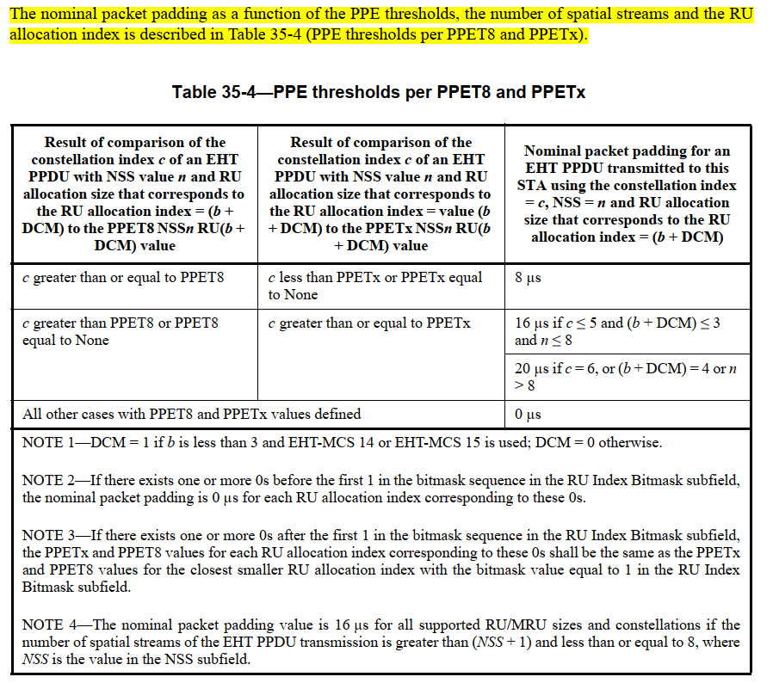

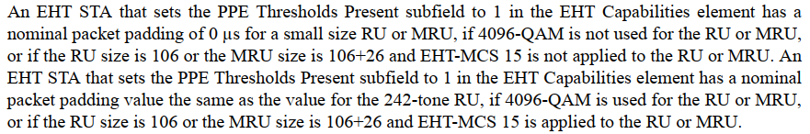
Discussio ends.

CID 7734
Page.  Line | Clause Number | Comment | Proposed Change | Resolution
302.65 | 35.9 | "If EHT-MCS 14 or EHT-MCS 15 is applied to an RU or MRU indicated by the RU allocation index equal to 3  or 4, then the nominal packet padding value for the same RU or MRU is used. If DCM is considered, the RU allocation indices (b + DCM) for the 80 MHz, 160 MHz, and 320 MHz PPDUs using EHT-MCS 14 are equal to 3, 3, and 4, respectively" confusing and partially duplicated | If EHT-MCS 15 is applied to an RU or MRU indicated by the RU allocation index equal to 3 or 4, then the nominal packet padding value for the same RU or MRU is used. If EHT-MCS 14 is applied, the RU allocation indices (b + DCM) for the 80 MHz, 160 MHz, and 320 MHz PPDUs are equal to 3, 3, and 4, respectively | ACCEPTED  Note to the EDITOR: The place is Page 421, L48 in D1.3.
Discussion:
Agree with the commenter that the second sentence colored with yellow contains the EHT-MCS-14 in the first sentence. Thus, it is fine to separate them.

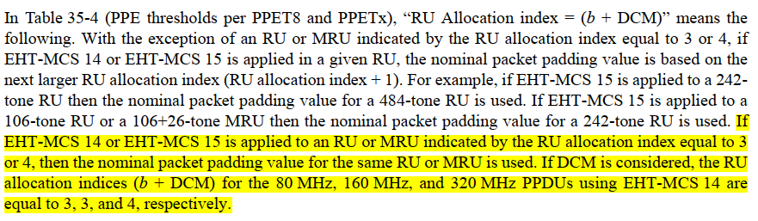
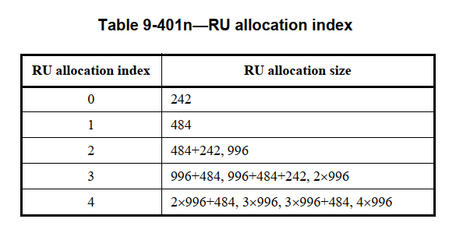
Discussion ends.

CID 7735
Page.  Line | Clause Number | Comment | Proposed Change | Resolution
300.1 | 35.9 | suggest to reorgnize 35.9 as follow: 1) from P.L. 300.10 to 300.56: PPET not present in both EHT and HE; 2) From P.L. 300.57 to P.L.301.33: PPET not present in EHT but present in HE; 3) From P.L. 302.34 to P.L.304.9 PPET present in EHT. | as commented | REVISED  This will make the structure clearer.  Instructions to the editor:  Please make the changes as shown under CID 7735 in 11-22/0183r1.
Discussion:
The last three paragraphs of 35.12 in 802.11be D1.3:
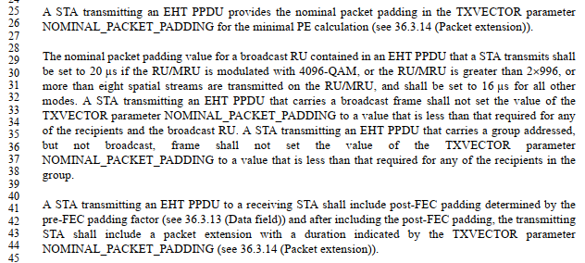
Discusson ends.

Instructions to the editor, please add the following subclause for the paragraphs from P418, L3 to P419, L28 in P802.11be D1.3:

35.12.1 General
An EHT STA with dot11EHTPPEThresholdsRequired set to false may set the PPE Thresholds Present subfield in the EHT Capabilities element that it transmits to 0.

An EHT STA with dot11EHTPPETThresholdsRequired set to true shall set the PPE Thresholds Present subfield in the EHT Capabilities element that it transmits to 1

35.12.2 PPET not present in both HE and EHT
An EHT STA that sets the PPE Thresholds Present subfield to 0 in both the EHT and HE Capabilities elements …

Instructions to the editor, please add the following subclause for the paragraphs from P419, L29 to P420, L32 in P802.11be D1.3:
35.12.3 PPET not present in EHT but present in HE
An EHT STA that sets the PPE Thresholds Present subfield to 0 in the EHT Capabilities element, and sets it to 1 in the HE Capabilities element …

Instructions to the editor, please add the following subclause for the paragraphs from P420, L33 to P422, L24 in P802.11be D1.3:
35.12.4 PPE Thresholds present in EHT
An EHT STA that sets the PPE Thresholds Present subfield to 1 in the EHT Capabilities element …

Instructions to the editor, please add the following subclause for the paragraphs from P420, L25 to the end of subclause 35.12 in P802.11be D1.3:
35.12.5 STA behavior related to nominal packet padding
…

CID 7737
Page.  Line | Clause Number | Comment | Proposed Change | Resolution
300.13 | 35.9 | "for all constellations, NSS and large size RU allocations that  it supports." NSS should be Nss. Same for the next paragraph | as commented | REJECTED  In 802.11ax-2021, NSS is also used in the same paragraph. Here the NSS means “Number of Spatial Stream”. Using the “NSS” here is also clear and reasonable.

Discussion:
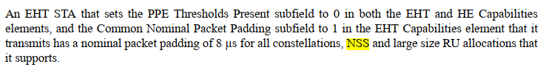
Discussion ends.

CID 7738
Page.  Line | Clause Number | Comment | Proposed Change | Resolution
300.45 | 35.9 | " In the case of the Common Nominal Packet Padding subfield set to 3, the nominal packet padding of  20 µs is used for the small size RU/MRU modulated with 4096-QAM, and the nominal packet padding of  16 µs is used if the RU size is 106 or the MRU size is 106+26 and EHT-MCS 15 is applied to the RU or  MRU." this is an example. should say "for example...", otherwise it reads like another rule. | as commented | REVISED  Agree with the commenter.  Instructions to the editor:  Please make the changes as follows to Page 418, L45 in 802.11be D1.3:  Add “For example,” to the beginning of the sentence “in the case of the Common …”
Discussion:
The following sentence colored with yellow is an example of the previous sentence colored with blue. Thus it is fine to add “For example at the beginning of th last sentence”.
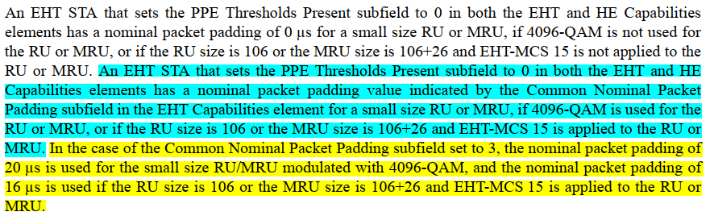
Discussion ends.

CID 7940
Page.  Line | Clause Number | Comment | Proposed Change | Resolution
300.07 | 35.9 | Extra "T" in the MIB variable | Change "dot11EHTPPETThresholdsRequired" to "dot11EHTPPEThresholdsRequired"  (Notice the "TT" became "T") | ACCEPTED  Note to the EDITOR: The comment in this CID has been resolved in 11-21/0062r0. No further change is needed.

CID 7942
Page.  Line | Clause Number | Comment | Proposed Change | Resolution
302.15 | 35.9 | Table 35-3 could be written more clearly/precisely.  For example, what does the "HE nominal packet padding value" and "Common Nominal Packet Padding" mean in this table?  Also, adding a column for RU/MRU size > 2x996 would make the table even more helpful. | In Table 35-3:  - In the first row, delete "Small Size RU/MRU < 242"  - In the first row, change "RU/MRU < 106" to "RU/MRU size < 106-tone"  - In the first row, change "242 <= Large size RU/MRU <= 2x996" to "242-tone <= RU/MRU size <= 2x996-tone"  - In the second row, change "HE nominal packet padding value (= 0 us)" to "0 us (see NOTE 1)" (in two locations)  - In the third row, change "Common Nominal Packet Padding" to "EHT common nominal packet padding value"  - In the fifth row, change "HE nominal packet padding value for HE-MCS 0 + DCM (=0 us)" to "0 us (see NOTE 1)"  - At the bottom of Table 35-3, add a new row spanning all columns, with content  "NOTE 1 - The nominal packet padding value conveyed by the PPE Thresholds field in the HE Capabilities element is 0 us these cases.  NOTE 2 - HE nominal packet padding value is the value conveyed by the PPE Thresholds field in the HE Capabilities element.  NOTE 3 - EHT common nominal packet padding value is the value conveyed by the Common Nominal Packet Padding in the EHT PHY Capabilities Information field in the HE Capabilities element."  - Add one more column as the last column, with the column title being "RU/MRU size > 2x996-tone", and content for all MCS rows being "EHT common nominal padding value"  Also, delete "and RU/MRU <= 2x996" from the title of Table 35-3. | REVISED  Agree with the commenter. The update will make the table more understandable. (The meaning of the updated table is the same as the previous one)  Instructions to the editor:  Please make the changes as shown under CID 7942 in 11-22/0183r1.
Instructions to the editor, please make the changes as follows to table 35-3 in P802.11be D1.3:
Table 35-3—EHT nominal packet padding indication for NSS ≤ NSTS+1 when the PPE Thresholds Present subfield is set to 0 in the EHT Capabilities element and 1 in the HE Capabilities element

EHT-MCS |  |  | 242-tone ≤  RU/MRU size  ≤ 2×996-tone | RU/MRU size > 2x996-tone
 | RU/MRU size < 106-tone | 106-tone RU and 106+26-tone MRU
0–11 | 0 µs (see NOTE 1) | 0 µs (see NOTE 1) | HE nominal packet padding value | EHT common nominal packet padding value
12 and 13 | EHT common nominal packet padding value | EHT common nominal packet padding value | EHT common nominal packet padding value | EHT common nominal packet padding value
14 | — | — | HE nominal packet padding value for HE- MCS 0 + DCM | EHT common nominal packet padding value
15 | 0 µs (see NOTE 1) | HE nominal packet padding value for HE- MCS 0 + DCM | HE nominal packet padding value for HE- MCS 0 + DCM | EHT common nominal packet padding value
NOTE 1 - The nominal packet padding value conveyed by the PPE Thresholds field in the HE Capabilities element is 0 us in these cases.

NOTE 2 - HE nominal packet padding value is the value conveyed by the PPE Thresholds field in the HE Capabilities element.

NOTE 3 - EHT common nominal packet padding value is the value conveyed by the Common Nominal Packet Padding subfield in the EHT PHY Capabilities Information field in the EHT Capabilities element.

Instructions to the editor, please make the changes as follows to table 35-2 in P802.11be D1.3 (to be consistent with the above table):
Table 35-2—EHT nominal packet padding indication when the PPE Thresholds Present sub field is set to 0 in both the EHT and HE Capabilities elements

EHT-MCS |  |  | RU/MRU size  ≥ 242-tone
 | RU/MRU size < 106-tone | 106-tone RU and 106+26-tone MRU
0–11 | 0 µs | 0 µs | EHT common nominal packet padding value
12 and 13 | EHT common nominal packet padding value | EHT common nominal packet padding value | EHT common nominal packet padding value
14 | — | — | EHT common nominal packet padding value
15 | 0 µs | EHT common nominal packet padding value | EHT common nominal packet padding value
NOTE - EHT common nominal packet padding value is the value conveyed by the Common Nominal Packet Padding subfield in the EHT PHY Capabilities Information field in the EHT Capabilities element.

CID 7943
Page.  Line | Clause Number | Comment | Proposed Change | Resolution
302.37 | 35.9 | Reference for EHT PPE Thresholds should be updated. | Change "9.4.2.295c" to "9.4.2.295c.5" | REVISED  Update the reference.  Instructions to the editor:  Please make the changes as follows to Page 420, L37 in 802.11be D1.3:  Change “9.4.2.313 (EHT Capabilities element)” to “9.4.2.313.5 (EHT PPE Thresholds field)”

CID 7944
Page.  Line | Clause Number | Comment | Proposed Change | Resolution
304.09 | 35.9 | TXVECTOR parameter NOMINAL_PACKET_PADDING is not present for EHT TB PPDU. | Change  "A STA transmitting an EHT PPDU"  to  "A STA transmitting an EHT MU PPDU" | REVISED  Instructions to the editor:  Please make the changes as follows to Page 422, L25 and Page 422, L40 in 802.11be D1.3:  Change “A STA transmitting an EHT PPDU” to “A STA transmitting an EHT MU PPDU”

Discussion:
The above comment talks about this paragraph in D1.3:
Similarly, the following paragraph in D1.3 should also be changed.
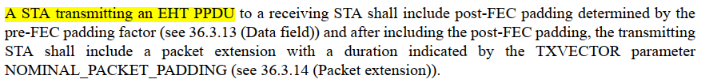
Discussion ends.

CID 7945
Page.  Line | Clause Number | Comment | Proposed Change | Resolution
304.27 | 35.9 | Packet extension duration does not always equal the NOMINAL_PACKET_PADDING.  For example, if pre-FEC padding factor is 1 and NOMINAL_PACKET_PADDING is 16 us, the pacekt extention duration could be as short as 12 us. | Change  "a duration indicated by the TXVECTOR"  to  "a duration computed based on the TXVECTOR" | ACCEPTED  Note to the EDITOR: The place is Page 422, L43 in D1.3.

CID 7946
Page.  Line | Clause Number | Comment | Proposed Change | Resolution
304.24 | 35.9 | What is the NOMINAL_PACKET_PADDING value to use between STAs which are not associated to each other? | Add the following at P304L24:  "If a STA A is transmitting an EHT MU PPDU to a STA B, where the STA A has not received a frame  including the EHT Capabilities element from the STA B, then the STA A shall set the value of the  TXVECTOR parameter NOMINAL_PACKET_PADDING to:  - 20 us if the RU/MRU is modulated with 4096-QAM, the RU/MRU size is greater than 2x996-tone, or  the RU/MRU uses more than eight spatial streams.  - 16 us otherwise.  NOTE - One such situation is an AP transmitting to a nonassociated STA. Another such situation is a nonassociated STA  transmitting to an AP without having received a management frame including an EHT Capabilities element from the AP,  such as a Beacon or Probe Response frame." | ACCEPTED  Note to the EDITOR: The place is Page 422, L39 in D1.3.

