IEEE P802.11
Wireless LANs
CR for rTWT TXOP rules
Date: January 20, 2022
Author(s):
Name | Affiliation | Address | Phone | email
Jason Yuchen Guo | Huawei |  |  | guoyuchen@huawei.com
Ming Gan | Huawei
Yunbo Li | Huawei
Guogang Huang | Huawei
Yiqing Li | Huawei
Mengyao Ma | Huawei
Hongjia Su | Huawei
Yuxin Lu | Huawei
Arik Klein | Huawei
Michanel Montemurro | Huawei
Stephen McCann | Huawei
Edward Au | Huawei
Osama Aboul-Magd | Huawei
Insun Jang | LGE
SunHee Baek | LGE

Abstract
This submission proposes resolutions for following CIDs received for TGbe CC36:
5876, 6335, 8053
6411

Revisions:
- Rev 0: Initial version of the document.
- Rev 1: update the text based on offline feedback. Add the resolution for CID 6411.

Interpretation of a Motion to Adopt

A motion to approve this submission means that the editing instructions and any changed or added material are actioned in the TGbe Draft. This introduction is not part of the adopted material.

Editing instructions formatted like this are intended to be copied into the TGbe Draft (i.e. they are instructions to the 802.11 editor on how to merge the text with the baseline documents).

TGbe Editor: Editing instructions preceded by “TGbe Editor” are instructions to the TGbe editor to modify existing material in the TGbe draft. As a result of adopting the changes, the TGbe editor will execute the instructions rather than copy them to the TGbe Draft.

Part I: rTWT TXOP rules

CID | Commenter | Page | Clause | Comment | Proposed Change | Resolution
5876 | Liangxiao Xin | 298.43 | 35.6.4.1 | The non-AP EHT STA that is a member of that restricted TWT service period does not need to end the TXOP before the start of a restricted TWT service period if the TXOP is obtained outside of that restricted TWT service period. The non-AP EHT STA could continue its TXOP for low latency traffic transmission during the R-TWT SP. | A non-AP EHT STA with dot11RestrictedTWTOptionImplemented set to true as a TXOP holder shall ensure the TXOP ends before the start of a restricted TWT service period if the TXOP is obtained outside of that restricted TWT service period and the non-AP EHT STA is not a member of that restricted TWT service period | Revised-  Agree in principle with the comment.  TGbe editor:  Please implement changes as shown in this document tagged as 5876.
6335 | Ming Gan | 298.42 | 35.6.4.1 | This paragraph is not complete. If this non-AP EHT STA is transmitting low latency traffic, then does this STA still need to stop its TXOP before the start of any restricted TWT service periods | as in the comment | Revised-  Agree in principle with the comment  TGbe editor:  Please implement changes as shown in this document tagged as 6335.
8053 | Yuchen Guo | 298.43 | 35.6.4.1 | What if the obtained TXOP of the non-AP EHT STA is used for low latency transmission? In this case, the non-AP EHT STA may not end its TXOP. | Please clarify | Revised-  Agree in principle with the comment..  TGbe editor:  Please implement changes as shown in this document tagged as 8053.

Discussion: An r-TWT scheduled STA may have obtained a TXOP before the r-TWT SP. According to the current SPEC (Draft P802.11be D1.3), the r-TWT scheduled STA needs to end the TXOP before the r-TWT SP. This is OK when the TXOP is used for transmission of non low latency traffic, because the r-TWT SP is dedicated for low latency traffic transmission. However, if the TXOP is used for low latency traffic transmission, the r-TWT scheduled STA needs to end the TXOP before the r-TWT SP, and tries to contend for another TXOP within the r-TWT SP to continue the transmission of the low latency traffic according to the current TXOP rules of the r-TWT, which is very inefficient. Hence, we propose to add an exception rule to allow the r-TWT scheduled STA not to end the TXOP if the TXOP is used for the low latency traffic transmission.
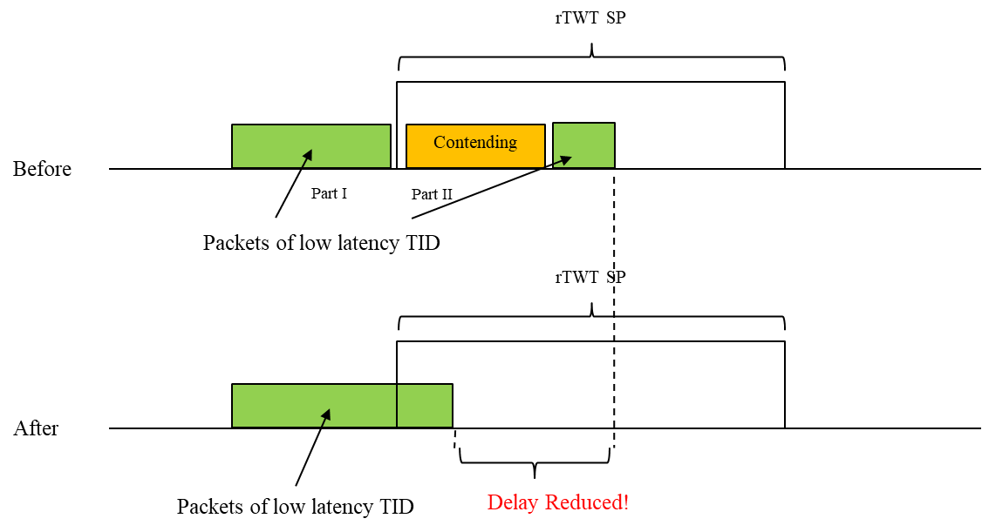

TGbe editor: Please note baselines are REVme D1.0 and 11be D1.4

35.7.4.1 TXOP rules for r-TWT SPs

A non-AP EHT STA with dot11RestrictedTWTOptionImplemented set to true as a TXOP holder shall ensure (#6950) the TXOP ends before the start time of any restricted TWT SPs advertised by the associated AP unless the non-AP EHT STA is a member of the upcoming r-TWT SP, and the TXOP is used for the transmission of QoS Data frames of r-TWT TID(s)(#5876) (#6335) (#8053).

Part II: Traffic Delivery in non-Trigger-Enabled rTWT

CID | Commenter | Page | Clause | Comment | Proposed Change | Resolution
6411 | Muhammad Kumail Haider | 126.18 | 9.4.2.199 | A PDT and motion(#2920) was passed to make changes to TWT element to accommodate restricted TWT schedule announcements and negotiations. Part of proposed changes is to introduce an r-TWT traffic info field to indicate latency sensitive TIDs. However, it is not specified whether there are any restrictions on the type of frames and whether frames of other TIDs may also be transmitted by member STAs of an r-SP. | Specify if and how TIDs indicated in r-TWT traffic info field are used to restrict certain type of traffic/frames from member STAs in r-SP (in 9.4.2.199 or 35.7). Appropriate restrictions should apply to prioritize and/or limit the usage of r-SPs for latency sensitive traffic delivery, in accordance with the objective of r-TWT operation. | Revised-  Agree in principle with the comment. Rules are added for the traffic delivery within the rTWT SP.  TGbe editor:  Please implement changes as shown in this document tagged as 6411.

Discussion: Since the design target of r-TWT is to designate a dedicated period of time for low latency traffic transmission, we should give the highest priority to the transmission of low latency traffic during the r-TWT SP. Hence it is reasonable to disallow the transmission of non low latency traffic during the r-TWT SP to make sure that only the traffic belonging to the low latency TIDs can be transmitted during the r-TWT SP. Once the transmissions of all the low latency TIDs are finished, and there are still some remaining time in the current r-TWT SP, the AP can terminate the current r-TWT SP, then all the STAs can contend the channel to transmit the non low latency traffic.

TGbe editor: Please note baselines are REVme D1.0 and 11be D1.4

37.7.5 Traffic delivery
TGbe editor: Please add the following at the end of this subclause
In a non-trigger-enabled r-TWT SP, an r-TWT scheduled STA shall not contend the channel to transmit QoS Data frames of TID(s) that are not r-TWT UL TID(s). A non-AP EHT STA with dot11RestrictedTWTOptionImplemented set to true that is not an r-TWT scheduled STA for the current r-TWT SP shall not contend the channel to transmit any frame. When the r-TWT scheduling AP finds that all the r-TWT scheduled STAs have completed the delivery of their buffered QoS Data frames of r-TWT TID(s), and the r-TWT scheduling AP has also completed the delivery of its buffered QoS Data frame of the DL r-TWT TID(s) for all the r-TWT scheduled STAs, the r-TWT scheduling AP should transmit a r-TWT SP termination frame to terminate the current r-TWT SP, after which the QoS Data frames of TID(s) that are not r-TWT UL TID(s) can be transmitted. (#6411)

Straw Poll: Do you support to incorporate the proposed draft text in this document 11-22/0139r1 to the next revision of TGbe Draft?
Result: Yes/No/Abstain

