IEEE P802.11
Wireless LANs
CR for rTWT TXOP rules
Date: January 20, 2022
Author(s):
Name | Affiliation | Address | Phone | email
Jason Yuchen Guo | Huawei |  |  | guoyuchen@huawei.com
Ming Gan | Huawei
Yunbo Li | Huawei
Guogang Huang | Huawei
Yiqing Li | Huawei
Mengyao Ma | Huawei
Hongjia Su | Huawei
Yuxin Lu | Huawei
Arik Klein | Huawei
Michanel Montemurro | Huawei
Stephen McCann | Huawei
Edward Au | Huawei
Osama Aboul-Magd | Huawei

Abstract
This submission proposes resolutions for following CIDs received for TGbe CC36:
5876, 6335, 8053

Revisions:
- Rev 0: Initial version of the document.

Interpretation of a Motion to Adopt

A motion to approve this submission means that the editing instructions and any changed or added material are actioned in the TGbe Draft. This introduction is not part of the adopted material.

Editing instructions formatted like this are intended to be copied into the TGbe Draft (i.e. they are instructions to the 802.11 editor on how to merge the text with the baseline documents).

TGbe Editor: Editing instructions preceded by “TGbe Editor” are instructions to the TGbe editor to modify existing material in the TGbe draft. As a result of adopting the changes, the TGbe editor will execute the instructions rather than copy them to the TGbe Draft.

CID | Commenter | Page | Clause | Comment | Proposed Change | Resolution
5876 | Liangxiao Xin | 298.43 | 35.6.4.1 | The non-AP EHT STA that is a member of that restricted TWT service period does not need to end the TXOP before the start of a restricted TWT service period if the TXOP is obtained outside of that restricted TWT service period. The non-AP EHT STA could continue its TXOP for low latency traffic transmission during the R-TWT SP. | A non-AP EHT STA with dot11RestrictedTWTOptionImplemented set to true as a TXOP holder shall ensure the TXOP ends before the start of a restricted TWT service period if the TXOP is obtained outside of that restricted TWT service period and the non-AP EHT STA is not a member of that restricted TWT service period | Revised-  Agree in principle with the comment.  TGbe editor:  Please implement changes as shown in this document tagged as 5876.
6335 | Ming Gan | 298.42 | 35.6.4.1 | This paragraph is not complete. If this non-AP EHT STA is transmitting low latency traffic, then does this STA still need to stop its TXOP before the start of any restricted TWT service periods | as in the comment | Revised-  Agree in principle with the comment  TGbe editor:  Please implement changes as shown in this document tagged as 6335.
8053 | Yuchen Guo | 298.43 | 35.6.4.1 | What if the obtained TXOP of the non-AP EHT STA is used for low latency transmission? In this case, the non-AP EHT STA may not end its TXOP. | Please clarify | Revised-  Agree in principle with the comment..  TGbe editor:  Please implement changes as shown in this document tagged as 8053.

Discussion: An r-TWT scheduled STA may have obtained a TXOP before the r-TWT SP. According to the current SPEC (Draft P802.11be D1.3), the r-TWT scheduled STA needs to end the TXOP before the r-TWT SP. This is OK when the TXOP is used for transmission of non low latency traffic, because the r-TWT SP is dedicated for low latency traffic transmission. However, if the TXOP is used for low latency traffic transmission, the r-TWT scheduled STA needs to end the TXOP before the r-TWT SP, and tries to contend for another TXOP within the r-TWT SP to continue the transmission of the low latency traffic according to the current TXOP rules of the r-TWT, which is very inefficient. Hence, we propose to add an exception rule to allow the r-TWT scheduled STA not to end the TXOP if the TXOP is used for the low latency traffic transmission.
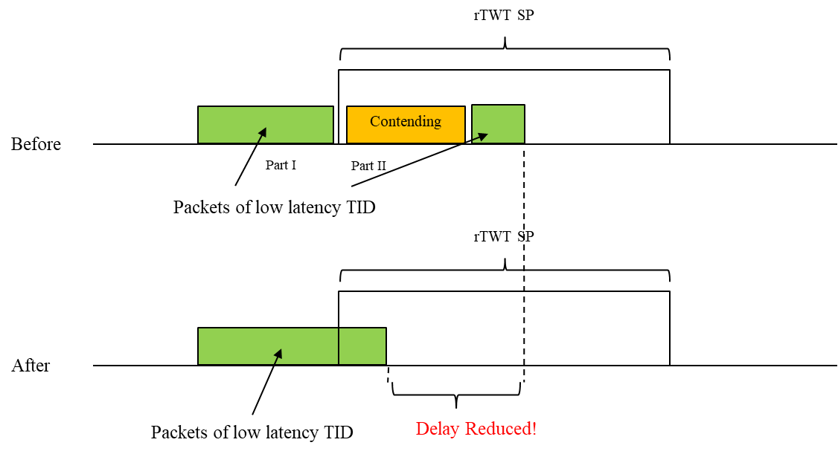

TGbe editor: Please note baselines are REVme D1.0 and 11be D1.4

35.7.4.1 TXOP rules for r-TWT SPs

A non-AP EHT STA with dot11RestrictedTWTOptionImplemented set to true as a TXOP holder shall ensure (#6950) the TXOP ends before the start time of any restricted TWT SPs advertised by the associated AP unless the TXOP is used for the transmission of QoS Data frames of r-TWT TIDs(#5876) (#6335) (#8053).

Straw Poll: Do you support to incorporate the proposed draft text in this document 11-22/0139r0 to the next revision of TGbe Draft?
Result: Yes/No/Abstain

