IEEE P802.11
Wireless LANs
CC36 CR for CIDs 5461 and 8089 related to RU_ALLOCATION
Date: 2022.01.26
Author(s):
Name | Company | Address | Phone | email
Mengshi Hu | Huawei Technologies | F3-6-A118, Huawei Base, Bantian, Longgang, Shenzhen, Guangdong, China, 518129 |  | humengshi@huawei.com
Ross Yu
Ming Gan
Bo Sun | ZTE Corporation
Bin Tian | Qualcomm
Abstract
This submission contains proposed 2 comment resolutions for the comments on P802.11be D1.0.

CIDs: 5461, 8089

Note 1: CID 5461 is a deferred CID in 11-21/1302.
Note 2: The page information of CID 8089 is incorrect, which should be P326 instead of P324 in D1.0.

Revision Notes
R0 | Initial revision

CID 5461
Page.  Line | Clause Number | Comment | Proposed Change | Resolution
326.21 | 36.2.2 | Clarify that RXVECTOR uses the 9 bits from the trigger frame, not just see 9.3.1.22 (Trigger frame format) for details | as in comment | REVISED  Add a clarification for the description “See 9.3.1.22 (Trigger frame format) for details”.  Instructions to the editor:  Please make the changes as shown in 11/22-0133r2, under CID 8089.

Discussion (D1.0)
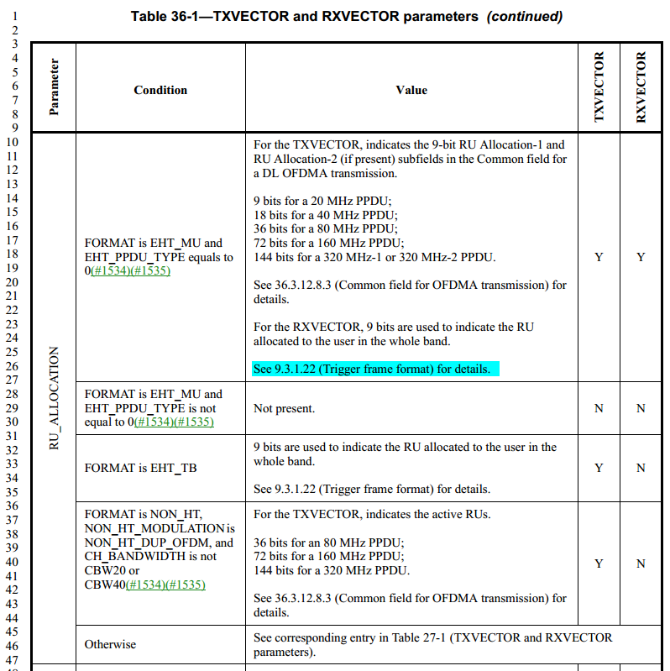
Discussion ends

CID 8089
Page.  Line | Clause Number | Comment | Proposed Change | Resolution
324.32 | 36.2.2 | add MRU after RU in descrption of RU_ALLOCATION parameter | as in comment | REVISED  Instructions to the editor:  Please make the changes as shown in 11/22-0133r1, under CID 8089.

Discussion (D1.3)
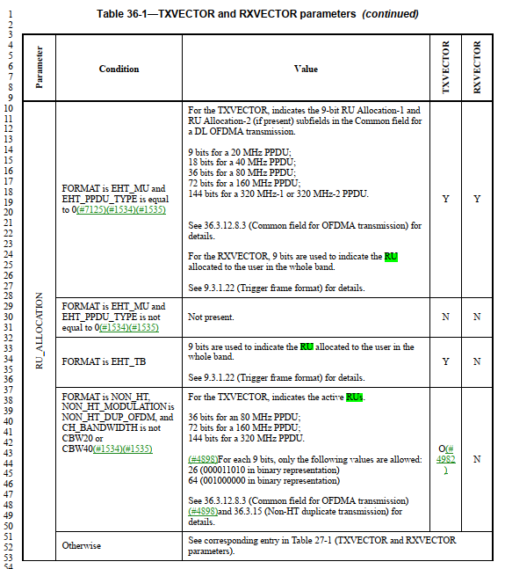
Discussion ends

Instructions to the editor, please make the following changes in P448 in P802.11be D1.3:
Table 36-1—TXVECTOR and RXVECTOR parameters (continued)

Parameter | Condition | Value | TXVECTOR | RXVECTOR
RU_ALLOCATION | FORMAT is EHT_MU and EHT_PPDU_TYPE is equal to 0(#7125)(#1534)(#1535) | For the TXVECTOR, indicates the 9-bit RU Allocation-1 and RU Allocation-2 (if present) subfields in the Common field for a DL OFDMA transmission.  9 bits for a 20 MHz PPDU; 18 bits for a 40 MHz PPDU; 36 bits for a 80 MHz PPDU; 72 bits for a 160 MHz PPDU;  144 bits for a 320 MHz-1 or 320 MHz-2 PPDU.  See 36.3.12.8.3 (Common field for OFDMA transmission) for details.  For the RXVECTOR, 9 bits using the same encoding of PS160 (B39) and RU Allocation (B12–B19) subfields in the EHT variant User Info field are used to indicate the RU/MRU allocated to the user in the whole band.  See 9.3.1.22 (Trigger frame format) for details. | Y | Y
 | FORMAT is EHT_MU and EHT_PPDU_TYPE is not equal to 0(#1534)(#1535) | Not present. | N | N
 | FORMAT is EHT_TB | 9 bits are used to indicate the RU/MRU allocated to the user in the whole band.  See 9.3.1.22 (Trigger frame format) for details. | Y | N
 | FORMAT is NON_HT, NON_HT_MODULATION is  NON_HT_DUP_OFDM, and CH_BANDWIDTH is not CBW20 or CBW40(#1534)(#1535) | For the TXVECTOR, indicates the active RUs/MRUs.  36 bits for an 80 MHz PPDU; 72 bits for a 160 MHz PPDU; 144 bits for a 320 MHz PPDU.  (#4898)For each 9 bits, only the following values are allowed: 26 (000011010 in binary representation)  64 (001000000 in binary representation)  See 36.3.12.8.3 (Common field for OFDMA transmission) (#4898)and 36.3.15 (Non-HT duplicate transmission) for details. | O(# 4982  ) | N
 | Otherwise | See corresponding entry in Table 27-1 (TXVECTOR and RXVECTOR parameters).

