IEEE P802.11
Wireless LANs
Text change for random LTF sequence index
Date: 2022-01-19
Author(s):
Name | Affiliation | Address | Phone | email
Shuling Feng | Mediatek |  |  | julia.feng@mediatek.com
ChaoChun | Mediatek |  |  | chaochun.wang@mediatek.com
Abstract

This submission proposed text changes for random LTF sequence index k in draft 11az-D4.0.

Revisions:
- Rev 0: Initial version of the document.

Discussions:
In page 240 of 11az draft 4.0, random LTF sequence are described from L26 to L29.
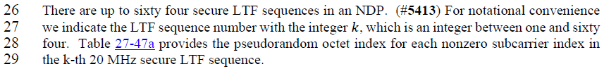
The integer “k” here is used to indicate “the LTF sequence number”. And in P239 L9 it says, “Secure HE-LTFs use randomized LTF sequences”. But how LTF sequence number is mapped to a LTF symbol number is not mentioned in D4.0 text. Missing of this important information causes confusions when secure LTF symbols are generated for each uer.
From contributions 1-20-0836 (Secure LTF Design) and 11-20-1863 (Secure LTFs: additional Design details), we know each randomized secure LTF sequence is used to generate each of the LTF symbols. We understand that “the LTF sequence number” k here also indicates LTF symbol number. Therefore we propose the following changes in text to clarify “k also indicates LTF symbol number”.

TGaz Editor: Please make the following change in P240L26-L29 in subclause 27.3.18a.3.1 Randomized LTF sequence for 20 MHz secure NDP of D4.0.
There are up to sixty four secure LTF sequences in an NDP. (#5413) For notational convenience we indicate the LTF sequence number with the integer 𝑘, which is an integer between one and sixty four. Since each secure LTF sequence is used to generate each of the LTF symbols, k also indicates LTF symbol number. Table 27-47a provides the pseudorandom octet index for each nonzero subcarrier index in the k-th 20 MHz secure LTF sequence.

