IEEE P802.11
Wireless LANs
CC36 CR for the EHT PHY DATA scrambler and descrambler
Date: 2022-01-18
Author(s):
Name | Affiliation | Address | Phone | email
Chenchen Liu | Huawei |  |  | liuchenchen1@huawei.com
Abstract
This submission proposes resolutions of comments received from TGbe comment collection CC36 based on TGbe D1.0 for following 40 CIDs:

Revisions:

- Rev 0: Initial version of the document.

- Introduction

Interpretation of a Motion to Adopt

A motion to approve this submission means that the editing instructions and any changed or added material are actioned in the TGbe Draft. The introduction and the explanation of the proposed changes are not part of the adopted material.

Editing instructions formatted like this are intended to be copied into the TGbe Draft (i.e. they are instructions to the 802.11be editor on how to merge the text with the baseline documents).

TGbe Editor: Editing instructions preceded by “TGbe Editor” are instructions to the TGbe editor to modify existing material in the TGbe draft. As a result of adopting the changes, the TGbe editor will execute the instructions rather than copy them to the TGbe Draft.

CID 4570
CID | Clause | PP.LL | Comment | Proposed Change | Resolution
4570 | 36.3.12.10 | 0.00 | There is a typo. 'A means for' should be revised as 'a mean for'. | As in the comment. | Rejected.  means is always singular when it's used to mean "a (single) method" or "a (single) way of doing something"
Discussion:

CID 4571
CID | Clause | PP.LL | Comment | Proposed Change | Resolution
4571 | 36.3.12.10 | 0.00 | There is a typo. 'The values of ...is ...' should be revised as 'The values of ...are ...'. | As in the comment. | Revised.  Agree with the comment in principle. Propose resolution to account for the suggested change.  Instructions to the editor：  Please replace the word “values” with “value” in P467.45
Discussion:
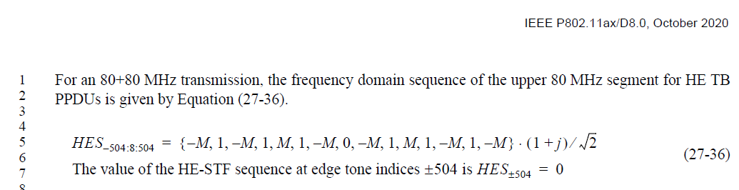

CID 4577
CID | Clause | PP.LL | Comment | Proposed Change | Resolution
4577 | 36.3.12.10 | 405.63 | The value of S_(k,20) should be clarified. | S_(k,20) is defined as the k-th element of S_(-26,26) in Equation (19-8) | Rejected.
Discussion:
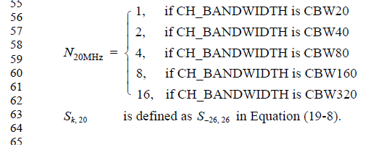

CID 4578
CID | Clause | PP.LL | Comment | Proposed Change | Resolution
4578 | 36.3.12.10 | 406.36 | The value of L_(k,20) should be clarified. | L_(k,20) is defined as the k-th element of L_(-26,26) in Equation (17-8) | Rejected.
Discussion:

CID 4580
CID | Clause | PP.LL | Comment | Proposed Change | Resolution
4580 | 36.3.12.10 | 0.00 | There is a typo. 'an 1x EHT LTF' should be 'a 1x EHT LTF'. | As in the comment. | Accepted.
Discussion:
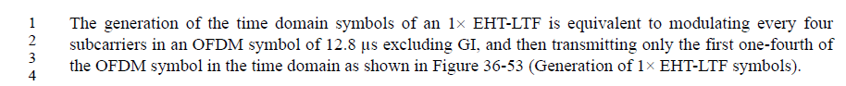

CID 4676
CID | Clause | PP.LL | Comment | Proposed Change | Resolution
4676 | 36.3.12.10 | 469.24 | First sentence at P469L60 duplicates first sentence at P469L60. Yet this ordering is helpful. | Change L24 to "In an EHT MU PPDU with a single RU/MRU, NEHTLTF is indicated in the EHT-SIG field. In an EHT MU PPDU with a single RU/MRU ...". Change L60 to "In an EHT MU PPDU with more than one RU/MRU, NEHTLTF is indicated in the EHT-SIG field. ... " | Rejected.  The original description is clear enough.
Discussion:

CID 4864
CID | Clause | PP.LL | Comment | Proposed Change | Resolution
4864 | 36.3.12.10 | 470.15 | Conditional mandatory is not used in table 36-44. delete it. | As in comment | Revised.  Instructions to the editor：  Please revise the sentence in P470.15 as:  “Table 36-44 (EHT-LTF type and GI duration combinations for various EHT PPDU formats) defines whether a particular EHT-LTF type and GI duration combination is mandatory, optional, or not supported for each EHT PPDU format.”
Discussion:
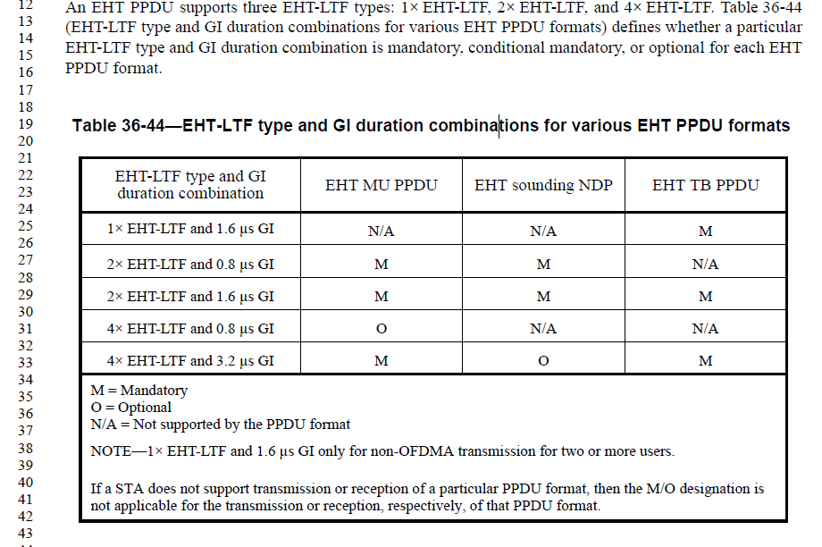

CID 4865
CID | Clause | PP.LL | Comment | Proposed Change | Resolution
4865 | 36.3.12.10 | 475.39 | The EHT no pilot EHT-LTF mode is not clear. change the text "the EHT no pilot EHT-LTF mode is used" with following  "EHT-LTF does not include the pilot."  and delete the editor's note | As in comment | Revised.  The mode is already defined in the HE. We can just inherit the definition form HE.  TGbe Editor please make changes following the instrucutions under CID 4865
Discussion:
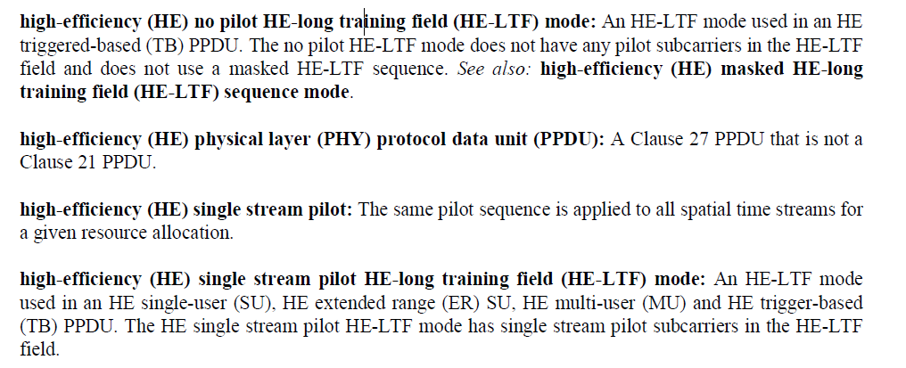

Instructions to the editor：
Please add the following definitions to chapter 3. Definitions, acronyms, and abbreviations
extremely high throughput (EHT) no pilot EHT-long training field (LTF) mode: An EHT-LTF mode used in EHT TB PPDU. The no pilot EHT-LTF mode does not have any pilot subcarriers in the EHT-LTF field
extremely high throughput (EHT) single stream pilot: The same pilot sequence is applied to all spatial time streams for a given resource allocation.
extremely high throughput (EHT) single stream pilot EHT-long training field (LTF) mode: An EHT-LTF mode used in an EHT multi-user (MU) and EHT trigger-based (TB) PPDU. The EHT single stream pilot EHT-LTF mode has single stream pilot subcarriers in the EHT-LTF field.

CID 5530
CID | Clause | PP.LL | Comment | Proposed Change | Resolution
5530 | 36.3.12.10 | 474.36 | There is no single stream pilot EHT-LTF mode defined in 11be. Modify as "EHT-LTF with single stream pilot is used", otherwise define the single stream pilot LTF-mode in the next version of spec. | As in comment | Revised.  CID4865 already solved this problem
Discussion:

CID 5531
CID | Clause | PP.LL | Comment | Proposed Change | Resolution
5531 | 36.3.12.10 | 475.39 | Remove the unnecessary sentence. EHT no pilot EHT-LTF mode is not even defined in the spec. | Delete the sentence of "If the 1x EHT-LTF is used for non-OFDMA UL MU-MIMO, the EHT no pilot EHT-LTF mode is used." | Revised.  CID4865 already solved this problem
Discussion:

CID 5721
CID | Clause | PP.LL | Comment | Proposed Change | Resolution
5721 | 36.3.12.10 | 469.57 | The indication of support for extra LTFs is carried in the first bit of "Maximum Number of Supported EHT-LTFs" subfield in "EHT PHY Capabilities Information field | Need to change "EHT PHY Capability field" to "EHT PHY Capabilities Information field". Optional: also change "Extra LTFs Support for Non-OFDMA PPDU" to "Maximumum Number of Supported EHT-LTFs subfield". The optional change can allow reader to easily locate location of relevant information in the document | Revised.  CID4865 already solved this problem
Discussion:

CID 7232
CID | Clause | PP.LL | Comment | Proposed Change | Resolution
7232 | 36.3.12.10 | 475.38 | "If the 1x EHT-LTF is used for non-OFDMA UL MU-MIMO, the EHT no pilot EHT-LTF mode is used.". Do we really define this as a mode, or is it just that no pilots are present? For a mode, one would expect an explicit indication. | Change to "If the 1x EHT-LTF is used for non-OFDMA UL MU-MIMO, no pilots are present in EHT-LTF" | Revised.  Same as CID4865
Discussion:

CID 7747
CID | Clause | PP.LL | Comment | Proposed Change | Resolution
7747 | 36.3.12.10 | 475.38 | "the EHT no pilot EHT-LTF mode" is not defined. To elaborate the definition. | If the 1 x EHT-LTF is used for non-OFDMA UL MU-MIMO, there are no pilot subcarriers in EHT-LTF. Suncarriers in EHT-LTF include data subcarriers over the PPDU bandwidth without preamble puncturing or the nonpunctured portions of the PPDU bandwidth with preamble puncturing, DC and Null subcarriers only. | Revised.  Same as CID 4865
Discussion:

CID 8026
CID | Clause | PP.LL | Comment | Proposed Change | Resolution
8026 | 36.3.12.10 | 475.41 | Define EHT no pilot EHT-LTF mode. | "Add the following text at P42L56:  ""extremely high throughput (EHT) no pilot EHT-long training field (EHT-LTF) mode: An EHT-LTF mode used in an EHT triggered-based (TB) PPDU. The no pilot EHT-LTF mode does not have any pilot subcarriers in the EHT-LTF field.""  Delete the Editor's note at P475L41." | Revised.  Same as CID 4865
Discussion:

CID 4866
CID | Clause | PP.LL | Comment | Proposed Change | Resolution
4866 | 36.3.12.10 | 476.19 | This text seems not to need. delete it or if it needs, add the description for this equation. | As in comment | Rejected.  This equation is ideed needed to support the equation (36-45)
Discussion:
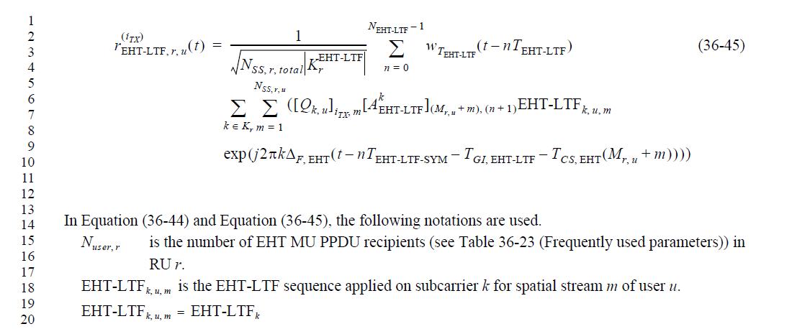

CID 4953
CID | Clause | PP.LL | Comment | Proposed Change | Resolution
4953 | 36.3.12.10 | 469.47 | What is "..." for in Table 36-43? | as in comment | Revised.  Instructions to the editor：  Please remove the last row of  Table 36-43—Initial number of EHT-LTFs required for different number of spatial streams
Discussion:

CID 5529
CID | Clause | PP.LL | Comment | Proposed Change | Resolution
5529 | 36.3.12.10 | 469.32 | In the Table 36-43 (Initial number of EHT-LTFs required for different number of spatial streams), last row may misleading that there could be any numbers possible more than 8. It'd better delete this row until we get any specific number. | As in comment | Revised.  CID4953 already solved this problem
Discussion:

CID 7229
CID | Clause | PP.LL | Comment | Proposed Change | Resolution
7229 | 36.3.12.10 | 469.46 | Replace last row of Table 36-43 with ">8 | Reserved" instead of "...|..." | See comment | Revised.  Same as CID4953
Discussion:

CID 7648
CID | Clause | PP.LL | Comment | Proposed Change | Resolution
7648 | 36.3.12.10 | 469.46 | The 3 dots (...) in both columns of Table 36-43 are misleading, because it suggests that more than 8 spatial streams are supported | Suggest to delete the row with the 3 dots ("...") | Revised.  Same as CID 4953
Discussion:

CID 4954
CID | Clause | PP.LL | Comment | Proposed Change | Resolution
4954 | 36.3.12.10 | 469.57 | "Supporting additional EHT-LTFs is optional for the receiver, which is indicated by the Extra LTFs Support for Non-OFDMA PPDU EHT PHY Capability field." I don't see this subfield defined in the PHY Capabilties IE. Furthermore, its PHY Capabilities, not Capability. | as in comment | Revised.  Instructions to the editor：  Please make the changes as shown below CID 4954
Discussion:
In order to improve the MIMO channel estimation for non-OFDMA transmission, the number of EHT-LTFs may be larger than the initial number of EHT-LTFs determined by the total number of spatial streams. If additional EHT-LTFs are used, then the total number of EHT-LTFs (which is signaled separately from N_{SS} )
shall be no more than twice the initial number of EHT-LTFs determined by the number of spatial streams as shown in Table 36-43 (Initial number of EHT-LTFs required for different number of spatial streams), and chosen from the set [2 4 8]. Supporting additional EHT-LTFs is optional for the receiver, which is indicated by the Maximum Number Of Supported EHT-LTFs of the EHT PHY Capabilities Information field.

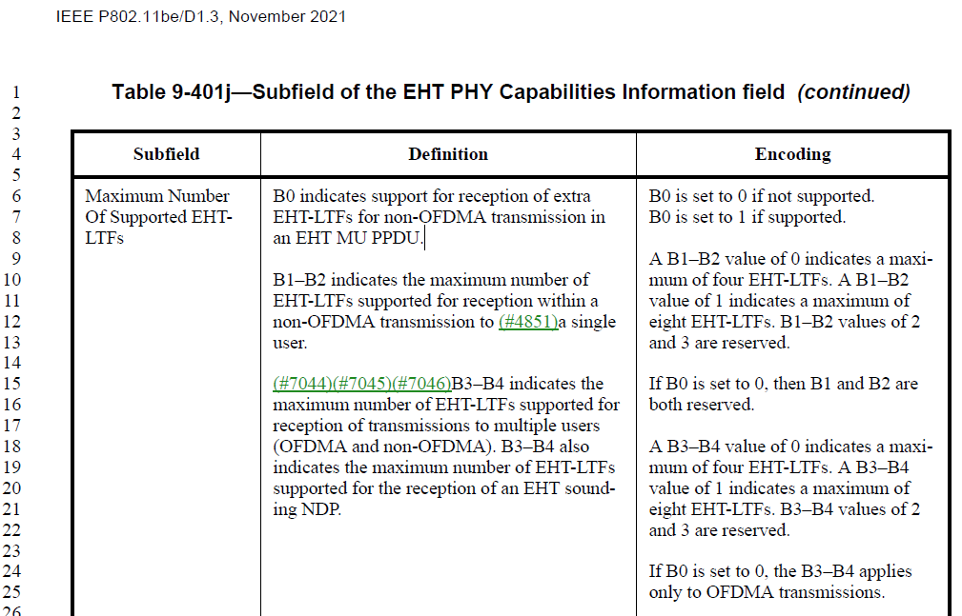

CID 5006
CID | Clause | PP.LL | Comment | Proposed Change | Resolution
5006 | 36.3.12.10 | 469.57 | Wrong reference. | Change "the Extra LTFs Support for Non-OFDMA PPDU EHT PHY Capability field" to "the Maximum Number Of Supported EHT-LTFs subfield in the EHT PHY Capabilities Information field in the EHT Capabilities element (see 9.4.2.295c.3 (EHT PHY Capabilities Information field))". | Revised.  Same as CID 4954
Discussion:

CID 5094
CID | Clause | PP.LL | Comment | Proposed Change | Resolution
5094 | 36.3.12.10 | 469.60 | Number of LTF symbols in any RU/MRU can not be greater than minimum of maximum number of LTFs indicated by all the STAs allocated within PPDU in Extra LTFs Support for Non-OFDMA PPDU EHT PHY Capability field. Need to add this limit | Modify as in comment | Rejected.  CID4954 already solved this problem
Discussion:

CID 5095
CID | Clause | PP.LL | Comment | Proposed Change | Resolution
5095 | 36.3.12.10 | 470.07 | Number of LTF symbols in any RU/MRU can not be greater than minimum of maximum number of LTFs indicated by all the STAs allocated within PPDU in Extra LTFs Support for Non-OFDMA PPDU EHT PHY Capability field. Need to add this limit | Modify as in comment | Rejected.  CID4954 already solved this problem
Discussion:

CID 6833
CID | Clause | PP.LL | Comment | Proposed Change | Resolution
6833 | 36.3.12.10 | 469.56 | Supporting additional EHT-LTFs is optional for the receiver, which is indicated by the Extra LTFs Support for Non-OFDMA PPDU EHT PHY Capability field. | "The name of the field in capabilities field is ""Maximum Number of Supported EHT-LTFs"" | Revised.  Same as CID 4954
Discussion:

CID 5007
CID | Clause | PP.LL | Comment | Proposed Change | Resolution
5007 | 36.3.12.10 | 470.38 | It is hard to always guarantee the situation mentioned in NOTE. For example, when an AP triggers UL MU MIMO with two users, GI And EHT-LTF Type subfield of the Common Info field in the Trigger frame is set to 1x EHT-LTF+1.6us GI to guarantee the NOTE. In that case two users shall transmit TB PPDU with 1x EHT-LTF + 1.6us GI. However, if one of the users cannot transmit TB PPDU, only one user transmits TB PPDU with 1x EHT-LTF + 1.6us GI. This case conflicts with the NOTE. Thus, NOTE needs to be modified to eliminate this contradiction, for example change the NOTE to "GI And EHT-LTF Type subfield of the Common Info field in the Trigger frame shall not be set to 1x EHT-LTF+1.6us GI except when an AP triggers non-OFDMA EHT TB PPDU with two or more users.". | See the comment. | Rejected.  We have already reach consensus on it since the constribution https://mentor.ieee.org/802.11/dcn/21/11-21-0680-02-00be-text-change-for-usage-of-1x-eht-ltf.docx
Discussion:
Please see https://mentor.ieee.org/802.11/dcn/21/11-21-0680-02-00be-text-change-for-usage-of-1x-eht-ltf.docx
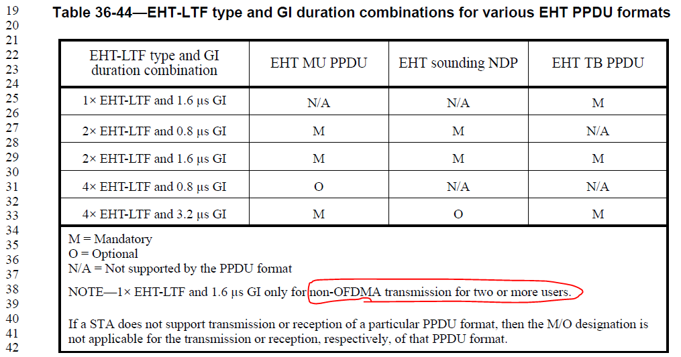

CID 5008
CID | Clause | PP.LL | Comment | Proposed Change | Resolution
5008 | 36.3.12.10 | 474.11 | Subcarriers for punctured channels are also set to zero. Change the sentence to "for all subcarriers that belong to unasigned RUs or punctured channels as well as ~". | See the comment. | Rejected.  RUs in the punctured channels are also Unassigned RUs.
Discussion:
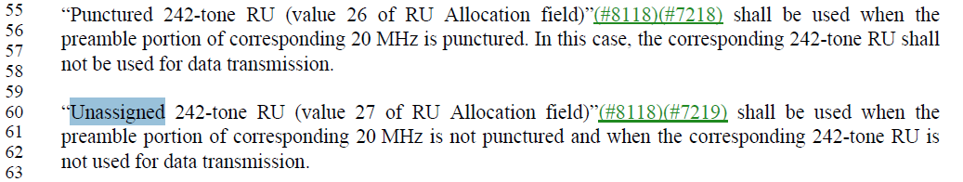

CID 5486
CID | Clause | PP.LL | Comment | Proposed Change | Resolution
5486 | 36.3.12.10 | 475.39 | Clarify that all tones are data tones of EHT-LTF when no pilot EHT-LTF mode is used. | as in comment | Rejected.  It is not true that “all tones are data tones of EHT-LTF when no pilot EHT-LTF mode is used”
Discussion:

CID 5720
CID | Clause | PP.LL | Comment | Proposed Change | Resolution
5720 | 36.3.12.10 | 469.07 | change '/' to 'or' for clarity. Same for L9, L20,L25,L61,L63, and elsewhere in the section | See comment | Rejected.  Both “RU/MRU” and “RU or MRU” are used throught the whole draft. “RU/MRU” is used more frequently than “RU or MRU”
Discussion:
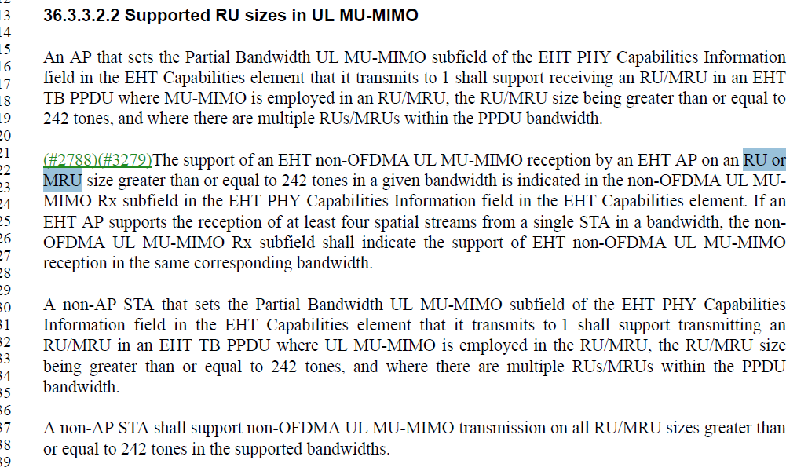

CID 5722
CID | Clause | PP.LL | Comment | Proposed Change | Resolution
5722 | 36.2.12.10 | 473.07 | While it doesn't cause any confusion here, the parameters "LTF_80MHz_left_4x" and "LTF_80MHz_left_right_4x" have been used in 27.3.11.10 before. May want to consider giving those two new sequences a different name here | See comment | Revised.  Instructions to the editor：  Please replace the “LTF_80MHz_left_4x” and “LTF_80MHz_right_4x” with “  LTF_80MHz_subblock_left_4x” and “  LTF_80MHz_subblock_right_4x” respectively in page 473
Discussion:

CID 6093
CID | Clause | PP.LL | Comment | Proposed Change | Resolution
6093 | 36.3.12.10 | 472.27 | Missing comma | Add comma between "0-1" (Ten positions from right side) | Accepted.  Instructions to the editor：  Please make the change as the commenter proposed
Discussion:
Commenter: Marcos Martinez Vazquez
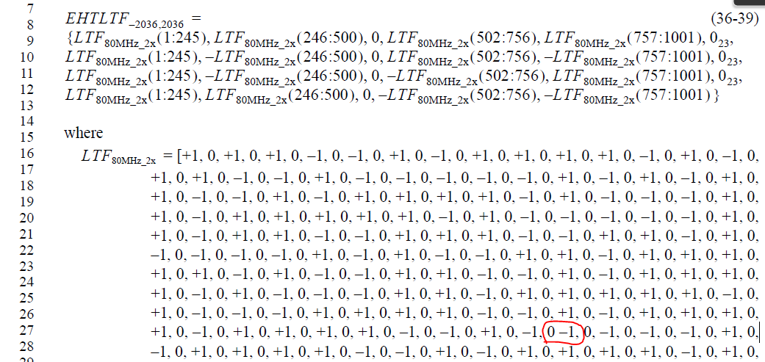

CID 6471
CID | Clause | PP.LL | Comment | Proposed Change | Resolution
6471 | 36.3.12.10 | 476.31 | There is no EHT SU PPDU | Remove "EHT SU PPDU and" | Accepted.  Instructions to the editor：  Please make the change as the commenter proposed
Discussion:
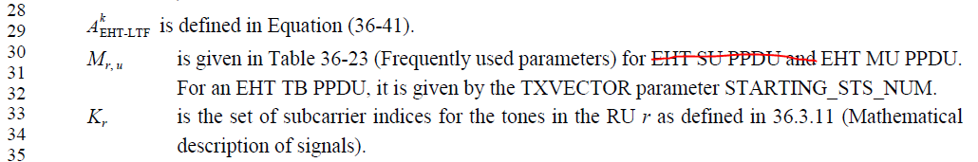

CID 7000
CID | Clause | PP.LL | Comment | Proposed Change | Resolution
7000 | 36.3.12.10 | 476.30 | There is no EHT SU PPDU, only EHT MU and EHT TB. | Remove 'EHT SU PPDU'. | Revised.  Same as CID 6471
Discussion:

CID 7745
CID | Clause | PP.LL | Comment | Proposed Change | Resolution
7745 | 36.3.12.10 | 476.30 | Remove EHT SU PPDU | as commented | Revised.  Same as CID 6471
Discussion:

CID 6834
CID | Clause | PP.LL | Comment | Proposed Change | Resolution
6834 | 36.3.12.10 | 469.60 | In an EHT MU PPDU, is indicated in the EHT-SIG field. | Exact sentence is repeated in line 24, remove | Rejected.  Line 24 is for EHT MU PPDU with a singleRU/MRU, while Line 60 is for EHT MU PPDU with more than one RU/MRU, it is ok to keep it.
Discussion:

CID 6835
CID | Clause | PP.LL | Comment | Proposed Change | Resolution
6835 | 36.3.12.10 | 470.05 | In an EHT TB PPDU, N_EHT-LTF is indicated in the Trigger frame that triggers the transmission of the PPDU. For an EHT TB PPDU, N_EHT-LTF may be greater than or equal to the maximum value of the initial number of EHT-LTF symbols for each RU/MRU r, which is calculated as a function of N_SS,r,total, separately based on Table 36-43 (Initial number of EHT-LTFs required for different number of spatial streams). | This paragraph treats UL-OFDMA and UL-MUMIMO TB-PPDU the same, which is in conflict with paragraph in page 469, lines 50-58, that specifies more restrictive conditions for N_EHT-LTF for "non-OFDMA" regardless of MU or TB-PPDU | Rejected.  There is no conflict
Discussion:
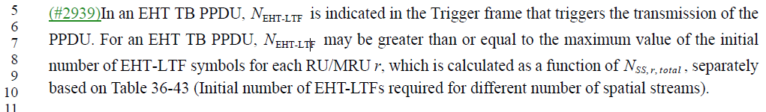

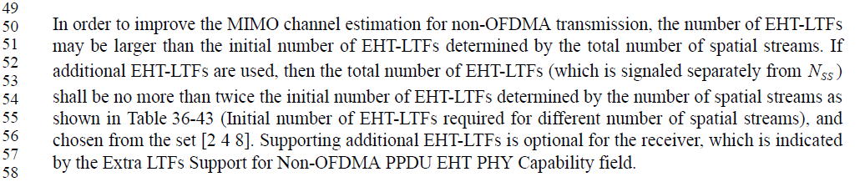

CID 6836
CID | Clause | PP.LL | Comment | Proposed Change | Resolution
6836 | 36.3.12.10 | 470.45 | In an EHT MU PPDU, the combination of EHT-LTF type and GI duration is indicated in U-SIG field. | Combination of EHT-LTF type and GI duration is indicated in EHT-SIG field (USIG overflow). | Revised.  Instructions to the editor：  Please replace the “U-SIG” with “EHT-SIG” in Page 470 Line 45
Discussion:
In an EHT MU PPDU, the combination of EHT-LTF type and GI duration is indicated in EHT-SIG field. In an EHT TB PPDU, the combination of EHT-LTF type and GI duration is indicated in the Trigger frame that triggers the transmission of the PPDU. If an EHT PPDU is an EHT sounding NDP, the combinations of EHT-LTF types and GI durations are listed in 36.3.18 (EHT sounding NDP).

CID 7231
CID | Clause | PP.LL | Comment | Proposed Change | Resolution
7231 | 36.3.12.10 | 470.45 | "In an EHT MU PPDU, the combination of EHT-LTF type and GI duration is indicated in U-SIG field.". Looks like it's indicated in the Common field of EHT-SIG. | Correct | Revised.  Same as CID6836
Discussion:

CID 7230
CID | Clause | PP.LL | Comment | Proposed Change | Resolution
7230 | 36.3.12.10 | 469.38 | In Note change "non-OFDMA" to "UL non-OFDMA" | See comment | Revised.  Instructions to the editor：  Please replace the “non-OFDMA” with “UL non-OFDMA” in Page 470 Line 38 of draft 1.0
Discussion:
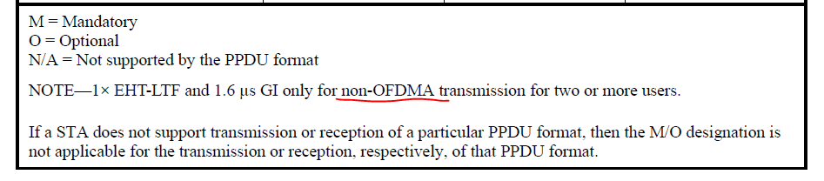

CID 7233
CID | Clause | PP.LL | Comment | Proposed Change | Resolution
7233 | 36.3.12.10 | 476.19 | Change "EHT-LTF_k,u,m = EHT-LTF_k" to "EHT-LTF_k,u,m = EHT-LTF_k for all values of u and m" | See comment | Accepted.  Instructions to the editor：  Please make the change as the commenter proposed
Discussion:
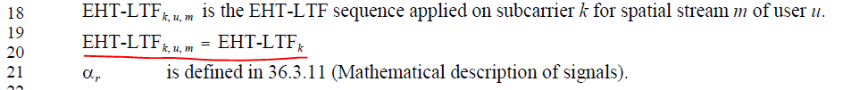

CID 7234
CID | Clause | PP.LL | Comment | Proposed Change | Resolution
7234 | 36.3.12.10 | 476.24 | "(M_r,u + r)" should be "(M_r,u + m)". "cyclic shift for the spatial stream M_r,u" should be "cyclic shift for the spatial stream M_r,u + m" | See comment | Revised.  Instructions to the editor：  Please make the changes as shown below CID 7234
Discussion:
T_{CS,} _{EHT}(M_{r,} _{u} + m) represents the cyclic shift for the spatial stream M_{r,} _{u} +mas defined in 36.3.12.2.2 (Cyclic shift for EHT modulated fields).

