IEEE P802.11
Wireless LANs
CIDs in EHT PHY Introduction CC36 CR
Date: 2022-01-10
Author(s):
Name | Affiliation | Address | Phone | email
Kanke Wu | Qualcomm, Inc. | 5775 Morehouse Dr.  San Diego, CA 92121 |  | kankew@qti.qualcomm.com
Bin Tian

Abstract
This submission proposes resolutions for the following 4 comments from CC36 in P802.11be D1.0:
7973, 4613, 7100, 7956

The changes indicated in this document is based on D1.3.

Revision History:

R0: Initial version.

CID 7973

CID | Clause | Page.Line | Comment | Proposed Change | Resolution
7973 | 36.1.1 | 315.03 | P315L3 says that only 80 MHz capable (160/320 incapable) STAs need to participate in 160 MHz OFDMA.  But P370L24 says 80 MHz operating STAs need to participate in 160 MHz OFDMA.  Similar comment on P351L5/9. | At P315L3 and P315L7, delete "capable of up to 80 MHz channel width and".  At P315L11, delete "capable of up to 160 MHz channel width and". | ACCEPTED.  Note to the editor:  P315L3 is at P436L52 in D1.3.  P315L7 is at P436L57 in D1.3.  P315L11 is at P436L61 in D1.3.

Background

D1.3 P436
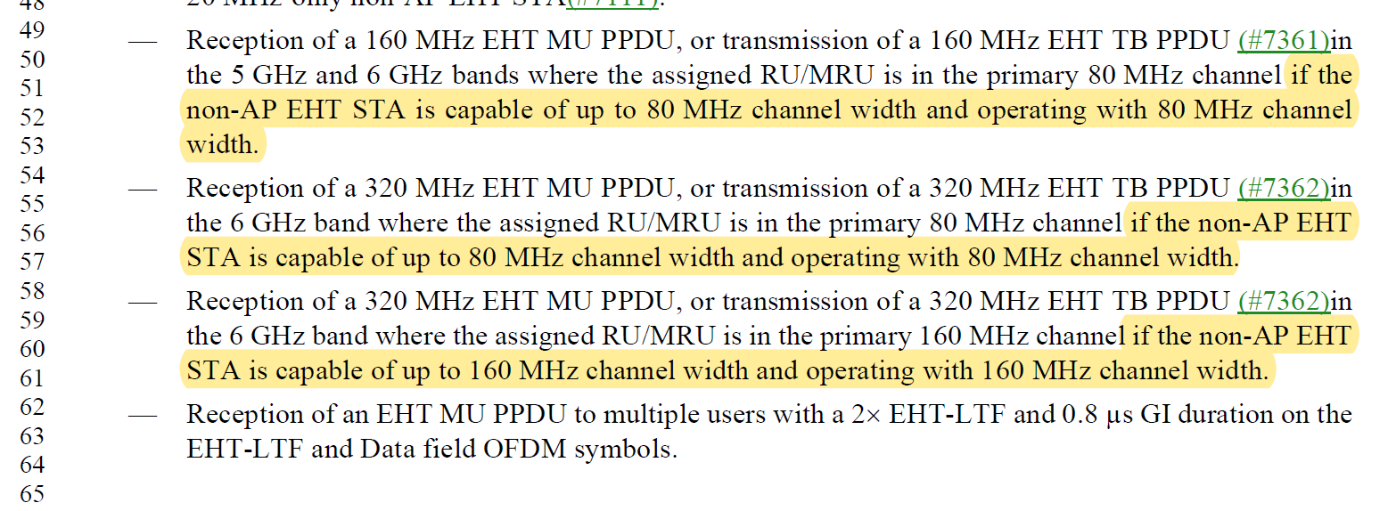

CID 4613

CID | Clause | Page.Line | Comment | Proposed Change | Resolution
4613 | 36.1.1 | 312.18 | The mandatory and optional "MRU and RU sizes" is not documented in this subclause (because it is complicated) but this subclause is intended to be a summary of available features | Under an "EHT STA shall support", add a bullet "Certain RU and MRU sizes as defined in 36.xx.xx". Under an "EHT STA may support", add a bullet "Certain RU and MRU sizes as defined in 36.xx.xx" | REVISED.  The mandatory/optional support set of MRU and RU are complicated, depending on OFDMA/non-OFDMA, supporting bandwidth, MCS (e.g. MCS 14), etc. The text like “ Certain RU and MRU size as defined …” may not be suitable for the shall/may requirement sections. Instead, we will provide general information on supported RU and MRUs at the beginning of the introduction section.  Instructions to the editor: Please insert the following paragraph at P433 L44.  “The EHT PHY defines RUs comprising of 26, 52, 106, 242, 484, 996, 2x996 or 4x996 tones in 36.3.2.1(Subcarriers and resource allocation for wideband), and MRUs comprising two or more RUs in certain combinations in 36.3.2.2 (Subcarriers and resource allocation for multiple RUs).”

Background

D1.3
P433
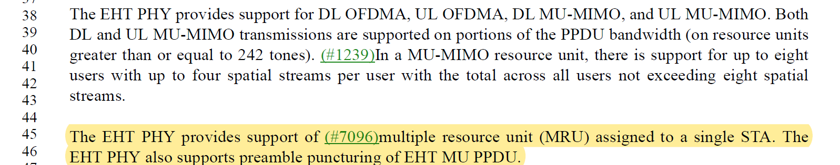

CID 7100, 7956

CID | Clause | Page.Line | Comment | Proposed Change | Resolution
7100 | 36.1.1 | 313.14 | LDPC may be supported as an optional feature "if the maximum number of spatial streams the STA is capable of transmitting or receiving in an EHT MU PPDU less than or equal to 4.". From the list on page 312, it looks like LDPC is mandatory for everything but 20-MHz only STAs. A non-20 MHz only STA with less than 4-stream support should mandatorily support LDPC, correct? | Clarify and correct | REVISED.  Agree with the commenter. This bullet is on LDPC code as an optionally supported feature for 20-MHz only STAs that supports less than 4ss, and does not support MCSs 10, 11, 12 and 13.  Instruction to the editor:  This issue is already addressed in 1903r1, CID4562. No further changes are needed.
7956 | 36.1.1 | 313.14 | LDPC coding could be mandatory in some cases even if a STA supports less than 4SS.  For example, LDPC is mandatory an 80 MHz STA supporting only 1SS. | Delete the bullet starting at P313L14 ("LDPC coding ...") | REVISED.  Agree with the commenter LDPC can be mandatory for STAs supporting less than 4ss. This bullet is on LDPC code as an optionally supported feature for 20-MHz only STAs that supports less than 4ss.  Updated text to be more specific.  Instruction to the editor:  This issue is already addressed in 1903r1,CID4562. No further changes are needed.

Background

D1.3 P435 L7

