IEEE P802.11
Wireless LANs
CC36 CR for EHT PPE Thresholds Field
Date: 2022.01.22
Author(s):
Name | Company | Address | Phone | email
Mengshi Hu | Huawei Technologies | F3-6-A118, Huawei Base, Bantian, Longgang, Shenzhen, Guangdong, China, 518129 |  | humengshi@huawei.com
Ross Yu
Ming Gan
Stephen McCann
Abstract
This submission contains proposed 6 comment resolutions for the comments on P802.11be D1.0.

CIDs: 4518, 4519, 7054, 7732, 7736, 8173

Revision Notes
R0 | Initial revision

CID 7054
Page.  Line | Clause Number | Comment | Proposed Change | Resolution
150.57 | 9.4.2.295c.5 | Figure 9-322av should be Table 9-322av | See comment | ACCEPTED  Note to the editor:  The location is P201, L48 in P802.11be D1.3.

Discussion:
In Draft 1.0:
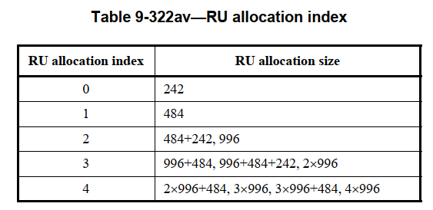
In Draft 1.3:
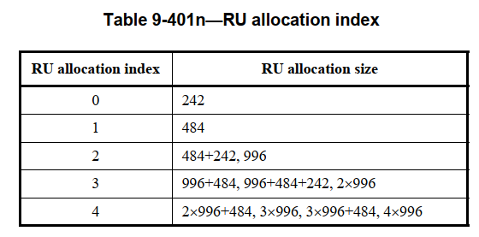

Discussion ends

CID 8173
Page.  Line | Clause Number | Comment | Proposed Change | Resolution
150.54 | 9.4.2.295c.5 | the dot at the end of the sentence is missing. | as in comment | REVISED  Agree with the commenter.  Instructions to the editor:  Add a full stop at the end of the sentence. The location is Page 150, Line 54 for D1.0 or Page 201, Line 44 for D1.3.

Discussion:
Discussion ends

CID 4518
Page.  Line | Clause Number | Comment | Proposed Change | Resolution
151.8 | 9.4.2.295c.5 | Not clear in "but the PPETx and PPET8 values are present" what the present means. Suggest rephrasing the same sentence like "the PPETx and PPET8 subfields for each RU allocation index corresponding to these 0s are not present while the PPETx and PPET8 values of that RU allocation index is the same as the PPETx and PPET8 values of the closest smaller RU allocation index which bitmap value is 1. | as in the comment. | REVISED  To make it clear, the sentence is rephrased.  Instructions to the editor:  Please make the changes as shown in 11/22-0063r1, under CID 7736.

CID 7732
Page.  Line | Clause Number | Comment | Proposed Change | Resolution
151.5 | 9.4.2.295c.5 | "the PPETx and PPET8 subfields for each RU allocation index corresponding to these 0s are not present, but the PPETx and PPET8 values are present, and the values shall be the same as the PPETx and PPET8 values for the closest smaller RU allocation index with  the bitmask value equal to 1 in the RU Index Bitmask subfield" if the fields don't exist how the value present? | the PPETx and PPET8 subfields for each RU allocation index corresponding to these 0s are not present, and the PPETx and PPET8 values shall be the same as the.... | REVISED  To make it clear, the sentence is rephrased.  Instructions to the editor:  Please make the changes as shown in 11/22-0063r1, under CID 7736.  Note: The resolutions for CIDs 4518 and 7732 are the same.

CID 4519
Page.  Line | Clause Number | Comment | Proposed Change | Resolution
150.50 | 9.4.2.295c.5 | Need to add a definition of PPETx. Also, may consider change the name since "Tx" sometimes is easiy to be confused as Transimission. | as in the comment. | REVISED.  Agree. Change “PPETx” into “PPETmax”  Instructions to the editor:  Please make the changes as shown in 11/22-0063r1, under CID 7736.

CID 7736
Page.  Line | Clause Number | Comment | Proposed Change | Resolution
150.40 | 9.4.2.295c.5 | Suggest to change the name of NSS subfield to NSS_PE. Reason is it's easy to be confused with NSS of data stream. E.g. table 35-3 Nss is refering to data but maybe confused with NSS subfield. In addition, NSS should start from 0 not 1, which also need to be clarified. | as commented | REVISED  I agree that NSS subfield is a little bit confusing here, because it does not mean the number of spatial streams being used. The NSS subfield shown here is used to indicate the scope of the PPETx and PPET8 subfields in PPE Thresholds Info field.  To make it clear, it is fine to change the name of NSS subfield.  Change NSS subfield into NSS_PE subfield.  Instructions to the editor:  Please make the changes as shown in 11/22-0063r1, under CID 7736.

Discussion:
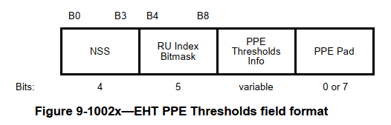
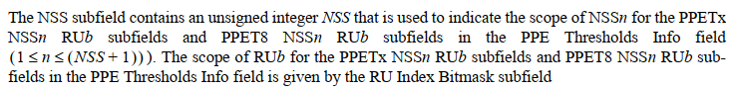

In addition, regarding the comment “NSS should start from 0 not 1”, I think the sentence “the NSS subfield contains an unsigned integer NSS” already reflects the value in NSS subfield starts from 0.

Discussion ends
Instructions to the editor, please make the following changes from P201, L21 in P802.11be D1.3:
        - EHT PPE Thresholds field

The EHT PPE Thresholds field determines the nominal packet padding value (see 35.12 (Nominal packet padding values selection rules)) for a particular RU/MRU size and a particular NSS in an EHT PPDU. The format of the EHT PPE Thresholds field is defined in Figure 9-1002x (EHT PPE Thresholds field format).

B0 B3 B4 B8

NSS_PE | RU Index Bitmask | PPE  Thresholds Info | PPE Pad
Bits: 4 5 variable 0 or 7

Figure 9-1002x—EHT PPE Thresholds field format

The NSS_PE subfield contains an unsigned integer NSS_PE that is used to indicate the scope of NSSn for the PPETmax NSSn RUb subfields and PPET8 NSSn RUb subfields in the PPE Thresholds Info field (1 ≤ n ≤ (NSS_PE + 1) ). The scope of RUb for the PPETmax NSSn RUb subfields and PPET8 NSSn RUb subfields in the PPE Thresholds Info field is given by the RU Index Bitmask subfield.

The RU Index Bitmask subfield contains a bitmask that indicates whether the PPE Thresholds Info field contains PPETmax and PPET8 subfields for the five possible RU allocation indices indicated in Table 9-401n (RU allocation index). The PPETmax and PPET8 subfields for RU allocation index k are present in the PPE Thresholds Info field only if bit k of the RU Index Bitmask subfield (bit 4 + k of the EHT PPE Thresholds field) is 1. For example, if B0 of the RU Index Bitmask subfield (B4 of the EHT PPE Thresholds field) is 1, the PPETmax and PPET8 subfields are present in the PPE Thresholds Info field for the RU allocation size corresponding to the RU allocation index 0 (242-tone RU). If B0 of the RU Index Bitmask subfield is 0, the PPETmax and PPET8 subfields are not present in the PPE Thresholds Info field for the RU allocation size corresponding to the RU allocation index 0. The RU Index Bitmask subfield shall contain at least one bit equal to 1. To indicate nominal packet padding values of 0 µs for all modes, the PPE Thresholds Present subfield and the Common Nominal Packet Padding subfield shall be set to 0 in the EHT Capabilities element (see 35.12 (Nominal packet padding values selection rules) for details). If there exists one or more 0s after the first 1 in the bitmask sequence in the RU Index Bitmask subfield, the PPETmax and PPET8 subfields for each RU allocation index corresponding to these 0s are not present, while the PPETmax and PPET8 values of that RU allocation index shall be the same as the PPETmax and PPET8 values of the closest smaller RU allocation index with the bitmask value equal to 1 in the RU Index Bitmask subfield.
The PPE Thresholds Info field contains 6 × (NSS_PE + 1) bits, where NSS_PE is the value in the NSS_PE field, for every bit in the RU Index Bitmask subfield that is nonzero. The format of the PPE Thresholds Info field is defined in Figure 9-1002y (PPE Thresholds Info field format).
B0 B2 B3 B5
PPETmax NSS1 RUy | PPET8 NSS1 RUy | … | PPETmax NSS1 RUm | PPET8 NSS1 RUm | … | PPETmax NSS(NSS_PE+1)  RUm | PPET8 NSS(NSS_PE+1)  RUm

Bits: 3 3 3 3 3 3
Figure 9-1002y—PPE Thresholds Info field format
The PPETmax and PPET8 subfields for various NSS and RU allocation index values appear in increasing NSS value and increasing RU allocation index value order. Lower numbered PPE Thresholds Info field bits contain PPETmax and PPET8 subfields corresponding to lower numbered NSS values. Within a set of PPETmax and PPET8 subfields corresponding to a single value of NSS, lower numbered PPE Thresholds Info field bits contain PPETmax and PPET8 subfields corresponding to lower numbered RU index values. The PPETmax NSSn RUb and PPET8 NSSn RUb subfields are present for all values of n and b where 1 ≤ n ≤ (NSS_PE + 1) and where b belongs to the set of RU allocation indices [y, …, m] equal to the ordered list of bit positions of all bits that are set to 1 in the RU Index Bitmask subfield, with y being the lowest value.

Each PPETmax NSSn RUb and PPET8 NSSn RUb subfield contains an integer as defined in Figure 9-401m (Constellation index), which is used to compute the nominal packet padding value (see Table 35-4 (PPE thresholds per PPET8 and PPETmax)).
Table 9-401m—Constellation index
Constellation index | Corresponding transmission constellation
0 | BPSK
1 | QPSK
2 | 16-QAM
3 | 64-QAM
4 | 256-QAM
5 | 1024-QAM
6 | 4096-QAM
7 | None

The value of the PPET8 NSSn RUb subfield is always less than the value of the PPETmax NSSn RUb subfield, except if the PPET8 subfield is 7.
The RU allocation index for each RU allocation size is defined in Figure 9-401n (RU allocation index). For RU allocation index 2, 3, and 4, more than one RU/MRU shares the same RU allocation index. The RU allo cation index for the 80 MHz PPDU using EHT-MCS 14 is equal to 2.

Table 9-401n—RU allocation index
RU allocation index | RU allocation size
0 | 242
1 | 484
2 | 484+242, 996
3 | 996+484, 996+484+242, 2×996
4 | 2×996+484, 3×996, 3×996+484, 4×996

The PPE Pad field contains all 0s. The number of bits in the PPE Pad field is the least number of bits required to round the length of the PPE Thresholds Info field to an integer number of octets.

Instructions to the editor, please make the following changes for CID 4519 & 7736 (Draft 1.3):

- Page 421, Line 36:
NOTE 4—The nominal packet padding value is 16 µs for all supported RU/MRU sizes and constellations if the number of spatial streams of the EHT PPDU transmission is greater than (NSS_PE + 1) and less than or equal to 8, where NSS_PE is the value in the NSS_PE subfield.
- Page 422, Line 9:
The PPETmax and PPET8 subfields for an NSS value n are present only if n is less than or equal to (NSS_PE + 1), where NSS_PE is the value in the NSS_PE subfield in the EHT PPE Thresholds field of the EHT Capabilities element. When the number of spatial streams of the EHT PPDU transmission is greater than (NSS_PE + 1) and less than or equal to 8, the nominal packet padding value is 16 µs for all supported RU/MRU sizes and constellations.

- Global search (Draft 1.3):
Change all “PPETx” into “PPETmax”.

