IEEE P802.11
Wireless LANs
CC36 CR for Nominal Packet Padding Values Part 1
Date: 2022.01.13
Author(s):
Name | Company | Address | Phone | email
Mengshi Hu | Huawei Technologies | F3-6-A118, Huawei Base, Bantian, Longgang, Shenzhen, Guangdong, China, 518129 |  | humengshi@huawei.com
Ross Yu
Ming Gan
Stephen McCann
Abstract
This submission contains proposed 10 comment resolutions for the comments on P802.11be D1.0.

CIDs: 4622, 4977, 6147, 6154, 6812, 6813, 6815, 7090, 7733, 7941.

Revision Notes
R0 | Initial revision

CID 4622 (In Annex C)
Page.  Line | Clause Number | Comment | Proposed Change | Resolution
591.51 | Annex C | dot11PPEThresholdsMappingsTable is already defined for HE. Meanwhile "dot11EHTPPEThresholdsMappingsTable" is used below | Change to "dot11EHTPPEThresholdsMappingsTable" | ACCEPTED  Note to the commenter: This proposed change was addressed by Editor in subsequent revisions.  Note to the EDITOR: No further change is needed.

Discussion:
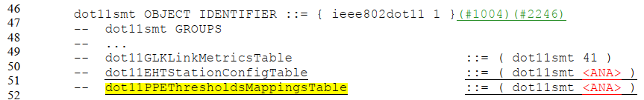

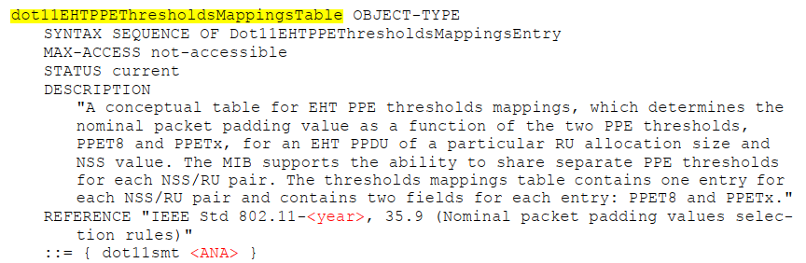
Discussion ends

CID 4977
Page.  Line | Clause Number | Comment | Proposed Change | Resolution
301.43 | 35.9 | Change " ~ derived above. In the case ~" to "~ derived above, in the case ~". | See the comment. | ACCEPTED.  Note to the Editor: Change the full stop into a comma, Followed by replacing “In” with “in”. The location is  Page 301, Line 43 for D1.0 or Page 419, Line 59 for D1.3

Discussion:
According to the third row of the PDT 11-21-0686-02, the full stop in Draft 1.0 should be a comma:
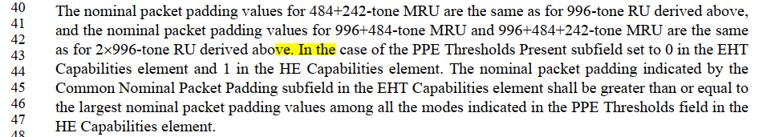
Need to change the full stop to a comma.
Discussion ends

CID 7090
Page.  Line | Clause Number | Comment | Proposed Change | Resolution
301.43 | 35.9 | Looks like incomplete sentence: "In the case of the PPE Thresholds Present subfield set to 0 in the EHT Capabilities element and 1 in the HE Capabilities element." | Correct | REVISED  Instructions to the editor:  Please make the changes as shown in CID 4977 in 11/22-0062r0.  Note: The resolutions for CIDs 4977, 7090, 7733, 7941 are the same.

CID 7733
Page.  Line | Clause Number | Comment | Proposed Change | Resolution
301.43 | 35.9 | In the case of the PPE Thresholds Present subfield set to 0 in the EHT Capabilities element and 1 in the HE Capabilities element. The nominal packet padding indicated | period should be a comma | ACCEPTED

CID 7941
Page.  Line | Clause Number | Comment | Proposed Change | Resolution
301.42 | 35.9 | Typo while implementing https://mentor.ieee.org/802.11/dcn/21/11-21-0686-02-00be-pdt-nominal-packet-padding-values-selection-rules-update-tbd.docx - a 'comma' became a 'period'.  This makes the second sentence of the paragraph starting at P301L40 to be incomplete.  Instead of just following 11-21-0686-02, suggest to rephrase the sentence to make things clearer. | as in comment | REVISED  Instructions to the editor:  Please make the changes as shown in CID 4977 in 11/22-0062r0.  Note: The resolutions for CIDs 4977, 7090, 7733, 7941 are the same.

CID 6154
Page.  Line | Clause Number | Comment | Proposed Change | Resolution
300.07 | 35.9 | "dot11EHTPPETThresholdsRequired" should be "dot11EHTPPEThresholdsRequired" (The T between "PPE" and "Thresholds" shall not exist) | "dot11EHTPPETThresholdsRequired" should be "dot11EHTPPEThresholdsRequired" | ACCEPTED  Note to the Editor: the location is  Page 300, Line 07 for D1.0 or Page 418, Line 07 for D1.3

Discussion:
In Draft 1.0:
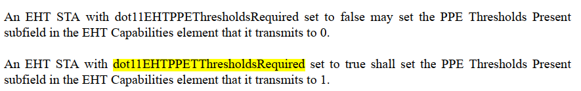
Discussion ends

CID 6147
Page.  Line | Clause Number | Comment | Proposed Change | Resolution
304.13 & 304.19 | 35.9 | "broadcast RU" should be "broadcast RU/MRU". Both Line 13 and 19 need to be changed. | Change "broadcast RU" into "broadcast RU/MRU" in Line 13 and 19 in Page 304. | ACCEPTED  Note to the Editor: The locations are  Page 304, Line 13&19 for D1.0 or Page 422, Line 29&35 for D1.3

Discussion:
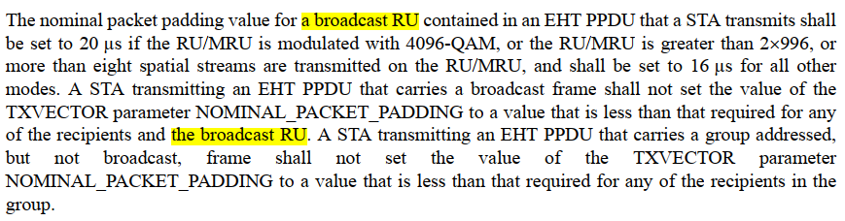
Discussion ends

CID 6812
Page.  Line | Clause Number | Comment | Proposed Change | Resolution
300.37 | 35.9 | Replace "small size RU or MRU" with "RU or MRU of size smaller than 242 tones" | As in comment | REVISED  The small size RU or MRU has been defined in the draft. Thus, it is fine to use them. To make it clear, a reference can be added in this subclause.  Instructions to the editor:  Please make the changes as shown in 11/22-0062r0, under CID 6812.

Discussion:
In Draft 1.3:
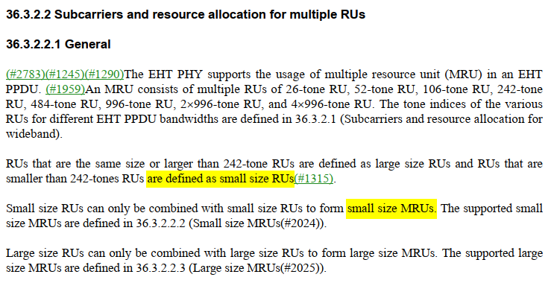
Discussion ends

Instructions to the editor, please make the following changes to P418, L38 in P802.11be D1.3:
An EHT STA that sets the PPE Thresholds Present subfield to 0 in both the EHT and HE Capabilities elements has a nominal packet padding of 0 µs for a small size RU or MRU (see 36.3.2.2 (Subcarriers and resource allocation for multiple RUs)), if 4096-QAM is not used for the RU or MRU; or if the RU size is 106 or the MRU size is 106+26 and EHT-MCS 15 is not applied to them.

CID 6813
Page.  Line | Clause Number | Comment | Proposed Change | Resolution
301.25 | 35.9 | Replace "small size RU or MRU" with "RU or MRU of size smaller than 242 tones" | As in comment | REVISED  A reference related to it has been added in this subclause to improve the readability.  Instructions to the editor:  Please make the changes as shown in 11/22-0062r0, under CID 6812.  NOTE to the commenter and Editor: It is the same resolution as CID 6812.

CID 6815
Page.  Line | Clause Number | Comment | Proposed Change | Resolution
304.02 | 35.9 | Replace "small size RU or MRU" with "RU or MRU of size smaller than 242 tones" | As in comment | REVISED  A reference related to it has been added in this subclause to improve the readability.  Instructions to the editor:  Please make the changes as shown in 11/22-0062r0, under CID 6812.  NOTE to the commenter and Editor: It is the same resolution as CID 6812.

