IEEE P802.11
Wireless LANs
Resolutions to NGV preamble and NGV receive procedure
Date: 2022-01-11
Author(s):
Name | Affiliation | Address | Phone | email
Yujin Noh | Senscomm |  |  | yujin.noh at senscomm.com
Abstract
This submission shows
- Comments from TGbd draft 3.0.
- Resolutions applied to TGbd draft 3.0.
- 14 CIDs:
3101, 3102, 3000, 3059, 3037, 3038, 3096, 3097, 3039, 3098
3040, 3099, 3041, 3100

Revisions:
- Rev 0: Initial version of the document.
- Rev 1:
- typos fixed
- resolution to CID3101 updated.

- Rev 2: updated text proposal in CID3102 and CID3097

CID | P.L | Comment | Proposed Change | Resolution
3101 | 100.01 | The sentence of "NGV-LTF-2x-Repeat is constructed by repeating the time domain symbol of NGV-LTF-2x ... " is a standalone one. Suggest to move it to P102L1 for complete description of NGV-LTF-2x-Repeat construction. | As in the comment. | Revised.  Agreed in principle.  TGbd Editor: Incorporate the changes in 11-22-0019-02-00bd-Resolutions to NGV preamble and NGV receive procedure.
Discussion
No discussion

To TGbd Editor: P100L6 update the description as below.
------------- Begin Text Changes ---------------

An NGV PPDU supports three NGV-LTF formats: NGV-LTF-1x, NGV-LTF-2x, and NGV-LTF-2x-Repeat. NGV-LTF-2x is the default LTF format; NGV-LTF-1x is used for high efficiency transmission of one spatial stream and NGV-LTF-2x-Repeat is used for extended range transmissions. When BPSK-DCM is applied to the NGV Data field of PPDU in 10 MHz, the NGV-LTF symbol uses NGV-LTF-2x-Repeat regardless of the value of the LTF Format subfield in the NGV-SIG field.(#2064, #2281) NGV-LTF-2x-Repeat is constructed by repeating the time domain symbol of NGV-LTF-2x excluding GI and preappend one cyclic prefix of duration 1.6 μs.

------------- End Text Changes ------------------

To TGbd Editor: P102L1 update the description as below.
------------- Begin Text Changes ---------------

NGV-LTF-2x-Repeat is constructed by repeating the time domain symbol of NGV-LTF-2x excluding GI and preappend one cyclic prefix of duration 1.6 μs. The generation of time domain symbol of NGV-LTF-2x-Repeat is equivalent to modulating every tone in an OFDM symbol of 6.4 μs excluding GI, and then the OFDM symbol is repeated in time domain, as shown in Figure 32-12 (Generation of NGV-LTF-2x-Repeat symbols).

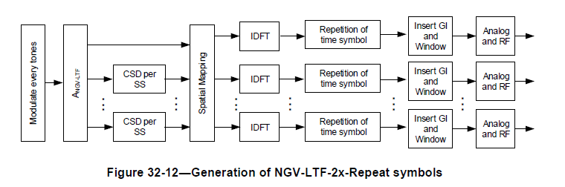

------------- End Text Changes ------------------

CID | P.L | Comment | Proposed Change | Resolution
3102 | 102.38 | The N_NGV-LTF mapping has been changed in Table 32-11 to accommodate LTF_REP. The size of A/R/P matrix is not correct now, which should be NssxN_NGV-LTF. Correspondingly, the definition of P in Eq. (32-26) also needs to be updated to [P2x2 P2x2] to accomodate repeated LTF in NGV ranging NDP. | As in the comment. | Revised.  Agreed in principle  TGbd Editor: Incorporate the changes in 11-22-0019-02-00bd-Resolutions to NGV preamble and NGV receive procedure.
Discussion
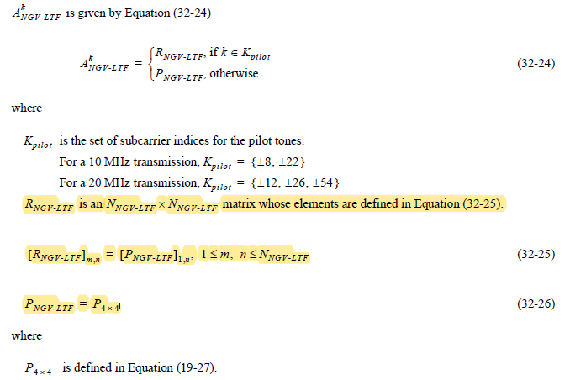

To TGbd Editor: P102L38 update the description as below.
------------- Begin Text Changes ---------------
$R_{NGV-LTF}$ is an $N_{NGV-LTF}N_{SS}×N_{NGV-LTF}$ matrix whose elements are defined in Equation (32-25).
${\left[R_{NGV-LTF}\right]}_{m,n}={\left[P_{NGV-LTF}\right]}_{1,n}, 1≤m,n≤N_{NGV-LTF}, 1≤m≤N_{SS}$ (32-25)
$P_{NGV-LTF}$=$P_{4×4}\left[{ P}_{2×2}{ P}_{2×2}\right]$

where

$P_{4×4}$ definded in Equation (19-27).
$P_{2×2}={P_{4×4}}_{\{1:2, 1:2\}}$, is a submatrix of $P_{4×4}$ with elements of the first two rows and two columns of $P_{4×4}$,
which is definded in Equation (19-27)

------------- End Text Changes ------------------

CID | P.L | Comment | Proposed Change | Resolution
3000 | 120.19 | "Set PHY_CCA indication() in accordance with TBD" , please clarify what is the TBD value for CCA | Define an acceptable CCA level. | Revised.  Agreed in principle. Add the reference to fill the TBD. Same resolution is applied to CIDs 3000 and 3059.  TGbd Editor: replace TBD with 32.3.11.5.
3059 | 120.21 | Fill TBD | as in comment | Revised.  Agreed in principle. Add the reference to fill the TBD. Same resolution is applied to CIDs 3000 and 3059.  TGbd Editor: replace TBD with 32.3.11.5.
Discussion

TBD is shown in Figure 32-17 (PHY receive state machine).
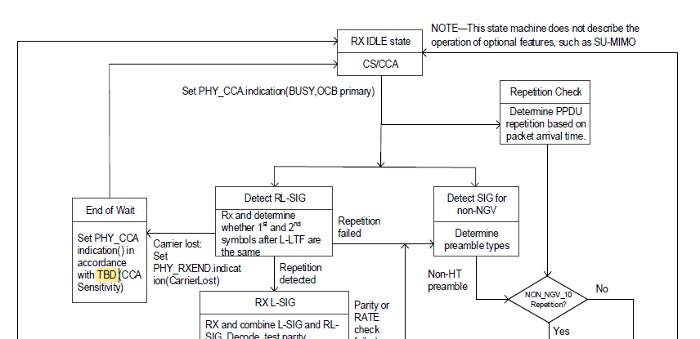

At P115L8, the corresponding subclause is found as below.
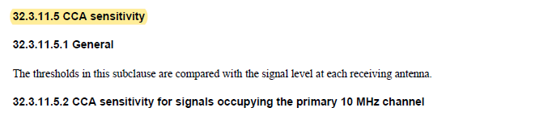

CID | P.L | Comment | Proposed Change | Resolution
3037 | 93.05 | The cyclic shift values defined in 32.3.8.2.1 (Cyclic shift for pre-NGV modulated fields) have nothing to do with the values in Cyclic shift for NGV modulated field. | delete the text "The cyclic shift values defined in 32.3.8.2.1 (Cyclic shift for pre-NGV modulated fields) apply to NGV-SIG and RNGV-SIG fields in the NGV format preamble." | Accepted.
Discussion
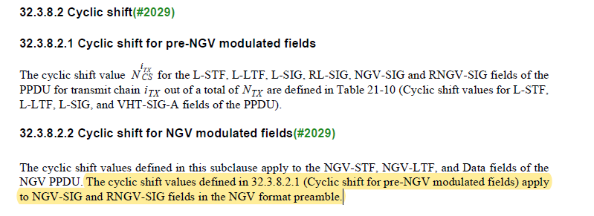

CID | P.L | Comment | Proposed Change | Resolution
3038 | 93.43 | MCS0 or MCS15 should be NGV-MCS 0 or NGV-MCS 15 | as in comment | Accepted.
Discussion

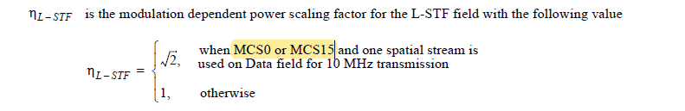

CID | P.L | Comment | Proposed Change | Resolution
3096 | 96.60 | The description in "NOTE" is confusing. It says "Reserved", and also "set to 1 if NGV-LTF-2x-Repeat is used". | Change the NOTE as "NOTE-If NGV-LTF-2x-Repeat is used (see 32.3.8.10 (NGV-LTF definition) with B2 set to 0, B3-B6 set to 15 and B7 set to 0, this field is Reserved and set to 1." | Accepted.
Discussion

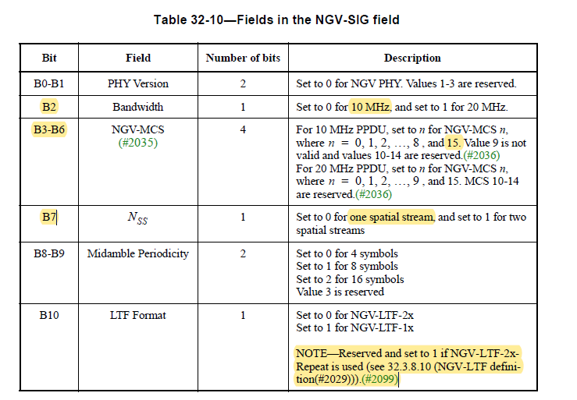

CID | P.L | Comment | Proposed Change | Resolution
3097 | 97.11 | The description for value 0 is redundant. Suggest to follow B11, and describe as "Set to 1 for .... Set to 0 otherwise". | As in the comment. | Revised.  Agreed in principle  TGbd Editor: Incorporate the changes in 11-220019-02-00bd-Resolutions to NGV preamble and NGV receive procedure.
Discussion
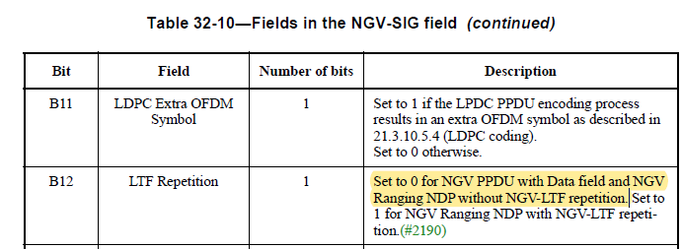

To TGbd Editor: P97L11 update the description as below.
------------- Begin Text Changes ---------------

…
B12 | LTF Repetition | 1 | Set to 0 for NGV PPDU with Data field and NGV  Ranging NDP without NGV-LTF repetition.  Set to 1 for NGV rRanging NDP with NGV-LTF repetition.(#2190).  Set to 0 otherwise.
…

------------- End Text Changes ------------------

CID | P.L | Comment | Proposed Change | Resolution
3039 | 97.17 | delete perid before B14 | as in comment | Accepted.
Discussion

CID | P.L | Comment | Proposed Change | Resolution
3098 | 98.25 | Add the definition of p_3 in Eq. (32-13), similar to p_1 definition in Eq. (32-11). | As in the comment. | Revised.  Agreed in principle.  TGbd Editor: Incorporate the changes in 11-22-0019-02-00bd-Resolutions to NGV preamble and NGV receive procedure.
Discussion

To TGbd Editor: P98L40 update the description as below.
------------- Begin Text Changes ---------------

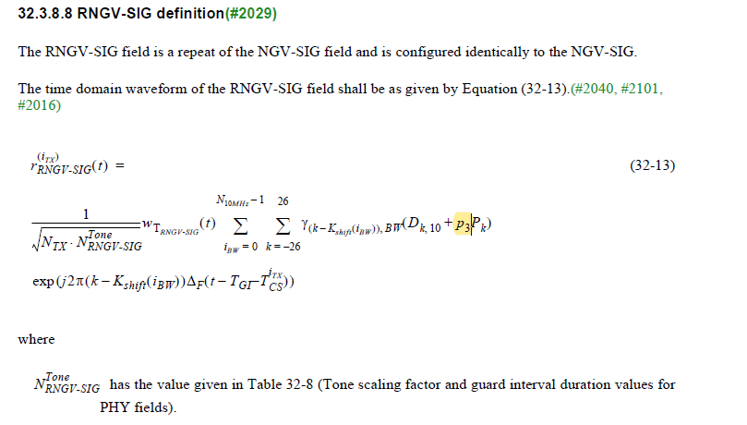
p₃ is the fourth pilot value in the sequence defined in 17.3.5.10 (OFDM modulation).

------------- End Text Changes ------------------

CID | P.L | Comment | Proposed Change | Resolution
3040 | 98.57 | delete period before ,28. -28.,28 should be -28,28 | as in comment | Accepted.
Discussion

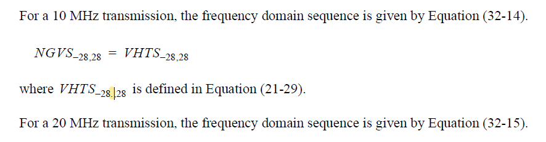

CID | P.L | Comment | Proposed Change | Resolution
3099 | 99.10 | Change "N_STS" to "N_SS" in Eq. (32-16). | As in the comment. | Accepted.
Discussion
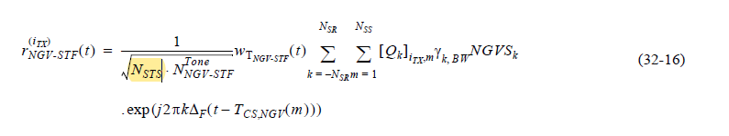

CID | P.L | Comment | Proposed Change | Resolution
3041 | 99.31 | This is the first place to use NGV-LTF such that delete NGV Long Training field and use NGV-LTF instead. | For examplem, "The NGV Long Training field (NGV-LTF) field provides" should be "The NGV-LTF field provides" | Accepted.  Agreed in principle. The intention in the comment seems that this is not the first place to use NGV-LTF.
Discussion
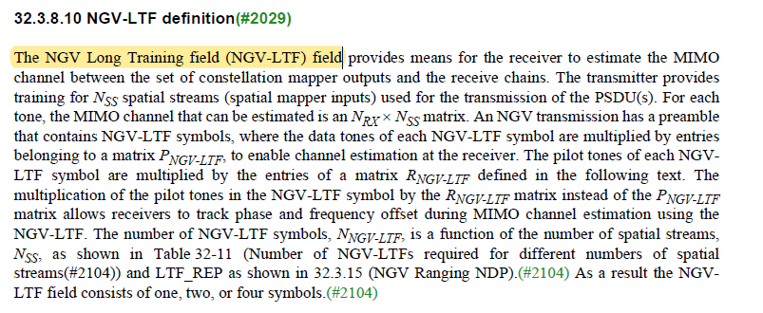

CID | P.L | Comment | Proposed Change | Resolution
3100 | 99.63 | "When BPSK-DCM is applied to the NGV Data field of PPDU in 10 MHz, the NGV-LTF symbol uses NGV-LTF-2x-Repeat", need to add the condition of one spatial stream. It is also not clear how transmitter chooses LTF format and how to signal it. Need to add text to describe that. | Change the text to "A transmitter shall use the NGV-LTF-2x-Repeat format if the NGV Data field of a 10 MHz NGV PPDU is modulated with BPSK-DCM and one spatial stream; the transmitter shall use the NGV-LTF-2x for NGV ranging NDP; Otherwise, the transmitter can choose either NGV-LTF-2x or NGV-LTF-1x. The NGV-LTF format of NGV-LTF-1x or NGV-LTF-2x is signaled by B10 in NGV-SIG field. The NGV-LTF-2x-Repeat format is signaled by the combination of B2 equals 0, B3-B6 equals 15 and B7 equals 0 in NGV-SIG, and B10 is Reserved". | Revised.  Agreed in principle. This description is not enough to cover all the cases for each NGV-LTF format to be used under certain condition. Resolution to CID 3096 is reused for the condition of NGV-LTF-2x Repeat format.  TGbd Editor: Incorporate the changes in 11-22-0019-02-00bd-Resolutions to NGV preamble and NGV receive procedure.
Discussion
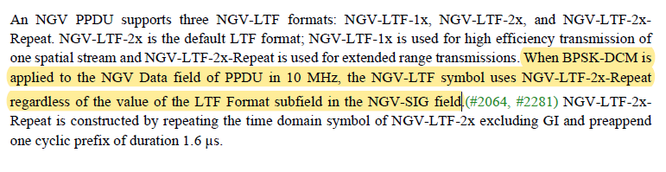

In accordance with the 11bd specification,

A transmitter shall use
- The NGV-LTF-2x-Repeat format if the NGV Data field of a 10 MHz NGV PPDU is modulated with BPSK-DCM and one spatial stream
- only the NGV-LTF-2x format, if the NGV Data field is modulated with two spatial streams
- only the NGV-LTF-2x format, if NGV ranging NDP is transmitted
Otherwise, the transmitter can choose either NGV-LTF-2x or NGV-LTF-1x.

To TGbd Editor: P99L63 update the description as below.
------------- Begin Text Changes ---------------

An NGV PPDU supports three NGV-LTF formats: NGV-LTF-1x, NGV-LTF-2x, and NGV-LTF-2x-Repeat. NGV-LTF-2x is the default LTF format; NGV-LTF-1x is used for high efficiency transmission of one spatial stream and NGV-LTF-2x-Repeat is used for extended range transmissions. When BPSK-DCM is applied to the NGV Data field of PPDU in 10 MHz, the NGV-LTF symbol uses NGV-LTF-2x-Repeat regardless of the value of the LTF Format subfield in the NGV-SIG field. A transmitter shall use the NGV-LTF-2x-Repeat format if the NGV Data field of a 10 MHz NGV PPDU is modulated with BPSK-DCM and one spatial stream; the transmitter shall use the NGV-LTF-2x if the NGV Data field is modulated with two spatial streams; the transmitter shall use the NGV-LTF-2x for NGV ranging NDP; otherwise, the transmitter can choose either NGV-LTF-2x or NGV-LTF-1x. The NGV-LTF format of NGV-LTF-1x or NGV-LTF-2x is signaled by B10 in NGV-SIG field. The NGV-LTF-2x-Repeat format is signaled by the combination of B2 set to 0, B3-B6 set to 15 and B7 set to 0 in NGV-SIG field, and B10 is Reserved and set to 1.

------------- End Text Changes ------------------

