IEEE P802.11  
Wireless LANs

|  |  |  |  |  |
| --- | --- | --- | --- | --- |
| Resolutions to NGV PHY Introduction to Mathematical description of signals | | | | |
| Date: 2022-01-11 | | | | |
| Author(s): | | | | |
| Name | Affiliation | Address | Phone | email |
| Yujin Noh | Senscomm |  |  | yujin.noh at senscomm.com |
|  |  |  |  |  |

Abstract

This submission shows

* Comments from TGbd draft 3.0.
* Resolutions applied to TGbd draft 3.0.
* 13 CIDs:   
  3028, 3029, 3091, 3092, 3030, 3031, 3093, 3094, 3032, 3033

3034, 3035, 3036

Revisions:

* Rev 0: Initial version of the document.
* Rev 1  
  - typos fixed  
  - resolution to 3091 updated.

|  |  |  |  |  |
| --- | --- | --- | --- | --- |
| **CID** | **P.L** | **Comment** | **Proposed Change** | **Resolution** |
| 3028 | 80.47 | add NGV-STF and NGV-LTF after RNGV-SIG fields because two field are part of NGV PHY preamble followed by PSDU. | For example, it could be "During transmission, a single PSDU is processed and appended to the NGV PHY preamble including L-STF, L-LTF, L-SIG, RL-SIG, NGV-SIG, RNGV-SIG, NGV-STF, and NGV-LTF fields to create the NGV PPDU." | Accepted. |

***Discussion***

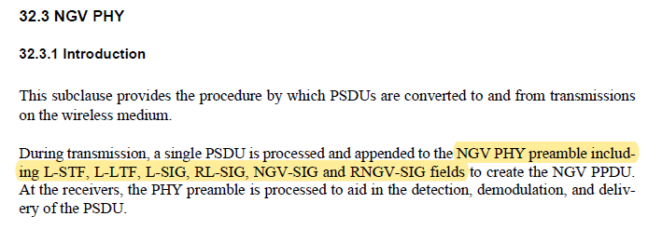

|  |  |  |  |  |
| --- | --- | --- | --- | --- |
| **CID** | **P.L** | **Comment** | **Proposed Change** | **Resolution** |
| 3029 | 81.33 | N_NGV_LTF can be determined by SS and LTF_REP(not only SS) as currently described. | For example, sentence could be updated as ".....N_NGV_LTF can be 1, 2, or 4 and is determined by the total number of spatial streams .... and LTF_REP..." If needed, the reference to LTF_REP also could be added. | Revised.  Agreed in principle.  The same resolution to CID3029 and 3091.  TGbd Editor: change to "can be 1, 2 or 4 and is determined by the total number of spatial streams being transmitted in the NGV PPDU and whether the NGV-LTF is repeated in NGV ranging NDP" |
| 3091 | 81.33 | N_NGV_LTF can be 4 for NGV ranging NDP. | Change "can be either 1 or 2 and is determined by the total number of spatial streams being transmitted in the NGV PPDU" to "can be 1, 2 or 4 and is determined by the total number of spatial streams being transmitted in the NGV PPDU and whether the NGV-LTF is repeated in NGV ranging NDP"; | Accepted.  The same resolution to CID3029 and 3091. |

***Discussion***

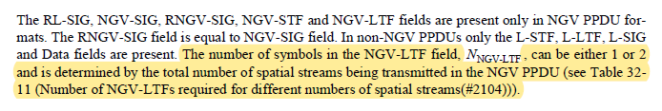

|  |  |  |  |  |
| --- | --- | --- | --- | --- |
| **CID** | **P.L** | **Comment** | **Proposed Change** | **Resolution** |
| 3092 | 81.55 | There is no "LDPC tone mapper" in NGV PPDU, remove block i) in the list. | As in the comment. | Accepted. |

***Discussion***

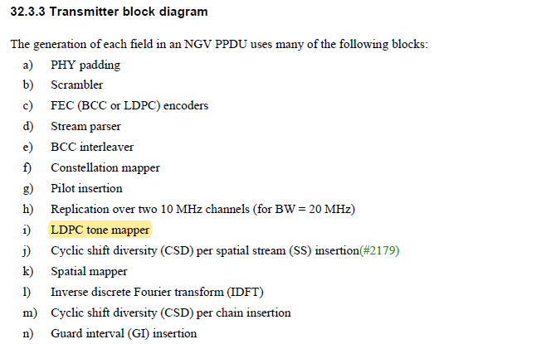

11bd has decided not to support LDPC tone mapper based on the DCN20/887.

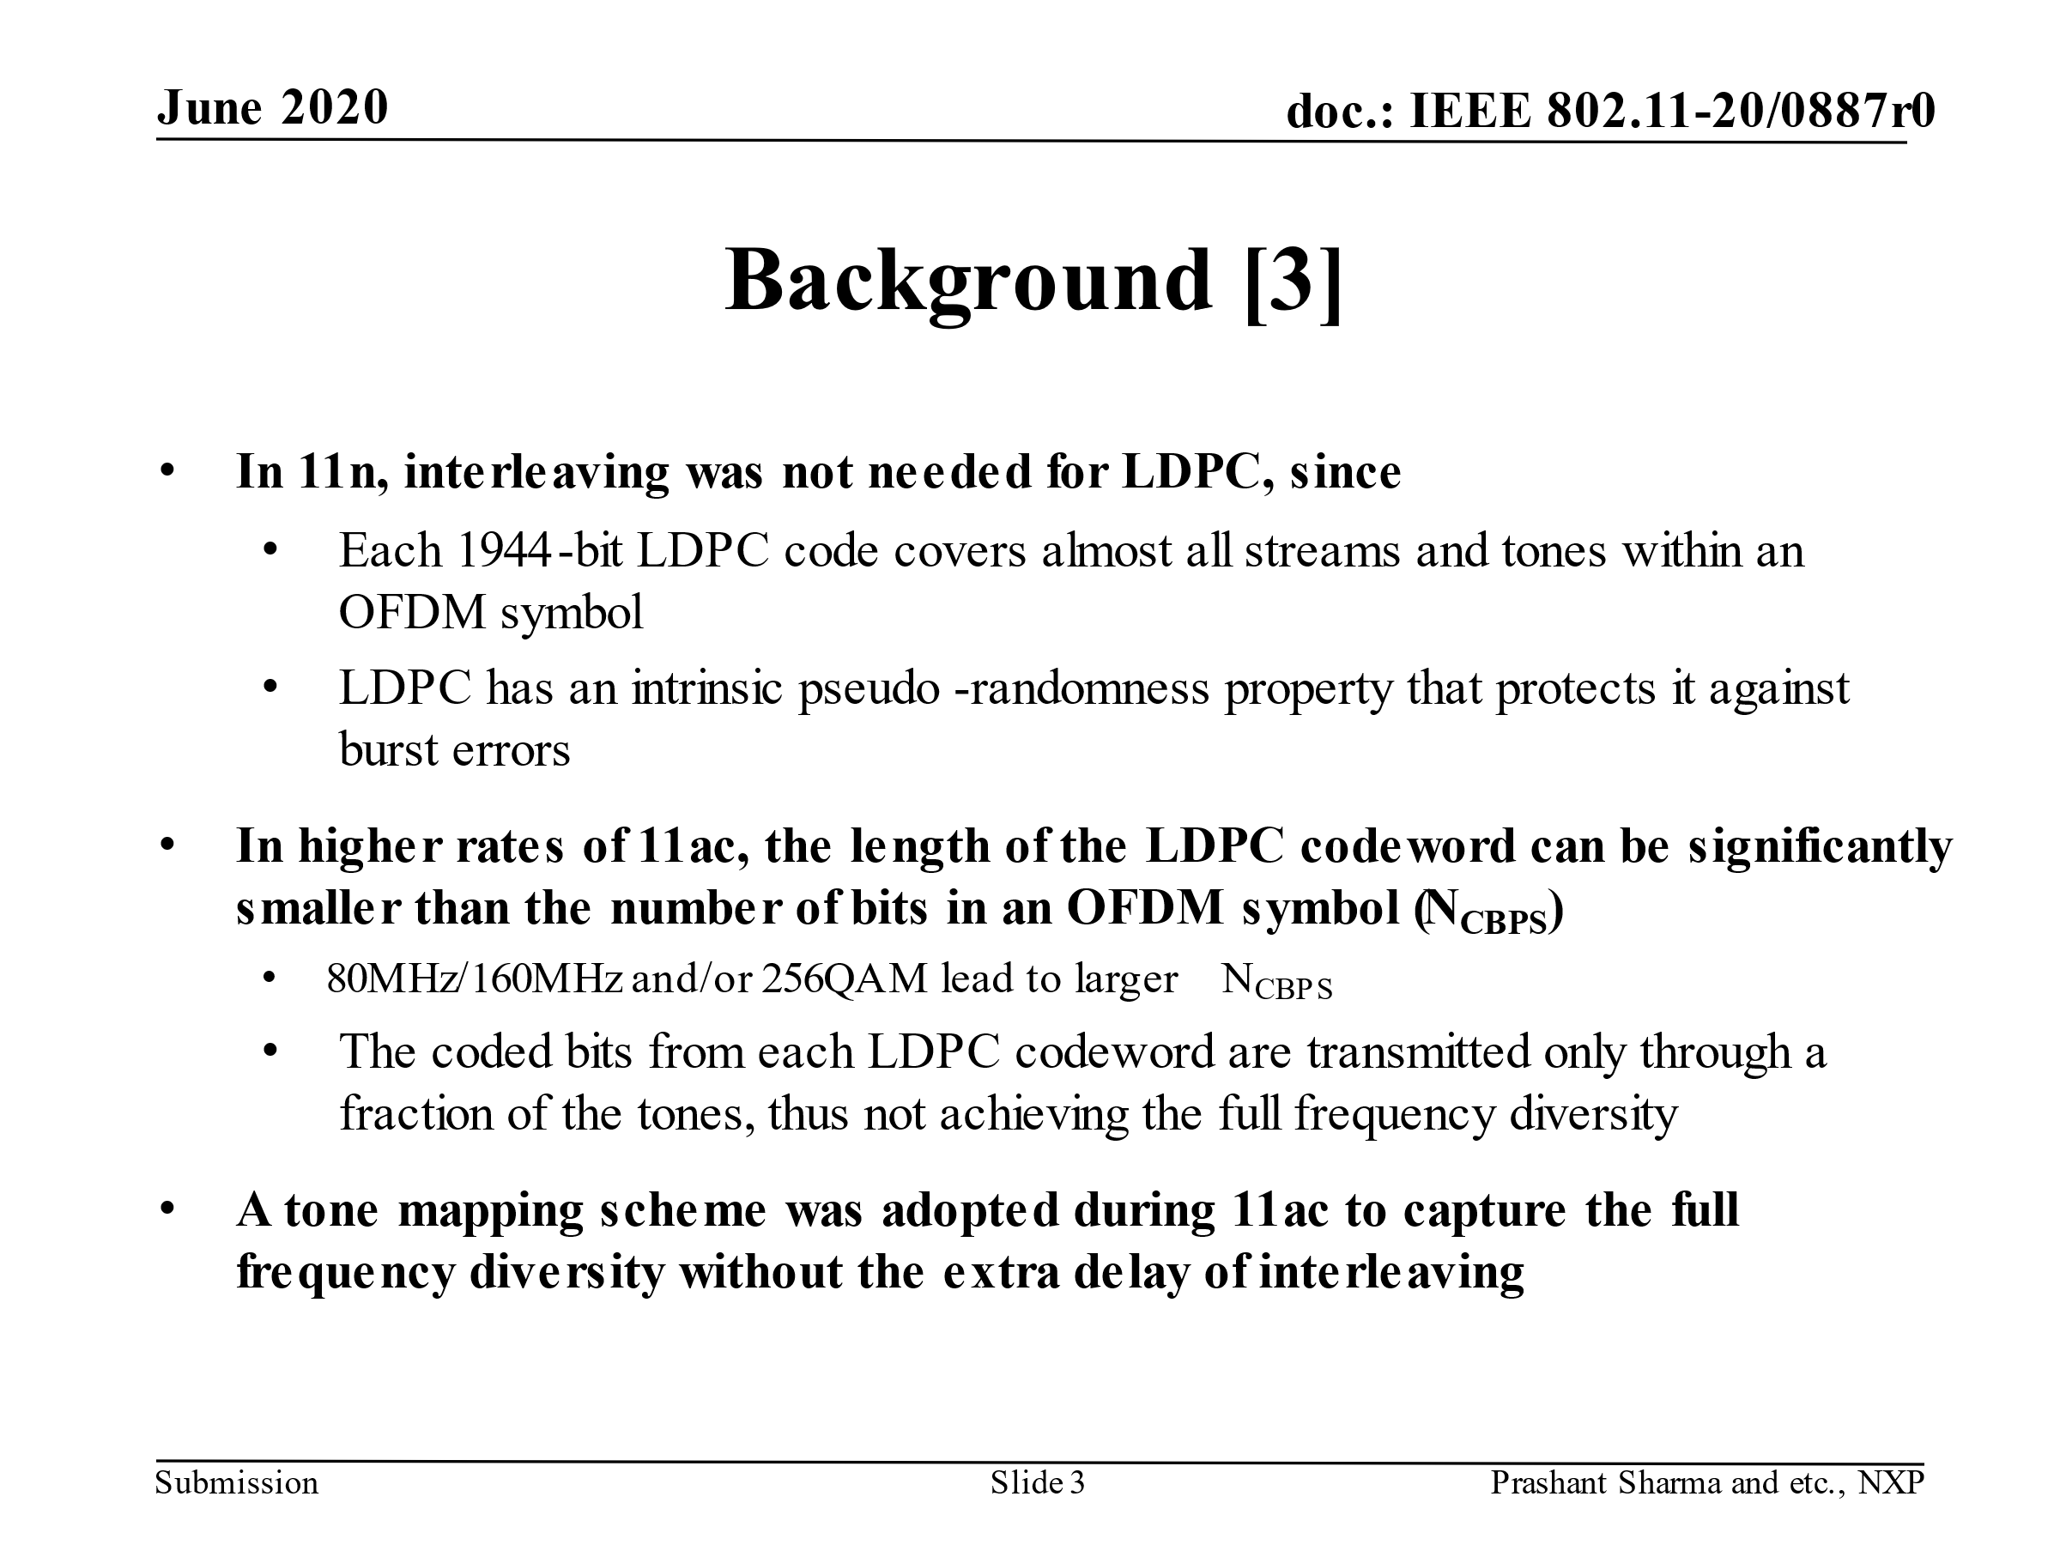

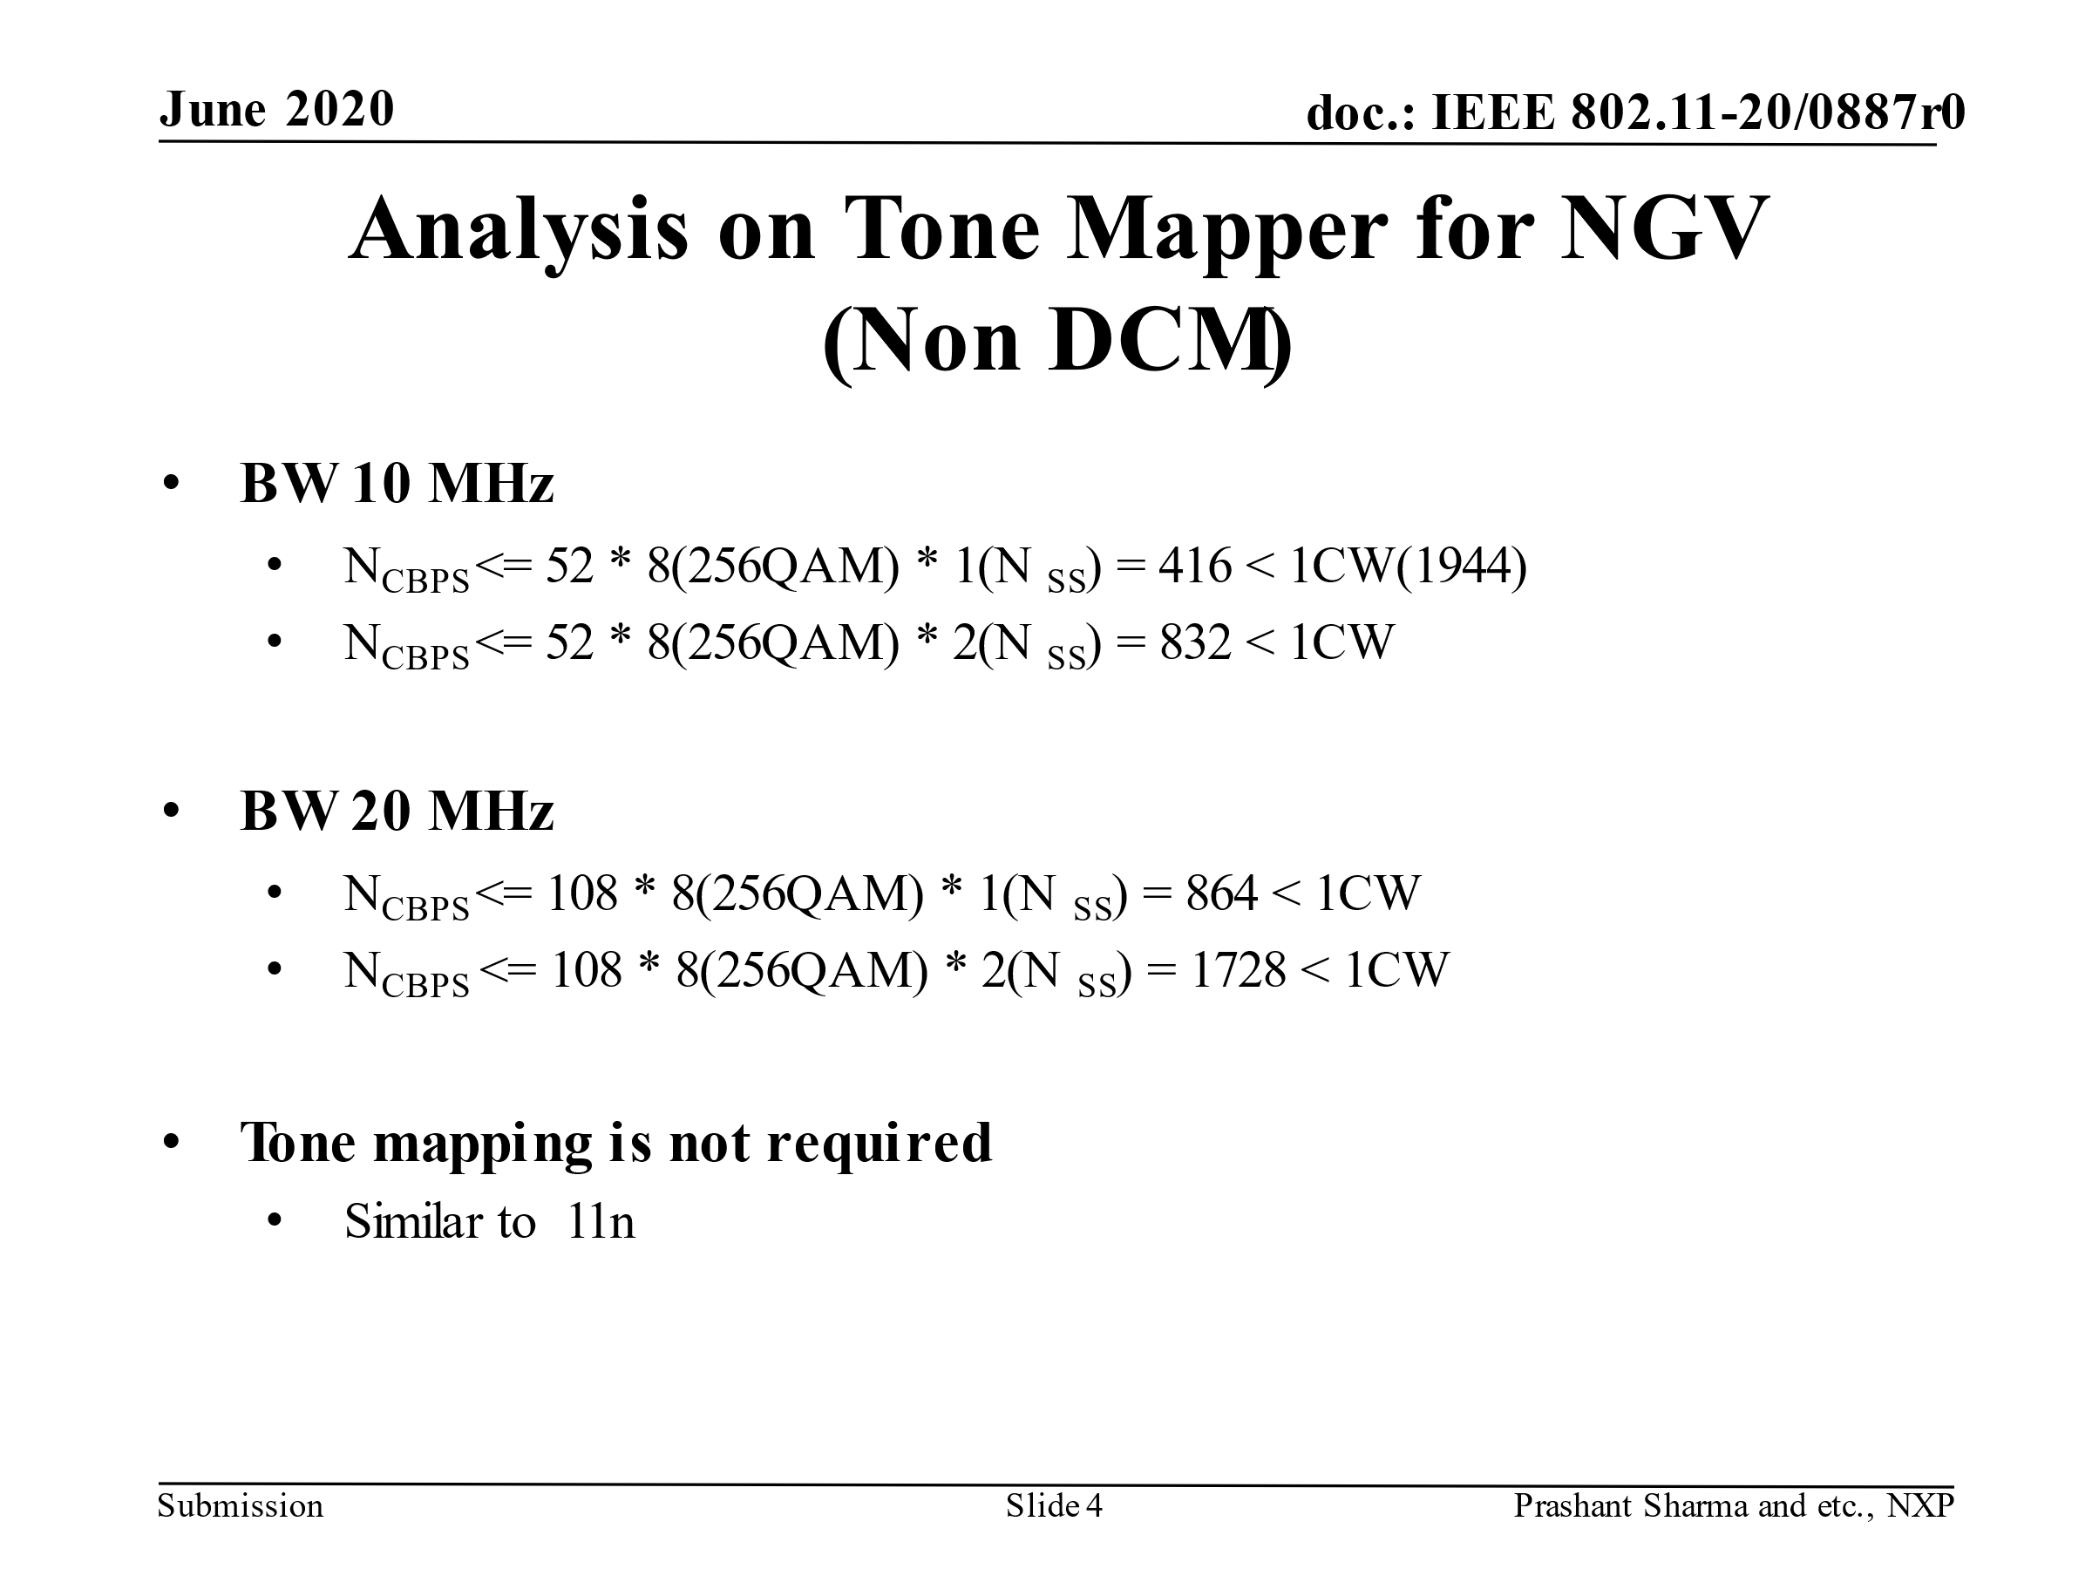

|  |  |  |  |  |
| --- | --- | --- | --- | --- |
| **CID** | **P.L** | **Comment** | **Proposed Change** | **Resolution** |
| 3030 | 83.01 | MCS field should be NGV-MCS field. | as in comment | Accepted |
| 3031 | 83.02 | NGV SIG should be NGV-SIG field | as in comment | Accepted |
| 3093 | 83.13 | "Pilot Insertion" block is missing in Figure 32-7. | Add "Pilot Insertion" block in the figure. | Revised.  Same resolution to CIDs 3093 and 3094. Combing Figure 32-7 and 32-8, the comment is naturally resolved.  TGbd Editor: Incorporate the text changes in 11-22-0018-01-00bd-Resolutions to NGV PHY Introduction to Mathematical description of signals.  TGbd Editor: Incorporate the figure changes in 11-22-0020-00-00bd-Fig32-7 transmitter block diagram for the data field of an NGV transmssion with single SS which is visio file. |
| 3094 | 83.13 | "Sptial Mapping" block is missing in Figure 32-7. As there is only one PPDU format and coding for NGV Data, and the only difference between Figure 32-7 and Figure 32-8 is the number of sreams. Suggest to merge two figures into one, same as 11n/ac. | as in the comment. | Revised.  Agreed in principle. Two figures are merged into Figure 32-7.  Same resolution to CIDs 3093 and 3094.  TGbd Editor: Incorporate the text changes in 11-22-0018-01-00bd-Resolutions to NGV PHY Introduction to Mathematical description of signals.  TGbd Editor: Incorporate the figure changes in 11-22-0020-00-00bd-Fig32-7 transmitter block diagram for the data field of an NGV transmssion with single SS which is visio file. |

***Discussion***

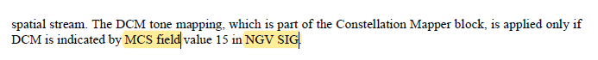

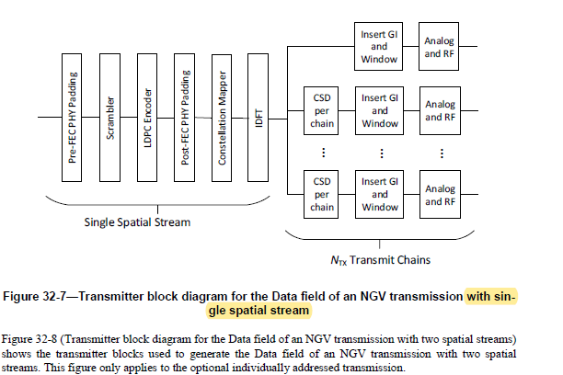

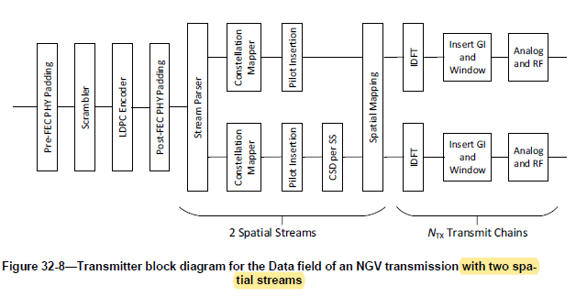

***To TGbd Editor:*** ***P82L43*** *update the description as below.*

***------------- Begin Text Changes ---------------***

Figure 32-7 (Transmitter block diagram for the Data field of an NGV transmission ~~with single spatial stream~~) shows the transmitter blocks used to generate the Data field of an NGV transmission ~~with single spatial stream~~. The DCM tone mapping, which is part of the Constellation Mapper block, is applied only if DCM is indicated by NGV-MCS field value 15 in NGV-SIG field.

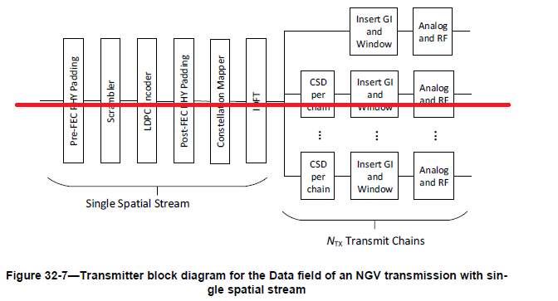



**Figure 32-7⎯Transmitter block diagram for the Data field of an NGV transmission**

~~Figure 32-8 (Transmitter block diagram for the Data field of an NGV transmission with two spatial streams) shows the transmitter blocks used to generate the Data field of an NGV transmission with two spatial streams. This figure only applies to the optional individually addressed transmission.~~

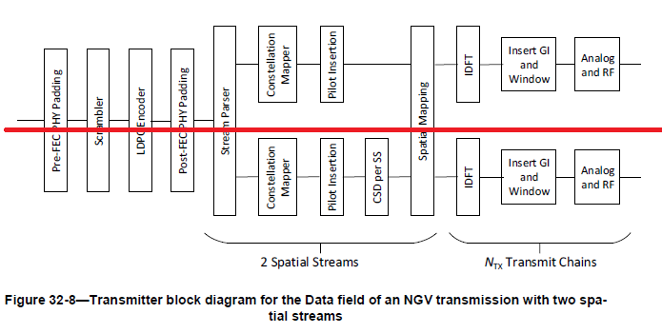

***------------- End Text Changes ------------------***

|  |  |  |  |  |
| --- | --- | --- | --- | --- |
| **CID** | **P.L** | **Comment** | **Proposed Change** | **Resolution** |
| 3032 | 85.24 | L-SIG should be L-SIG field | as in comment | Accepted. |

***Discussion***



|  |  |  |  |  |
| --- | --- | --- | --- | --- |
| **CID** | **P.L** | **Comment** | **Proposed Change** | **Resolution** |
| 3033 | 85.65 | NGV-SIG should be NGV-SIG field. | as in comment | Accepted. |

***Discussion***



|  |  |  |  |  |
| --- | --- | --- | --- | --- |
| **CID** | **P.L** | **Comment** | **Proposed Change** | **Resolution** |
| 3034 | 88.58 | add LTF_REP at the end of the Table 32-7 | as in comment | Revised.  Agreed in principle  TGbd Editor: Incorporate the changes in 11-22-0018-01-00bd-Resolutions to NGV PHY Introduction to Mathematical description of signals. |

***Discussion***

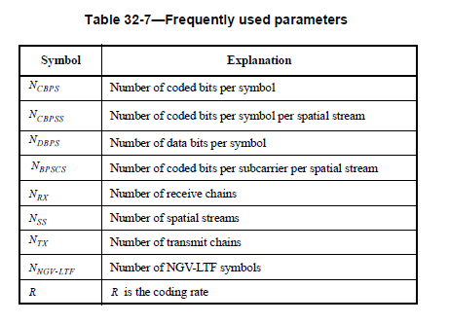

***To TGbd Editor:*** ***P88L142*** *update the table as below.*

***------------- Begin Text Changes ---------------***

|  |  |
| --- | --- |
| * Frequently used parameters | |
| Symbol | Explanation |
|  | Number of coded bits per symbol |
|  | Number of coded bits per symbol per spatial stream |
|  | Number of data bits per symbol |
|  | Number of coded bits per subcarrier per spatial stream |
|  | Number of receive chains |
|  | Number of spatial streams |
|  | Number of transmit chains |
|  | Number of NGV-LTF symbols |
|  | is the coding rate |
| LTF_REP | Number of repetitions of the NGV-LTF symbols |

***------------- End Text Changes ------------------***

|  |  |  |  |  |
| --- | --- | --- | --- | --- |
| **CID** | **P.L** | **Comment** | **Proposed Change** | **Resolution** |
| 3035 | 89.08 | delete "and 21.3.7.1 (Notation)". There is no meaning added by refering 21.3.7.1 (Notation) | as in comment | Rejected.  21.3.7.1 is the first location to describe the dimension of the Q matrix which is important concept. It is good to have here in Notation part. |

***Discussion***

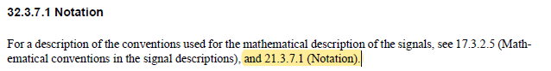

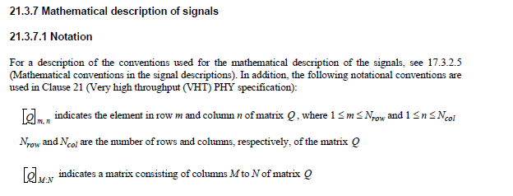

|  |  |  |  |  |
| --- | --- | --- | --- | --- |
| **CID** | **P.L** | **Comment** | **Proposed Change** | **Resolution** |
| 3036 | 91.44 | MCS 0 or MCS 15 should be NGV-MCS 0 or NGV-MCS 15. | as in comment | Accepted. |

***Discussion***

