IEEE P802.11
Wireless LANs
Resolutions to Annex C
Date: 2022-01-11
Author(s):
Name | Affiliation | Address | Phone | email
Yujin Noh | Senscomm |  |  | yujin.noh at senscomm.com
Hiroyuki Motozuka | Panasonic | 600 Saedo-cho, Tsuzuki-ku, Yokohama, Kanagawa, Japan |  | motozuka.hiroyuki@jp.panasonic.com
Abstract
This submission shows
- Comments from TGbd draft 3.0.
- Resolutions applied to TGbd draft 3.0.
- 4 CIDs:
3023, 3021, 3022, and 3046

Revisions:
- Rev 0: Initial version of the document.
- Rev 1: CID3022 updated

CID | P.L | Comment | Proposed Change | Resolution
3023 | 0.00 | The description of "dot11StationmeasurementPeriod" should be similar to "dot11RadioEnvironmentMeasurementPeriod". | Please add "It is written by an external management entity or the SME. Changes take effect as soon as practical in the implementations." after the first sentence in the description | Accepted.  Note: TGbd Editor: the location is at P136L12.
Discussion

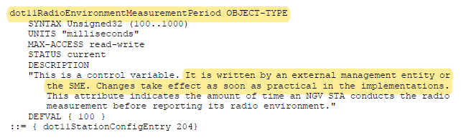

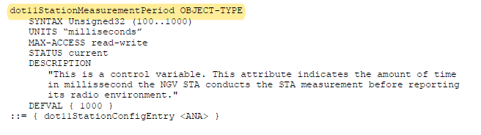

CID | P.L | Comment | Proposed Change | Resolution
3021 | 135.26 | The "dot11NONNGVRadioEnvionrmentSupported" entry is not formated as the other entries | Format the entry as the other entries | Revised.  Agreed in principle  TGbd Editor: Incorporate the changes in 11-22-0017-01-00bd-Resolutions to Annex C.
Discussion

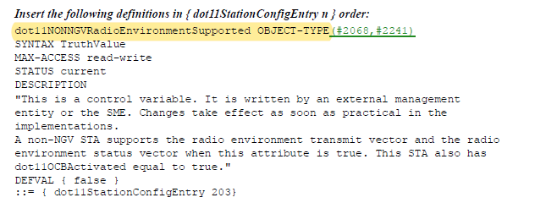

To TGbd Editor: P135L27 update the description as below.
------------- Begin Text Changes ---------------

dot11NONNGVRadioEnvironmentSupported OBJECT-TYPE(#2068,#2241)
SYNTAX TruthValue
MAX-ACCESS read-write
STATUS current
DESCRIPTION
"This is a control variable. It is written by an external management entity or
the SME. Changes take effect as soon as practical in the implementations. A non-
NGV STA supports the radio environment transmit vector and the radio environment
status vector when this attribute is true. This STA also has dot11OCBActivated
equal to true."
DEFVAL { false }
::= { dot11StationConfigEntry 203}
------------- End Text Changes ------------------

CID | P.L | Comment | Proposed Change | Resolution
3022 | 135.42 | In C.3 dot11NGVActivated is defined twice on P135L42-52 and differently on P136L2-10. | Delete second definition on P136L2fl10 | Revised.  It turned out that the second “dot11NGVActivated” should be replaced with “dot11VirtualCSonOCBSecondaryImplemented” in DCN 21/0070r5.  TGbd Editor: change “dot11NGVActivated” should be replaced to “dot11VirtualCSonOCBSecondaryImplemented” at P136L02
Discussion

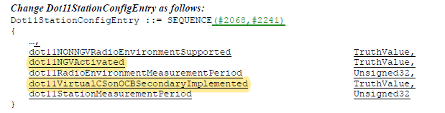

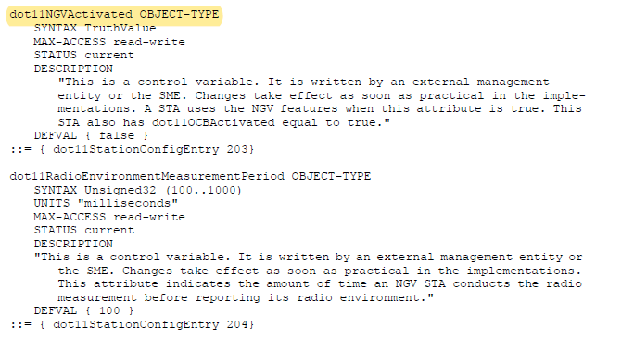
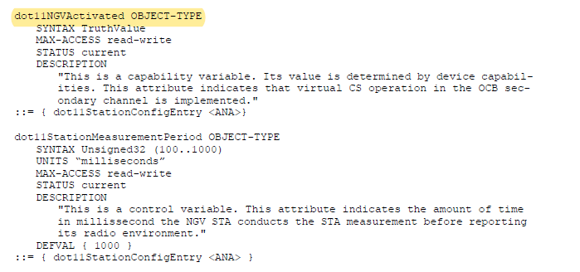

In DCN 21/0070r5,

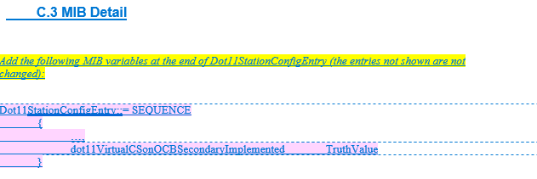
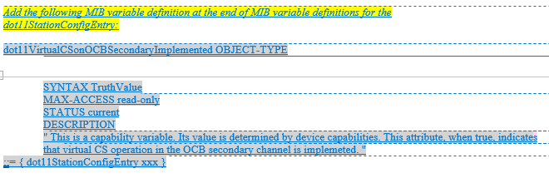

CID | P.L | Comment | Proposed Change | Resolution
3046 | 138.36 | "dot11PhyNGVEntry 5" is used twice. | Please change "dot11PhyNGVEntry 5" to "dot11PhyNGVEntry 6" for dot11NGVDYN20MAllowed that is at P138L36. | Accepted.
Discussion

