IEEE P802.11
Wireless LANs
Resolutions to Editorial Comments Part 2
Date: 2022-01-11
Author(s):
Name | Affiliation | Address | Phone | email
Yujin Noh | Senscomm |  |  | yujin.noh at senscomm.com
Abstract
This submission shows
- Comments from TGbd draft 3.0.
- Resolutions applied to TGbd draft 3.0.
- 15 CIDs:
3003, 3104, 3072, 3075, 3055, 3056, 3008, 3026, 3049, 3050,
3013, 3024, 3025, 3086, and 3095

Revisions:
- Rev 0: Initial version of the document.
- Rev 1: update resolution to CID 3056

CID | P.L | Comment | Proposed Change | Resolution
3003 | 116.55 | TXVECTOR is typically described as having parameters not elements, so "The TXVECTOR elements ..." is odd | Change to "The TXVECTOR parameters ..." | Accepted.
Discussion

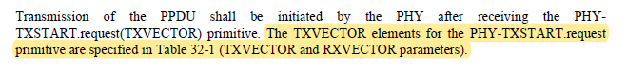
The commentor is correct that the TXVECTOR “parameter” is the common terminogy in the spec even though the TXVECTOR elements have been used in the transmit procedure section of the several amendments. However, the lastest amendments such as 11ax and 11be starts using the TXVECTOR parameter even in the transmit procedure section.

CID | P.L | Comment | Proposed Change | Resolution
3104 | 139.18 | As there is no change to Annex D.2.1 and D.2.2, suggest to remove these two subclauses in the 11bd draft. | As in the comment. | Accepted
Discussion

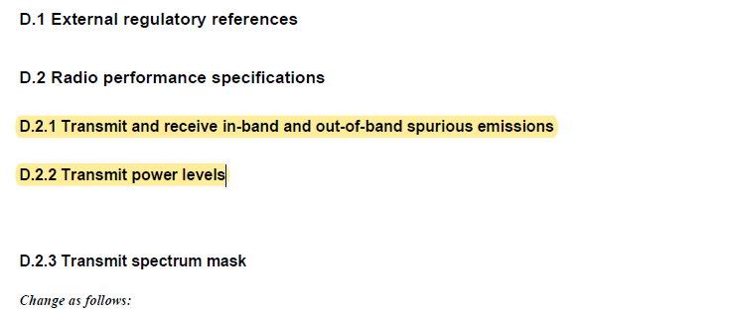

CID | P.L | Comment | Proposed Change | Resolution
3072 | 19.15 | OCB is defined in the first paragraph in the OCB clause, so there is no need to spell it out in the forth paragraph. Simply used OCB. | Delete "outside the context of a BSS" and remove the parentheses from around OCB. | Accepted.
Discussion

In IEEE Std 802.11™-2020,
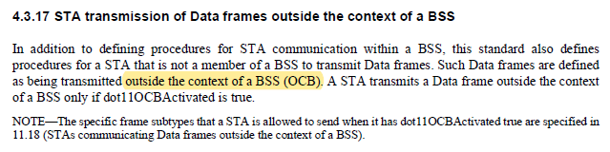

In 11bd D3.0,
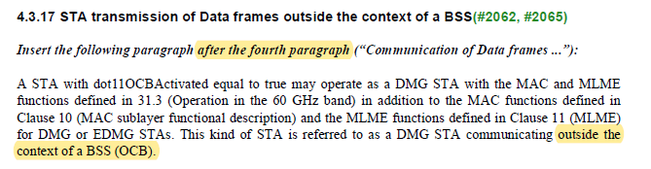

CID | P.L | Comment | Proposed Change | Resolution
3075 | 19.25 | NGV must be spelled out at first use, in the paragraph, it is not enough to spell it out in the clause title. | Replace the first instance of: "NGV"  With: "Next Generation Vehicle-to-everything (NGV)" | Accepted
Discussion

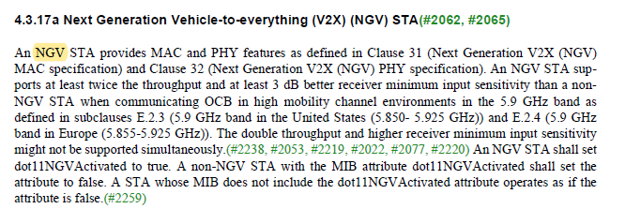

CID | P.L | Comment | Proposed Change | Resolution
3055 | 19.53 | The relationship of the dot bullets items to the dash bullet items is not clear and should be explicitly stated. Also, it is not clear if the mandatory support for some items applies to all 10 MHz and 20 MHz PPDUs or just 10 MHz and 20 MHz NGV PPDUs. | Rewrite as follows (dash bullet level):  - Mandatory support for the 10 MHz NGV PPDU format and optional support for the 20 MHz NGV PPDU and 20 MHz non-NGV duplicate PPDU formats.  - For the 20 MHz and 10 MHz NGV PPDU, mandatory support for LDPC coding, midambles, BPSK-DCM, and 256-QAM.  - For the 20 MHz NGV PPDU, mandatory support for transmit spectral mask C2. | Revised.  Agreed in principle.  TGbd Editor: Incorporate the changes in 11-22-0016-01-00bd-Resolutions to Editorial Comments Part 2
Discussion

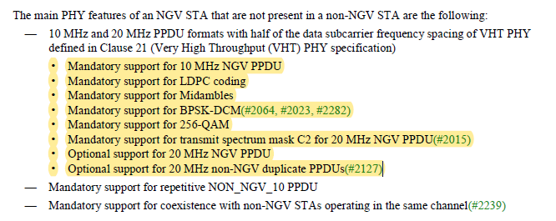
Rearraning features
from
- 10 MHz and 20 MHz PPDU formats with half of the data subcarrier frequency spacing of VHT PHY defined in Clause 21 (Very High Throughput (VHT) PHY specification)
- Mandatory support for 10 MHz NGV PPDU
- Mandatory support for LDPC coding
- Mandatory support for Midambles
- Mandatory support for BPSK-DCM (#2064, #2023, #2282)
- Mandatory support for 256-QAM
- Mandatory support for transmit spectrum mask C2 for 20 MHz NGV PPDU (#2015)
- Optional support for 20 MHz NGV PPDU
- Optional support for 20 MHz non-NGV duplicate PPDUs (#2127)

To
- Mandatory support for the 10 MHz NGV PPDU format and optional support for the 20 MHz NGV PPDU and 20 MHz non-NGV duplicate PPDU formats
- For the 20 MHz and 10 MHz NGV PPDU, mandatory support for LDPC coding, midambles, BPSK-DCM, and 256-QAM
- For the 20 MHz NGV PPDU, mandatory support for transmit spectral mask C2.

To TGbd Editor: P19L49 update the description as below.
------------- Begin Text Changes ---------------

The main PHY features of an NGV STA that are not present in a non-NGV STA are the following:
- 10 MHz and 20 MHz PPDU formats with half of the data subcarrier frequency spacing of VHT PHY defined in Clause 21 (Very High Throughput (VHT) PHY specification)
- Mandatory support for 10 MHz NGV PPDU
- Mandatory support for LDPC coding
- Mandatory support for Midambles
- Mandatory support for BPSK-DCM (#2064, #2023, #2282)
- Mandatory support for 256-QAM
- Mandatory support for transmit spectrum mask C2 for 20 MHz NGV PPDU (#2015)
- Optional support for 20 MHz NGV PPDU
- Optional support for 20 MHz non-NGV duplicate PPDUs (#2127)
- Mandatory support for the 10 MHz NGV PPDU format and optional support for the 20 MHz NGV PPDU and 20 MHz non-NGV duplicate PPDU formats.
- For the 20 MHz and 10 MHz NGV PPDU, mandatory support for LDPC coding, midambles, BPSK-DCM, and 256-QAM.
- For the 20 MHz NGV PPDU, mandatory support for transmit spectral mask C2.
- Mandatory support for repetitive NON_NGV_10 PPDU

------------- End Text Changes ------------------

CID | P.L | Comment | Proposed Change | Resolution
3056 | 20.40 | Non-TB Ranging: unnecessary capitalization | Change to "non-TB ranging". TGaz should make a similar change. | Revised.  Agreed in principle. There are additional locations to be modified as suggested.  TGbd Editor: Incorporate the changes as proposed at P20L41, P38L13, P66L5, P66L21, P66L24, P141L25, and P142L40.  TGbd Ediotr: as for reference, 11.21.6.4.4 (Non-TB Ranging measurement exchange) should be replaced with 11.21.6.4.4 (Non-TB ranging measurement exchange) at P20L43, P38L13, P66L5, P66L52, P129L60, and P131L06.  TGbd Editor: Incorporate the changes in 11-22-0016-01-00bd-Resolutions to Editorial Comments Part 2
Discussion 1

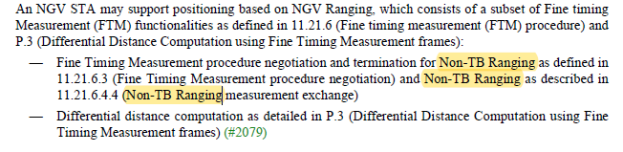
Discussion 2

In 11bd D3.0
EDCA Ranging in 11bd is used as EDCA based ranging in 11az.
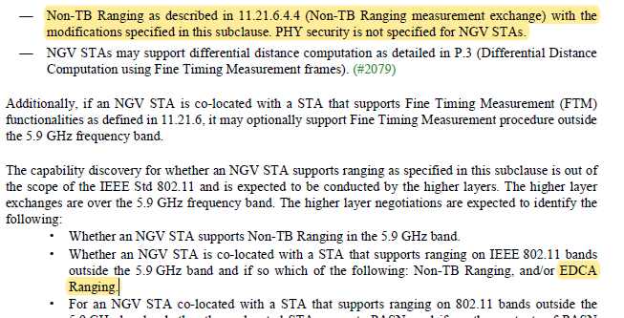

In 11az D4.0,
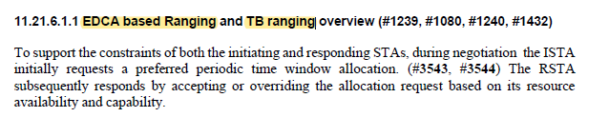

To TGbd Editor: P66L24 update the description as below.
------------- Begin Text Changes ---------------

- Whether an NGV STA is co-located with a STA that supports ranging on IEEE 802.11 bands outside the 5.9 GHz band and if so which of the following: Nnon-TB Rranging, and/or EDCA based Rranging (see 11.21.6.1.1 (EDCA based ranging and TB ranging overview)).

------------- End Text Changes ------------------

CID | P.L | Comment | Proposed Change | Resolution
3008 | 23.65 | According to resolution of CID #2248, "transmit power level" is replaced by "transmit power spectral density". | Replace "transmit power level" by "transmit power spectral density". | Accepted.
Discussion

2248 | 23 | 26 | The transmit power level of the radio environment request vector should be in dBm, not in dBm/10 MHz. It si not a power spectral density. | In the paragraph for the transmit power level member, change "dBm/10 MHz" to "dBm" in four places. [Editorial]: Also, in the second sentence of the paragraph, insert a comma between "MSDU" and "in units of" | Revised  Discussion: Generally agree with the commenter that the name and the description are not consistant. Since the Tx BW can be either 10MHz or 20MHz, the power spectral density is used in the name.  TGbd editor to change “transmit power level” to “transmit power spectral densirty” in 5.2.3.2, 31.5

With the resolution, two locations are updated as below.
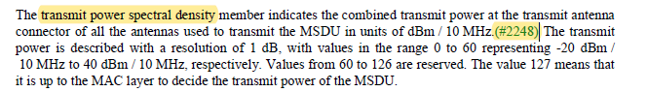

The commentor is correct that tranmit power level at P23L65 should be updated as below.

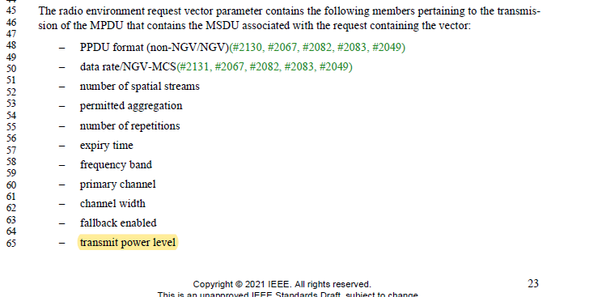

CID | P.L | Comment | Proposed Change | Resolution
3026 | 24.26 | In the first sentence of the following paragraph, it says 'number of spatial streams member'.  In the 2nd sentence it says 'number of spatial streams parameter'. It would be better to be consistent.  Suggest changing 'member' in the 1st sentence to 'parameter'  "The number of spatial streams member with value 1 or 2 indicates the number of spatial streams being used  to transmit the PPDU carrying the MSDU. The number of spatial streams parameter with value 0 means that  the number of spatial streams is decided by the MAC layer." | Change 'member' to 'parameter' in the following sentence: "The number of spatial streams member with value 1 or 2 indicates the number of spatial streams being used  to transmit the PPDU carrying the MSDU." so that it reads instead:  "The number of spatial streams parameter with value 1 or 2 indicates the number of spatial streams being used  to transmit the PPDU carrying the MSDU.  Also, consider changing 'member' to 'parameter' for the other terms in the subclause such as number of repetitions, permitted aggregation, etc. | Revised.  Agreed in principle. However, by definition, the radio environment request vector parameter contains different members such as PPDU format, data rate/NGV-MCS, etc at P23L45.  So, parameter should be replaced with member to be consistent.  TGbd Editor: Incorporate the changes in 11-22-0016-01-00bd-Resolutions to Editorial Comments Part 2
Discussion

At P24L26 as below,

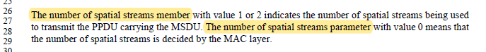
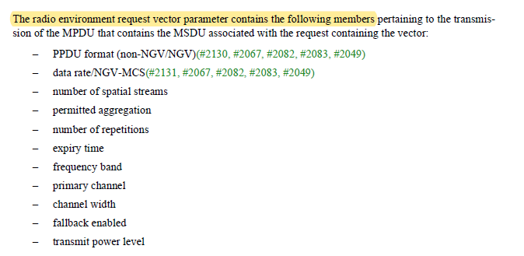

To TGbd Editor: P24L26 update the description as below.
------------- Begin Text Changes ---------------

The number of spatial streams member with value 1 or 2 indicates the number of spatial streams being used to transmit the PPDU carrying the MSDU. The number of spatial streams parametermember with value 0 means that the number of spatial streams is decided by the MAC layer.

------------- End Text Changes ------------------

CID | P.L | Comment | Proposed Change | Resolution
3049 | 40.46 | Periods at the end this sentence are duplicated. | Please remove one period. | Accepted.
Discussion

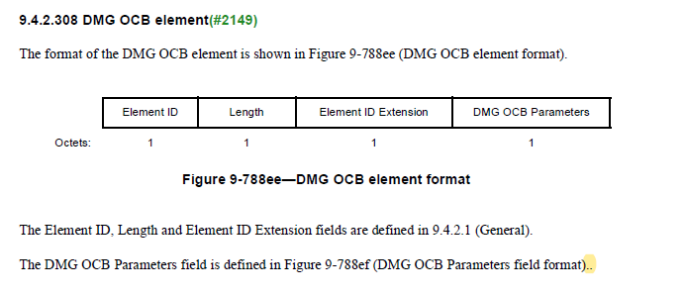

CID | P.L | Comment | Proposed Change | Resolution
3050 | 41.27 | In Figure 9.849-a, the Poll Required subfield should use B16, not B9-B23. | Please correct it. | Accepted.
Discussion

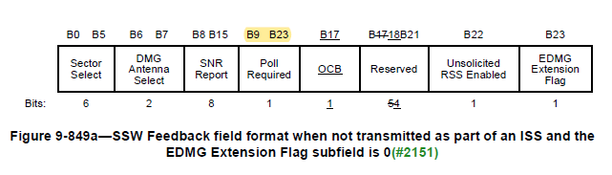

CID | P.L | Comment | Proposed Change | Resolution
3013 | 44.49 | In 11az D4.0 there are no numbers between "HE Ranging" and "NDP" on P110L10-11, but in 11bd D3.0 P44L49-50 there is a "10" and an "11". | Remove "10" and "11" between "HE Ranging" and "NDP" on L49 and L50. | Accepted.
Discussion

In 11az D4.0,

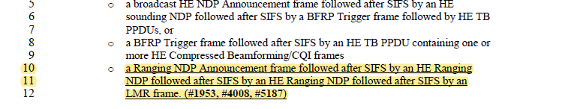
In 11bd D3.0,

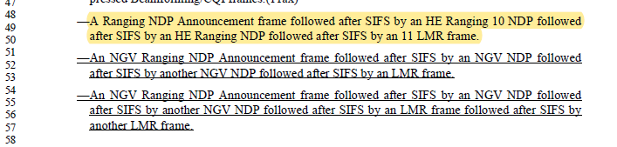

CID | P.L | Comment | Proposed Change | Resolution
3024 | 57.54 | there seems to be an extra/unneeded '(' after 'sequence) and before '(with) in line 54 of the following:  The first 7 bits of the scrambling sequence shall be set as shown in Table 17-7 (Contents of the first 7 bits of the scrambling sequence) (with field values defined in Table 17-8 (TXVECTOR parameter CH_BANDWIDTH_IN_NON_HT values), Table 17-8a (TXVECTOR parameter CH_BANDWIDTH_IN_NON_NGV values),and Table 17-10 DYN_BANDWIDTH_IN_NON_HT values) and Table 17-10a (DYN_BANDWIDTH_IN_NON_NGV values) and shall be also used to initialize the state of the scrambler  Consider deleting the '(' | change "...7 bits of the scrambling sequence) (with field values defined in Table 17-8 ..."  to  "7 bits of the scrambling sequence) with field values defined in Table 17-8" | Accepted.
Discussion

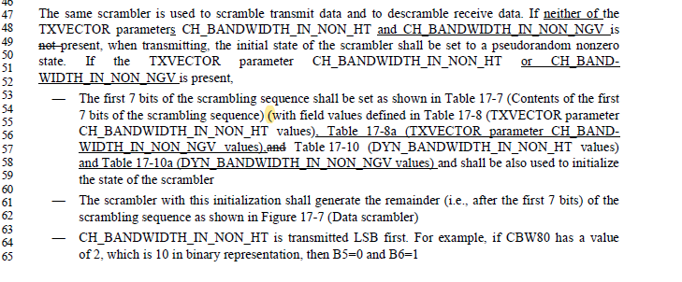

CID | P.L | Comment | Proposed Change | Resolution
3025 | 58.18 | I wonder if DYN_BANDWIDTH_IN_NOT_HT should be instead DYN_BANDWIDTH_IN_NON_HT  in table 17-7 under the condition column | Check if this is correct: "DYN_BANDWIDTH_IN_NOT_HT" If not, replace it with  "DYN_BANDWIDTH_IN_NON_HT" for the 3 occurrences in table 17-7 | Accepted.
Discussion

At P58L18,
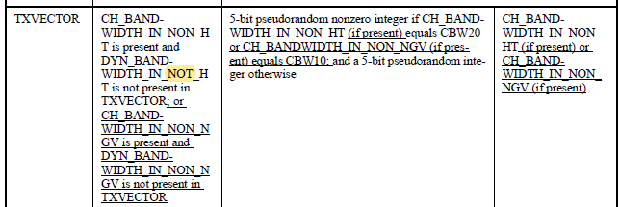

At P58L33,
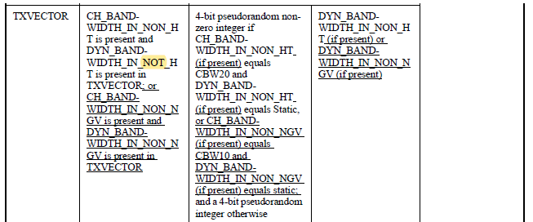

At P58L51,
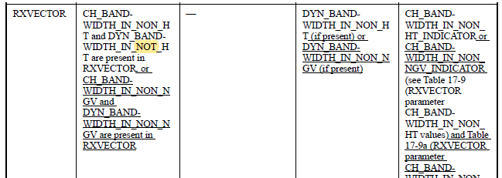

CID | P.L | Comment | Proposed Change | Resolution
3086 | 61.19 | Spell out OCB to be consistent with the style in the paragraph above. | As in comment. | Revised.  Agreed in principle to keep the consistent style. However, since OCB is introduced at P17L35 first, outside the conext of a BSS is replaced with OCB.  TGbd Editor: replace “outside the conext of a BSS” with “OCB” at P61L13.
Discussion

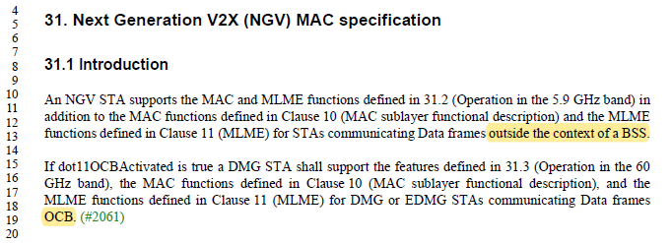

CID | P.L | Comment | Proposed Change | Resolution
3095 | 96.05 | Change "RL-SIG shall be modulated same as L-SIG" to "RL-SIG shall be modulated the same as L-SIG". | As in the comment. | Revised.  Agreed in principle. And additional modification is applied.  TGbd Editor: Incorporate the changes in 11-22-0016-01-00bd-Resolutions to Editorial Comments Part 2
Discussion

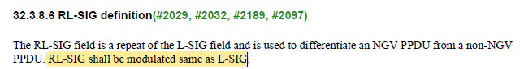

To TGbd Editor: P96L04 update the description as below.
------------- Begin Text Changes ---------------

The RL-SIG field is a repeat of the L-SIG field and is used to differentiate an NGV PPDU from a non-NGV PPDU. RL-SIG field shall be modulated the same as L-SIG field.

------------- End Text Changes ------------------

