IEEE P802.11
Wireless LANs
Resolutions to Editorial Comments Part 1
Date: 2022-01-11
Author(s):
Name | Affiliation | Address | Phone | email
Yujin Noh | Senscomm |  |  | yujin.noh at senscomm.com
Abstract
This submission shows
- Comments from TGbd draft 3.0.
- Resolutions applied to TGbd draft 3.0.
- 11 CIDs:
3079, 3042, 3043, 3004, 3005, 3007, 3006, 3073, 3074, 3078,
3045

Revisions:
- Rev 0: Initial version of the document.
- Rev 1: Direction for editor clarified in CID 3078
- Rev 2: CID 3043 is updated based on the Editor’s meeting on 1/17/2022.

CID | P.L | Comment | Proposed Change | Resolution
3042 | 1.05 | REVme is not an amendment or baseline of 11bd. | Remove "as amended by IEEE P802.11-REVme(TM)/D0.4," | Accepted.
Discussion
According to the current projected publication date,
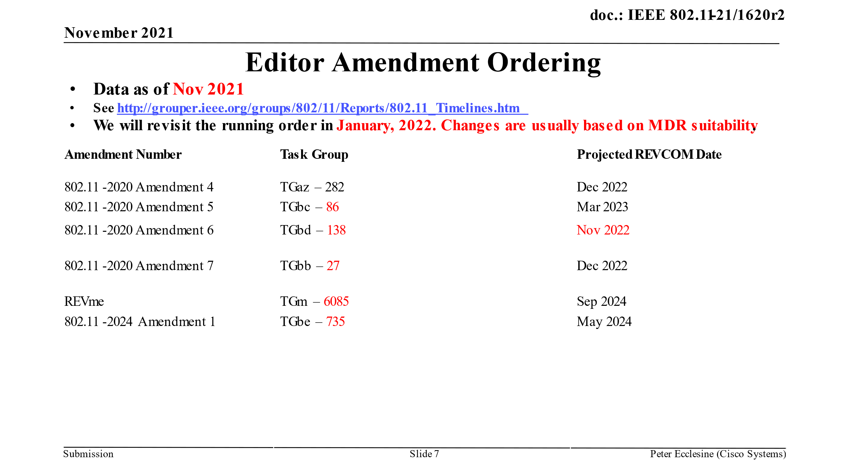
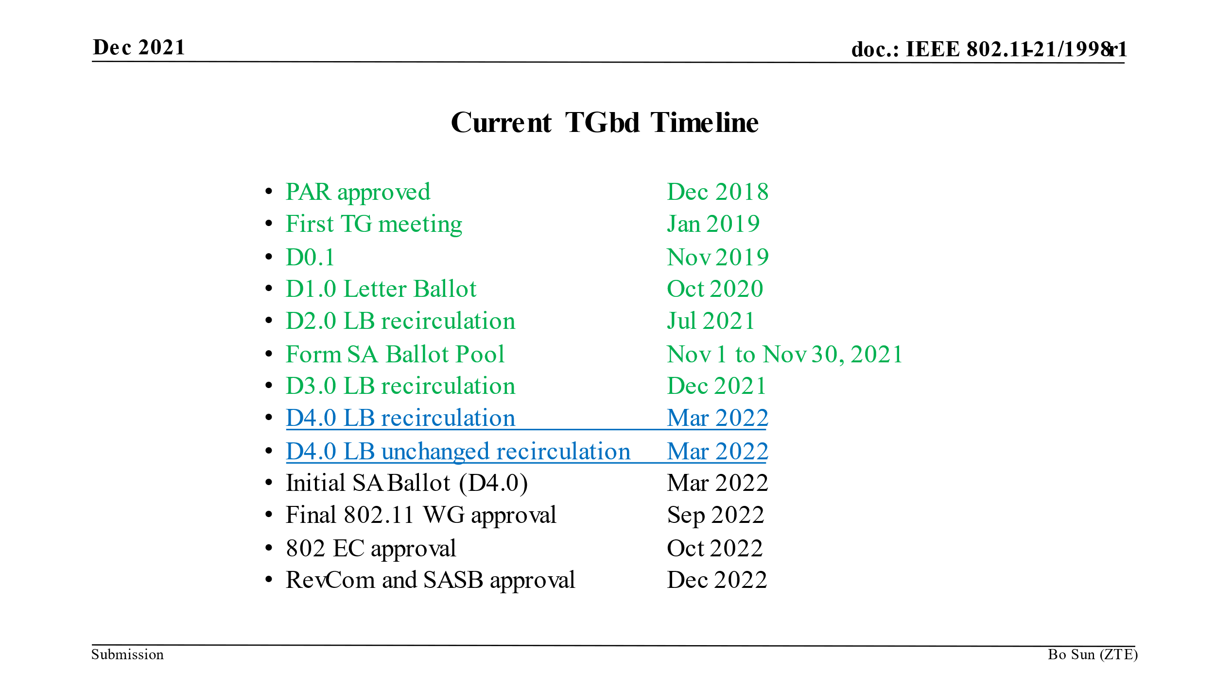

The references in D3.0 should consider up to Amendment 5 on top of IEEE Std 802.11™-2020. Amendments 1, 2 and 3 have already been published such as 11ax, 11ay and 11ba.

It turned out that the baseline documents in D3.0 should be as below.

IEEE P802.11bd™/D3.0, Nov 2021
(amendment to IEEE Std 802.11™-2020,
as amended by IEEE P802.11-REVme™/D0.4,
as amended by IEEE Std 802.11ax™-2021,
as amended by IEEE P802.11ay™/D7.0,
as amended by IEEE P802.11ba™/D8.0,
as amended by IEEE P802.11az™/D4.0,
and IEEE P802.11bc™/D1.04)

CID | P.L | Comment | Proposed Change | Resolution
3043 | 1.32 | There are 5 amendments preceeding 11bd (ax, ay, ba, az, bc) so this amendment should be Amendment 6. As a matter of the fact, 11bc for sale has title of "Amendment 5" | Change "Amendment 5" to "Amendment 6". | Rejected.  Based on the discussion in Editor’s meeting on 1/17/2022, 11bd is decided to Amendment 5 in accordance with Projected REVCOM Date.
Discussion
At Nov 2021,

At Jan 2022, the updated document is not uploaded yet. But Editors decided to update the Amemendment order. So 11bd is Amendment 5.

CID | P.L | Comment | Proposed Change | Resolution
3004 | 7.17 | 11bd D3.0 amends REVme D0.4. According to REVme D0.4 subclause 4.3.17 became 4.3.19 (STA transmission of Data frames outside the context of a BSS). Similar 4.3.22, 9.2.4.7, 9.7.3 of 11-2020 became 4.3.24, 9.2.4.8, 9.7.2 in REVme D0.4. | Update subclause number 4.3.17 according to REVme D0.4 to 4.3.19 on P19L7. Also update subclause number 4.3.22 according to REVme D0.4 to 4.3.24 on P20L53, 9.2.47 to 9.2.4.8 on P36L9, and 9.7.3 to 9.7.2 on P41L57. | Rejected.  Given the resolution in CID3042, 11bd D3.0 should consider IEEE Std 802.11™-2020, 11ax, 11ay, 11ba, 11az, and 11bc (not REVmeD0.4) because we have REVme publishing after 11bd.  No need to update the number based on REVme D0.4.
3073 | 19.07 | Clause 4.3.17 is not the OCB clause in the current baseline, it is clause 4.3.19 (.11 REVmd D1.0) | Correct the clause reference to 4.3.19 | Rejected.  Given the resolution in CID3042, 11bd D3.0 should consider IEEE Std 802.11™-2020, 11ax, 11ay, 11ba, 11az, and 11bc (not REVmeD0.4) because we have REVme publishing after 11bd.  No need to update the number based on REVme D0.4.
3074 | 19.22 | The clause reference 4.3.17a is not correct as the intent is to place this clause following the OCB clause (4.3.19 in .11 REVmd D1.0) | Correct the clause reference to 4.3.19a | Rejected.  Given the resolution in CID3042, 11bd D3.0 should consider IEEE Std 802.11™-2020, 11ax, 11ay, 11ba, 11az, and 11bc (not REVmeD0.4) because we have REVme publishing after 11bd.  No need to update the number based on REVme D0.4.
Discussion

Given the resolution in CID3042, 11bd D3.0 should consider IEEE Std 802.11™-2020, 11ax, 11ay, 11ba, 11az, and 11bc (not REVmeD0.4) because we have REVme publishing after 11bd.

In 11bd D3.0 and IEEE Std 802.11™-2020, subclauses 4.3.17, 4.3.22, 9.2.4.7, and 9.7.3 remains unchanged as below.
In 11bd,

In IEEE Std 802.11™-2020

CID | P.L | Comment | Proposed Change | Resolution
3005 | 9.17 | In REVme D0.4 there already exists sublcaus 17.2.2.9. | Update subclause numbers 17.2.2.9 and 17.2.2.10 to 17.2.2.10 and 17.2.2.11 on P55L36 and P55L45. | Rejected.  Given the resolution in CID3042, 11bd D3.0 should consider IEEE Std 802.11™-2020, 11ax, 11ay, 11ba, 11az, and 11bc (not REVmeD0.4) because we have REVme publishing after 11bd.  No need to update the number based on REVme D0.4.
Discussion
Given the resolution in CID3042, 11bd D3.0 should consider IEEE Std 802.11™-2020, 11ax, 11ay, 11ba, 11az, and 11bc (not REVmeD0.4) because we have REVme publishing after 11bd.

In 11bd D3.0 and IEEE Std 802.11™-2020, the order of subclauses 27.2.2.7 and 27.2.2.8 in TXVECTOR parameters and 27.2.3.7 and 27.2.3.8 in RXVECTOR parameters remains unchanged as below. The current subclause numbers are correct.

In IEEE Std 802.11™-2020,

In 11bd D3.0,

CID | P.L | Comment | Proposed Change | Resolution
3007 | 12.04 | Several of the figure numbers have been udpated from 11-2020 to REVme D0.4 and need to be updated in 11bd D3.0: Figure 9-79, 9-848, 9-849a, | Update Figure 9-79 to Figure 9-126 on P39L8, Figure 9-848 to Figure 9-1063 on P41L19, Figure 9-849a to Figure 9-1065 on P41L35 | Rejected.  Given the resolution in CID3042, 11bd D3.0 should consider IEEE Std 802.11™-2020, 11ax, 11ay, 11ba, 11az, and 11bc (not REVmeD0.4) because we have REVme publishing after 11bd.  No need to update the number based on REVme D0.4.
Discussion
Given the resolution in CID3042, 11bd D3.0 should consider IEEE Std 802.11™-2020, 11ax, 11ay, 11ba, 11az, and 11bc (not REVmeD0.4) because we have REVme publishing after 11bd.

In 11bd D3.0,

In IEEE Std 802.11™-2020,

CID | P.L | Comment | Proposed Change | Resolution
3006 | 13.11 | Several of the table numbers have been updated from 11-2020 to REVme D0.4 and need to be udpated in 11bd D3.0: Table 9-25 , 9-45, 9-69, 9-94 to Table 9-34, 9-73, 9-97, 9-128 | Update Table 9-25 to Table 9-34 on P36L17, Table 9-45 to Table 9-73 on P38-L41, Table 9-69 to Table 9-97 on P39L30, Table9-94 to Table 9-128 on P39L57. | Revised.  Given the resolution in CID3042, 11bd D3.0 should consider IEEE Std 802.11™-2020, 11ax, 11ay, 11ba, 11az, and 11bc (not REVmeD0.4) because we have REVme publishing after 11bd.  No need to update the number based on REVme D0.4. However, it turned out that Table 9-94 should be Table 9-92 based on IEEE Std 802.11™-2020.  TGbd Editor: replace Table 9-94 with Table 9-92.
Discussion

In 11bd D3.0,

In IEEE Std 802.11™-2020,

CID | P.L | Comment | Proposed Change | Resolution
3078 | 19.46 | Clause 11.18 is not OCB - it is clause 11.9 in .11 REVmd D1.0. | Insert the correct clause reference. | Revised.  Given the resolution in CID3042, 11bd D3.0 should consider IEEE Std 802.11™-2020, 11ax, 11ay, 11ba, 11az, and 11bc (not REVmeD0.4) because we have REVme publishing after 11bd.  No need to update the number based on REVme D0.4. However, it should tag the cross-reference because 11bd D3.0 contains the corresponding subclause.  To TGbd editor: tag the cross-reference for 11.18 (STAs communicating  Data frames outside the context of a BSS) at P19L46
Discussion

In 11bd D3.0,

In IEEE Std 802.11™-2020,

CID | P.L | Comment | Proposed Change | Resolution
3045 | 29.09 | 11bc already uses subclauses 6.3.126 and 6.3.127.  Additionally, for readers convenience, the subclauses may be re-ordered within this amendment so that 5.9GHz related subclauses are arranged nearby. | Change subclause  - 6.3.126(Cancel transmissions...) to 6.3.128,  - 6.3.127(DMG...) to 6.3.130, and  - 6.3.128(NGV radio environment measurement) to 6.3.129, and reorder the subclauses based on the new subclause number. | Accepted
Discussion

In 11bc D1.04,

In 11bd D3.0,

CID | P.L | Comment | Proposed Change | Resolution
3079 | 0.00 | Review and update all clause references to align with the 802.11bd baseline documents. It seems that many of the clause references are incorrect. | Correct all incorrect clause references | Revised.  Agreed in principle. This resolution includes to 1) fix the references and 2) add the cross-references.  TGbd Editor: incorporate the changes below  P11L48, MIB Detail should be MIB detail. The corresponding subclause should be updated together through the spec.  P19L13, add the cross-reference in 31.3 (Operation in the 60 GHz band).  P19L39, E.1 replaced with E.1 (Country information and operating classes).  P19L45, add cross-reference in 11.18 (STAs communicating Data frames outside the context of a BSS)  P20L38, add cross-reference in 11.21.6 (Fine timing measurement (FTM) procedure) and P.3 (Differential Distance Computation using Fine Timing Measurement frames)  P20L45, add cross-reference in P.3 (Differential Distance Computation using Fine Timing Measurement frames)  P20L53, in 4.3.22 (DMG STA) each subclause is not completed with its title. Add the title after each subclause in 4.3.22 (DMG STA). There are examples such as Clause 10 (MAC sublayer functional description), Clause 11 (MLME), Clause 20 (Directional multi-gigabit (DMG) PHY specification), 10.39 (DMG and CMMG channel access), 10.42 (DMG beamforming) and 20.9 (Beamforming) and GCM encryption as described in  12.5.5 (GCM protocol (GCMP)).  P37L29, Table 20-29 (DMG PHY characteristics) replaced with Table 20-30 (DMG PHY characteristics).  P39L56, Table 9-94 (Element IDs) replaced with Table 9-92 (Element IDs)  P53L4, 12.12 (Pre Association Security Negotiation) should be 12.12 (Preassociation security negotiation)  P56L50, delete 17.3.1 (Introduction) and 17.3.2.1 (General) since there is no modification applied to this subclause.  P65L65 add cross-reference in 11.21.6 (Fine timing measurement (FTM) procedure)  P66L8, add cross-reference in P.3  P66L13, add cross-reference in 11.21.6 (Fine timing measurement (FTM) procedure)  P66L61, 12.12 (Pre Association Security Negotiation) should be 12.12 (Preassociation security negotiation)  P72L19 17.2.2.5 replaced with 17.2.2.5 (TXVECTOR TXPWR_LEVEL_INDEX)  P113L25, add cross-reference in D.2.2 (Transmit power levels))  P114L29, add cross-reference in D.2.2 (Transmit power levels))

Discussion

In IEEE Std 802.11™-2020,

In 11az D4.0,

