IEEE P802.11
Wireless LANs
CC36 resolution to CID 5958 for
NSTR mobile AP MLD operation

Date: 2021-12-27
Author(s):
Name | Affiliation | Address | Phone | email
Liuming Lu | OPPO |  |  | luliuming@oppo.com
Lei Huang | OPPO
Chaoming Luo | OPPO
Pei Zhou | OPPO

Abstract
This submission proposes resolutions for the following CIDs for TGbe CC36:
5958

Revisions:
- Rev 0: Initial version of the document

Interpretation of a Motion to Adopt

A motion to approve this submission means that the editing instructions and any changed or added material are actioned in the TGbe Draft. This introduction is not part of the adopted material.

Editing instructions formatted like this are intended to be copied into the TGbe Draft (i.e. they are instructions to the 802.11 editor on how to merge the text with the baseline documents).

TGbe Editor: Editing instructions preceded by “TGbe Editor” are instructions to the TGbe editor to modify existing material in the TGbe draft. As a result of adopting the changes, the TGbe editor will execute the instructions rather than copy them to the TGbe Draft.

TGbe editor: The baseline for this document is 11be D1.31.

CID | Commenter | Pg/Ln | Comment | Proposed Change | Resolution
5958 | Liuming Lu | 284.28 | The additional constraints are currently specified for the transmission in the nonprimary link of a NSTR Soft AP, which may limit the efficency of frame exchanges between a NSTR Soft AP and non-AP MLD. For non-AP MLD its affiliated STA can initiate its transmission by obtaining the TXOP through EDCA mechanism to become a TXOP holder or get the TXOP shared by the Soft AP MLD. The current specificaiton lacks of the mechanism to allow the non-AP MLD to request the AP MLD to share its obtained TXOP with the non-AP MLD. | Suggest to specify the mechanism to allow the non-AP MLD to request the AP MLD to share its obtained TXOP with the non-AP MLD. And the mechanism of synchronous transmission in two links for non-AP MLD by obtaining the TXOP through EDCA to become a TXOP holder or get the TXOP shared by the Soft AP MLD needs to be considered to be specified. | Revised  Agreed it is necessary to specify an extended method of the synchronous transmission in two links for a non-AP MLD that is associated with an NSTR mobile AP MLD by using the time allocated by an AP or two APs affiliated with the Mobile AP MLD for transmission.  TGbe editor to make the changes shown in 11-21/2032r0 under all headings that include CID 5958.

Discussion:

This document proposes an extended method of the synchronous transmission in two links for a non-AP MLD that is associated with an NSTR mobile AP MLD by using the time allocated by an AP or two APs affiliated with the Mobile AP MLD for uplink transmission. An example of the synchronous transmission is shown as follows.

Assuming STA1 and STA2 affliated with a non-AP MLD that is associated with a NSTR Mobile AP MLD need to transmit synchronously in Link1(primary link) and Link2(non-primary link), the following procedure is shown:
- STA1 and STA2 invokes their respective backoff procedures and STA1 firstly gains transmission opportunity but STA2 needs more time to finish its backoff procedure.
- STA1 sends an PPDU which carries a frame with AAR control subfield to request the AP MLD to help its intention for the uplink transmission in the link2.
- When the NSTR Moblie AP MLD knows the non-AP MLD needs to do synchronous transmission in Link1 and Link2, AP2 can allocate the time within its TXOP to STA2 by sending MU-RTS TXS Trigger frame to STA2 if AP-MLD gains the transmission opportunity in Link2.
- Non-AP MLD uses the time duration within the TXOP in Link1 gained by STA1 itself and the time allocated to STA2 by AP2 to do synchronous transmission in Link1 and Link2.
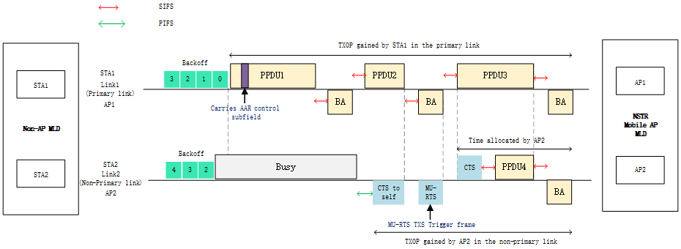
Figure.1 an example of synchronous transmission for NSTR mobile AP MLD operation

Proposed Text Change:

35.3.18 NSTR mobile AP MLD operation
TGbe Editor: Change paragraphs below of this subclause as follows (#CID 5958):
STAs affiliated with a non-AP MLD that is associated with an NSTR mobile AP MLD and APs affiliated with an NSTR mobile AP MLD shall follow the procedure defined in 35.3.15.6 (Start time sync PPDUs medium access) when intending to initiate a transmission in the nonprimary link with the following additional constraints.
—A STA affiliated with the non-AP MLD may initiate a PPDU transmission to its associated AP affiliated with the NSTR mobile AP MLD in the nonprimary link only if the STA affiliated with the same MLD in the primary link is also initiating the PPDU as a TXOP holder with the same start time.
—An AP affiliated with the NSTR mobile AP MLD may initiate a PPDU transmission to its associated non-AP STA in the nonprimary link only if the AP affiliated with the same NSTR mobile AP MLD in the primary link is also initiating the PPDU as a TXOP holder with the same start time.
STAs affiliated with a non-AP MLD that is associated with an NSTR mobile AP MLD shall follow the procedure defined in 35.3.15.5 (PPDU end time alignment) when intending to transmit a PPDU within the time allocated by an AP affiliated with the NSTR mobile AP MLD in the nonprimary link with the following additional constraint.
—A STA affiliated with the non-AP MLD may transmit a PPDU within the time allocated by an AP affiliated with the NSTR mobile AP MLD in the nonprimary link only if the STA affiliated with the same MLD in the primary link is also transmitting a PPDU within a TXOP duration as a TXOP holder or transmitting a PPDU within the time allocated by an AP affiliated with the NSTR mobile AP MLD in the primary link at the same time.

