DMG sensing procedure
Date: 2022-01-11
Author(s):
Name | Affiliation | Address | Phone | email
Solomon Trainin | Qualcomm |  |  | strainin@qti.qualcomm.com
Assaf Kasher | Qualcomm |  |  | akasher@qti.qualcomm.com
Alecsander Eitan | Qualcomm |  |  | eitana@qti.qualcomm.com
Abstract
Presentation of the DMG sensing procedure

7.2 DMG sensing (SENS) procedure

7.2.1 Overview
DMG sensing types include monostatic, bistatic, multistatic, monostatic sensing with coordination, and bistatic sensing with coordination. The monostatic sensing with coordination is an extension of monostatic to coordinate monostatic devices. The bistatic sensing with coordination is an extension of bistatic type to coordinate multiple responders by one initiator.
The DMG sensing procedures define all types of the DMG sensing.
A DMG sensing procedure is a subset of the WLAN sensing procedure. Unless otherwise noted, the rules for the WLAN SENS apply to the DMG SENS.
A DMG sensing procedure is composed of one or more of the following: sensing session setup, DMG measurement setup, DMG sensing burst, DMG sensing instance, sensing measurement setup termination, and sensing session termination
A DMG sensing procedure may be comprised of multiple DMG sensing bursts. A DMG sensing burst may be comprised of multiple DMG sensing instances.
NOTE: Measurements over a certain time period are needed to compute the Doppler frequency shift. The occupancy time per link access cannot exceed the TXOP limit. If a longer measurement time is needed, then the approach of the DMG sensing burst allows scheduling of the multiple link accesses to collect measurements for the Doppler frequency shift computation.
One responder may participate in multiple DMG sensing bursts and DMG sensing instances associated with different DMG measurement setups.
An initiator may maintain multiple responders in multiple DMG sensing bursts and DMG sensing instances associated with different DMG measurement setups.
An initiator may instruct the responder in the receiver role or in the receiver and transmitter role to report at the DMG sensing instance, or/and it may instruct the responder to accumulate the results and report once per the DMG sensing burst.
The examples of the DMG sensing procedure are shown in Figures 1- 7
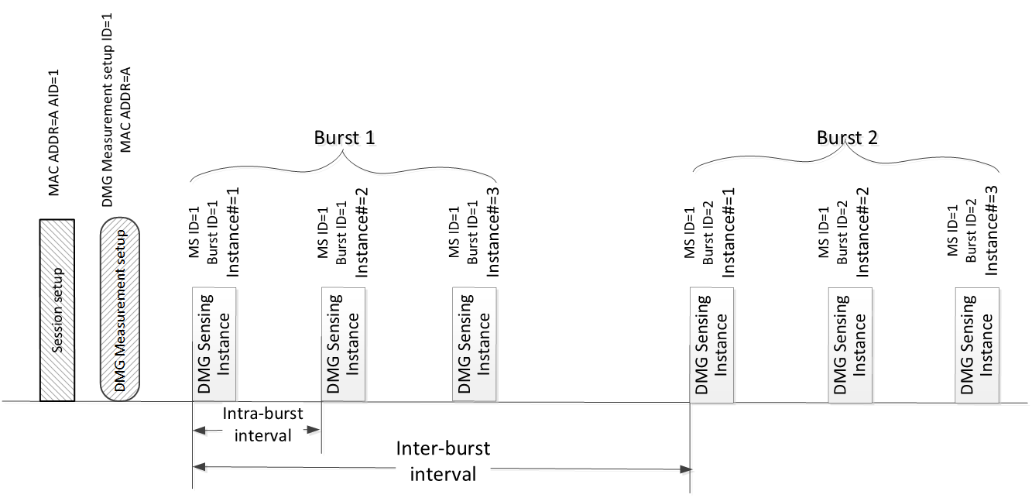
Figure 1. DMG sensing procedure with one responder

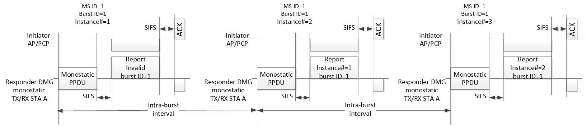
Figure 2. DMG sensing instances of one DMG sensing burst with AP/PCP as initiator and single monostatic sensing device as responder. Per DMG sensing instance delayed reporting.

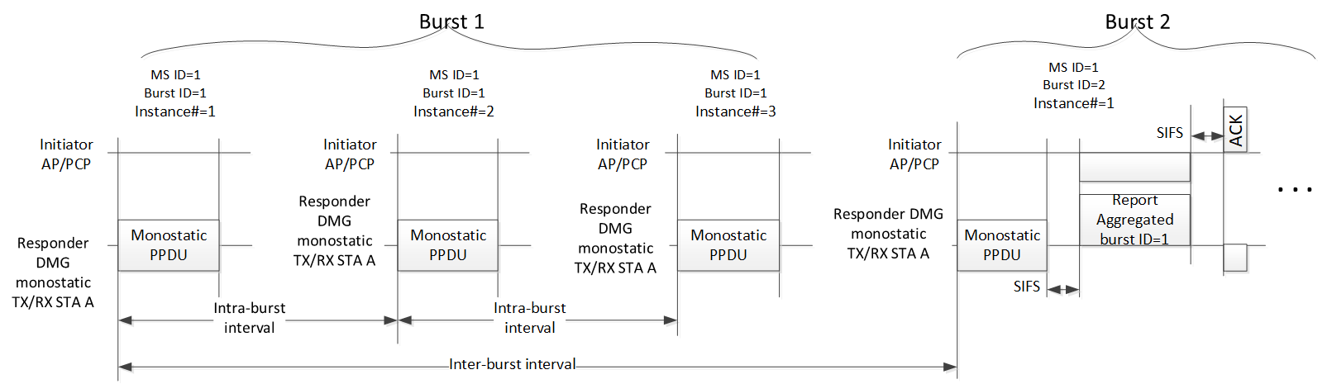
Figure 3. DMG sensing instances with AP/PCP as initiator and single monostatic sensing device as responder. Per DMG sensing burst delayed delivery of the aggregated report.

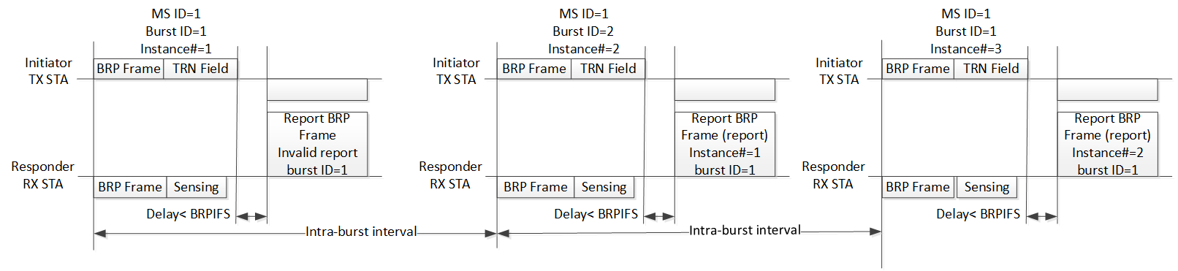
Figure 4. DMG sensing instances of one DMG sensing burst of the bistatic sensing with the initiator in TX role. Per DMG sensing instance delayed delivery of the report.
NOTE: The BRP frame is an Action No Ack frame.
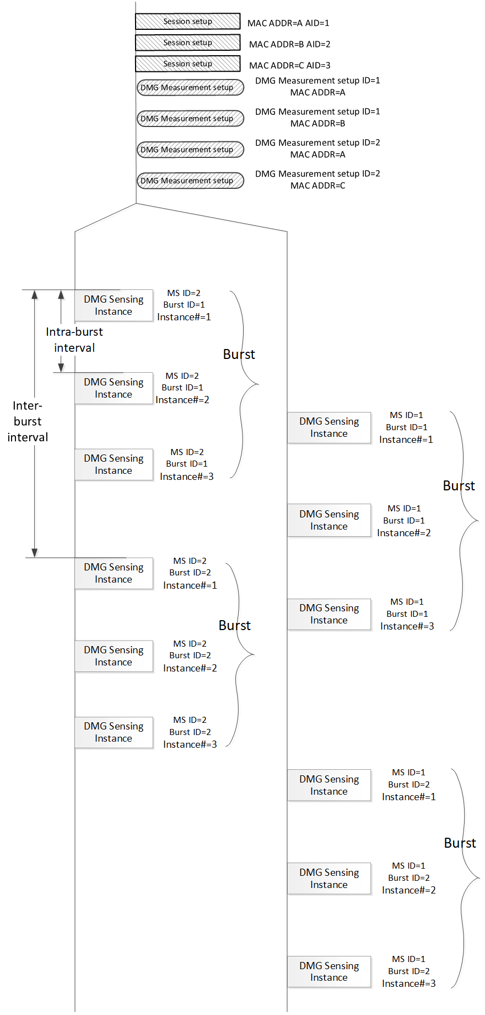
Figure 5. DMG sensing procedure with three responders

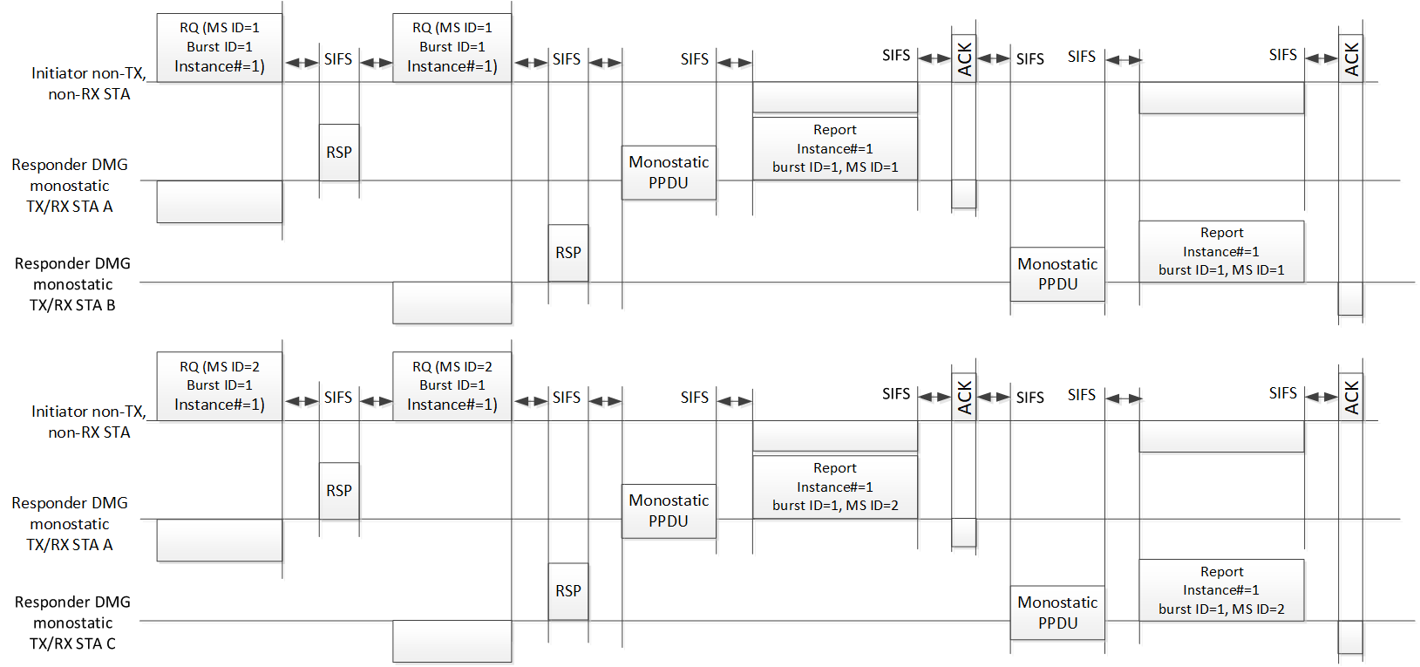
Figure 6. DMG Sensing instances with AP/PCP as initiator and two monostatic sensing devices as responders. The sounding phase of both monostatic devices in the instance may happen in parallel. Two illustrated instances belong to two different DMG Measurement setups.

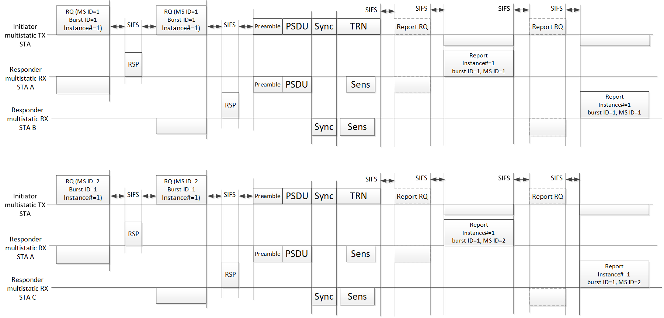
Figure 7. DMG Sensing instances of multistatic sensing. The AP/PCP is an initiator and in the role of the transmitter and two responders are in the role of receivers. Two illustrated instances belong to two different DMG Measurement setups.

References:
- 11-21-1068-00-00bf-a-framework-for-edmg-monostatic-radar
- 11-21-1799-01-00bf-dmg-bistatic-radar
- 11-21-1865-01-00bf-dmg-multi-static-ppdu-structure
- 11-21-1914-00-00bf-coordination-among-multiple-monostatic-radars
- 11-21-1890-01-00bf DMG Sensing taxonomy

SP
Do you agree to append the text on page 2 and the figures to the SFD?

