IEEE P802.11
Wireless LANs
TGbe CC36 Comment Resolutions for 35.5.3 – Part 3
Date: 2022-02-10
Author(s):
Name | Affiliation | Address | Phone | Email
Jinyoung Chun | LG Electronics | 19, Yangjae-daero 11gil, Seocho-gu, Seoul 137-130, Korea |  | jiny.chun@lge.com
Dongguk Lim |  |  |  | dongguk.lim@lge.com
Eunsung Park |  |  |  | esung.park@lge.com
Insik Jung |  |  |  | insik0618.jung@lge.com
Jinsoo Choi |  |  |  | js.choi@lge.com
Wook Bong Lee | Samsung |  |  | wookbong.lee@samsung.com
Alfred Asterjadhi | Qualcomm |  |  | aasterja@qti.qualcomm.com
Arik Klein | Huawei |  |  | arik.klein@huawei.com
Zinan Lin | InterDigital |  |  | Zinan.Lin@InterDigital.com

Abstract
This submission proposes a resolution for 11 CIDs: CID 8369, 8370, 8214, 8215, 7080, 7930, 7929, 8371, 7931, 4430 and 7932

Revisions:
- Rev 0: Initial version of the resolution document based on 11be Draft 1.31.
- Rev 1: change some resolutions during Joint CC
- Rev 2: change the resolution of CID 8370
- Rev 3: some change of CID 8370

CID 8369
CID | Commenter | PP.LL | Comment | Proposed Change | Resolution
8369 | Zinan Lin | 294.48 | There is only one value in the Max Nc subfield in the EHT PHY Capbailities Information field in the EHT Capbilities elment set by one EHT BE | Nc value indicated by the Max Nc subfield in the EHT PHY Capabilities Information field in the EHT Capabilities element sent by the EHT beamformee | Revised  Let’s follow the exact definition of ‘Max Nc’ in EHT PHY Capabilites as ‘indicates the maximum supported Nc’.  Instructions to the editor:  Please modify the text in P409 L47 of D1.31 to ‘The maximum supported Nc indicated~’
Background text in Page 409 of D1.31

CID 8370
CID | Commenter | PP.LL | Comment | Proposed Change | Resolution
8370 | Zinan Lin | 294.56 | The sentence "The EHT beamformer shall set the TXVECTOR parameter CH_BANDWIDTH or CH_BANDWIDTH_IN_NON_HT, the Partial BW Info subfield of the EHT NDP Announcement frame, depending on the operating channel width, as defined in Table 9-28e (Settings for BW, Partial BW Info subfield in the EHT NDP Announcement frame)." is not clear. | The EHT beamformer shall set the TXVECTOR parameter CH_BANDWIDTH or CH_BANDWIDTH_IN_NON_HT according to the Partial BW Info subfield of the EHT NDP Announcement frame, which depends on the operating channel width, as defined in Table 9-28e (Settings for BW, Partial BW Info subfield in the EHT NDP Announcement frame). | Revised  The operating channel width isn’t clearly stated.  Instructions to the editor:  Please modify the text in P409 L47 of D1.31 as below:  ‘The EHT beamformer shall set the TXVECTOR parameter CH_BANDWIDTH or CH_BANDWIDTH_IN_NON_HT, the Partial BW Info subfield of the EHT NDP Announcement frame, depending on the operating channel width of the beamformee, the operating channel width of the beamformer and the feedback RU/MRU size, as defined in Table 9-42c (Settings for BW, Partial BW Info subfield in the EHT NDP Announcement frame).’
Background text in 26.7.3 Rules for HE sounding protocol sequences (P4188) of REVme D0.4:
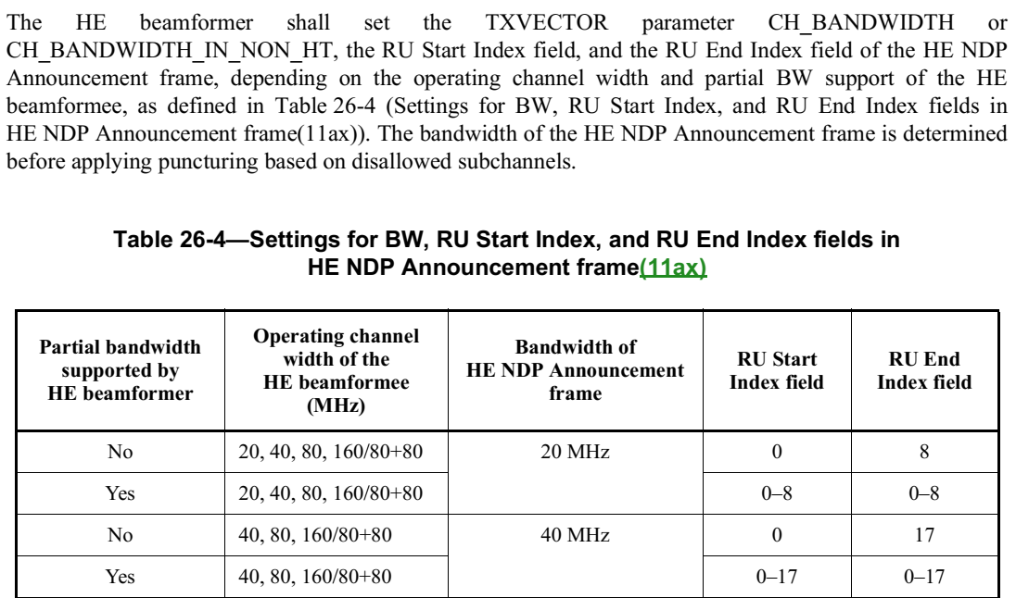

Background text in Page 409 of D1.31:
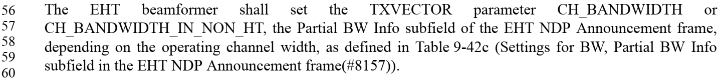
Background text in 9.3.1.19 NDP Announcement frame format (P111) of D1.31:
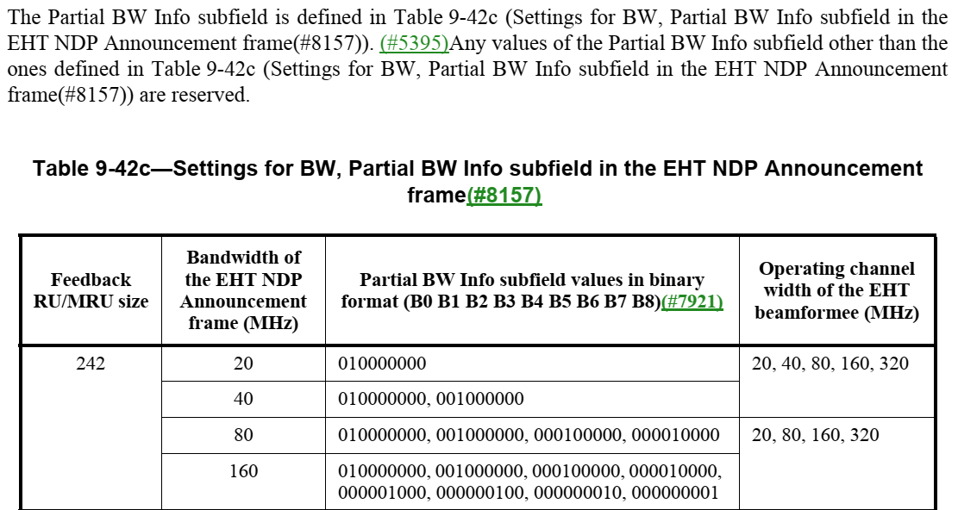

CID 8214 and 8215
CID | Commenter | PP.LL | Comment | Proposed Change | Resolution
8214 | Yusuke Tanaka | 295.02 | It is unclear which element is referenced under which conditions by just connecting sentences with "if present". | Please organize the conditions, for example, by describing frequency where the EHT beamformer operates. One of the good reference is 11ax D8.0のP.215 LL27 9.4.2.249. | Revised  The condition is in each section of each Operation element as you said. So it’s better to add the reference without the duplication.  Instructions to the editor:  Please add the text ‘(see 9.4.2.249 (HE Operation element) and 9.4.2.311 (EHT Operation element))’ at the end of the sentence in P410 L5 of D1.31
8215 | Yusuke Tanaka | 295.17 | It is unclear which element is referenced under which conditions by just connecting sentences with "if present". | Please organize the conditions, for example, by describing frequency where the EHT beamformer operates. One of the good reference is 11ax D8.0のP.215 LL27 9.4.2.249. | Revised  The comment is same with CID 8214.  Instructions to the editor:  Please add the text ‘(see 9.4.2.249 (HE Operation element) and 9.4.2.311 (EHT Operation element))’ at the end of the sentence in P410 L20 of D1.31
Background text in Page 410 of D1.31
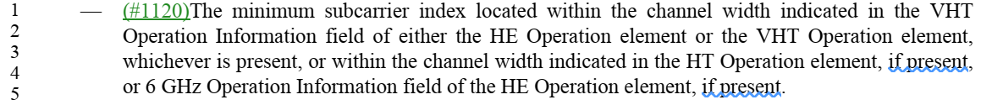
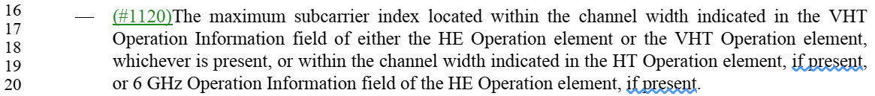

CID 7080
CID | Commenter | PP.LL | Comment | Proposed Change | Resolution
7080 | Sigurd Schelstraete | 295.41 | "The EHT beamformee shall transmit the EHT compressed beamforming/CQI report a SIFS after the EHT sounding NDP.". This has already been stated elsewhere and is out of place here. | Delete "The EHT beamformee shall transmit the EHT compressed beamforming/CQI report a SIFS after the EHT sounding NDP." | Rejected  The comment fails to specify the precise location of the other duplicate text. Please submit a comment identifying it.
Background text in Page 410 of D1.31
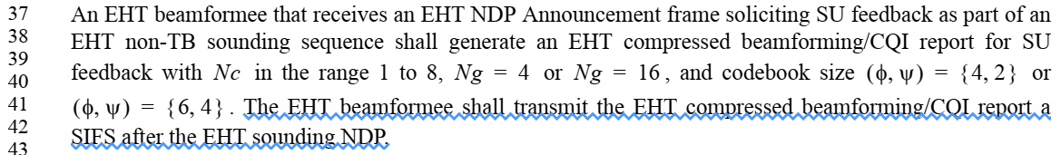

CID 7930, 7929 and 8371
CID | Commenter | PP.LL | Comment | Proposed Change | Resolution
7930 | Youhan Kim | 295.52 | The first sentence of the paragraph starting at P295L50 and the other sentences in the same paragraph are not related to each other. | Start a new paragraph starting from the second sentence of the paragraph starting at P295L50 (the second sentence starts at the middle of P295L52). | Revised  Agree with the commenter.  Instructions to the editor:  Please make the changes shown as the proposed text change in CID 8371 of 11-21/2014r1
7929 | Youhan Kim | 295.55 | P292L7 states that an EHT non-TB sounding sequence has both the characteristics of being individually addressed and having exactly one STA Info field. | Option 1:  Change at P295L54  "that contains the EHT beamformee's MAC address in the RA field (indicating a non-TB sounding sequence)"  to  "that contains the EHT beamformee's MAC address in the RA field and has exactly one STA Info field (indicating a non-TB sounding sequence)"  Option 2:  Change at P295L53  "An EHT beamformee that receives an EHT NDP Announcement frame from an EHT beamformer with which it is associated and that contains the EHT beamformee's MAC address in the RA field (indicating a non-TB sounding sequence)"  to  "An EHT beamformee that receives an EHT NDP Announcement frame as part of an EHT non-TB sounding sequence" | Revised  Agree with the commenter. And option 2 looks better for consistency with the previous sentence. Also, ‘receives an EHT sounding NDP a SIFS after the EHT NDP Announcement frame’ also looks redundant.  Instructions to the editor:  Please make the changes shown as the proposed text change in CID 8371 of 11-21/2014r1
8371 | Zinan Lin | 295.59 | "Indicate" is redundant in this sentence and needs to be deleted | The TXVECTOR parameter CH_BANDWIDTH for the PPDU containing the EHT compressed beamforming/CQI report shall be set to indicate a bandwidth not wider than that indicated by the RXVECTOR parameter CH_BANDWIDTH of the EHT sounding NDP. | Revised  Agree with the commenter. But the text is deleted by CID 7648.  Instructions to the editor:  No further change is needed.
Proposed text change in Page 410 Line 53 of D1.31:
An EHT beamformee that receives an EHT NDP Announcement frame soliciting CQI feedback as part of an EHT TB sounding sequence shall generate an EHT compressed beamforming/CQI report for CQI feedback with determined by the EHT beamformer.
(Start new paragraph)
An EHT beamformee that receives an EHT NDP Announcement frame as part of an EHT non-TB sounding sequence shall transmit its EHT compressed beamforming/CQI report a SIFS after the EHT sounding NDP.

CID 7931
CID | Commenter | PP.LL | Comment | Proposed Change | Resolution
7931 | Youhan Kim | 296.17 | There are two sentences in the paragraph starting at P296L16 w/ 'shall' requirements, but essentially saying the same thing. Make one of them a 'description', and leave only one 'shall' requirement.  Also, this requirement (set the Partial BW Info subfield in EHT MIMO Control field to be the same as that in NDPA) is applicable to AP beamformee as well. | Change  "An EHT beamformee that is a non-AP STA that transmits an EHT Compressed Beamforming/CQI Report frame shall set the Partial BW Info subfield"  to  "An EHT beamformee that transmits an EHT Compressed Beamforming/CQI Report frame sets the Partial BW Info subfield" | Revised  Agree with the commenter.  Instructions to the editor:  Please make the changes shown as the proposed text change in below CID 7931 of 11-21/2014r1
Proposed text change in Page 411 Line 16~20 of D1.31:
An EHT beamformee that transmits an EHT Compressed Beamforming/CQI Report frame sets the Partial BW Info subfield of the EHT MIMO Control field to indicate the range of subcarriers for which compressed beamforming/CQI information is provided. The Partial BW Info subfield shall be set to the value of the Partial BW Info subfield of the NDP Announcement frame for the EHT beamformee.

CID 4430 and 7932
CID | Commenter | PP.LL | Comment | Proposed Change | Resolution
4430 | Arik Klein | 296.23 | Add clarification for the indication of the maximum PPDU duration that is set by the EHT Beamformer | Revise the sentence as follows:"An EHT beamformee that transmits EHT compressed beamforming feedback shall include neither the EHT compressed beamforming report information nor the EHT MU exclusive beamforming report information if the transmission duration of the PPDU carrying the EHT compressed beamforming report information and any EHT MU exclusive beamforming report information would exceed the maximum PPDU duration *,as indicated in the UL Length field in the preceding BFRP Trigger frame*" | Revised  The maximum PPDU duration is defined in Table 9-34 (Maximum data unit sizes (in octets) and durations (in microseconds). Then let’s just refer it.  Instructions to the editor:  Please add the reference at the end of the sentence in P411 L27 to ‘(see Table 9-34 (Maximum data unit sizes (in octets) and durations (in microseconds)).’
7932 | Youhan Kim | 296.23 | There is no definition of EHT MIMO Control field which corresponds to the case of including neither the EHT compressed beamforming report information nor the EHT MU exclusive beamforming report information for SU or MU type feedback.  Also, what would be the use of transmitting an (incorrect) EHT MIMO Control field, but with no actual 'payload'? | Change the paragraph starting at P296L23 to say that an EHT beamformee shall not respond to BFRP Trigger frame if the beamforming report would not fit in the TB PPDU. | Rejected  In an EHT Compressed Beamforming/CQI frame not carrying all or part of an EHT compressed beamforming/CQI report, the subfield setting of EHT MIMO Control field is described in the setion 9.4.1.70 (EHT MIMO Control field).
Background text in Page 411 of D1.31:
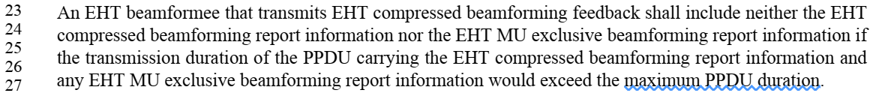
Background text in 9.4.1.70 EHT MIMO Control field (Page 151) of D1.31:
