IEEE P802.11
Wireless LANs
TGbe CC36 Comment Resolutions for 35.5.3 – Part 2
Date: 2022-01-06
Author(s):
Name | Affiliation | Address | Phone | Email
Jinyoung Chun | LG Electronics | 19, Yangjae-daero 11gil, Seocho-gu, Seoul 137-130, Korea |  | jiny.chun@lge.com
Dongguk Lim |  |  |  | dongguk.lim@lge.com
Eunsung Park |  |  |  | esung.park@lge.com
Insik Jung |  |  |  | insik0618.jung@lge.com
Jinsoo Choi |  |  |  | js.choi@lge.com
Wook Bong Lee | Samsung |  |  | wookbong.lee@samsung.com
Alfred Asterjadhi | Qualcomm |  |  | aasterja@qti.qualcomm.com
Arik Klein | Huawei |  |  | arik.klein@huawei.com

Abstract
This submission proposes a resolution for 6 CIDs: CID 4244, 4245, 7928, 7079, 7072 and 7075

Revisions:
- Rev 0: Initial version of the resolution document based on 11be Draft 1.31.

CID 4244
CID | Commenter | PP.LL | Comment | Proposed Change | Resolution
4244 | Alfred Asterjadhi | 292.47 | Need to add a reference as to what requirements apply to the BFRP trigger frame (setting of the fields), such as those defined in the Trigger frame normative behavior (clause 26) and those expanded for the EHT variant. | As in comment. | Revised  This paragraph describes the flow of EHT TB sounding sequence and the BFRP is described in the previous sentence in view of TB sounding sequence. Also the details of BFRP trigger frame is in other place of this section. So let’s just delete the sentence here.  Instructions to the editor:  Please delete the sentence: ‘BFRP Trigger frames sent within an EHT TB sounding sequence shall solicit EHT TB PPDUs.’ in P407 L58 of D1.31
Background text in Page 407 of D1.3
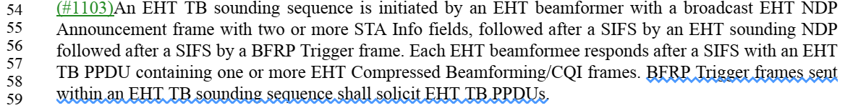

CID 4245, 7928 and 7079
CID | Commenter | PP.LL | Comment | Proposed Change | Resolution
4245 | Alfred Asterjadhi | 293.20 | Have we specified somewhere that the additional sequences of the BFRP polling are for polling other STAs? Please ensure that is the case since the same STA cannot be re-polled for segments. But can it be polled again if nothing made it through? | As in comment. | Revised  The same STA can’t be re-polled but the other STAs can be polled by additional BFRP Trigger in the same TXOP. The description is in the section and the next section. Please refer the background text below CID 7079.  But the text ‘one or more sequences’ in the figure makes some confusion.  Instructions to the editor:  Please delete the text ‘one or more sequences’ in the Figure 35-29 (An illustration of EHT TB sounding) (P406L5 in D1.3), and make the changes shown as the proposed text change in below CID 7079 of 11-21/2013r0
7928 | Youhan Kim | 294.21 | It is not clear what "another" BFRP Trigger frame means. | At P294L21, change  "may send another BFRP Trigger frame"  to  "may sent one or more BFRP Trigger frames" | Revised  Agree with the commenter. But one BFRP transmission is default.  Instructions to the editor:  Please make the changes shown as the proposed text change in below CID 7079 of 11-21/2013r0
7079 | Sigurd Schelstraete | 294.21 | "may send another BFRP Trigger frame in the same TXOP as shown in Figure 35-18". This is not shown in Figure 35-18. | Remove reference to figure or add figure that shows multiple BFRPs. | Revised  Agree with the commenter. And the resolution is same with CID 4245.
Background text related to BFRP Trigger frame of D1.31:
- Page 408
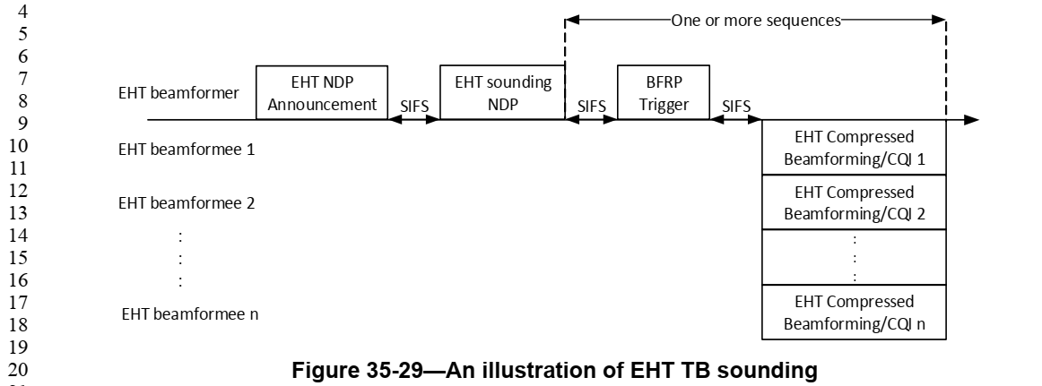
- Page 409
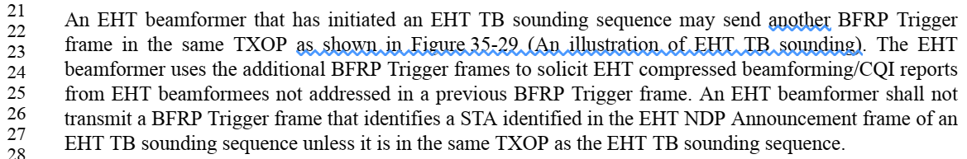
- Page 411
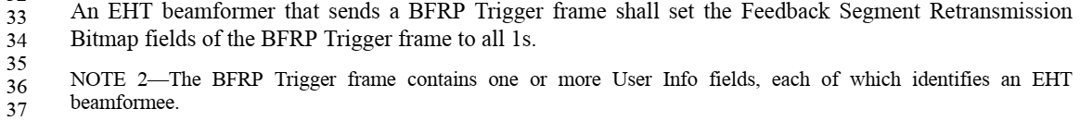
- Page 412
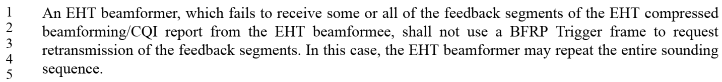

Proposed text change in P409 L21~23 of D1.31:
An EHT beamformer that has initiated an EHT TB sounding sequence may send more than one BFRP Trigger frame in the same TXOP.

CID 7072 and 7075
CID | Commenter | PP.LL | Comment | Proposed Change | Resolution
7072 | Sigurd Schelstraete | 292.04 | Section 35.5.3 really discusses three separate things: frame sequences, NDPA and feedback. We propose reorganizing 35.5.3 along those lines. | See comment. | Revised  Agree with the commenter. Currently, the description of BFRP Trigger is distributed. (See the background text above CID 7072) So let’s gather the paragraphs about BFRP in P410 L36 because all the paragraphs corresponding to the BFer that discuss the content of the NDPA should be together before the paragraphs corresponding to the BFer that discuss the content of the BFRP.  Instructions to the editor:  Please move the paragraphs in P409L21~28 and P411L32~37 to P410 L36 of D1.31
7075 | Sigurd Schelstraete | 292.04 | A lot of requirements on the NDP Annoucement in section 35.5.3 are already contained in the definition of NDPA (see 9.3.1.19) - e.g lines 1-15 on page 294 and numerous other details. Propose to clean up any repetition and refer to 9.3.1.19 where appropriate. | Clean up to avoid repetition | Rejected  Here, NDPA is described by TB sounding sequence or non-TB sounding sequence, respectively. So it’s better to keep the sentences.

