IEEE P802.11
Wireless LANs
TGbe CC36 Comment Resolutions for 35.5.3 – Part 1
Date: 2022-01-06
Author(s):
Name | Affiliation | Address | Phone | Email
Jinyoung Chun | LG Electronics | 19, Yangjae-daero 11gil, Seocho-gu, Seoul 137-130, Korea |  | jiny.chun@lge.com
Dongguk Lim |  |  |  | dongguk.lim@lge.com
Eunsung Park |  |  |  | esung.park@lge.com
Insik Jung |  |  |  | insik0618.jung@lge.com
Jinsoo Choi |  |  |  | js.choi@lge.com
Wook Bong Lee | Samsung |  |  | wookbong.lee@samsung.com
Alfred Asterjadhi | Qualcomm |  |  | aasterja@qti.qualcomm.com
Arik Klein | Huawei |  |  | arik.klein@huawei.com

Abstract
This submission proposes a resolution for 15 CIDs: CID 7648, 7073, 7926, 5562, 6060, 5563, 7074, 4428, 7076, 4429, 6061, 5564, 7077, 7078 and 7927

Revisions:
- Rev 0: Initial version of the resolution document based on 11be Draft 1.31.

CID 7648
CID | Commenter | PP.LL | Comment | Proposed Change | Resolution
7648 | Wookbong Lee | 292.05 | Propose to use only EHT MU PPDU with same bandwidth as EHT NDP-A to carry EHT Compressed Beamforming/CQI report for non-TB souding. RXVECTOR CHAN_MAT, DELTA_SNR assumes EHT MU PPDU format. | Modify P292L9 as follows: "The EHT beamformee responds after SIFS with an EHT Compressed Beamforming/CQI frame using an EHT MU PPDU with the same bandwidth as the EHT NDP Announcement frame." | Revised  Agree with the commenter that EHT MU PPDU has the same bandwidth with EHT NDPA and NDP in non-TB sounding. Then the related text is also should be deleted. Please see the proposed change.  Instructions to the editor:  Please make the changes shown as the proposed text change in below CID 7648 of 11-21/2012r0.
Proposed text change in Page 407 Line 18 of D1.31:
35.5.3 Rules for EHT sounding protocol sequences

An EHT non-TB sounding sequence is initiated by an EHT beamformer with an individually addressed EHT NDP Announcement frame comprising exactly one STA Info field, followed after SIFS by an EHT sounding NDP. The EHT beamformee responds after SIFS with EHT Compressed Beamforming/CQI frame(s) carried in an EHT MU PPDU that has the same bandwidth as the soliciting EHT NDP Announcement frame.
Proposed text change in Page 410 Line 53 of D1.31:
An EHT beamformee that receives an EHT NDP Announcement frame from an EHT beamformer with which it is associated and that contains the EHT beamformee’s MAC address in the RA field (indicating a non-TB sounding sequence) and also receives an EHT sounding NDP a SIFS after the EHT NDP Announcement frame shall transmit its EHT compressed beamforming/CQI report a SIFS after the EHT sounding NDP, using an EHT MU PPDU with the same bandwidth as the EHT NDP Announcement frame.

CID 7073, 7926, 5562 and 6060
CID | Commenter | PP.LL | Comment | Proposed Change | Resolution
7073 | Sigurd Schelstraete | 292.12 | Lines 12-14 are largely repeated in the paragraph on lines 32-36. | Clean up to avoid repetition | Revised  Agree with the commenter.  Instructions to the editor:  Please delete 2nd paragraph in the subclause 35.5.3 (P407L24~26 of D1.31).
7926 | Youhan Kim | 292.12 | Paragraph starting at P292L12 has duplicate information as the paragraph starting at P292L32. | Delete the paragraph starting at P292L12. | Revised  Agree with commenter.  The resolution is same with CID 7073.
5562 | JINYOUNG CHUN | 292.13 | In EHT NDP Announcement frame, AID 0 is defined to 'addressed to the associated AP'. But here AID 0 is for mesh STA, AP or IBSS STA. Clarify it. | as a comment | Revised  Agree with the commenter. But this paragraph is deleted by other CIDs.  The resolution is same with CID 7073.
6060 | Liwen Chu | 292.32 | With this paragraph the 2nd paragraph in the subclause is not needed. | Change the text according to the comment. | Revised  Agree with the commenter.  The resolution is same with CID 7073.
Background text in Page 407 of D1.31

CID 5563
CID | Commenter | PP.LL | Comment | Proposed Change | Resolution
5563 | JINYOUNG CHUN | 292.36 | In EHT NDP Announcement frame, AID 0 is defined to 'addressed to the associated AP'. But here AID 0 is for mesh STA, AP or IBSS STA. Clarify it. | as a comment | Revised  Agree with the commenter.  In the section 9.3.1.19 (NDPA frame format), AID 0 was already clarified as ‘STA Info field is addressed to the associated AP or mesh AP or IBSS STA’ in D1.3. So let’s follow that.  Instructions to the editor:  Please modify the text in P407L48 of D1.31 to ‘~ 0 if the STA identified by the RA field is an associated AP, mesh STA or IBSS STA.’
Background text in Page 407 of D1.31
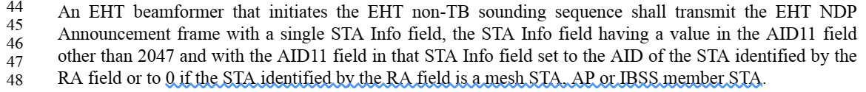

CID 7074
CID | Commenter | PP.LL | Comment | Proposed Change | Resolution
7074 | Sigurd Schelstraete | 292.44 | "Each EHT beamformee responds after a SIFS with an EHT TB PPDU containing one or more EHT Compressed Beamforming/CQI frames.". An AP may receive multiple TB PPDUs at the same time, but it's not clear how a single TB PPDU could contain more than one Compressed Beamforming/CQI frame. | Change "one or more" to "one" | Rejected  A single TB PPDU can contain one or more EHT Compressed Beamforming/CQI frames. Please refer the below text in the section 35.5.4 (Rules for generating segmented feedback):  ‘Each feedback segment shall be included in a separate EHT Compressed Beamforming/CQI frame.’, ‘All feedback segments shall be sent in a single A-MPDU contained in a PPDU.’
Background text in Page 407 of D1.31
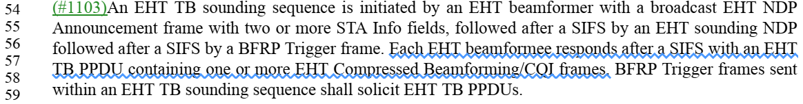

CID 4428, 7076 and 4429
CID | Commenter | PP.LL | Comment | Proposed Change | Resolution
4428 | Arik Klein | 293.30 | Please clarify what does "feedback variant" mean and how it is indicated in NDPA frame by the EHT Beamformer. | As in comment. | Revised  Agree with the commenter. There’s no definition of feedback variant in the draft. Feedback variant looks to mean SU, MU, or CQI feedback, but the text of ‘computed based on parameters’ is still unclear and looks implementation issue. So it’s better to delete the paragraph.  Instructions to the editor:  Please delete the paragraph in P408L29~33 of D1.31
7076 | Sigurd Schelstraete | 293.30 | The term "feedback variant" is only used in this paragraph. Either define or use a term that is clearer. | See comment | Revised  Agree with the commenter.  The resolution is same with CID 4428
4429 | Arik Klein | 296.31 | Please clarify what are the parameters that, if not supported by the EHT beamformee, the EHT beamformer can't solicit a feedback variant, as stated in the following sentence "otherwise, the EHT beamformer shall not solicit a feedback variant computed based on parameters not supported by the EHT beamformee " | As in comment | Revised  The page and line number is wrong, but I think it means ‘feedback variant’ in P293L30 of D1.0.  So the resolution is same with CID 4428
Background text in Page 408 of D1.31
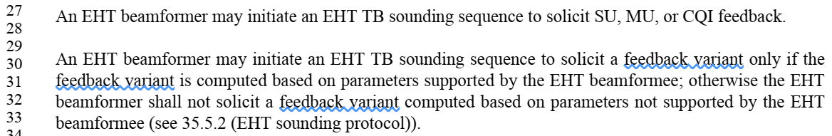

CID 6061
CID | Commenter | PP.LL | Comment | Proposed Change | Resolution
6061 | Liwen Chu | 293.40 | Rx Control Frame To MultiBSS doesn't exist in EHT Capabilities element. | Change the text according to the comment. | Revised  Agree with commenter, and it was already fixed to ‘HE Capabilities element’ in D1.2  Instructions to the editor:  No further change is needed.

CID 5564
CID | Commenter | PP.LL | Comment | Proposed Change | Resolution
5564 | JINYOUNG CHUN | 293.52 | In EHT NDP Announcement frame, AID 0 is defined to 'addressed to the associated AP'. But here AID 0 is for mesh STA, AP or IBSS STA. Clarify it. | as a comment | Revised  Agree with the commenter.  In NDPA section, AID 0 was already clarified as ‘STA Info field is addressed to the associated AP or mesh AP or IBSS STA’ in D1.2. So follow that.  Instructions to the editor:  Please modify the text in P408L51~54 of D1.31 to ‘~ that is an associated AP, mesh STA or IBSS STA, shall include one STA ~’
Background text in Page 408 of D1.31

CID 7077 and 7078
CID | Commenter | PP.LL | Comment | Proposed Change | Resolution
7077 | Sigurd Schelstraete | 293.57 | Change "a non-AP" to "each non-AP" | See comment | Revised  Agree with the commenter. To clarify, let’s add the text that the non-AP is EHT beamformee.  Instructions to the editor:  Please make the changes shown as the proposed text change in below CID 7078 of 11-21/2012r0.
7078 | Sigurd Schelstraete | 293.57 | Improve wording : "identifying a non-AP STA to the eleven LSBs of the AID" | See comment | Revised  The resolution is same with CID 7077.  Instructions to the editor:  Please make the changes shown as the proposed text change in below CID 7078 of 11-21/2012r0.
Background text in Page 408 of D1.31
Proposed text change in P408 L56~59 of D1.31:
When an EHT beamformer is an AP and EHT beamformees are non-AP STAs, the EHT beamformer that transmits an EHT NDP Announcement frame to one or more EHT beamformees shall set the AID11 fieldto 11 LSBs of the AID of each EHT beamformee.

CID 7927
CID | Commenter | PP.LL | Comment | Proposed Change | Resolution
7927 | Youhan Kim | 294.10 | The two sentences in the paragraph starting at P294L7 seems unrelated to each other. | Separate the two sentences in the paragraph starting at P294L7 to two separate paragraphs. | Revised  Agree with the commenter.  Instructions to the editor:  Please separate the two sentences in P409 L7~14 of D1.31
Background text in Page 409 of D1.31
