IEEE P802.11
Wireless LANs
Annex Z Example for small RUs/MRUs
Date: 2021-12-07
Author(s):
Name | Affiliation | Address | Phone | email
Mahmoud Kamel | InterDigital Inc. | 1000 Sherbrooke West, Montréal, QC, H3A 3G4 Canada |  | mahmoud.kamel@interdigital.com
Zinan Lin |  | 111 West 33rd Street  New York, NY 10120  USA
Hanqing Lou
Rui Yang

Abstract
This submission proposes draft text (Baseline P802.11be D1.3) to add a new example to Annex Z to cover the case of small RUs/MRUs and punctured channels.

Revisions:
Rev 0: first draft of the document.

Discussion (Not a part of the PDT):
802.11be has an elegant signalling designation that allows for the flexible allocation of resources which encompasses several different scenarios and use cases. Further, it defines the use of small and large MRUs along with small and large RUs.

To complement the signalling examples provided in Annex-Z, this contribution presents a new example of the EHT-SIG encoding. The main goal of this example is to cover other resource allocation signalling scenarios which includes punctured channels, small RUs, and small MRUs combined with large RUs/MRUs. The allocation of small RUs/MRUs involves encoding more than one User field in the User Specific field of the EHT-SIG content channel for the same 20 MHz subchannel. This would necessitate including a significantly large number of User fields in the same content channel of the EHT-SIG and makes the balancing of the content channels hardly attainable.

Also, not all allocations are allowed in any 20 MHz since the allowed allocations may differ based on the location of a specific 20 MHz subchannel in an 80 MHz subblock. For example, in the fourth 20 MHz of an 80 MHz subblock (the green box in the figure below) the only allowed 106+26-tone MRU is MRU8. Accordingly, only the allocation of index 50 is allowed, but not index 48. However, in the third 20 MHz subchannel (the red box), the only allowed 106+26-tone MRU is MRU5 in which the index 48 is allowed, but not index 50. Indicating these cases in a new example would be helpful for developers to identify the allowed allocations as indicated in the figure below and to show the flexibility of the resource allocation with combination of small and large RUs/MRUs in 802.11be.

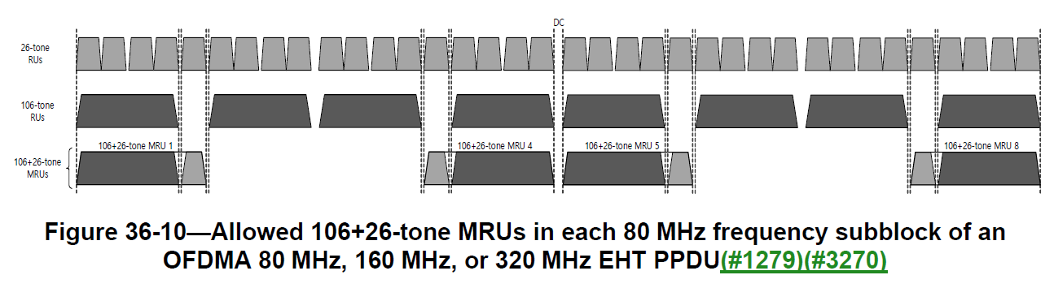

Discussion End
TGbe Editor: Please add the following text in annex Z (802.11be Draft 1.3)

Discussion End

Instruction to the editor: please add the following at the end of Annex Z of P802.11be D1.3

Z.12 EHT-SIG Example 8

An example of the EHT-SIG field with U-SIG overflow and resource allocation signalling for a 160 MHz OFDMA transmission using EHT MU PPDU are shown in Table Z-38 (U-SIG overflow example 8) and Table Z-39 (Resource allocation signalling example 8) respectively. This example covers the cases with preamble puncturing, small RUs and small MRUs combined with large RUs/MRUs.

Table Z-38—U-SIG overflow example 8

Subfield | Indication | Meaning
Spatial Reuse | 1111 | PSR_AND_NON_SRG_OBSS_PD_PROHIBITED.
GI+LTF Size | 11 | 4× EHT-LTF and 3.2 µs GI.
Number Of EHT-LTF Symbols | 010 | 4 EHT-LTF symbols.
LDPC Extra Symbol Segment | 1 | An LDPC extra symbol segment is present.
Pre-FEC Padding Factor | 01 | A pre-FEC padding factor of 1.
PE Disambiguity | 0 | The condition in Equation (36-94) is not met.
Disregard | 1111

Table Z-39—Resource allocation signalling example 8

RU/MRU | 242-tone RU 1 | 484+242-tone MRU 1  ([]-242-484) | 484+242-tone MRU 8  (484-242-[]) | 106-tone RU15 | 106+26-tone  MRU 16
SS0 | Punctured | STA-ID 1441,  EHT-MCS 10, LDPC, 2SS | STA-ID 1443,  EHT-MCS 8, LDPC, 2SS, Tx  beamforming | STA-ID 1444,  EHT-MCS 4, BCC, Tx beamforming | STA-ID 1445,  EHT-MCS 7, BCC, Tx beamforming
SS1 |  |  |  | N/A
SS2 |  | STA-ID 1442,  EHT-MCS 4, LDPC, 2SS | N/A
SS3

In this example, the EHT-SIG content channels per 80 MHz frequency subblock are set to the same values by the AP. The EHT-SIG content channels per 80 MHz frequency subblock can also be different. The illustration of an RU Allocation subfield for each of the four 80 MHz frequency subblocks is given in Table Z-40 (Resource Allocation subfield illustration for each 80 MHz frequency subblock example 8).

Table Z-40—Resource Allocation subfield illustration for each 80 MHz frequency subblock example 8

 | RU Allocation subfield illustration
Content channel 1 | 242 (0 User fields) | 484 (0 User field) | 484-242-[], MRU 8  (1 User field) | 242 (0 User field)
Content channel 2 | []-242-484, MRU 1  (2 User fields) | 484 (0 User field) | 484 (0 User field) | 242 (2 User field)

In this example, STAs 1441-1445 are operating on the primary 80 MHz channel, which is the lower 80 MHz. The User field for STA 1443 is in content channel 1 while the User fields for STAs 1441, 1442, 1444, and 1445 are in content channel 2 in the lower 80 MHz. No User fields exist in the upper 80 MHz. The contents of the entire EHT-SIG field in each 80 MHz for this example is shown in Table Z-41 (EHT- SIG content in each 80 MHz frequency subblock for example 8).

Table Z-41—EHT-SIG content in each 80 MHz frequency subblock for example 8
 | EHT-SIG content channel 1 |  | EHT-SIG content channel 2
Common field (U-SIG Overflow, 2 RU Allocation-1 subfields, CRC, Tail, 2 RU Allocation-2 subfields, CRC, Tail) | 1111 11 010 1 10 0 1111 |  | 1111 11 010 1 10 0 1111
 | 010110000 101110000 0110 000000 |  | 100001100 101110000 1101 000000
 | 000111100 001110000 1111 000000 |  | 101110000 010011000 1111 000000
User Specific field | STA 1443 | 11000101101 | STA 1441 | 10000101101
 |  | 0001 1 1000 1 1 |  | 0101 1 001000
 | CRC and Tail | 0011 000000 | STA 1442 | 01000101101  0010 1 001000
 | Padding | 00000000  00000000  00000000  00000000  00000000  00000000  00000000  00000000  00000000  0000000 | CRC and Tail | 1100 000000
 |  |  | STA 1444 | 00100101101  0010 1 0000 1 0
 |  |  | STA 1445 | 10100101101  1110 1 0000 1 0
 |  |  | CRC and Tail | 0110 000000
 |  |  | Padding | 000
EHT-SIG field content in  binary, organized as octets  (LSB first) | 11111101 01100111 10101100 00101110 00001100 00000000 11110000 11100001 11100000 01100010 11010001 11000110 01100000 00000000 00000000 00000000 00000000 00000000 00000000 00000000 00000000 00000000 00000000 |  | 11111101 01100111 11000011 00101110 00011010 00000101 11000001 00110001 11100000 01000010 11010101 10010000  10001011 01001010 01000110 00000000  01001011 01001010 00010101 00101101 11101000 01001100 00000000
EHT-SIG field content in  binary, organized as octets  (MSB first within each octet) | 10111111 11100110 00110101 01110100 00110000 00000000 00001111 10000111 00000111 01000110 10001011 01100011 00000110 00000000 00000000 00000000 00000000 00000000 00000000 00000000 00000000 00000000 00000000 |  | 10111111 11100110 11000011 01110100  01011000 10100000 10000011 10001100  00000111 01000010 10101011 00001001  11010001 01010010 01100010 00000000  11010010 01010010 10101000 10110100  00010111 00110010 00000000
EHT-SIG field content in hexa-  decimal, organized as octets | BF E6 35 74 30 00 0F 87 07 46 8B 63 06 00 00 00 00 00 00 00 00 00 00 |  | BF E6 C3 74 58 A0 83 8C 07 42 AB 09 D1 52 62 00 D2 52 A8 B4 17 32 00

