IEEE P802.11
Wireless LANs
CC36 CR for SPATIAL_REUSE and BEAMFORMED in TXVECTOR and RXVECTOR
Date: 2021.12.06
Author(s):
Name | Company | Address | Phone | email
Mengshi Hu | Huawei Technologies | F3-6-A118, Huawei Base, Bantian, Longgang, Shenzhen, Guangdong, China, 518129 |  | humengshi@huawei.com
Ross Yu
Ming Gan
Shimi Shilo
Abstract
This submission contains proposed 7 comment resolutions for the comments on P802.11be D1.0.

CIDs: 4534, 5460, 6781, 6923, 7124, 7989, 7653

Revision Notes
R0 | Initial revision

CIDs related to SPATIAL_REUSE

CID 4534
Page.  Line | Clause Number | Comment | Proposed Change | Resolution
325.39 | 36.2.2 | Spatial_REUSE need to be updated. It presents in the EHT_MU format | as in the comment. | REVISED  Note to the Editor: The proposed changes have been reflected in Draft 1.3.  No further changes are needed.

Discussion：
Text in Draft 1.0:
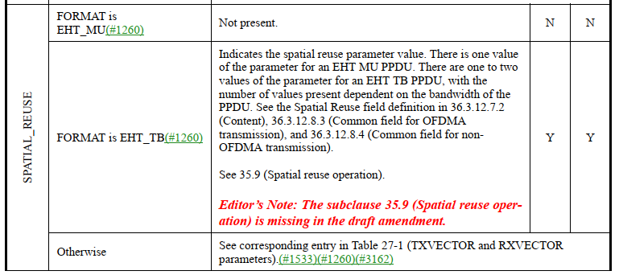
Text in Draft 1.3:
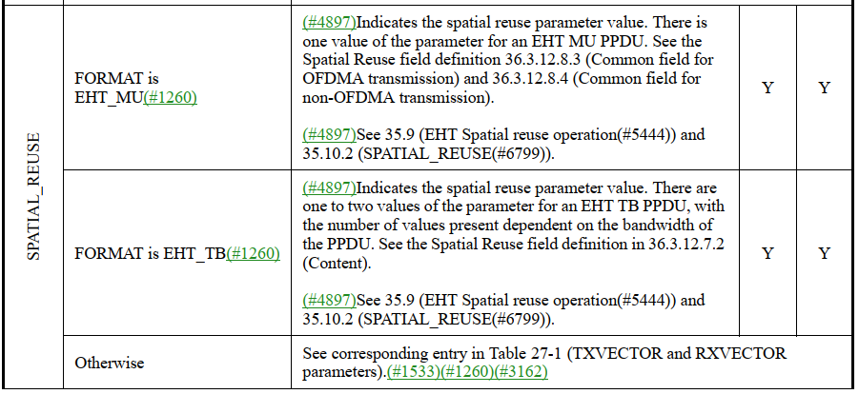
Discussion ends.

CID 5460
Page.  Line | Clause Number | Comment | Proposed Change | Resolution
325.53 | 36.2.2 | Correct the reference, include both HE and EHT spatial reuse as reference. Correct the format. EHT MU and EHT TB both have spatail reuse TXVECTOR and RXVECTOR | as in comment | REVISED  For the EHT spatial reuse, the reference has been incorporated in Draft 1.3.  For the HE spatial reuse,  the references are already included in 36.3.12.8.3 and 36.3.12.8.4. Readers would refer to these two subclauses for details.  Note to the Editor: The proposed changes have been reflected in Draft 1.3.  No further changes are needed.

Discussion：
Discussion ends.

CID 6781
Page.  Line | Clause Number | Comment | Proposed Change | Resolution
325.39 | 36.2.2 | TXVECTOR and RXVECTOR parameter SPATIAL_REUSE needs to be defined for EHT MU PPDU, since this field is defined in EHT SIG Common Info field - see Table 36-33 (Common field for OFDMA transmission) and Table 36-36 (Common field for non-OFDMA transmission to a single user and non-OFDMA transmission to multiple users) | Include definition similar to the HE case (27.2.2) | REVISED  Note to the Editor: The proposed changes have been reflected in Draft 1.3.  No further changes are needed.

CID 6923
Page.  Line | Clause Number | Comment | Proposed Change | Resolution
325.42 | 36.2.2 | The description for Value with condition on "FORMAT is EHT_TB" has a sentence "There is one value of the parameter for an EHT MU PPDU." But, the description for Value with condition on "FORMAT is EHT_MU" is "Not present.". This is very confusing | If "SPATIAL_REUSE" may have value when FORMAT is EHT_MU, replace "Not present" to "Indicates the spatial reuse parameter value. There is one value of the parameter for an EHT MU PPDU." | REVISED  Note to the Editor: The proposed changes have been reflected in Draft 1.3.  No further changes are needed.

CID 7124
Page.  Line | Clause Number | Comment | Proposed Change | Resolution
325.42 | 36.2.2 | SPATIAL_REUSE shows "Not Present" for EHT_MU. Yet, the text for EHT_TB includes the sentence "There is one value of the parameter for an EHT MU PPDU.". What is the meaning of this? | Clarify | REVISED  Note to the Editor: The proposed changes have been reflected in Draft 1.3.  No further changes are needed.

CID 7989
Page.  Line | Clause Number | Comment | Proposed Change | Resolution
325.52 | 36.2.2 | Delete reference to non-existing subclause. | Delete "See 35.9." and the subsequent Editor's Note. | REVISED  Note to the Editor: The proposed changes have been reflected in Draft 1.3.  No further changes are needed.

Discussion:
Discussion ends.

CIDs related to BEAMFORMED

CID 7653
Page.  Line | Clause Number | Comment | Proposed Change | Resolution
326.56 | 36.2.2 | Clarify whether BEAMFORMED = 1 is allowed in EHT TB PPDU. | See comment. | REJECTED  BEAMFORMED = 1 is allowed for an EHT TB PPDU, according to the content shown in the parameter BEAMFORMED in Table 36-1 of P802.11be D1.3, which is also consistent with the same parameter in IEEE 802.11ax-2021.  Note: This comment is rejected since it does not result in a change to the draft.

Discussion:
BEAMFORMED in 11ax: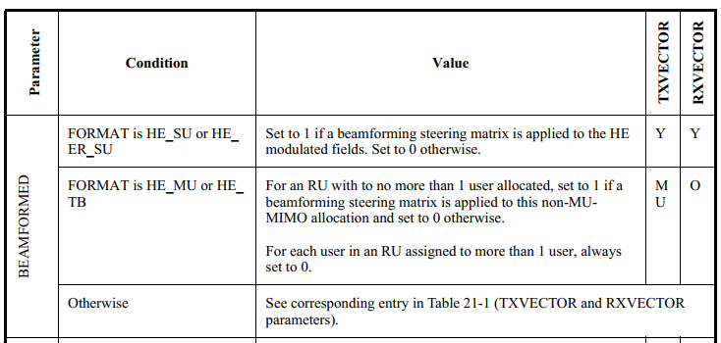
BEAMFORMED in 11be (Draft 1.3):
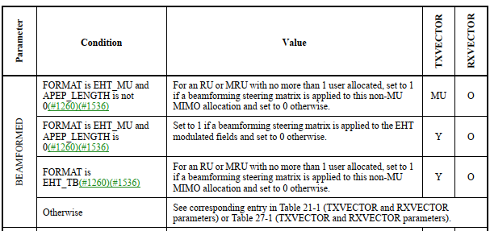
Discussion ends.

