IEEE P802.11
Wireless LANs
Resolution to CC36 CID 4305
Date: 2021-12-09
Author(s):
Name | Affiliation | Address | Phone | email
Michael Montemurro | Huawei |  |  | montemurro.michael@gmail.com
Background
This contribution proposes a comment resolution to CC36 CID 4305

Straw_poll: Adopt the resolutions in document 11-21/1918r0 for CIDs 4305

Comment
CID | Page | Clause | Comment | Proposed Change
4305 | 10.2.7 | 0.00 | Maybe better to be a little bit clearer here. SA field? It should be Address 4 I think. Also Since this an MLD functionality probably the rule needs to be in the MLD operation. That way everything is in one place. | As in comment.

Discussion:
The cited text is the following (note that the clause number has changed in D1.3):
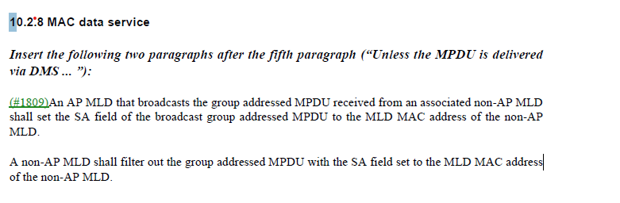

In the base standard (REVme D0.4), the paragraph in 10.2.8 immediately preceding this added text is:

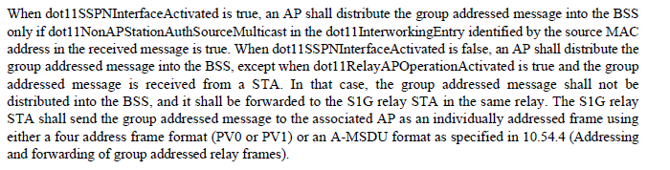

Clause 35.3.14 describes delivery and reception of group-addressed frames for MLO and for the most part, points to baseline behaviour. In this case, the requirement should be in Clause 35.3.14 Move the AP MLD requirement to the “delivery” clause and the non-AP MLD requirement to the “reception” clause.

Proposed Resolution: (4305)
Revised. The text is specific to MLO and should be included in clause 35 rather than clause 10.

Relative to P802.11b3 D1.3, move the following text from 222.7 to 367.43:
“An AP MLD that broadcasts the group addressed MPDU received from an associated non-AP MLD shall set the SA field of the broadcast group addressed MPDU to the MLD MAC address of the non-AP MLD.”

Move the following text from 222.12 to 368.28:
“A non-AP MLD shall filter out the group addressed MPDU with the SA field set to the MLD MAC address of the non-AP MLD.”

