IEEE P802.11  
Wireless LANs

|  |  |  |  |  |
| --- | --- | --- | --- | --- |
| CR for MLE Fragmentation | | | | |
| Date: November 10, 2021 | | | | |
| Author(s): | | | | |
| Name | Affiliation | Address | Phone | email |
| Jason Yuchen Guo | Huawei |  |  | guoyuchen@huawei.com |
| Ming Gan | Huawei |  |  |  |
| Yunbo Li | Huawei |  |  |  |
| Guogang Huang | Huawei |  |  |  |
| Yiqing Li | Huawei |  |  |  |
| Mengyao Ma | Huawei |  |  |  |
| Hongjia Su | Huawei |  |  |  |
|  |  |  |  |  |

Abstract

This submission proposes resolutions for following CIDs received for TGbe CC36:

5063, 4015

Revisions:

* Rev 0: Initial version of the document.

Interpretation of a Motion to Adopt

A motion to approve this submission means that the editing instructions and any changed or added material are actioned in the TGbe Draft. This introduction is not part of the adopted material.

***Editing instructions formatted like this are intended to be copied into the TGbe Draft (i.e. they are instructions to the 802.11 editor on how to merge the text with the baseline documents).***

***TGbe Editor: Editing instructions preceded by “TGbe Editor” are instructions to the TGbe editor to modify existing material in the TGbe draft. As a result of adopting the changes, the TGbe editor will execute the instructions rather than copy them to the TGbe Draft.***

|  |  |  |  |  |  |  |
| --- | --- | --- | --- | --- | --- | --- |
| **CID** | **Commenter** | **Page** | **Clause** | **Comment** | **Proposed Change** | **Resolution** |
| 5063 | Gaurang Naik | 133.32 | 9.4.2.295b.2 | When a Per-STA Profile subelement of the Basic variant Multi-Link element carries the complete profile of a reported STA of an MLD, even with inheritance, there may be scenarios where the size of the subelement exceeds 255 octets. It is not clear how the spec addressed this scenario. | As in comment. The commenter will provide a contribution to address this issue. | Revised –  Agree in principle with the comment. Add a new subelement to the Basic Multi-Link element to indicate a fragment subelement.  In order to address the case when a long Multi-Link element carries the information of a nontransmitted BSSID’s MLD, add a MLD ID subfield to the Common Info field of the Basic Multi-Link element to indicate the MLD whose information is carried in the Basic Multi-Link element. Hence, the Basic Multi-Link element can be carried outside of the Multiple BSSID element, which avoids a multi-level fragmentation.  TGbe editor:  Please implement changes as shown in this document tagged as 5063. |
| 4015 | Abhishek Patil | 133.27 | 9.4.2.295b.2 | Table 9-92 indicates if an element is fragmentable or not. Clause 10.28.11 defines the procedure if the Information field of a fragmentable element is more than 255 octets. However, there is no procedure defined for the case where the Data field of a subelement (within an element) is more than 255 octets. It is possible that the Per-STA Profile subelement of the Basic variant Multi-Link element is greater than 255 octets. | Define a procedure to handle the case where the Per-STA Profile subelement carries in the Link Info field of Multi-Link element is greater than 255 octets. | Revised –  Agree in principle with the comment. Add a new subelement to the Basic Multi-Link element to indicate a fragment subelement.  In order to address the case when a long Multi-Link element carries the information of a nontransmitted BSSID’s MLD, add a MLD ID subfield to the Common Info field of the Basic Multi-Link element to indicate the MLD whose information is carried in the Basic Multi-Link element. Hence, the Basic Multi-Link element can be carried outside of the Multiple BSSID element, which avoids a multi-level fragmentation.  TGbe editor:  Please implement changes as shown in this document tagged as 5063. |

**Discussion**: There is a possibility that the length of a per-STA profile is longer than 255 octets. It may happen in the case that the reported STA has many elements that are different from the reporting STA or specific to the reported STA. In that case, the information to be carried in the Multi-Link element will also be longer than 255 octets. Subclause 10.28.11 defines a procedure for element fragmentation, but it does not cover subelement fragmentation. Doc. 11-21/1175r4 (Abhishek Patil) proposes a method to fragment the Per-STA Profile subelement, but it does not cover the case when the MLE is carried in the Nontransmitted BSSID Profile subelement of a Multiple BSSID element. Doc. 11-21/1508r2 (Liwen Chu) proposes that the non-transmitted BSSID transmits the ML probe response as an action frame, therefore not following the baseline where the transmitted BSSID transmits the Probe Response frame.

This contribution proposes another way around to solve the problem: after receiving the ML probe request corresponding to a non-transmitted BSSID, the AP corresponding to the transmitted BSSID sends the probe response. The info of the AP that corresponds to the targeted non-transmitted BSSID will be carried in a Nontransmitted BSSID Profile subelement of the Multiple BSSID element. The info of other APs affiliated with the same AP MLD as the targeted AP will be carried in an MLE that is NOT in the Nontransmitted BSSID Profile subelement, but in the frame body of the ML probe response. In other words, the Multiple BSSID element and the MLE are located in the same level of the frame body of the ML probe response. The MLE in the ML probe response does not carry the information of the transmitted BSSID’s MLD, instead, the MLE carries the information of the MLD which the non-transmitted BSSID is affiliated with. In order to indicate this, the MLE needs to carry an MLD ID field, whose value is set to the MLD ID of the non-transmitted BSSID’s MLD.

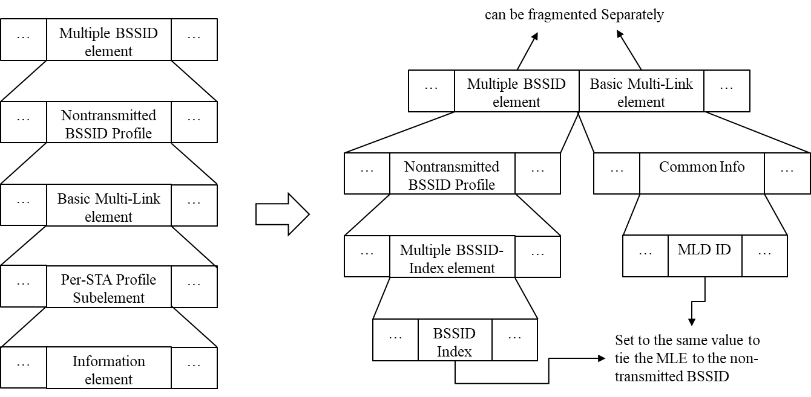

***TGbe editor: Please note baselines are REVme D0.3, 11ax-2021 and 11be D1.2***

**9.4.2.312 Multi-Link element**

**9.4.2.312.1 General**

***TGbe editor: Please update Table 9-322an as shown below:***

(#5833)The Subelement ID field values for the defined subelements of the Multi-Link element are shown in  
Table 9-322an (Optional subelement IDs for Multi-Link element(#5833)).

**Table 9-401c—** **Optional subelement IDs for Multi-Link element(#5833)(#5063)**

|  |  |  |
| --- | --- | --- |
| **Subelement ID** | **Name** | **Extensible** |
| 0 | Per-STA Profile | Yes |
| 1–220 | Reserved |  |
| 221 | Vendor Specific | Vendor defined |
| 222 – 253 | Reserved |  |
| 254 | Fragment | No |
| 255 | Reserved |  |

**9.4.2.312.2 Basic Multi-Link element** **(#6700)**

**9.4.2.312.2.1** **Multi-Link Control field of the Basic Multi-Link element(#7567)**

(#6700)The Basic Multi-link element is used to carry information of an MLD and its affiliated STAs during multi-link discovery (see 35.3.4.4 (Multi-Link element usage rules in the context of discovery)) and multilink setup (see 35.3.5.4 (Usage and rules of Basic Multi-Link element in the context of multi-link (re)setup(#6700))).

(#3247)The format of the Presence Bitmap subfield of the (#6700)Basic Multi-Link element is defined in Figure 9-788eh (Presence Bitmap subfield of the Basic Multi-Link element format(#6700)(#3247)(#1773)(#2603)(#1078)(#1475)(#2981)(#3017)).

|  |  |  |  |  |  |  |  |
| --- | --- | --- | --- | --- | --- | --- | --- |
|  | B0 | B1 | B2 | B3 | B4 | B5 | B6 B11 |
|  | Link ID Info Present | BSS  Parameters Change Count Present | Medium Synchronization Delay Information Present | EML  Capabilities Present | MLD  Capabilities Present | MLD ID Present | Reserved |
| Octets: | 1 | 1 | 1 | 1 | 1 | 1 | 6 |
|  | Figure 9-1002d—Presence Bitmap subfield of the Basic Multi-Link element format(#6700)(#3247)(#1773)(#2603)(#1078)(#1475)(#2981)(#3017)(#5063) | | | | | | |

(#3017)The Link ID Info Present subfield is set to 1 if the Link ID Info subfield is present in the Common Info field. Otherwise, the Link ID Info Present subfield is set to 0.

(#1068)The BSS Parameters Change Count Present subfield is set to 1 if the BSS Parameters Change Count subfield is present in the Common Info field. Otherwise, the BSS Parameters Change Count Present subfield is set to 0.

(#4815)(#7568)The Medium Synchronization Delay Information Present subfield is set to 1 if the Medium Synchronization Delay Information subfield is present in the Common Info field. Otherwise, the Medium Synchronization Delay Information Present subfield is set to 0.

(#4816)(#1773)(#2603)The EML Capabilities Present subfield is set to 1 if the EML Capabilities subfield is present in the Common Info field. Otherwise, the EML Capabilities Present subfield is set to 0.

(#1078)(#1475)(#2981)The MLD Capabilities Present subfield is set to 1 if the MLD Capabilities subfield is present in the Common Info field. Otherwise, the MLD Capabilities Present subfield is set to 0.

(#5063)The MLD ID Present subfield is set to 1 if the MLD ID field is present in the Common Info field. Otherwise the MLD ID Present subfield is set to 0.

**9.4.2.295b.2.2 Common Info field of the Basic Multi-Link element(#7567)**

The format of the Common Info field of the (#6700)Basic Multi-Link element is defined in Figure 9-788ei (Common Info field of the Basic Multi-Link element format(#6700)(#5043)(#1068)(#2139)(#2159)(#2161)(#3018)(#1773)(#2603)(#3017)).

|  |  |  |  |  |  |  |  |  |
| --- | --- | --- | --- | --- | --- | --- | --- | --- |
|  | Common Info Length | MLD MAC  Address | Link ID Info | BSS  Parameters Change Count | Medium Synchronization Delay Information | EML  Capabilities | MLD  Capabilities | MLD ID |
| Octets: | 1 | 6 | 0 or 1 | 0 or 1 | 0 or 2 | 0 or 2 | 0 or 2 | 0 or 1 |
| Figure 9-1002e—Common Info field of the Basic Multi-Link element format(#6700)(#5043)(#1068)(#2139)(#2159)(#2161)(#3018)(#1773)(#2603)(#3017) (#5063) | | | | | | | | |

***TGbe editor: Please add the following contents in this subclause to the end of the subclause***

(#5063)The MLD ID subfield indicates the identifier of the AP MLD whose MLD information is carried in the Basic Multi-Link element.

***TGbe editor: Please add the following as a new subclause after subclause 35.3.2.3:***

**35.3.2.4 Per-STA Profile Subelement Fragmentation** (#5063)

If the length of a Per-STA Profile subelement for a reported STA exceeds 255 octets, the transmitting STA shall fragment the contents across a series of subelements consisting of the Per-STA Profile subelement (Subelement ID set to 0 as shown in Table 9-401c), immediately followed by one or more Fragment subelements (Subelement ID set to 254 as shown in Table 9-401c) as illustrated in Figure 35.xx (Per-STA Profile subelement fragmentation). All the information for a fragmented subelement shall be carried across the same Basic Multi-Link element and its Fragment element(s). A Per-STA profile subelement shall not be fragmented if the length of the Data field of the subelement is less than 255 octets. A Fragment subelement shall not be the first subelement or the only subelement within a Link Info field of the Basic Multi-Link element.

NOTE 1 – When the length of the Per-STA Profile subelement is greater than 255 octets, the length of Basic Multi-Link element that carries the subelement would exceed 255 octets. As a result, the element is fragmented by following the procedure defined in 10.28.11 (Element fragmentation).

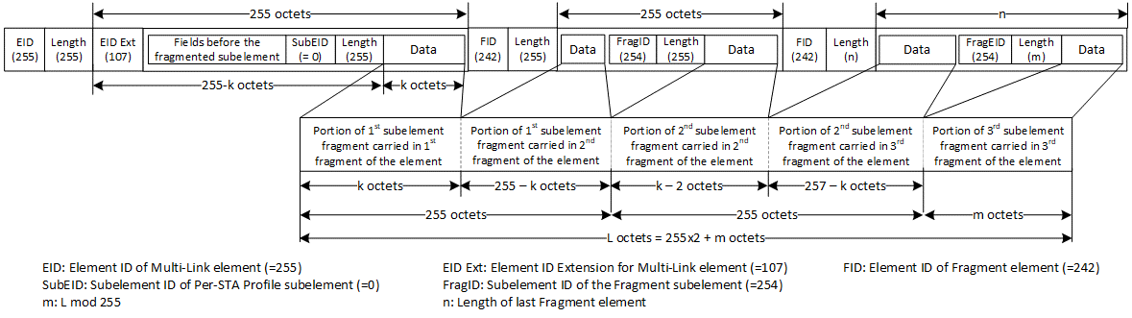

**Figure 35-xx: Per-STA Profile subelement fragmentation**

The information to be fragmented is divided into *P* + *Q* portions, where:

* *P* is .
* *Q* is equal to 1 if *L* mod 255 > 0 and equal to 0 otherwise.
* *L* is the size of the information in octets.

The Per-STA Profile subelement into which the information does not fit is filled with the first segment of information. This subelement is immediately followed by *P* – 1 Fragment subelements, each containing the subsequent segments of 255 octets of information. If *Q = 1*, these subelements are immediately followed by another Fragment subelement containing the remaining segment of information. The length of this last Fragment subelement shall be (L mod 255).

NOTE 2—A Fragment subelement never follows a subelement with fewer than 255 octets of information.

A Per-STA Profile subelement that has its information fragmented shall be followed by one or more Fragment subelements. To reconstruct the original information, the portion of information from the Per-STA Profile subelement shall be concatenated, in order, with the portions of information from the series of Fragment subelements that follow it. The defragmentation procedure shall complete when any subelement other than a Fragment subelement is encountered or the end of the last Fragment element of the Basic Multi-Link element is reached.

NOTE 3 – The receiving STA follows the procedure defined in 10.28.12 (Element defragmentation) to defragment the Basic variant Multi-Link element.

**35.3.4.2 Use of ML probe request and response(#2583)(#3360)**

***TGbe editor: Please add the following at the end of subclause 35.3.4.2:***

(#5063)An AP corresponding to the transmitted BSSID in a multiple BSSID set shall transmit an ML probe response in response to an ML probe request which is soliciting information of an MLD with which an AP corresponding to the nontransmitted BSSID in the same multiple BSSID set is affiliated. Such an ML probe response shall carry a Basic Multi-Link element containing information of the solicited AP MLD and one or more APs affiliated with it. The Basic Multi-Link element shall be carried in the frame body of the ML probe response, whose location is outside of the Multiple BSSID element carried in the frame. The MLD ID Present subfield of the Presence Bitmap subfield of the Basic Multi-Link element shall be set to 1. The MLD ID subfield of the Common Info field of the Basic Multi-Link element shall be present, and shall be set to the same value as the BSSID Index subfield of the Multiple-BSSID Index element carried in the Nontransmitted BSSID Profile subelement of the Multiple BSSID element, which carries the information of the AP corresponding to the nontransmitted BSSID.

An ML probe request shall solicit information of no more than one AP MLD and one or more APs affiliated with that MLD.

An ML probe response shall carry information of no more than one AP MLD and one or more APs affiliated with that MLD.

**Straw Poll: Do you support to incorporate the proposed draft text in this document 11-21/1869r0 to the next revision of TGbe Draft?**

**Result: Yes/No/Abstain**