IEEE P802.11
Wireless LANs
Resolution Text for Clause 5
Date: 2021-11-11
Author(s):
Name | Affiliation | Address | Phone | email
Hitoshi Morioka | SRC Software | Fukuoka, JAPAN |  | hmorioka@src-soft.com
Abstract
This document describes the resolutions for LB257.

The baseline is D2.0.

Suggested resolution

5.1.5 MAC data service architecture

5.1.5.1 General

Replace the Figure 5-1 with the following image:
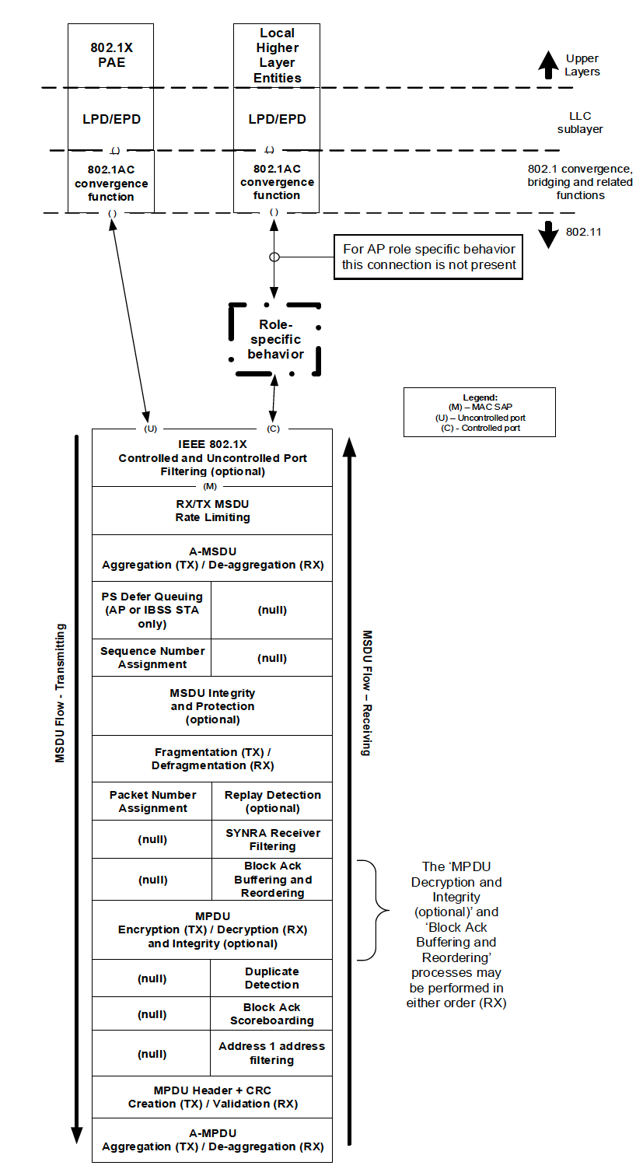
[w/o CID]
(U)
(C)
(M)
EBCS DL Filtering (optional)
IEEE 802.1X Controlled and Uncontrolled Port Filtering (optional)
Figure 5-1---MAC data plane architecture

NOTE—EBCS UL is a Management frame and this figure does not apply. [2168, 2004, 2255]

5.1.5.2 Non-GLK non-AP role

The MAC data plane architecture of a non-GLK non-AP STA is completed by replacing the role-specific behavior block with the shown in Figure 5-3 (Role-specific behavior block for non-GLK non-AP STA). The function of this block in a non-AP STA is to perform destination address filtering as described in 10.2.8 (MAC Data service).

In the context of EBCS DL, the EBCS filter strips the EBCS content ID. the EBCS DL Filtering block is present as shown in Figure 5-1. The EBCS DL Filtering block removes MSDUs where the EBCS content ID that was specified in the MPDU(s) carrying the MSDU is not present in dot11EBCSContentList. [2170, 2114, 2143, 2216, 2256]

NOTE 1—In implementations, the DA address filtering function may be done "lower in the stack." It is shown in the role-specific behavior block location for simplicity, and any implementation choice needs to provide equivalent behavior.

NOTE 2—An EBCS traffic stream passes through the IEEE 802.1X Controlled Port even if this is blocked (e.g. because the STA is not associated) (see 11.55.2.3 (EBCS DL operation at an EBCS receiver)). Since the IEEE 802.1X Controlled and Uncontrolled Port Filtering block shown in Figure 5-1 does not exist in an unassociated non-AP STA, an EBCS traffic stream passes through the IEEE 802.1X Controlled and Uncontrolled Port Filtering block shown in Figure 5-1. [2115, 2144]

5.1.5.3 Non-GLK AP role

In a non-GLK AP, the MAC data plane architecture includes distribution system access in its role-specific behavior block, as shown in Figure 5-4 (Role-specific behavior block for a non-GLK AP). This block provides access to the DS for associated non-AP STAs as described in 4.5.2.1 (Distribution).

In the context of EBCS DL, an EBCS traffic stream mapper, located at the entry of the DS, assigns the EBCS content ID for frames of EBCS traffic stream according to the configuration. an EBCS traffic stream mapper block is present at the entry of the DS as shown in Figure 5-4. The EBCS traffic stream mapper block assigns the EBCS content ID to the MSDUs of EBCS traffic streams using their destination IP address and UDP port, or destination MAC address if the MSDU does not have IP address. [2145, 2171, 2117, 2116]

NOTE 1—This behavior block indicates that there is no access through the controlled port to or from the local upperlayers (the LLC sublayer) at an AP. Any such access is logically achieved in the architecture via transition of the DS and Portal to an integrated LAN. In actual implementations, this is likely to be optimized, and Data frames appear to be delivered directly to one or more local LLC sublayer entities on the same physical device as the AP. Such optimization is effectively distributing the functions of the DS and Portal, and it is the responsibility of the implementation to ensure the logical behavior of these entities is maintained.

NOTE 2—The EBCS DL traffic might originate from another STA in the ESS, or from a device outside the ESS, through a portal. [2244, 2118, 2146]

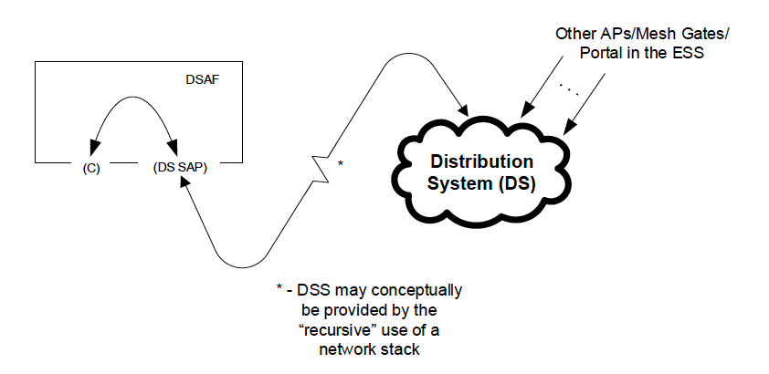
EBCS traffic stream mapper
(optional)
Figure 5-4---Role-specific behavior block for a non-GLK AP

5.2.3 MA-UNITDATA.request

5.2.3.2 Semantics of the service primitive

Modify the parameters of MA-UNITDATA.request as follows:

The parameters of the primitive are as follows:

MA-UNITDATA.request(
source address,
destination address,
routing information,
data,
priority,
drop eligible,
service class,
station vector,
MSDU format,
EBCS content ID
)

Insert the following paragraph at the end of clause 5.2.3.2:

The EBCS content ID parameter allows different EBCS traffic streams with the same destination address parameter to be distinguished. If the MSDU does not carry part of an EBCS traffic stream, the EBCS content ID parameter is null.

