IEEE P802.11
Wireless LANs
Channel Switch
Date: 2021-11-8
Author(s):
Name | Affiliation | Address | Phone | email
Youhan Kim | Qualcomm |  |  | youhank@qti.qualcomm.com

Abstract
This submission proposes resolutions for the following comments from comment collection on P802.11-REVme D0.0:

511

NOTE – Set the Track Changes Viewing Option in the MS Word to “All Markup” to clearly see the proposed text edits.

Revision History:

R0: Initial version.

CID 511

CID | Clause | Page.Line | Comment | Proposed Change
511 | 9.3.3.2 | 847.28  (D0.4 1013.13) | "Channel Switch Announcement element is optionally present if  dot11SpectrumManagementRequired is true." -- so you can't do channel switch without spectrum management? | Just say it's optionally present

Discussion

Comment is on the Beacon frame body where Channel Switch Announcement (CSA) is said to be optinally present if dot11SpectrumManagementRequired is true in the Beacon frame.

D0.4 P1013:
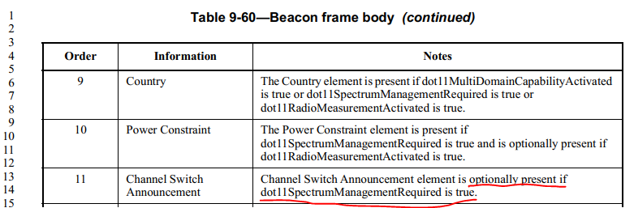

Hence, the commenter is asking whether this means that an AP is prohibited from including a CSA (and thus perform channel switch) if the AP has dot11SpectrumManagementRequired equal to FALSE.

Let us review the history of Channel Switch Announcement.
- IEEE 802.11a-1999 does not include the Channel Switch Announcement
  - I.e., an 11a-only AP cannot switch channels
- IEEE 802.11h-2003 added the Channel Switch Announcement
  - 11h states that the CSA element may be present in the Beacon frame if dot11SpectrumManagementRequired is true, which is what REVme D0.4 still has.
- IEEE 802.11y-2008 added the Extended Channel Switch Announcement (ECSA)
- IEEE 802.11n-2009 made it mandatory for HT STAs to support ECSA
  - “For an HT STA, the following MIB attributes shall be set to TRUE: … dot11ExtendedChannelSwitchEnabled”

Note that REVme D0.4 states the following:

D0.4 P2840:
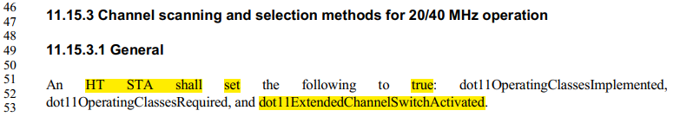

D0.4 P2798-2799
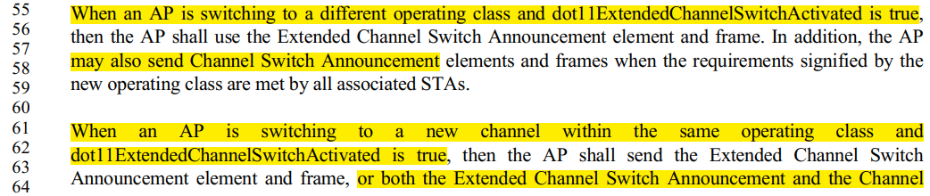

I.e., an HT AP may send CSA regardless of whether dot11SpectrumManagementRequired is true or false.
And since a VHT STA and HE STA are both an HT STA as well, VHT and HE APs may also send CSA regardless of whether dot11SpectrumManagementRequired is true or false.

In case some have doubts on whether an HE STA in the 6 GHz is an HT STA or not, we can bypass such doubts for this discussion by noting that REVme states:

D0.4 P4261:

In summary:
- An 11a-only AP does not support CSA unless it has dot11SpectrumManagementRequired equal to true
- HT/VHT/HE APs support CSA regardless of dot11SpectrumManagementRequired being true or false
  - Because HT/VHT/HE STAs have dot11ExtendedChannelSwitchEnabled equal to true

Therefore, the following proposed text update is recommended, which does not make any technical changes but just clarifies that an AP may include the CSA in Beacon frames even if dot11SpectrumManagementRequired is false as long as dot11ExtendedChannelSwitchActivated is true (which is the case for HT/VHT/HE APs).

Table 9-60 – Beacon frame body
Order | Information | Notes
…
11 | Channel Switch Announcement | Channel Switch Announcement element is optionally present if either dot11SpectrumManagementRequired or dot11ExtendedChannelSwitchActivated is true.

Proposed Resolution: CID 511
Revised.
Note to Commenter:
HT/VHT/HE APs support CSA because HT/VHT/HE STAs have dot11ExtendedChannelSwitchEnabled equal to true. But an 11a-only AP which has dot11SpectrumManagementRequired equal to false does not support CSA.
The instruction to Editor below clarifies that CSA element may be present if dot11ExtendedChannelSwitchEnabled is true.

Instruction to Editor:
At D0.4 P1013L13, change
“present if dot11SpectrumManagementRequired is true.”
to
“present if either dot11SpectrumManagementRequired or dot11ExtendedChannelSwitchActivated is true.”

[End of File]

