IEEE P802.11
Wireless LANs
REVme CIDs 175, 23
Date: 2021-11-17
Author(s):
Name | Affiliation | Address | Phone | Email
Mark Hamilton | Ruckus/CommScope | 350 W Java Dr  Sunnyvale, CA, 94089 | +1 303 818 8472 | Mark.hamilton@commscope.com

Abstract
This document contains discussion and proposed resolutions for the following comments from TGme CC35 on IEEE P802.11-REVme/D0.0:

175, 23

As references are to D0.0 numbering.

Revision Notes

R0 – initial version

CID 175

CID | Clause/Page | Comment | Proposed Change
175 | 12.4.3 | There are two references to "a non-NULL dot11RSNAConfigPasswordIdentifier" but this term is not defined here or in the MIB | Change each instance to "a dot11RSNAConfigPasswordIdentifier that does not have a zero length" and in C.3 show a DEFVAL of "{ }" for dot11RSNAConfigPasswordIdentifier

Discussion:

P2532.64:
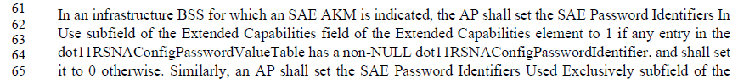

P
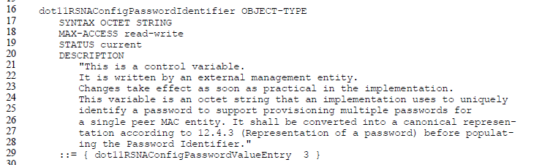

Agree with the commenter that this is not a defined term. Specifying the OCTET STRING is not of zero length seems unambiguous and matches the datatype usage.

For the DEFVAL, RFC 2578 provides the hint that a hexadecimal string can be represented with “an even number (possibly zero) of hexadecimal digits, preceded by a single (') and followed by either the pair ('H) or ('h).” It also provides this example:
OCTET STRING DEFVAL { 'ffffffffffff'H }

So, it appears the correct style for a ‘NULL’ string (zero length) would be:
DEFVAL { ‘’H }

We also notice that similar examples can be found in existing Annex C text, for this format, and none for DEFVAL { }, or DEFVAL “{ }”..

Proposed Resolution:

Revised.

At P2532.64 and P2533.2, replace “has a non-NULL dot11RSNAConfigPasswordIdentifier” with “has a dot11RSNAConfigPasswordIdentifier that does not have a zero length”.

At P4067.29, insert
“DEFVAL { ‘’H }”
as a new line, before
“::= {dot11RSNAConfigPasswordValueEntry 3 }”.

CID 23

CID | Clause/Page | Comment | Proposed Change
23 | C.3; P3779.47 | MIB seems to be missing an entry for dot11PhyVHTTable in "dot11phy OBJECT IDENTIFIER ::= { ieee802dot11 4 }" | Insert "-- dot11PHYCMMGTable ::= { dot11phy 23 }". Also entries 25, 26, 27 and 28 seem to be missing. If omitted for some good reason unknown to this commenter, please add an explanation in earlier the "DEFINED ..." text.

Discussion:

The comment references the definition of dot11phy, and the accompanying commentary:
P3779.20:
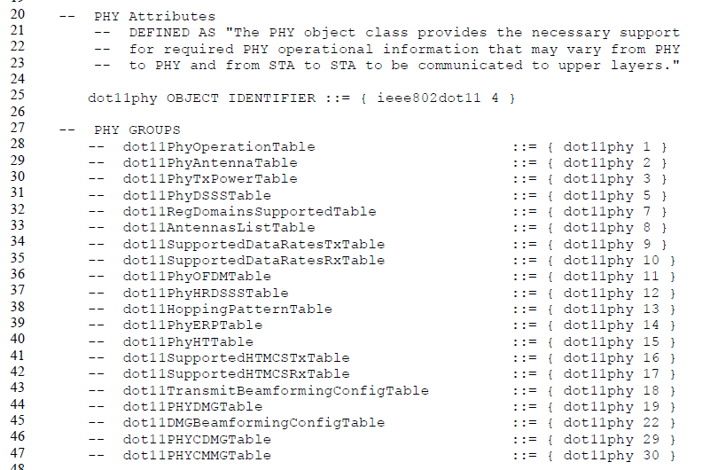

For each of the groups listed in the comments, there is a definition later in the MIB for that sub-identifier of the dot11phy OBJECT IDENTIFIER.

The commenter is correct that dot11PHYVHTTable is missing from this comment. It does appear later in the MIB, as:
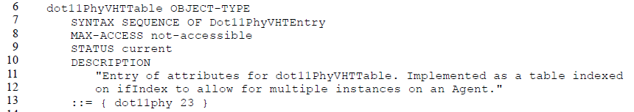

Thus, dot11PhyVHTTable could/should appear in the comments, with sub-identifier 23. Similarly, dot11VHTTransmitBeamformingConfigTable is missing as sub-identifier 24.

The commenter notes some other sub-identifiers that are not listed in the comment, and we note there are even more that the commenter did not mention. Specifically,
- 4: This was the FHSS phy.
- 6: This was the IR phy.
- 20: Skipped during 11ad?
- 21: Skipped during 11ad?
- 24: Is defined as the dot11VHTTransmitBeamformingConfigTable
- 25: Is defined as the dot11PhyTVHTTable
- 26: Is defined as the dot11TVHTTransmittedBeamformingConfigTable
- 27: Is defined as the dot11PhyS1GTable
- 28: Is defined as the dot11S1GTransmitBeamformingConfigTable

Without deeper research into (presumably) some proposal during approximately the same time as 802.11ad was developed, the abandoned use of sub-identifiers 20 and 21 is unknown.

Proposed Resolution:

Revised.

Insert the following rows, in the correct numeric sequence, in the comments following the definition of dot11phy, on P3779.27:
“-- dot11PhyFHSSTable ::= { dot11phy 4 } – No longer used”
“-- dot11PhyIRTable ::= { dot11phy 6 } – No longer used”
“-- dot11PhyVHTTable ::= { dot11phy 23 }
“-- dot11VHTTransmitBeamformingConfigTable ::= { dot11phy 24 }
“-- dot11PhyTVHTTable ::= { dot11phy 25 }
“-- dot11TVHTTransmittedBeamformingConfigTable ::= { dot11phy 26 }”
“-- dot11PhyS1GTable ::= { dot11phy 27 }
“-- dot11S1GTransmitBeamformingConfigTable ::= { dot11phy 28 }”

