IEEE P802.11
Wireless LANs
Resolution for CIDs related to Restricted TWT Schedule Announcement (CC36)
Date: November 2nd, 2021
Author(s):
Name | Affiliation | Address | Phone | Email
Rubayet Shafin | Samsung Research America | 6625 Excellence Ave., Plano, TX, 75023 |  | r.shafin@samsung.com
Boon Loong Ng
Ahmed Ibrahim
Peshal Nayak
Vishnu Ratnam

Abstract
This submission proposes resolutions for following 1 comment received for TGbe CC36:
- 1 CID: 6814

Revisions:
- Rev 0: Initial version of the document.

TGbe editor: Please note Baseline is 11be D1.2

Interpretation of a Motion to Adopt
A motion to approve this submission means that the editing instructions and any changed or added material are actioned in the TGbe Draft. This introduction is not part of the adopted material.

CID | Commenter | Clause | Pg/Ln | Comment | Proposed Change | Resolution
6414 | M. Kumail Haider | 35.6.3 | 298.30 | The text specifies that modified version of broadcast TWT element shall be used for restricted TWT schedule announcements in Management frames as specified in 26.8.3 (Broadcast TWT operation). A PDT and motion(#2920) was also passed to make changes to TWT element to accommodate restricted TWT announcements. However, broadcast TWT element does not convey occupancy information of SPs. For example, AP may announce r-SP schedule to invite membership but no STAs have established membership in such a schedule. In that case, EHT STAs supporting r-TWT operation should not have to end their TXOPs prior to such unoccupied SPs. Moreover, r-SP announcement via b-TWT element does not present a consolidated timeline view of future occurrence of r-SPs and r-SP start boundaries to be used by EHT STAs supporting r-TWT operation to end their TXOPs. | Additional signaling should be introduced to indicate r-SP occupancy information and present a consolidated channel-time view of r-SP occurrence and start boundaries | Revised.  TWT element format is updated to accommodate restricted TWT schedule occupancy information announced by restricted TWT scheduling AP.  TGbe editor, please make change as shown in this doc 11-21/1768 tagged by 6814.

Discussion:

A restricted TWT scheduling AP can advertise or announce the restricted TWT schedules in its BSS. During this advertisement phase, information such as congestion level of the advertised schedule (indicated via the number of STAs that currently have an active membership of the schedule) and maximum number of allowed STAs for the schedule is not carried in the corresponding Broadcast TWT element. However, such information can be crucial for an STA intending to establish restricted TWT schedule for judiciously deciding whether or not to join an advertised schedule or which, out of multiple advertised restricted TWT schedules, to join. Currently, no mechanism exists to include such information in the advertised restricted TWT schedule. Moreover, advertising such information would also be important for restricted TWT scheduled STAs to choose appropriate restricted TWT parameters when requesting for a new restricted TWT schedule.

This contribution provides mechanisms and framework for providing additional information by restricted TWT scheduling APs during restricted TWT schedule advertisement that would help STAs, interested in establishing restricted TWT schedule(s), to judiciously decide whether or not to join an advertised schedule or which, out of multiple advertised restricted TWT schedules, to join, or what restricted TWT parameters to choose when requesting for a new restricted TWT schedule that would satisfy the STA’s latency-sensitive traffic requirement. For example, the STA may want to join the restricted TWT schedule that fulfils the STA’s low-latency traffic requirement, such as lower congestion level, and avoid the restricted TWT schedule with high congestion level.

9. Frame formats
9.4.2.199 TWT element

TGbe editor: Please Change Figure 9-687b (Broadcast TWT Parameter Set field format) as follows:
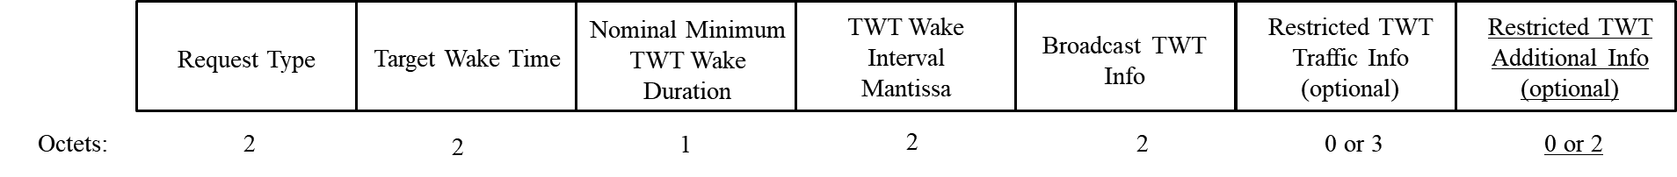
Figure 9-687b: Broadcast TWT Parameter Set field format (#6814)

TGbe editor: Please add the following paragraphs including Figure 9-yyy-a after Figure 9-687b in 9.4.2.199
The format of the Restricted TWT Additional Info subfield in Broadcast TWT Parameter Set field is shown in Figure 9-yyy-a (Restricted TWT Additional Info field format)

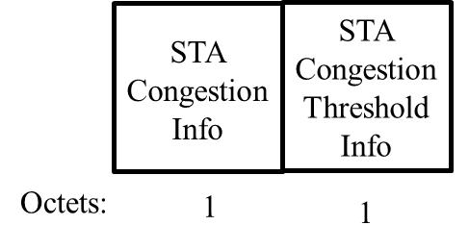
Figure 9-yyy-a: Restricted TWT Additional Info field format (#6814).

The STA Congestion Info subfield in Restricted TWT Additional Info field is of length 1 octet and indicates the number of restricted TWT scheduled STAs that have active membership of the restricted TWT schedule corresponding to the Restricted TWT Parameter Set (#6814).
The STA Congestion Threshold Info subfield in Restricted TWT Additional Info field is 1 octet long, and specifies the maximum number of STAs that the restricted TWT scheduling AP will allow to obtain membership of the corresponding restricted TWT schedule (#6814).
TGbe editor: Please Change Figure 9-689a (Broadcast TWT Info subfield format) as follows:

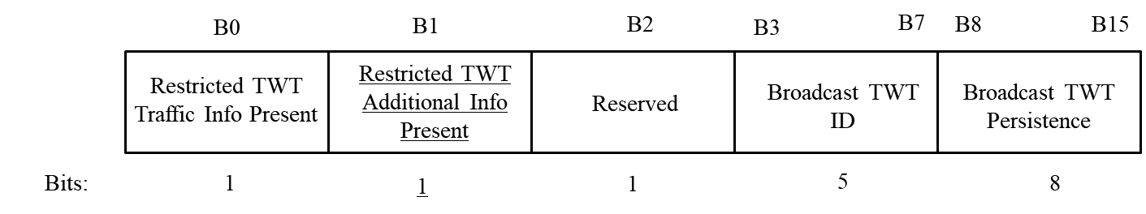
Figure 9-689a: Broadcast TWT Info subfield format(#6814)

TGbe editor: Please add the following paragraph after Figure 9-689a in 9.4.2.199
The presence of Restricted TWT Additional Info field in Restricted TWT Parameter Set field can be indicated by the Restricted TWT Additional Info Present subfield in Broadcast TWT Info subfield in the Restricted TWT Parameter Set field. If Restricted TWT Additional Info Present subfield in Broadcast TWT Info subfield in Restricted TWT Parameter Set field is set to 1, it would indicate that the Restricted TWT Additional Info subfield is present in Restricted TWT Parameter Set field corresponding to the restricted TWT schedule; otherwise, Restricted TWT Additional Info subfield is not present in the Restricted TWT Parameter Set field (#6814).

35.7.3 Restricted TWT service periods announcement
TGbe editor: Please add the following paragraphs after the first paragraph in 35.7.3
A restricted TWT scheduling AP may include Restricted TWT Additional Information subfields in Broadcast TWT Parameter Set fields as defined in 9.4.2.199 (TWT element), and announce the occupancy information of the all restricted TWT schedules present in the BSS. STA Congestion Info subfield in a Restricted TWT Additional Information subfield provides the number of restricted TWT scheduled STAs that are currently members of the restricted TWT schedule corresponding to the restricted TWT Parameter Set. STA Congestion Threshold Info subfield in a Restricted TWT Additional Information subfield provides the maximum number STAs that the restricted TWT scheduling AP will allow to obtain membership for that restricted TWT schedule (#6814).
A restricted TWT scheduled STA shall not request for membership of a restricted TWT schedule whose value in STA Congestion Info subfield in Restricted TWT Additional Information subfield equals the value in STA Congestion Threshold Info subfield in that Restricted TWT Additional Information subfield (#6814).

