IEEE P802.11  
Wireless LANs

|  |  |  |  |  |
| --- | --- | --- | --- | --- |
| D1.0 CRs on 36.2.4 PHY CONFIG_VECTOR parameters | | | | |
| Date: 2021-12-13 | | | | |
| Author(s): | | | | |
| Name | Affiliation | Address | Phone | email |
| Bo Gong | Huawei |  |  | [gongbo8@huawei.com](mailto:gongbo8@huawei.com) |
| Ross Jian Yu |  |  | [ross.yujian@huawei.com](mailto:ross.yujian@huawei.com) |
| Brian Hart | Cisco Systems |  |  | [brianh@cisco.com](mailto:brianh@cisco.com) |
| Eunsung Park | LG Electronics |  |  | [esung.park@lge.com](mailto:esung.park@lge.com) |
| Bo Sun | ZTE |  |  | [sun.bo1@ZTE.COM.CN](mailto:sun.bo1@ZTE.COM.CN) |

This submission shows

* Resolution for a comment received from TGbe comment collection (Based on TGbe Draft D1.0)
* The proposed changes are based on 11be D1.3.

The submission provides resolutions to following CIDs

4624, 7129, 7130

# Revision Notes

|  |  |
| --- | --- |
| R0 | Initial revision |
| R1 | Add modifications for 36.2.6 Support for non-HT, HT, VHT, and HE formats, as suggested by Brian |
| R2 | Edited changes |
|  |  |
|  |  |
|  |  |

## CID 4624

|  |  |  |  |  |
| --- | --- | --- | --- | --- |
| Page. Line | Clause Number | Comment | Proposed Change | Resolution |
| 331.11 | 36.2.4 | " The PHY shall set dot11EHTCurrentChannelWidthSet to a value that is obtained from the Supported Channel Width Set subfield of a transmitted EHT Capabilities element (see 9.4.2.295c)(#1540)." has two problems: a) I cannot find that string in 9.4.2.295c (e.g. search for Channel or Width, and you see it being referenced but never defined), b) the PHY is not privy to the semantics of what is transmitted. If the PHY needs to know what is transmitted in the Supported Channel Width Set subfield of a transmitted EHT Capabilities element, then the MAC needs to tell the PHY via an explicit parameter in PHYCONFIG_VECTOR | Both a) define Supported Channel Width Se in clause 9, and b) add an explicit parameter for the Supported Channel Width Set in the PHYCONFIG_VECTOR, and require the MAC to configure this when anything changes. | Revised  Agreed in principle. Reflect the detailed explanation.  **Instructions to the editor**  **Please make the changes as shown in 11/21-1762r2**  Note that the resolutions for CIDs 4624, 7129, and 7130 are the same. |

## CID 7129

|  |  |  |  |  |
| --- | --- | --- | --- | --- |
| Page. Line | Clause Number | Comment | Proposed Change | Resolution |
| 331.12 | 36.2.4 | "The PHY shall set dot11EHTCurrentChannelWidthSet to a value that is obtained ...". dot11EHTCurrentChannelWidthSet is a collection of values. | Change "to a value that is obtained" to "to values that are obtained" | Revised  Agreed in principle. Reflect the detailed explanation.  **Instructions to the editor**  **Please make the changes as shown in 11/21-1762r2**  Note that the resolutions for CIDs 4624, 7129, and 7130 are the same. |

## CID 7130

|  |  |  |  |  |
| --- | --- | --- | --- | --- |
| Page. Line | Clause Number | Comment | Proposed Change | Resolution |
| 331.13 | 36.2.4 | "Supported Channel Width Set subfield of a transmitted EHT Capabilities element". No such subfield. "Supported Channel Width Set subfield" is in HE Capabilities Element. | Correct | Revised  Agreed in principle. Reflect the detailed explanation.  **Instructions to the editor**  **Please make the changes as shown in 11/21-1762r2**  Note that the resolutions for CIDs 4624, 7129, and 7130 are the same. |

**Discussion:**

1. In Line 10, Page 453 of TGbe Draft D1.3, the description ‘The PHY shall set dot11CurrentChannelWidth to the value of this parameter.’ is incorrect. The dot11CurrentChannelWidth is a VHT PHY MIB attribute, and can be set to cbw20(0), cbw40(1), cbw80(2), cbw160(3), or cbw80p80(4) to indicate the operating channel width. The operating channel width for EHT PHY may take 320MHz. In the current spec, an EHT PHY MIB attribute dot11EHTCurrentChannelWidth is defined. For EHT PHY, the interface parameter CHANNEL_WIDTH should be linked to dot11EHTCurrentChannelWidth instead of dot11CurrentChannelWidth. In addition, the description that dot11EHTCurrentChannelWidth can be set as cbw20(0), cbw40(1), cbw80(2), cbw160(3), cbw320-1(4), or cbw320-2(5) is inaccurate since the center frequency is known by EHT PHY and there is no need to distinguish the 320MHz operating channel bandwidth as 320-1MHz and 320-2 MHz.

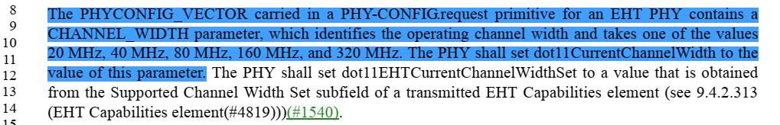

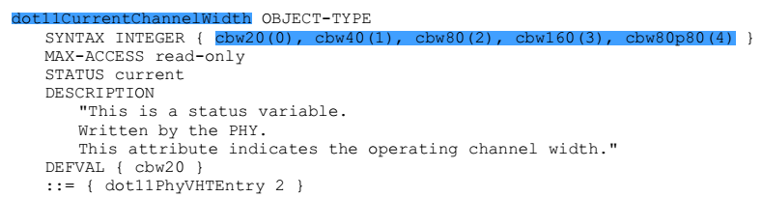

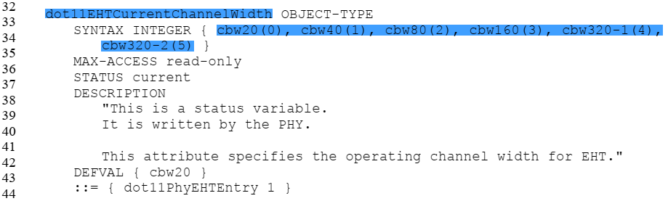

1. (1) In HE PHY Capabilities Information field, there exists an Supported Channel Width Set with 7 bits and the corresponding MIB attribute is dot11HECurrentChannelWidthSet. Since the definitions of Supported Channel Width Set for 2.4G and 5G/6G are different, the MIB attribute dot11HECurrentChannelWidthSet is defined as dynamic and configurable MIB attribute. Thus, according to the description in 27.2.4 PHYCONFIG_VECTOR parameters in IEEE Std 802.11ax-2020, it seems that a parameter Support_Channel_Width_Set is missing in PHYCONFIG_VECTOR since HE Capabilities element is an MAC frame and is transparent to the PHY.

(2) For EHT PHY, the supported channel width set for EHT can be obtained from the Supported Channel Width Set subfield in the HE Capabilities element and the Supported For 320MHz In 6 GHz subfield in the EHT Capabilities element. Different from Supported Channel Width Set subfield in the HE Capabilities element, the Supported For 320MHz In 6 GHz subfield is not involved in different frequency bands and doesn’t need to be changed. Thus, the corresponding MIB attribute is static, which can not be modified once a WLAN chip has been produced. Thus, there is no need to define a PHY CONFIG_VECTOR parameter for Supported For 320MHz In 6 GHz subfield. The related description about dot11EHTCurrentChannelWidthSet can be deleted.

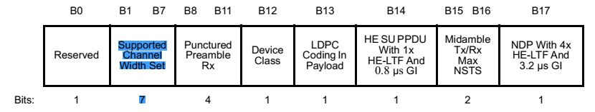

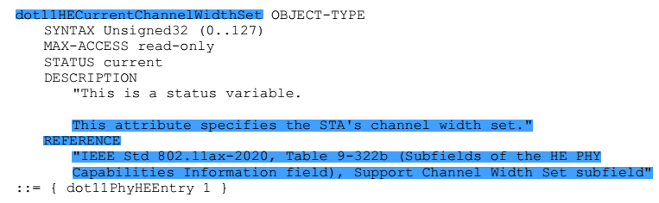



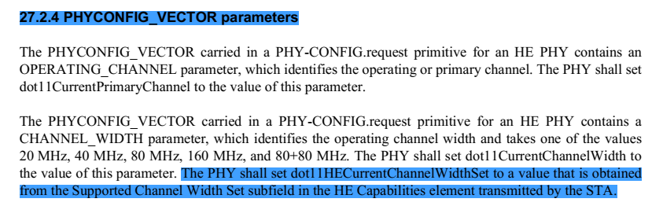

1. In Line 19, Page 453 of TGbe Draft D1.3, the description ‘The PHY shall set dot11CurrentChannelCenterFrequencyIndex0 to the value of this parameter.’ is inaccurate, since dot11CurrentChannelCenterFrequencyIndex0 indicates the location of the channel center frequency of the channel width 20M, 40M, 80M, 160M and the location of the channel center frequency of the primary 80M of 80+80M channel. Here, a MIB attribute indicating the channel center frequency of a 20 MHz, 40 MHz, 80 MHz, 160 MHz, or 320 MHz channel is needed. Thus, dot11EHTCurrentChannelCenterFrequencyIndex0 should be defined. In addition, for better consistency with the PHYCONFIG_VECTOR parameters of VHT/HE PHY, the CENTER_FREQUENCY_SEGMENT should be renamed as CENTER_FREQUENCY_SEGMENT_0.





1. Since an EHT STA is also a non-HT, HT, VHT and HE STA, on receipt of a

PHY-CONFIG.request(PHYCONFIG_VECTOR) primitive, the EHT STA will config all PHYs including non-HT PHY, HT PHY, VHT PHY, HE PHY and EHT PHY. Since VHT and HE PHYs don’t understand 320MHz, if the channel width is 320MHz, the CHANNEL_WIDTH parameter should be replaced by 160MHz and the CENTER_FREQUENCY_SEGMENT_0 should be replaced by the center of the primary 160 MHz channel. The related configuration should be reflected in 36.2.6.4 Support for VHT format and 36.2.6.5 Support for HE format.

**Instructions to the editor:**

1. Please make the following changes in Line 8, Page 453in TGbe Draft D1.3:

The PHYCONFIG_VECTOR carried in a PHY-CONFIG.request primitive for an EHT PHY contains a CHANNEL_WIDTH parameter, which identifies the operating channel width and takes one of the values 20 MHz, 40 MHz, 80 MHz, 160 MHz, and 320 MHz. The PHY shall set dot11EHTCurrentChannelWidth to the value of this parameter.

The PHYCONFIG_VECTOR carried in a PHY-CONFIG.request primitive for an EHT PHY contains a CENTER_FREQUENCY_SEGMENT_0 parameter, which identifies the center frequency of the channel and takes a value between 1 and 255. The PHY shall set dot11EHTCurrentChannelCenterFrequencyIndex0 to the value of this parameter.

1. Please make the following changes in Line 32, Page 721in TGbe Draft D1.3:

dot11EHTCurrentChannelWidth OBJECT-TYPE

SYNTAX INTEGER { cbw20(0), cbw40(1), cbw80(2), cbw160(3), cbw320(4) }

MAX-ACCESS read-only

STATUS current

DESCRIPTION

"This is a status variable.It is written by the PHY.This attribute specifies the operating channel width for EHT."

DEFVAL { 0}

::= { dot11PhyEHTEntry 1 }

Please make the following changes in Line 30, Page 721in TGbe Draft D1.3:

Dot11PhyEHTEntry ::=

SEQUENCE {

dot11EHTCurrentChannelWidth INTEGER,

dot11EHTSupportFor320MHzImplemented TruthValue,

dot11EHTNonOFDMAULMUMIMOLessThanOrEqualto80Implemented TruthValue,

dot11EHTNonOFDMAULMUMIMOEqualto160Implemented TruthValue,

dot11EHTNonOFDMAULMUMIMOEqualto320Implemented TruthValue,

dot11EHTPartialBWULMUMIMOImplemented TruthValue,

dot11EHTMUPPDUwith4xEHTLTFand0point8usecGIImplemented TruthValue,

dot11EHTPSRBasedSRImplemented TruthValue,

dot11EHTPowerBoostFactorImplemented TruthValue,

dot11EHTTx1024QAMand4096QAMLessThan242ToneRUImplemented TruthValue,

dot11EHTRx1024QAMand4096QAMLessThan242ToneRUImplemented TruthValue,

dot11EHTExtraLTFsImplemented TruthValue,

dot11EHTMaxNumberOfSupportedEHTLTFsForSU INTEGER,

dot11EHTMaxNumberOfSupportedEHTLTFsForMUandNDP INTEGER,

dot11EHTMCS15For52p26and106p26MRUImplemented TruthValue,

dot11EHTMCS15For484p242MRUImplemented TruthValue,

dot11EHTMCS15For996p484and996p484p242MRUImplemented TruthValue,

dot11EHTMCS15For3x996MRUImplemented TruthValue,

dot11EHTDupImplemented TruthValue,

dot11EHTSupportFor242ToneRUInBWWiderThan20Implemented TruthValue,

dot11EHT20MHzOperatingSTARxNDPwithWiderBWImplemented TruthValue,

(#7574)dot11MSOFDMEDthreshold Unsigned32

dot11EHTCurrentChannelCenterFrequencyIndex0 Unsigned32,

}

Please add the following MIB attribute in Line 57, Page 726 in TGbe Draft D1.3:

dot11EHTCurrentChannelCenterFrequencyIndex0 OBJECT-TYPE

SYNTAX Unsigned32 (0..255)

MAX-ACCESS read-only

STATUS current

DESCRIPTION

"This is a status variable.

It is written by the PHY.

This attribute specifies the channel center frequency for a 20 MHz, 40 MHz, 80 MHz, 160MHz or 320 MHz

channel.

DEFVAL { 0 }

::= { dot11PhyEHTEntry 23 }

Please add the following MIB attribute in Line 50, Page 680 in TGbe Draft D1.3:

**Table 36-68—EHT PHY MIB attributes *(continued)***

|  |  |  |
| --- | --- | --- |
| **Managed object** | **Default value/ range** | **Operational semantics** |
| **dot11PHYEHTTable** | | |
| dot11EHTCurrentChannelWidth | Implementation dependent | Dynamic |
| dot11EHTSupportFor320MHzImplemented | false/Boolean | Static |
| dot11EHTNonOFDMAULMUMIMOLessThanOrEqualto80Implemented | false/Boolean | Static |
| dot11EHTNonOFDMAULMUMIMOEqualto160Implemented | false/Boolean | Static |
| dot11EHTNonOFDMAULMUMIMOEqualto320Implemented | false/Boolean | Static |
| dot11EHTPartialBWULMUMIMOImplemented | false/Boolean | Static |
| dot11EHTMUPPDUwith4xEHTLTFand0point8usecGIImplemented | false/Boolean | Static |
| dot11EHTPSRBasedSRImplemented | false/Boolean | Static |
| dot11EHTPowerBoostFactorImplemented | false/Boolean | Static |
| dot11EHTTx1024QAMand4096QAMLessThan242ToneRUImplemented | false/Boolean | Static |
| dot11EHTRx1024QAMand4096QAMLessThan242ToneRUImplemented | false/Boolean | Static |
| dot11EHTExtraLTFsImplemented | false/Boolean | Static |
| dot11EHTMaxNumberOfSupportedEHTLTFsForSU | Implementation dependent | Static |
| dot11EHTMaxNumberOfSupportedEHTLTFsForMUandNDP | Implementation dependent | Static |
| dot11EHTMCS15For52p26and106p26MRUImplemented | false/Boolean | Static |
| dot11EHTMCS15For484p242MRUImplemented | false/Boolean | Static |
| dot11EHTMCS15For996p484and996p484p242MRUImplemented | false/Boolean | Static |
| dot11EHTMCS15For3x996MRUImplemented | false/Boolean | Static |
| dot11EHTDupImplemented | false/Boolean | Static |
| (#1306)dot11EHTSupportFor242ToneRUInBWWiderThan20Implemente d | false/Boolean | Static |
| dot11EHT20MHzOperatingSTARxNDPwithWiderBWImplemented | false/Boolean | Static |
| dot11EHTCurrentChannelCenterFrequencyIndex0 | Implementation  dependent | Dynamic |

1. Please make the following changes in 36.2.6 Support for non-HT, HT, VHT, and HE formats of TGbe Draft D1.3

In Line 58, Page 457:

To support the non-HT format, the EHT PHY, on receipt of a PHY-CONFIG.request(PHYCONFIG_VECTOR) primitive, behaves as if it were a Clause 15 (DSSS PHY specification for the 2.4 GHz band designated for ISM applications), Clause 16 (High rate direct sequence spread spectrum (HR/DSSS) PHY specification), Clause 17 (Orthogonal frequency division multiplexing (OFDM) PHY specification), or Clause 18 (Extended Rate PHY (ERP) specification) PHY that had received a PHY-CONFIG.request(PHYCONFIG_VECTOR) primitive but without the PHYCONFIG_VECTOR parameters CHANNEL_WIDTHand CENTER_FREQUENCY_SEGMENT_0.

In Line 32, Page 458:

On receipt of a PHY-CONFIG.request(PHYCONFIG_VECTOR) primitive, the EHT PHY behaves, for the purposes of HT PPDU transmission and reception, as if it were a Clause 19 (High Throughput (HT) PHY specification) PHY that had received PHY-CONFIG.request(PHYCONFIG_VECTOR) primitive but without the PHYCONFIG_VECTOR parameters CHANNEL_WIDTH andCENTER_FREQUENCY_SEGMENT_0 and with the PHYCONFIG_VECTOR parameter SECONDARY_CHANNEL_OFFSET set to SECONDARY_CHANNEL_NONE if dot11CurrentChannelWidth indicates 20 MHz, to SECONDARY_CHANNEL_ABOVE if , or to SECONDARY_CHANNEL_BELOW otherwise.

In Line 5, Page 459:

On receipt of a PHY-CONFIG.request(PHYCONFIG_VECTOR) primitive, the EHT PHY behaves, for the purposes of VHT PPDU transmission and reception, as if it were a Clause 21 (Very High Throughput (VHT) PHY specification) PHY that received the PHY-CONFIG.request(PHYCONFIG_VECTOR) primitive except that:

* the CHANNEL_WIDTH parameter, if it is equal to 320MHz, is replaced by 160 MHz
* the CENTER_FREQUENCY_SEGMENT_0 parameter, if the CHANNEL_WIDTH parameter is equal to 320MHz, is replaced by the center of the primary 160 MHz channel.

In Line 33, Page 459:

On receipt of a PHY-CONFIG.request(PHYCONFIG_VECTOR) primitive, the EHT PHY behaves, for the purposes of HE PPDU transmission and reception, as if it were a Clause 27 (High Efficiency (HE) PHY specification) PHY that received the PHY-CONFIG.request(PHYCONFIG_VECTOR) primitiveexcept that:

* the CHANNEL_WIDTH parameter, if it is equal to 320MHz, is replaced by 160 MHz
* the CENTER_FREQUENCY_SEGMENT_0 parameter, if the CHANNEL_WIDTH parameter is equal to 320MHz, is replaced by the center of the primary 160 MHz channel.

1. Please change dot11CurrentChannelCenterFrequencyIndex0 as dot11EHTCurrentChannelCenterFrequencyIndex0 in **36.3.11.3 Channel frequencies** ofTGbe Draft D1.3.

In Line 19, Page 518:

*fc,*idx0 = dot11EHTCurrentChannelCenterFrequencyIndex0

In Line 27, Page 518:

where dot11EHTCurrentChannelCenterFrequencyIndex0 and dot11CurrentPrimaryChannel are defined in Table 36-24 (Fields to specify EHT channels)(#4693), and dot11ChannelStartingFactor denotes channel starting frequency.

In Line 41, Page 518:

Table 36-24—Fields to specify EHT channels

|  |  |
| --- | --- |
| **Field** | **Meaning** |
| (#4625)dot11EHTCurrentChannelWidth | Channel width.  Possible values represent 20 MHz, 40 MHz, 80 MHz,  160 MHz, and 320 MHz channels. |
| dot11EHTCurrentChannelCenterFrequencyIndex0 | For a 20 MHz, 40 MHz, 80 MHz, 160 MHz, or 320 MHz  channel, it denotes the location of the channel center frequency.  (#6807)Valid range is 1 to 13 for 2.4 GHz band,  1 to 200 for 5 GHz band, and 1 to (#2612)233 for 6 GHz band. |
| dot11CurrentPrimaryChannel | Denotes the location of the primary 20 MHz channel. (#6807)Valid range is 1 to 13 for 2.4 GHz band, 1 to 200  for 5 GHz band, and 1 to (#2612)233 for 6 GHz band. |

In Line 9, Page 519:

(#1259) *n*P20 is an integer indicating the primary 20 MHz channel location corresponding to dot11EHTCurrentChannelCenterFrequencyIndex0 and dot11EHTCurrentChannelWidth values, with possible range 0  *n*P20  *N*20MHz – 1.