IEEE P802.11
Wireless LANs
D1.0 CRs on 36.2.4 PHY CONFIG_VECTOR parameters
Date: 2021-11-02
Author(s):
Name | Affiliation | Address | Phone | email
Bo Gong | Huawei |  |  | gongbo8@huawei.com
Bo Sun | ZTE |  |  | sun.bo1@ZTE.COM.CN
Ross Jian Yu | Huawei |  |  | ross.yujian@huawei.com

This submission shows
- Resolution for a comment received from TGbe comment collection (Based on TGbe Draft D1.0)
- The proposed changes are based on 11be D1.2.

The submission provides resolutions to following CIDs

4624, 7129, 7130

Revision Notes

R0 | Initial revision

CID 4624
Page. Line | Clause Number | Comment | Proposed Change | Resolution
331.11 | 36.2.4 | " The PHY shall set dot11EHTCurrentChannelWidthSet to a value that is obtained from the Supported Channel Width Set subfield of a transmitted EHT Capabilities element (see 9.4.2.295c)(#1540)." has two problems: a) I cannot find that string in 9.4.2.295c (e.g. search for Channel or Width, and you see it being referenced but never defined), b) the PHY is not privy to the semantics of what is transmitted. If the PHY needs to know what is transmitted in the Supported Channel Width Set subfield of a transmitted EHT Capabilities element, then the MAC needs to tell the PHY via an explicit parameter in PHYCONFIG_VECTOR | Both a) define Supported Channel Width Se in clause 9, and b) add an explicit parameter for the Supported Channel Width Set in the PHYCONFIG_VECTOR, and require the MAC to configure this when anything changes. | Revised  Agreed in principle. Reflect the detailed explanation.  Instructions to the editor  Please make the changes as shown in 11/21-1762r0  Note that the resolutions for CIDs 4624, 7129, and 7130 are the same.

CID 7129
Page. Line | Clause Number | Comment | Proposed Change | Resolution
331.12 | 36.2.4 | "The PHY shall set dot11EHTCurrentChannelWidthSet to a value that is obtained ...". dot11EHTCurrentChannelWidthSet is a collection of values. | Change "to a value that is obtained" to "to values that are obtained" | Revised  Agreed in principle. Reflect the detailed explanation.  Instructions to the editor  Please make the changes as shown in 11/21-1762r0  Note that the resolutions for CIDs 4624, 7129, and 7130 are the same.

CID 7130
Page. Line | Clause Number | Comment | Proposed Change | Resolution
331.13 | 36.2.4 | "Supported Channel Width Set subfield of a transmitted EHT Capabilities element". No such subfield. "Supported Channel Width Set subfield" is in HE Capabilities Element. | Correct | Revised  Agreed in principle. Reflect the detailed explanation.  Instructions to the editor  Please make the changes as shown in 11/21-1762r0  Note that the resolutions for CIDs 4624, 7129, and 7130 are the same.

Discussion:

- PHY MIB attributes can be categorized as static ones and dynamic ones. Static MIB attributes can not be modified once a WLAN chip has been produced and dynamic MIB attributes can be modified. The related clarification can be referred to Line 43, Page 657 in TGbe Draft D1.2 (36.4.2 PHY MIB).

36.4.2 PHY MIB
EHT PHY MIB attributes are defined in Annex C with specific values defined in Table 36-68 (EHT PHY MIB attributes). The “Operational semantics” column in Table 36-68 (EHT PHY MIB attributes) contains two types: static and dynamic.
—Static MIB attributes are fixed and cannot be modified for a given PHY implementation.
—Dynamic MIB attributes are interpreted according to the MAX-ACCESS field of the MIB attribute. If MAX-ACCESS is equal to read-only, the MIB attribute value may be updated by the PLME and read from the MIB attribute by management entities. If MAX-ACCESS is equal to read-write, the MIB attribute may be read and written by management entities.

- For EHT PHY, the new MIB attributes include:

Managed object | Default value/ range | Operational semantics
dot11PHYEHTTable
dot11EHTCurrentChannelWidth | Implementation dependent | Dynamic
dot11EHTSupportFor320MHzImplemented | false/Boolean | Static
dot11EHTNonOFDMAULMUMIMOLessThanOrEqualto80Implemented | false/Boolean | Static
dot11EHTNonOFDMAULMUMIMOEqualto160Implemented | false/Boolean | Static
dot11EHTNonOFDMAULMUMIMOEqualto320Implemented | false/Boolean | Static
dot11EHTPartialBWULMUMIMOImplemented | false/Boolean | Static
dot11EHTMUPPDUwith4xEHTLTFand0point8usecGIImplemented | false/Boolean | Static
dot11EHTPSRBasedSRImplemented | false/Boolean | Static
dot11EHTPowerBoostFactorImplemented | false/Boolean | Static
dot11EHTTx1024QAMand4096QAMLessThan242ToneRUImplemented | false/Boolean | Static
dot11EHTRx1024QAMand4096QAMLessThan242ToneRUImplemented | false/Boolean | Static
dot11EHTExtraLTFsImplemented | false/Boolean | Static
dot11EHTMaxNumberOfSupportedEHTLTFsForSU | Implementation dependent | Static
dot11EHTMaxNumberOfSupportedEHTLTFsForMUandNDP | Implementation dependent | Static
dot11EHTMCS15For52p26and106p26MRUImplemented | false/Boolean | Static
dot11EHTMCS15For484p242MRUImplemented | false/Boolean | Static
dot11EHTMCS15For996p484and996p484p242MRUImplemented | false/Boolean | Static
dot11EHTMCS15For3x996MRUImplemented | false/Boolean | Static
dot11EHTDupImplemented | false/Boolean | Static
(#1306)dot11EHTSupportFor242ToneRUInBWWiderThan20Implemente d | false/Boolean | Static
dot11EHT20MHzOperatingSTARxNDPwithWiderBWImplemented | false/Boolean | Static
dot11EHTTransmitBeamformingConfigTable
dot11EHTSUBeamformerImplemented | false/Boolean | Static
dot11EHTSUBeamformeeImplemented | false/Boolean | Static
dot11EHTMUBeamformerLessThanOrEqualTo80Implemented | false/Boolean | Static
dot11EHTMUBeamformerEqualTo160Implemented | false/Boolean | Static
dot11EHTMUBeamformerEqualTo320Implemented | false/Boolean | Static
dot11EHTPartialBWDLMUMIMOImplemented | false/Boolean | Static
dot11EHTTriggeredSUBeamformingFeedbackImplemented | false/Boolean | Static
dot11EHTTriggeredMUBeamformingPartialBWFeedbackImplemented | false/Boolean | Static
dot11EHTTriggeredCQIFeedbackImplemented | false/Boolean | Static
dot11EHTNonTriggeredCQIFeedbackImplemented | false/Boolean | Static
dot11EHTBeamformeeSSLessThanOrEqualTo80 | Implementation dependent | Static
dot11EHTBeamformeeSSEqualTo160 | Implementation dependent | Static
dot11EHTBeamformeeSSEqualTo320 | Implementation dependent | Static
dot11EHTNumberSoundingDimensionsLessThanOrEqualTo80 | Implementation dependent | Static
dot11EHTNumberSoundingDimensionsEqualTo160 | Implementation dependent | Static
dot11EHTNumberSoundingDimensionsEqualTo320 | Implementation dependent | Static
dot11EHTNG16SUFeedbackImplemented | false/Boolean | Static
dot11EHTNG16MUFeedbackImplemented | false/Boolean | Static
dot11EHTCodebookSizePhi4Psi2SUFeedbackImplemented | false/Boolean | Static
dot11EHTCodebookSizePhi7Psi5MUFeedbackImplemented | false/Boolean | Static
dot11EHTMaxNc | Implementation dependent | Static
dot11EHTNDPwith4xEHTLTFand3point2GIImplemented | false/Boolean | Static

- From the table above, it can be seen that only dot11EHTCurrentChannelWidth is dynamic and can be reset. The attribute dot11EHTCurrentChannelWidth specifies the operating channel width for EHT and should be set as one of the following values cbw20, cbw40, cbw80, cbw160, cbw320-1, and cbw320-2, which can be refered to in Line 31, Page 697 of TGbe Draft D1.2. Thus, the description in Line 8, Page 381 of TGbe Draft D1.2 is not accurate.

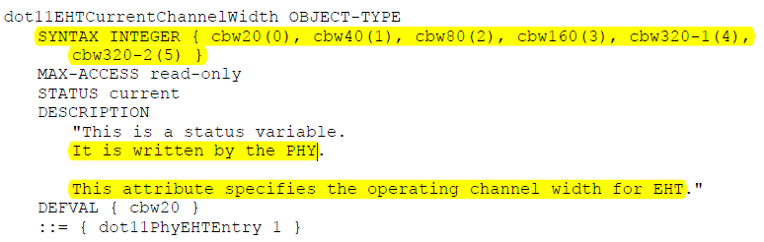

The PHYCONFIG_VECTOR carried in a PHY-CONFIG.request primitive for an EHT PHY contains a CHANNEL_WIDTH parameter, which identifies the operating channel width and takes one of the values 20 MHz, 40 MHz, 80 MHz, 160 MHz, and 320 MHz. The PHY shall set dot11CurrentChannelWidth to the value of this parameter.

- In addition, there exists a dynamic MIB attribute for HE PHY, which is dot11HECurrentChannelWidthSet. It specifies the STA’s channel width set and can be reset according to Support Channel Width Set subfield in Table 9-322b (Subfields of the HE PHY Capabilities Information field), which is described in Page 733 in IEEE Std 802.11ax-2020. However, according to the description in 27.2.4 PHYCONFIG_VECTOR parameters in IEEE Std 802.11ax-2020, it seems that a parameter Support_Channel_Width_Set is missing in PHYCONFIG_VECTOR since HE Capabilities element is an MAC frame and is transparent to the PHY.

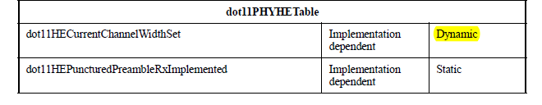

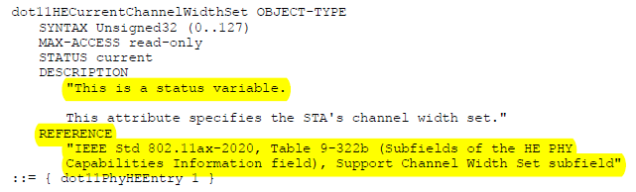

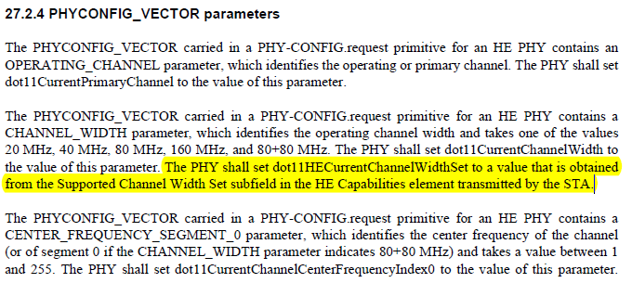

- For EHT PHY, there exists no dot11EHTCurrentChannelWidthSet. The supported channel width set for EHT can be obtained from the Supported Channel Width Set subfield in the HE Capabilities element and the Supported For 320MHz In 6 GHz subfield in the EHT Capabilities element. However, the MIB attribute dot11EHTSupportFor320MHzImplemented is static, which can not be modified. Thus, the bandwidth 320MHz should be regarded as supported if it is implemented. The related description in 36.2.4 PHY CONFIG_VECTOR in Line 12, Page 431 of TGbe Draft D1.2 is not accurate.

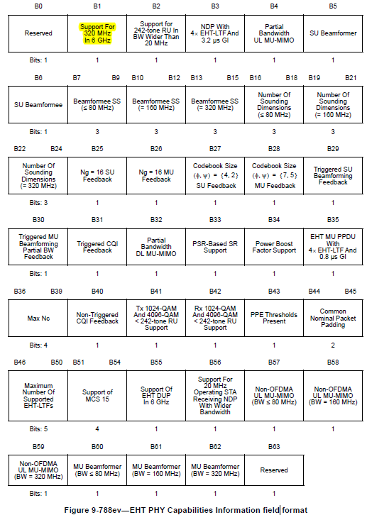

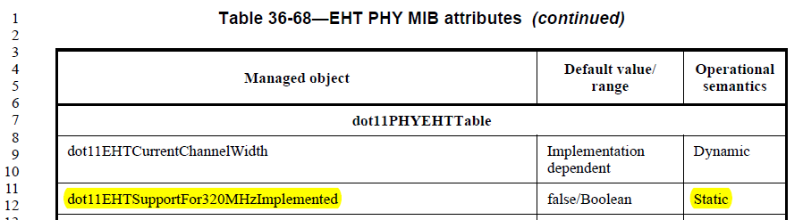

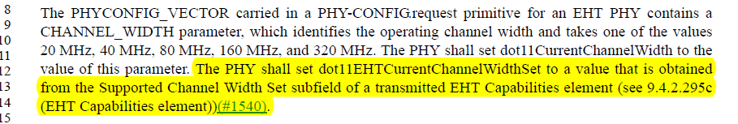

Instructions to the editor:

Please add the following sentence in Line 8, Page 431 in TGbe Draft D1.2:

The PHYCONFIG_VECTOR carried in a PHY-CONFIG.request primitive for an EHT PHY contains a CHANNEL_WIDTH parameter, which identifies the operating channel width and takes one of the values 20 MHz, 40 MHz, 80 MHz, 160 MHz, 320-1 MHz, and 320-2 MHz. The PHY shall set dot11EHTCurrentChannelWidth to the value of this parameter.

