IEEE P802.11
Wireless LANs
CR on Beacon frame and Group frames type information
Date: 2021-10-31
Author(s):
Name | Affiliation | Address | Phone | email
Jarkko Kneckt  Yong Liu,  Tianyu Wu,  Qi Wang,  Jinjing Jiang | Apple Inc | Cupertino, CA |  | jkneckt@apple.com
Pooya Monajemi | Cisco
Srinivas Kandala,  Ravi Gidvani | Samsung
Rojan Chitrakar  Rajat Pushkarna | Panasonic
Mark Hamilton  Peter Khoury | Ruckus / CommScope
Abstract
This submission provides comment resolution for the following 10 CIDs: 5324, 5325, 5327, 5332, 5334, 5335, 5337, 5338, 5340, and 5341.

CID | Clause | Page | Comment | Proposed Change | Resolution
5324 | 35.3.4.1 | 251.33 | The RNR element should signal whether a reported AP sends beacon on high transmission rates, lets say higher than 12 Mbit/s or 24 mbit/s. This helps STA to optimize scanning of the AP and helps to determine the reported BSS range. | Please add a bit to the RNR to signal whether the reported AP sends Beacons in transmission rate that is smaller or equal to 24 Mbit/s. | Revised.  Agree in principle with the comment. RNR needs a subfield that characterizes transmitted Beacon type for passive scanning non-associated STAs. The submission 11-21-1737r1 explains this in more details.  TGbe Editor, as a resolution of the comment, please incorporate to the 802.11be draft the normative text identified by the CID #5324 from 11-21-1756r1.
5325 | 9.4.2.170 | 123.21 | The RNR element should signal whether AP sends beacon in non-HT PPDU format. This helps STA to optimize scanning of the AP and helps to determine whether AP optimizes its range. | Please add a bit to signal whether AP sends Beacons on non-HT PPDU or Non-HT Duplicate PPDU. | Revised.  Agree in principle with the comment. RNR should have a subfield that characterizes transmitted Beacon type for passive scanning non-associated STAs. The submission 11-21-1737r1 explains this in more details.  TGbe Editor, as a resolution of the comment, please incorporate to the 802.11be draft the normative text identified by the CID #5325 from 11-21-1756r1.
5327 | 9.4.2.170 | 123.21 | Low Power Indoor (LPI) AP in the 6 GHz band may transmit Beacons on larger than 20 MHz BW. To maximize the range from which the scanning STA is able to receive these Beacon frames, the scanning STA should have out-of-band infromation to use wider than 20MHz RX BW. | Please add a bit to the RNR to signal whether the reported AP transmits Beacons on wider than 20 MHz BW. | Rejected.  The Beacon BW information is present in the HE Operation Information element provides BW information of the Beacon frame.  The Beacon frame BW of the reported AP is not added to the RNR element, because it would increase the Beacon frame size. Also, it is hard to signal Beacon frame BW with a single bit.
5332 | 9.4.2.295a | 126.42 | An AP MLD should provide information of the affiliated APs Beacon and other discovery frame types and transmission parameters (MCS, BW and Primary 20 MHz channel) that the affiliated APs transmit. This information helps the STAs to determine the range of the affilaited APs and allows the scaning STAs to optimize their scanning/link maintenance with the affiliated APs. The Beacon BW and P20 information are needed especially for the 6 GHz band where the non-HT Duplicate PPDU may transmit a Beacon to other than primary 20 MHz channels. | Please add to the EHT Operation element, or create a new element to signal the P20 of the BSS, Beacon frame type and its transmission parameters. Please ensure that AP MLD transmits the information of all affiliated APs. | Revised.  Agree in principle of the comment.  Target is to provide affiliated APs Beacon frame type information to help STA to discover affiliated APs and estimate whether the scanning STA may receive a frame from the affiliated AP. The signaling is done through Per-STA Profile of the ML element and the RNR element.  TGbe Editor, as a resolution of the comment, please incorporate to the 802.11be draft the normative text identified by the CID #5332 from 11-21-1756r1.
5334 | 9.3.3.2 | 105.07 | All associated non-AP MLDs should detect, if an affiliated AP changes its Beacon frame transmission parameters. | Please add beacon frame transmission parameter modification as a criterion to add AP specific Change Sequence Counter to let all associated non-AP MLDs to detect the link specific beacon frame parameters change. | Revised.  Agree in principle with the comment. A change in Beacon frame transmission parameters will modify the range of the BSS. In some cases, this may cause some STAs to lose BSS connectivity. Associated STAs should notify such a change and obtain connectivity through other link.  TGbe Editor, as a resolution of the comment, please incorporate to the 802.11be draft the normative text identified by the CID #5334 from 11-21-1756r1.
5335 | 9.4.2.295a | 133.43 | The Per-STA Profile of the multi-link element should provide detailed parameters of the transmitted Beacon frame type and transmission mode of the reported AP | Please add detailed information of the Beacon frame type and its transmission parameters to Per-STA Profile of the reported AP. | Revised.  Agree in principle with the comment.  TGbe Editor, as a resolution of the comment, please incorporate to the 802.11be draft the normative text identified by the CID #5335 from 11-21-1756r1.
5337 | 9.4.2.36 | 120.30 | The group addressed frames transmission rate and PPDU type is currently not signaled to the scanning STAs or associated STAs. This information may help select an AP from which the STA receives group frames. | Please add information of the group addressed frames transnmission rate and PPDU type to the candidate AP/affiliated APs of the AP MLDs. | Revised.  Agree in principle with the comment. Signaling of the high-level description of the group frames transmission parameters is added.  TGbe Editor, as a resolution of the comment, please incorporate to the 802.11be draft the normative text identified by the CID #5337 from 11-21-1756r1.
5338 | 9.4.2.295a | 126.42 | An AP MLD should provide information of the affiliated APs group addressed frames transmission rate and PPDU type. This information helps the STAs to selet the AP from which they receive group addressed frames. | Please add to EHT Operation element, or create a new element to signal the group addressed frames type and their transmission parameters. Please ensure that AP MLD transmits the information to all affiliated APs. | Revised.  Agree in principle with the comment. The signaling is included to the Per-STA Profile of the ML element. Revised. Agree in principle with the comment. Signaling of the high-level description of the group frames transmission parameters is added.  TGbe Editor, as a resolution of the comment, please incorporate to the 802.11be draft the normative text identified by the CID #5338 from 11-21-1756r1.
5340 | 35.3.13 | 273.21 | All associated non-AP MLDs should detect, if an affiliated AP changes its group addressed frames transmission parameters in otfer to receive the frames from a link that transmits the frames reliably and in short duration. | Please add group frame transmission parameter modification as a criteria to add AP specific Change Sequence Counter to let all associated non-AP MLDs to detect the link specific group addressed frames parameters change. | Revised.  Agree in principle with the comment.  TGbe Editor, as a resolution of the comment, please incorporate to the 802.11be draft the normative text identified by the CID #5340 from 11-21-1756r1.
5341 | 9.4.2.295a | 133.43 | The Per-STA Profile of the multi-link element should provide detailed parameters of the transmitted group frames type and transmission mode of the reported AP | Please add detailed information of the Group frames type and its transmission parameters to Per-STA Profile of the reported AP. | Revised.  Agree in principle with the comment. The submission 1737r1 explains the group frames transmission parameters.  TGbe Editor, as a resolution of the comment, please incorporate to the 802.11be draft the normative text identified by the CID #5341 from 11-21-1756r1.
9.4.2.170 Reduced Neighbor Report element
9.4.2.170.2 Neighbor AP Information field
TGbe Editor: Please update the Figure 9-632b as shown below and add the new paragraph at the end of the clause.

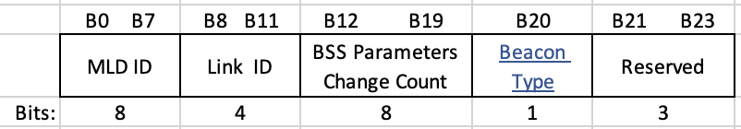
Figure 9-632b—MLD Parameters subfield format

The Beacon Type subfield is set to 0, if the reported AP transmits its Beacon frames as non-HT PPDU or non-HT Duplicate PPDU and the transmission rate of the PPDU containing the Beacon frame is less or equal to 24 Mb/s, otherwise the subfield is set to 1. (#5324, #5325)

9.4.2.295b.2.3 Link Info field of the Basic Multi-Link element(#7567)
TGbe Editor: Please update the figure Figure 9-788ej as shown below and add the new paragraph as the new eighth paragraph after the Figure 9-788ej.
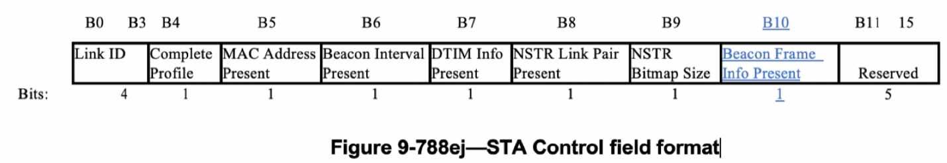

The Beacon Frame Info Present subfield indicates the presence of the Beacon Frame Info subfield in the STA Info field and is set to 1 if the Beacon Frame Info subfield is present in the STA Info field; otherwise set to 0. A non-AP STA sets the Beacon Frame Info Present subfield to 0 in the transmitted Basic Multi-Link element. An AP sets this subfield to 1 when the element carries complete profile. (#5332, #5335)

TGbe Editor: Please update the figure Figure 9-788ep as shown below.
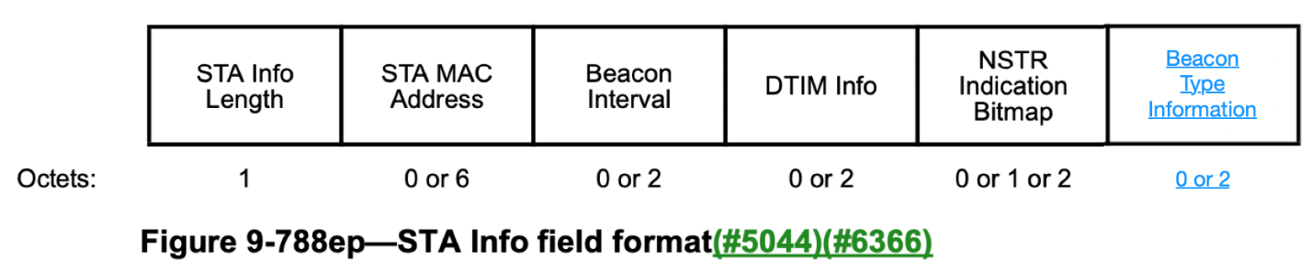

TGbe Editor: Please add the new figure and new paragraphs before the last paragraph of the clause. Please renumber the captions accordingly.
 | Group Frames TX Mode | Beacon TX Power Difference | Beacon MCS | Reserved
Bits: | 2 | 6 | 4 | 4
Figure 9-788xx—Beacon Type Information field format
The Group Frames TX Mode subfield indicates the group frames transmission mode. The subfield endocing is shown in the Table XX below. (#5337, #5338, #5341)

Table XX – Group Frames TX Mode subfield encoding.
Value | Meaning
0 | The AP transmits all group frames and Beacon frames at the same MCS, BW and PPDU Type.
1 | The condition of the value 0 is not met and the AP transmits all group frames as non-HT or non-HT Duplicate PPDU with ≤ 24 Mb/s rate.
2 | The condition of the value 1 is not met. The AP may use any mandatory rate for group frames transmission.
3 | Reserved

The Beacon Tx Power Difference subfield of the STA Info field is six bits in length and represents a 2s complement signed integer in dB. It carries the beacon transmit power (expressed in EIRP) normalized to 20 MHz of the AP reported in the Per-STA Profile subelement minus the beacon transmit power of the transmitting AP (expressed in EIRP) normalized to 20 MHz. The maximum value indicates a value that is higher or equal to the maximum value. The minimum value indicates a value that is lower or equal to the minimum value. (#5332, #5335)

NOTE – For example, if the beacon transmit power (in EIRP) normalized to 20 MHz of the AP that transmitted the ML probe response is 23 dBm and the beacon transmit power (in EIRP) normalized to 20 MHz of an AP that is reported is 20 dBm then the Beacon TxPower Difference subfield carries the binary value 111101. (#5332, #5335)

The Beacon MCS subfield specifies the MCS of the Beacon PPDU. The subfield encoding is shown in the Table XX+1 below. (#5332, #5335)

Table XX+1 – Beacon BW subfield encoding.
Beacon MCS subfield value | DSSS PPDU rate | Non-HT OFDM MCS | HE MCS
0 | 1 Mb/s | 6 Mb/s | 0
1 | 2 Mb/s | 9 Mb/s | 1
2 | 5.5 Mb/s | 12 Mb/s | 2
3 | 11 Mb/s | 18 Mb/s | 3
4 | Reserved | 24 Mb/s | 4
5 | Reserved | 36 Mb/s | 5
6 | Reserved | 48 Mb/s | 6
7 | Reserved | 54Mb/s | 7
8 – 15 | Reserved | Reserved | Reserved
11.2.3.15 TIM Broadcast
TGbe Editor: Please add the row to the end of the list.

s) Modification of the Beacon Type Information field. (#5334, #5340)

35.3.4 Discovery of AP MLD
TGbe editor: Please insert the following (new) subclause as shown below:
35.3.4.x Estimating Link Reachability (#5332, #5335)

An AP affiliated with an AP MLD can independently select the MCS and transmit power for the Beacon frames that it transmits based on deployment scenario or to satisfy regulatory requirements. In addition, the pathloss characteristics for each band are different. Therefore, it is possible that there will be a situation in which a STA of a non-AP MLD is able to receive Beacon frames transmitted by an AP affiliated with an AP MLD while another STA affiliated with the same non-AP MLD is unable to receive Beacon frames from another AP affiliated with the same AP MLD. This subclause defines mechanisms by which an AP affiliated with an AP MLD advertises information that can help a non-AP MLD determine reachability for requested links.

The AP MLD shall signal in the Beacon Type subfield of the Reduced Neighbor Report element whether its affiliated APs transmit a Beacon frame in a Non-HT Duplicate PPDU or Non-HT PPDU at a rate that is less or equal to 24 Mb/s. This information helps a passive scanning STA to estimate whether it can receive Beacon frames from the reported APs affiliated with the same AP MLD. (#5324, #5325)

An AP affiliated with an AP MLD shall, when responding to an ML probe request that is requesting the complete profile of another AP affiliated with the same AP MLD, include Beacon Type Information field in the STA Profile field of the Per-STA Profile subelement of the Multi-link element corresponding to the reported AP. The AP shall transmit an ML probe response frame that carries the complete profile for one or more reported APs with the same TXVECTOR parameters as its Beacon frames.

NOTE – For the 6 GHz band, the Control field of the 6 GHz Operation Information field of the HE Operation Parameters element signals whether the AP in the 6 GHz band transmits Beacon frames in non-HT Duplicate PPDUs that can have up to the BSS bandwidth.

A non-AP MLD can estimate whether it is able to receive a Beacon on a requested link of the AP MLD by using the values carried in the Reduced Neighbor Report element, HE Operation Parameters element and the Beacon Type Information field. A non-AP MLD can estimate the difference in the receive power and the required receive power to receive a Beacon frame for the requested link of the AP MLD. A non-AP MLD can, based on this estimate, make decisions on selecting a suitable AP MLD for performing multi-link setup. For example, if the non-AP MLD estimates that it would not be able to receive Beacon frames from one or more reported AP(s) affiliated with the AP MLD, it can decide to select a different AP MLD for performing multi-link setup.

An example of reachability estimation is shown in Figure 35-xxx (Example of reachability estimation).
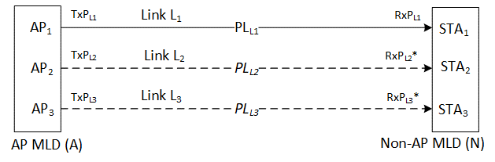
Figure 35-xxx – Example of reachability estimation

In the example shown in Figure 35-xxx (Example of reachability estimation), STA₁ affiliated with a non-AP MLD (N) sends an ML probe request to AP₁ affiliated with an AP MLD (A), requesting the complete information of AP₂ and AP₃, which are also affiliated with the AP MLD (A). AP₁ responds with an ML probe response, sent at the same transmit power as its Beacon frames, that provides:
- The AP₂ Beacon frame transmission rate and difference between the beacon transmit power between AP₁ and AP₂ (carried in the Per-STA Profile subelement of the Basic Multi-Link element corresponding to AP₂);
- The AP₃ Beacon frame transmission rate and and difference between the beacon transmit power between AP₁ and AP₃ (carried in the Per-STA Profile subelement of the Basic Multi-Link element corresponding to AP₃).
Using this information, the non-AP MLD (N) can estimate the required receive power to receive a Beacon frame and compute an estimate of the received power for the Beacon frames transmitted on L₂ by AP₂ and on L₃ by AP₃, respectively.
The computation of difference in the received power on links L₁ and L₂ is shown in Equation (35-x1).
${∆Rx}_{[L2-L1]}= {∆Tx}_{\left[L2-L1\right]}-{∆PL}_{[L2-L1]}$ (35-x1)
where,
${∆Rx}_{[L2-L1]}$ is the difference in receive power between link L₂ and link L₁
${∆Tx}_{[L2-L1]}$ is the difference in transmit power between link L₂ and link L₁
${∆PL}_{[L2-L1]}$ is the estimated difference in the path loss between link L₂ and link L₁
NOTE – The estimated difference in the path loss between the reporting link and the reported link depends on the device implementation and is outside the scope of this standard.
The computation of the estimated received power on link L₂ is shown in Equation (35-x2).
$RxP{}_{L2}$= ${RxP}_{L1}+{∆Rx}_{[L2-L1]}$ (35-x2)
where,
$RxP{}_{L2}$ is the estimated receive power on link L₂
${RxP}_{L1}$ is the actual received power on link L₁

35.3.15 Multi-link group addressed frame delivery and reception
35.3.15.2 Group addressed frame reception (#5337, #5338, #5341)
TGbe editor: Please insert the following (new) paragraph at the end of the clause:

A non-AP MLD may use the Beacon Type Information field of the STA Profile field of the Per-STA Profile subelement to select the AP affiliated with the associated AP MLD from which the non-AP MLD receives the group addressed frames. The Beacon Type Information subfield signals the transmission rates of the group frames enabling the non-AP MLD to estimate whether it can receive group frames from the affiliated AP.

