IEEE P802.11
Wireless LANs
CR on Beacon frame and Group frames type information
Date: 2021-10-31
Author(s):
Name | Affiliation | Address | Phone | email
Jarkko Kneckt | Apple Inc | Cupertino, CA |  | jkneckt@apple.com
Abstract
This submission provides comment resolution for the following 10 CIDs: 5324, 5325, 5327, 5332, 5334, 5335, 5337, 5338, 5340, and 5341.

The presentation 11-21-1737r1 provides more details of the Beacon frame and group frames information in RNR and Per-STA Profile of the ML element.

CID | Clause | Page | Comment | Proposed Change | Resolution
5324 | 35.3.4.1 | 251.33 | The RNR element should signal whether a reported AP sends beacon on high transmission rates, lets say higher than 12 Mbit/s or 24 mbit/s. This helps STA to optimize scanning of the AP and helps to determine the reported BSS range. | Please add a bit to the RNR to signal whether the reported AP sends Beacons in transmission rate that is smaller or equal to 24 Mbit/s. | Revised. Agree in principle with the comment. RNR should have a subfield that characterizes transmitted Beacon type for non-associated STAs. The submission 11-21- 1737r1 explains this in more details. TGbe Editor, as a resolution of the comment, please incorporate to the 802.11be draft the normative text identified by the CID #5324 from 11-21-1756r0.
5325 | 9.4.2.170 | 123.21 | The RNR element should signal whether AP sends beacon in non-HT PPDU format. This helps STA to optimize scanning of the AP and helps to determine whether AP optimizes its range. | Please add a bit to signal whether AP sends Beacons on non-HT PPDU or Non-HT Duplicate PPDU. | Revised. Agree in principle with the comment. RNR should have a subfield that characterizes transmitted Beacon type for non-associated STAs. The submission 11-21- 1737r1 explains this in more details. TGbe Editor, as a resolution of the comment, please incorporate to the 802.11be draft the normative text identified by the CID #5325 from 11-21-1756r0.
5327 | 9.4.2.170 | 123.21 | Low Power Indoor (LPI) AP in the 6 GHz band may transmit Beacons on larger than 20 MHz BW. To maximize the range from which the scanning STA is able to receive these Beacon frames, the scanning STA should have out-of-band infromation to use wider than 20MHz RX BW. | Please add a bit to the RNR to signal whether the reported AP transmits Beacons on wider than 20 MHz BW. | Rejected.  The Beacon frame BW of the reported AP is not added to the RNR element, because it would increase the Beacon frame size. Also, it is hard to signal Beacon frame BW with a single bit.
5332 | 9.4.2.295a | 126.42 | An AP MLD should provide information of the affiliated APs Beacon and other discovery frame types and transmission parameters (MCS, BW and Primary 20 MHz channel) that the affiliated APs transmit. This information helps the STAs to determine the range of the affilaited APs and allows the scaning STAs to optimize their scanning/link maintenance with the affiliated APs. The Beacon BW and P20 information are needed especially for the 6 GHz band where the non-HT Duplicate PPDU may transmit a Beacon to other than primary 20 MHz channels. | Please add to the EHT Operation element, or create a new element to signal the P20 of the BSS, Beacon frame type and its transmission parameters. Please ensure that AP MLD transmits the information of all affiliated APs. | Revised. Agree in principle of the comment.  Target is to provide affiliated APs Beacon frame type information to help STA to discover affiliated APs and estimate whether the scanning STA may receive a frame from the affiliated AP. The signaling is done through Per-STA Profile of the ML element. The RNR provides already the primary channel of the AP. TGbe Editor, as a resolution of the comment, please incorporate to the 802.11be draft the normative text identified by the CID #5332 from 11-21-1756r0.
5334 | 9.3.3.2 | 105.07 | All associated non-AP MLDs should detect, if an affiliated AP changes its Beacon frame transmission parameters. | Please add beacon frame transmission parameter modification as a criterion to add AP specific Change Sequence Counter to let all associated non-AP MLDs to detect the link specific beacon frame parameters change. | Revised. Agree in principle with the comment. A change in a Beacon frame transmission parameters will modify the range of the BSS. In some cases, this may cause some STAs to lose BSS connectivity. Associated STAs should notify such a change and obtain connectivity through other link.  TGbe Editor, as a resolution of the comment, please incorporate to the 802.11be draft the normative text identified by the CID #5334 from 11-21-1756r0.
5335 | 9.4.2.295a | 133.43 | The Per-STA Profile of the multi-link element should provide detailed parameters of the transmitted Beacon frame type and transmission mode of the reported AP | Please add detailed information of the Beacon frame type and its transmission parameters to Per-STA Profile of the reported AP. | Revised. Agree in principle with the comment. TGbe Editor, as a resolution of the comment, please incorporate to the 802.11be draft the normative text identified by the CID #5335 from 11-21-1756r0.
5337 | 9.4.2.36 | 120.30 | The group addressed frames transmission rate and PPDU type is currently not signaled to the scanning STAs or associated STAs. This information may help select an AP from which the STA receives group frames. | Please add information of the group addressed frames transnmission rate and PPDU type to the candidate AP/affiliated APs of the AP MLDs. | Revised. Agree in principle with the comment. Signaling of the high level description of the group frames transmission parameters is added. TGbe Editor, as a resolution of the comment, please incorporate to the 802.11be draft the normative text identified by the CID #5337 from 11-21-1756r0.
5338 | 9.4.2.295a | 126.42 | An AP MLD should provide information of the affiliated APs group addressed frames transmission rate and PPDU type. This information helps the STAs to selet the AP from which they receive group addressed frames. | Please add to EHT Operation element, or create a new element to signal the group addressed frames type and their transmission parameters. Please ensure that AP MLD transmits the information to all affiliated APs. | Revised. Agree in principle with the comment. The signaling is included to the Per-STA Profile of the ML element. Revised. Agree in principle with the comment. Signaling of the high level description of the group frames transmission parameters is added. TGbe Editor, as a resolution of the comment, please incorporate to the 802.11be draft the normative text identified by the CID #5338 from 11-21-1756r0.
5340 | 35.3.13 | 273.21 | All associated non-AP MLDs should detect, if an affiliated AP changes its group addressed frames transmission parameters in otfer to receive the frames from a link that transmits the frames reliably and in short duration. | Please add group frame transmission parameter modification as a criteria to add AP specific Change Sequence Counter to let all associated non-AP MLDs to detect the link specific group addressed frames parameters change. | Revised. Agree in principle.  TGbe Editor, as a resolution of the comment, please incorporate to the 802.11be draft the normative text identified by the CID #5340 from 11-21-1756r0.
5341 | 9.4.2.295a | 133.43 | The Per-STA Profile of the multi-link element should provide detailed parameters of the transmitted group frames type and transmission mode of the reported AP | Please add detailed information of the Group frames type and its transmission parameters to Per-STA Profile of the reported AP. | Revised. Agree in principle with the comment. The submission 1737r1 explains the group frames transmission parameters. TGbe Editor, as a resolution of the comment, please incorporate to the 802.11be draft the normative text identified by the CID #5341 from 11-21-1756r0.
9.4.2.170 Reduced Neighbor Report element
9.4.2.170.2 Neighbor AP Information field
Instructions to the TGbe Editor: Please update the Figure 9-632b as shown below and add the new paragraph at the end of the clause.

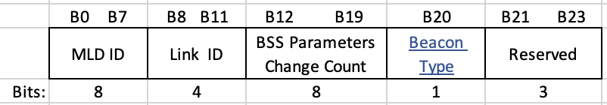
Figure 9-632b—MLD Parameters subfield format

The Beacon Type subfield is set to 0, if the reported AP transmits its Beacon frames as non-HT PPDU or non-HT Duplicate PPDU and the Beacon frames transmission rate is less or equal to 24 Mbit/s, otherwise the subfield is set to 1. (#5324, #5325)

9.4.2.295b.2.3 Link Info field of the Basic Multi-Link element(#7567)
Instructions to the TGbe Editor: Please update the figure Figure 9-788ej as shown below and add the new paragraph as the new eighth paragraph after the Figure 9-788ej.

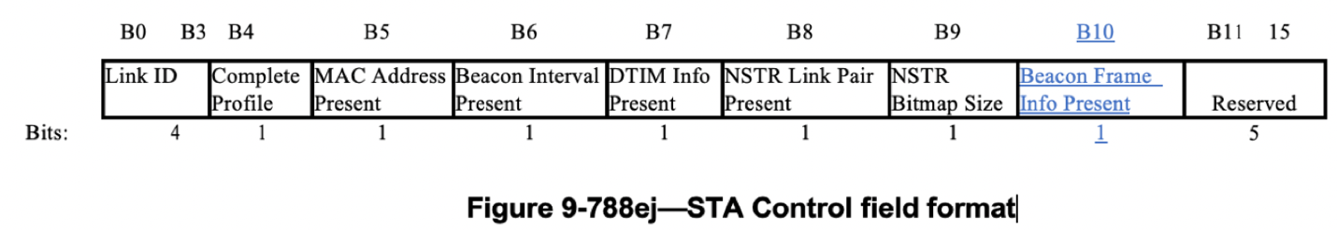

The Beacon Frame Info Present subfield indicates the presence of the Beacon Frame Info subfield in the STA Info field and is set to 1 if the Beacon Frame Info subfield is present in the STA Info field; otherwise set to 0. A non-AP STA sets the Beacon Frame Info Present subfield to 0 in the transmitted Basic Multi-Link element. An AP sets this subfield to 1 when the element carries complete profile. (#5332, #5335)

Instructions to the TGbe Editor: Please update the figure Figure 9-788ep as shown below.

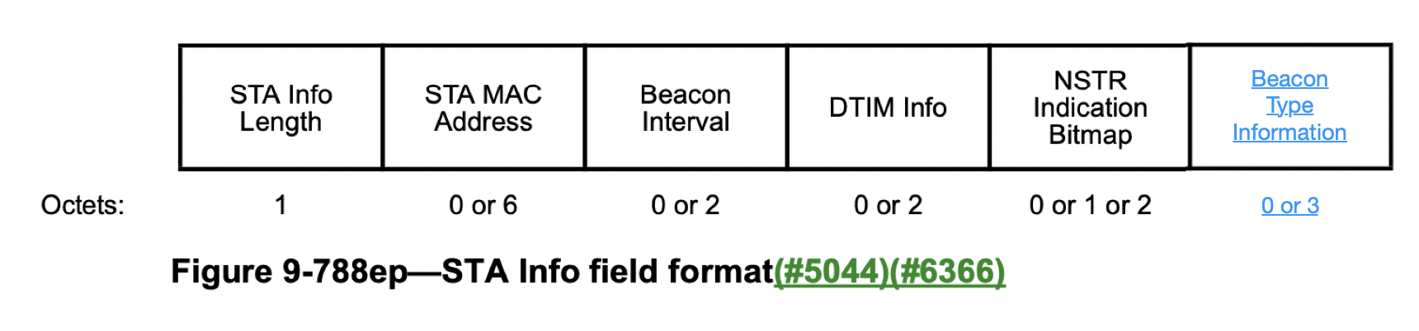

Instructions to the TGbe Editor: Please add the new figure and new paragraphs before the last paragraph of the clause. Please renumber the captions accordingly.
 | Beacon PPDU Type | Beacon BW | Beacon MCS | Beacon TX Power Difference | Group Frames TX Mode | Reserved
Bits: | 3 | 3 | 4 | 8 | 2 | 4

Figure 9-788xx—Beacon Type Information field format

The Beacon PPDU Type subfield indicates the PPDU type that carries the Beacon frames. The subfield encoding is shown in the Table XX below. (#5332, #5335)

Table XX – Beacon PPDU Type subfield encoding.
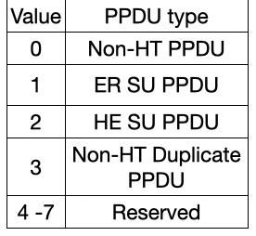

The Beacon BW subfield indicates the BW of the Beacon PPDU. The subfield encoding is shown in the Table XX+1 below. (#5332, #5335)
Table XX+1 – Beacon BW subfield encoding.
Value | BW
0 | 20
1 | 40
2 | 80
3 | 160
4 | 320
5 – 7 | Reserved

The Beacon MCS subfield specifies the MCS of the Beacon PPDU. The subfield encoding is shown in the Table XX+2 below. (#5332, #5335)

Table XX+2 – Beacon BW subfield encoding.
Beacon MCS subfield value | DSSS PPDU rate | non-HT OFDM MCS | HE MCS
0 | Basic rate | 0 | 0
1 | Enhanced rate | 1 | 1
2 | HR rate 1 | 2 | 2
3 | HR rate 2 | 3 | 3
4 | Reserved | 4 | 4
5 | Reserved | 5 | 5
6 | Reserved | 6 | 6
7 | Reserved | 7 | 7
8 | Reserved | Reserved | 8
9 | Reserved | Reserved | 9
10 | Reserved | Reserved | 10
11 | Reserved | Reserved | 11
12 – 15 | Reserved | Reserved | Reserved

The Beacon TxPower Difference subfield of the STA Info field is 1 octet in length and represents a 2s complement signed integer in dB. It carries the difference between the beacon transmit power (expressed in EIRP) normalized to 20 MHz of the AP reported in the Per-STA Profile subelement and the beacon transmit power (expressed in EIRP) normalized to 20 MHz of the AP transmitting the Basic variant Multi-Link element. (#5332, #5335)

NOTE – For example, if the beacon transmit power (in EIRP) normalized to 20 MHz of the AP that carries the ML probe response is 23 dBm and the beacon transmit power (in EIRP) normalized to 20 MHz of an AP that is reported in the Per-STA Profile subelement of the Basic variant Multi-Link element carried in the ML probe response is 20 dBm then the Beacon TxPower Difference subfield of the Per-STA profile subelement corresponding to that AP carries the binary value 11111101. (#5332, #5335)

The Group Frames TX Mode subfield indicates the group frames transmission mode. The subfield endocing is shown in the Table XX+3 below.( #5337, #5338, #5341)
Table XX+3 – Group Frames TX Mode subfield encoding.
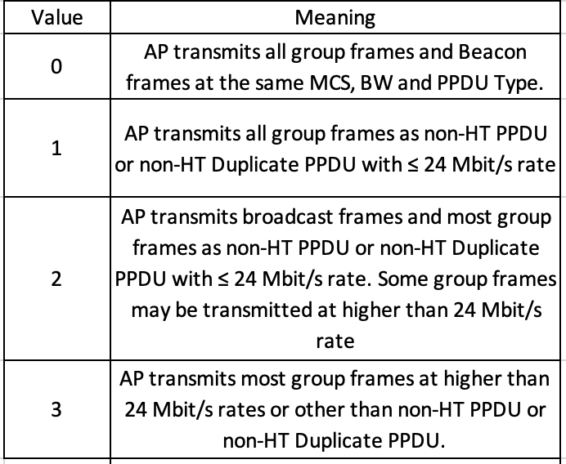

11.2.3.15 TIM Broadcast
Instructions to the TGbe Editor: Please add the row to the end of the list.

s) Modification of the Beacon Type Information field. (#5334, #5340)

